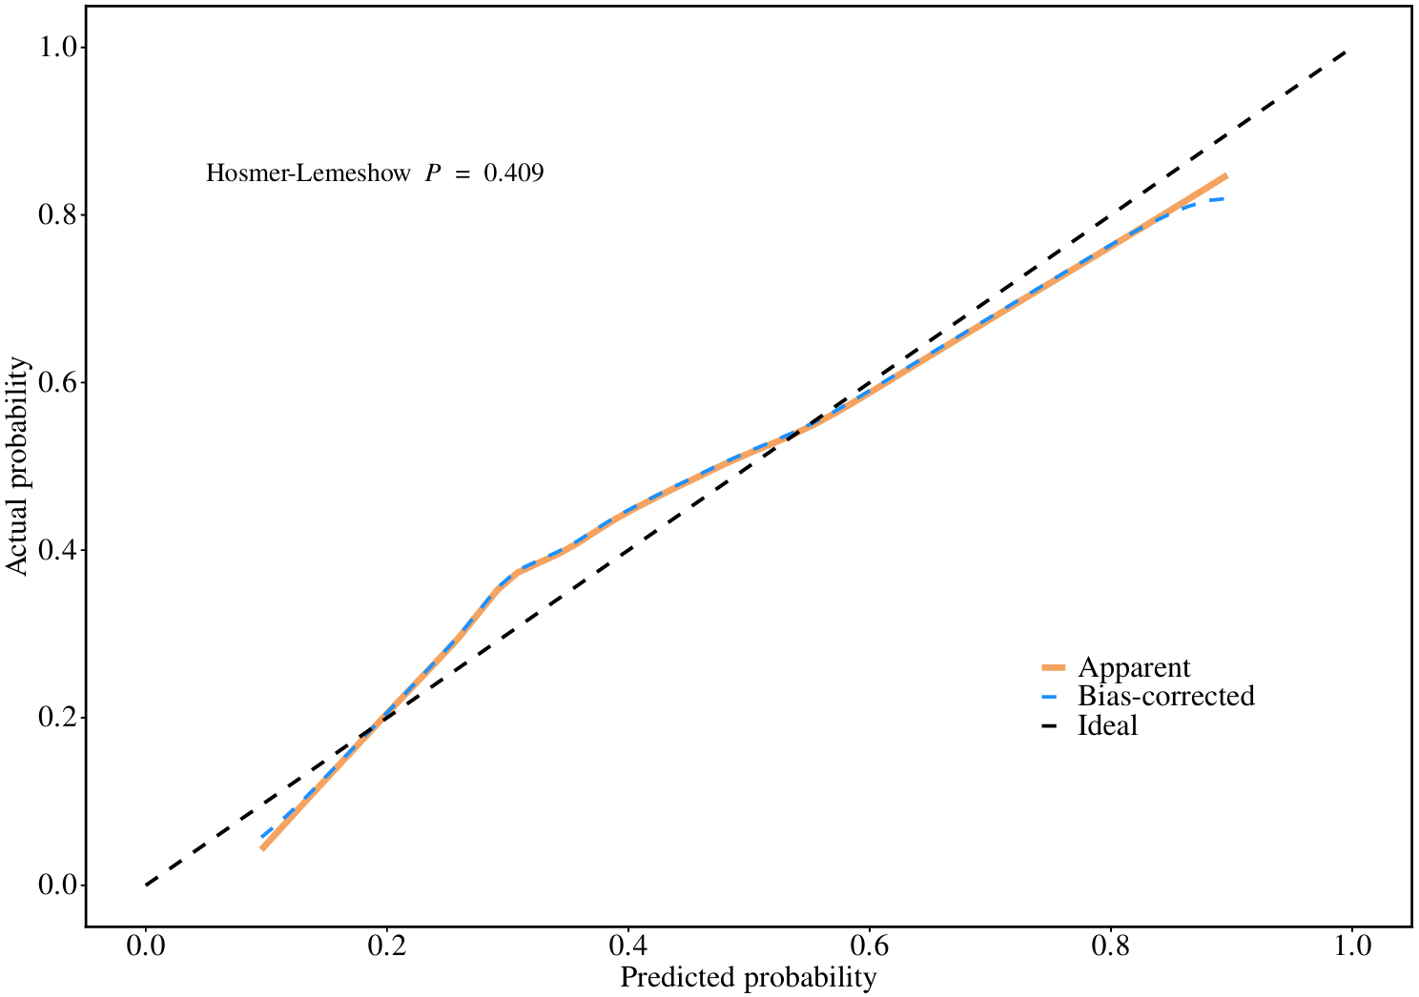
Figure S3 Calibration plot for the Preliminary Risk Stratification Model predicting HFNC failure. Hosmer-Lemeshow test P = 0.409, indicating good agreement between predicted and observed probabilities.

