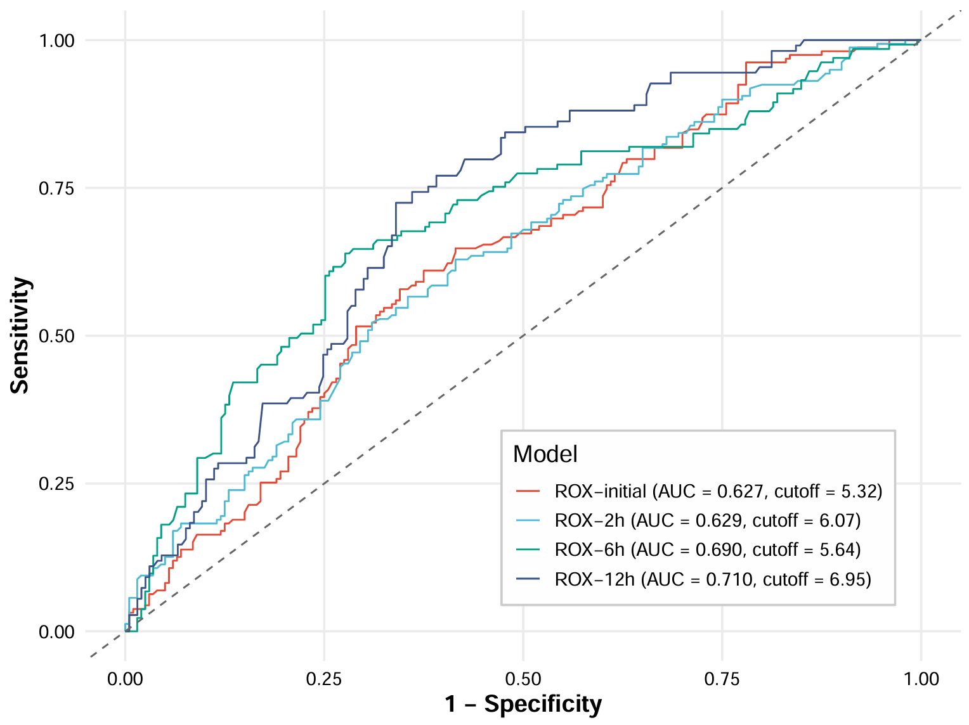Figure S4 ROC curve of ROX (expanded cohort, n=359)

