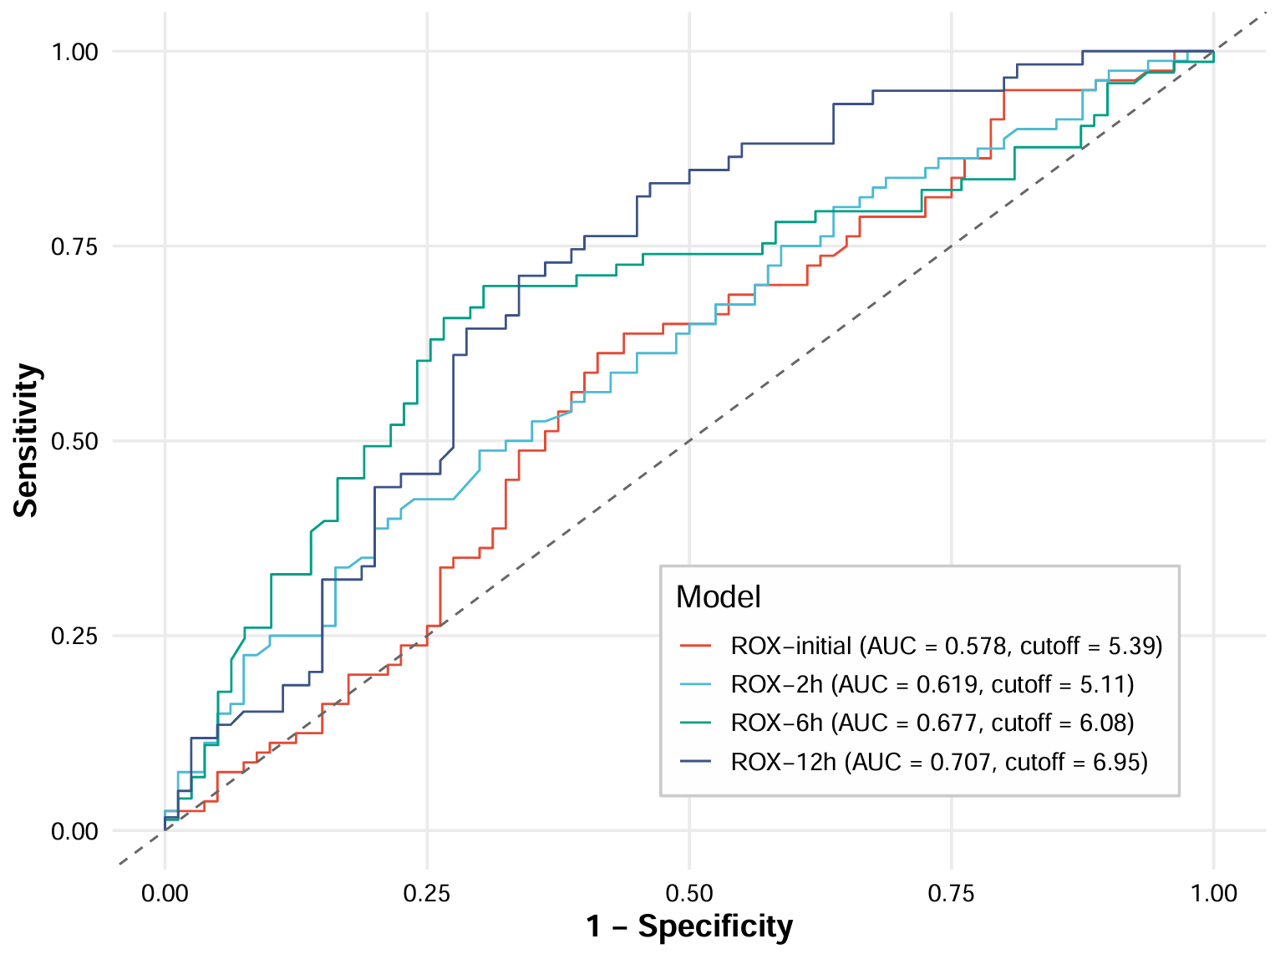Figure S5 ROC curve of ROX (PSM cohort, n=160)

