Magnitude and Longevity of Antibody Responses to Key Plasmodium vivax Erythrocyte Binding–Like Proteins in an Amazonian Cohort: A Long-Term Follow-Up Study

Gabriela M. Fernandes¹*, Samick L. Moreira-Nascimento¹*, Maria F. A. Nascimento¹, Sofia L. Afonso¹, Leticia M. Torres¹, Barbara G. S. Abreu¹, Clara F. O. D. Silva¹, Francis B. Ntumngia², John H. Adams², Cor J. F. Fontes³, Flora S. Kano¹, Luzia H. Carvalho¹

¹ Fundação Oswaldo Cruz, Fiocruz, Instituto René Rachou, Fiocruz Minas, Belo Horizonte, Minas Gerais, Brazil.
² Center for Global Health and Infectious Diseases Research, College of Public Health, University of South Florida, Tampa, Florida, United States of America.
³ Universidade Federal de Mato Grosso (UFMT), Hospital Júlio Müller, Faculdade de Medicina, Cuiabá, Mato Grosso, Brazil.
*These authors contributed equally to this work.

Additional file 3

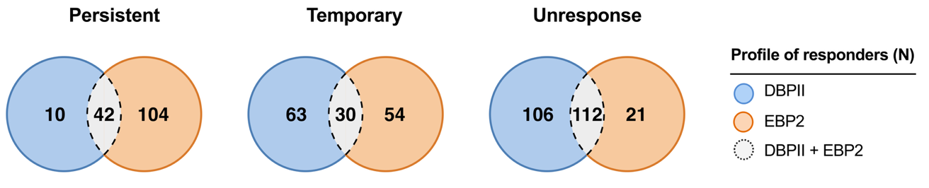

Figure S1. Overlap of longitudinal IgG response profiles to DBPII and EBP2 across the study cohort (N = 363). Venn diagrams illustrate the overlap and exclusivity of IgG response profiles to DBPII (blue) and EBP2 (orange) across three classification groups: (i) persistent responders, exhibiting sustained seropositivity; (ii) temporary responders, showing intermittent seropositivity; and (iii) non-responders, with no detectable antibodies at any time point. The dashed area represents individuals sharing the same response profile for both antigens simultaneously. Numbers indicate the count of participants (N) in each section.

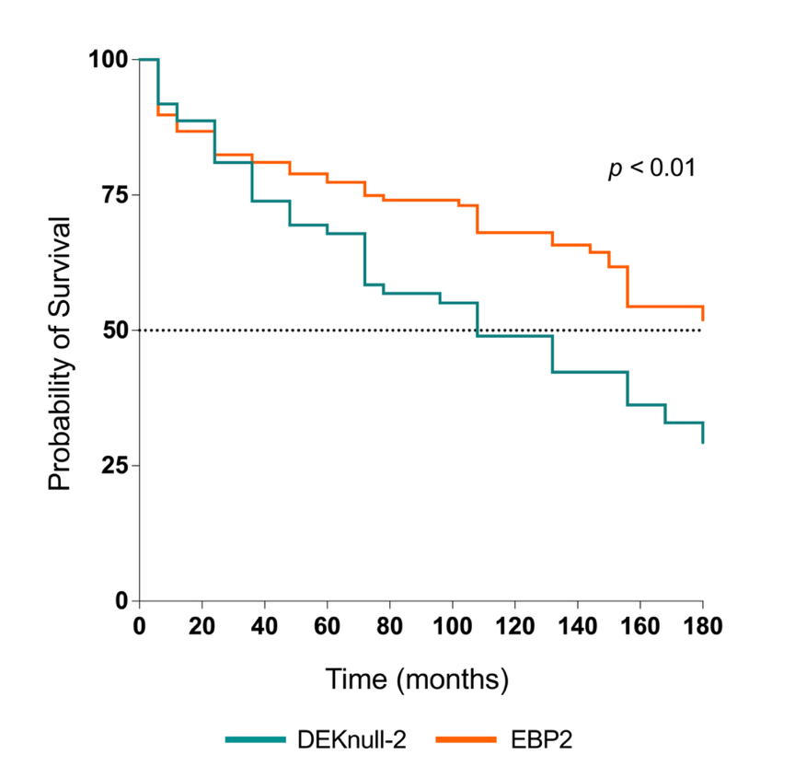
Figure S2. Time to first documented seroreversion of naturally acquired IgG antibody responses against P. vivax antigens, EBP2 and DEKnull-2, a novel engineered DBP immunogen targeting conserved DBPII epitopes [36]. Kaplan–Meier survival curves depicting the cumulative probability of maintaining IgG antibodies against EBP2 (orange) and DEKnull-2 (green). The event of interest was defined as seroreversion (first transition from seropositive to seronegative status). The dashed horizontal line indicates the 50% survival probability. Differences between survival curves were assessed using the log-rank (Mantel–Cox) test (p < 0.05).

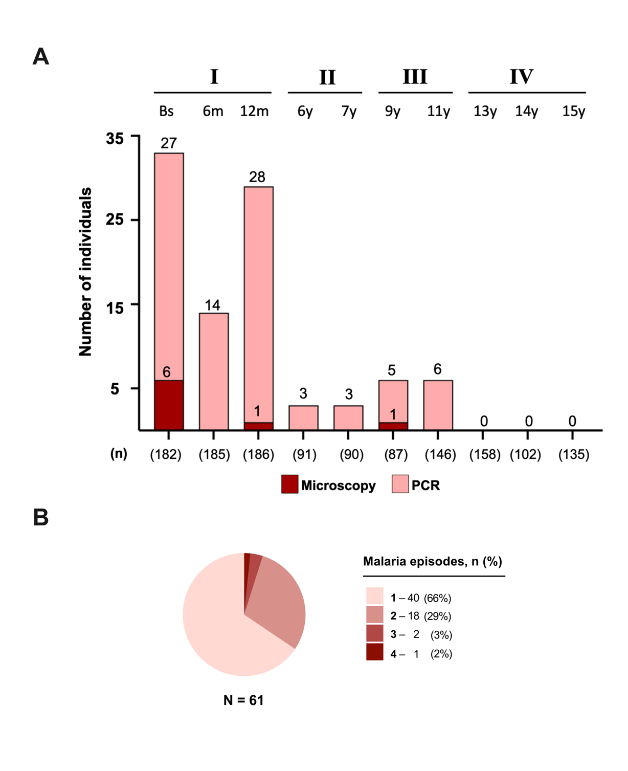

Figure S3. Plasmodium vivax malaria infections during the follow-up-period. A) Number of malaria positive samples as detected by optical microscopy (red bars) or species-specific PCR-based protocol [33] (light pink bars). Numbers at the bottom of each bar represent the number of participants (n) per survey. All PCR-positive participants were asymptomatic while microscopically positive participants reported signs and/or symptoms of uncomplicated malaria infection, with headache, fever, chills and myalgia were the most prevalent symptoms. B) Distribution of the cumulative number of P. vivax malaria episodes among the 61 participants with at least one malaria episode during follow-up. Most experienced a single episode (40/61, 66%), while 18 (29%), 2 (3%), and 1 (2%) experienced two, three, and four episodes, respectively.

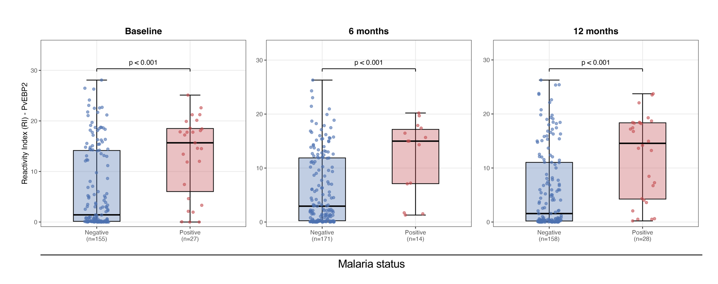
Figure S4. Association between malaria status and anti-EBP2 antibodies Reactivity Index (RI) at baseline, 6 and 12 months of follow up. Boxplots show the distribution of the anti-EBP2 RI according to malaria status (Negative/Positive), defined by positivity on optical microscopy and/or species-specific PCR. Comparisons between groups were performed using the Mann–Whitney U test, and effect size was estimated using the rank-biserial correlation (r). At all three time points (baseline, 6 months, and 12 months), anti-EBP2 IgG RI was significantly higher in malaria-positive individuals than in malaria-negative individuals (all p < 0.001), with effect sizes ranging from moderate to strong (r = 0.43, 0.53, and 0.50, respectively) (Cohen's conventions for effect sizes [38]).

