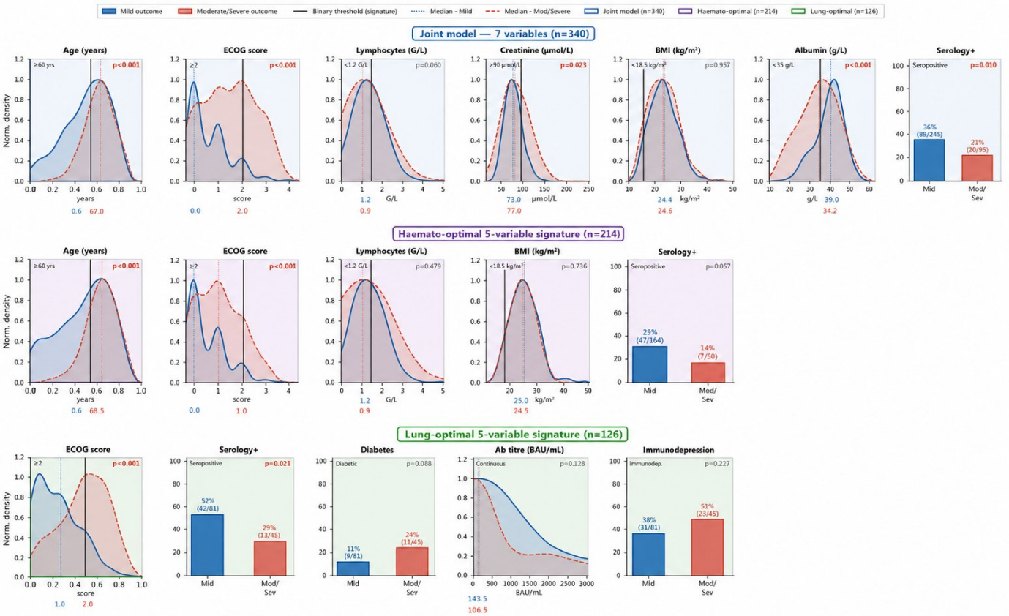Supplementary Figure 1: Complete feature-space distribution of the two outcome populations.
Variable distributions stratified by COVID-19 severity (Mild vs Moderate/Severe) across the three clinical signatures derived in this study. Blue distributions represent the mild outcome group; red/orange distributions represent the moderate/severe outcome group. Solid vertical lines indicate binary thresholds used in each signature; dotted lines indicate group medians. Blue/red numbers beneath each panel denote median values for mild and moderate/severe groups, respectively. Row 1 (blue border): Joint 7-variable model (n=340, internal CLB-IGH training cohort) — Age (≥60 yrs), ECOG score (≥2), Lymphocytes (<1.2 G/L), Creatinine (>90 μmol/L), BMI (<18.5 kg/m²), Albumin (<35 g/L), SARS-CoV-2 serology (seropositive). Row 2 (purple border): Haemato-optimal 5-variable signature (n=214, hematological cancer subset) — Age, ECOG score, Lymphocytes, BMI, SARS-CoV-2 serology. Row 3 (green border): Lung-optimal 5-variable signature (n=126, lung cancer subset) — ECOG score, SARS-CoV-2 serology, Diabetes, Antibody titre (BAU/mL), Immunodepression status. Creatinine (μmol/L) and Albumin (g/L) thresholds apply to the joint model only; antibody titre is reported as a continuous variable in the lung-optimal signature. CLB-IGH, Centre Léon Bérard – Institut Gustave Roussy – Hôpitaux de Paris cohort.

