Supplementary document 1. People Living with HIV and Proportion Diagnosed in Aotearoa New Zealand: First Published National Estimates from Two Modelling Approaches

CD4+ count categories at diagnosis and ECDC model additional fits and findings

Contents
CD4⁺ count categories since 2005 2
ECDC model additional methods 2
Model settings 3
Goodness of fit, overall model 4
ECDC overall model findings 7
ECDC subgroup model fits and findings 10
MSM: fits to data 10
MSM: Findings 12
Heterosexual men and women: fits to data 14
Heterosexual men and women: findings 16
Men: fits to data 18
Men: findings 20
Women: fits to data 22
Women: findings 24
Māori: fits to data 26
Māori: findings 28
Non-Māori, non-Pacific people: fits to data 30
Non-Māori, non-Pacific people: findings 32

CD4⁺ count categories since 2005
CD4⁺ at diagnosis was unknown for 481 people diagnosed in NZ (19%). The highest proportion of people diagnosed in NZ had a CD4⁺ count of >=500 (29%), but a substantial proportion had CD4⁺ count under 200 (22%). For those previously diagnosed overseas, CD4⁺ counts were mostly not collected (91%), and where included 45% (36/80) were from the time of NZ notification and 55% (44/80) from prior testing. For those diagnosed on immigration, CD4⁺ counts were unknown in 33%.
CD4⁺ count categories since 2005
CD4⁺ count category | Total notified 2005-2024 (%) | Diagnosed in NZ (%) | Diagnosed overseas (%) | Diagnosed on immigration (%)
All | 3823 (100) | 2583 (100) | 922 (100) | 318 (100)
>=500 | 828 (22) | 750 (29) | 20 | 58
350-499 | 471 (12) | 413 (16) | 16 | 42
200-349 | 467 (12) | 379 (15) | 25 | 63
<200 | 627 (16) | 560 (22) | 19 | 48
Unknown | 1430 (37) | 481 (19) | 842 | 107

ECDC model additional methods

Use of migration module
We took the following steps to enable use of the migration module to identify people previously diagnosed overseas, as NZ’s HIV surveillance system does not collect country of birth or nationality or date of arrival for immigrants with HIV, but has collected place of diagnosis and likely place of acquisition of infection since 1985 and ethnicity since 1996. For those previously diagnosed overseas before notification in NZ, ethnicity was used as country of nationality where available, then region of origin was assigned as outlined in the ECDC manual appendix. For people of Māori and NZ European ethnicity first diagnosed overseas, NZ was used as the country of nationality, but the region of origin was assigned as AUSNZ rather than reporting country, allowing these people to be considered part of the diagnosed migrant population. We did not use the migration module to estimate place of acquisition of infection for migrants, because likely country of acquisition is already included in NZ surveillance data. We also did not undertake analysis by region of origin in this study, but may do so in future work. For those diagnosed overseas, the date of notification in NZ was used as the date of arrival, assuming that people with known HIV seek care and are notified to the surveillance system within the year of arrival, and likely within months. For those diagnosed in NZ who acquired infection overseas, ethnicity was used as country of nationality where available, and was otherwise unknown, with region of origin assigned as above. Date of notification was also used as date of arrival for those diagnosed in NZ who acquired infection overseas, and were documented to have been tested for immigration or refugee testing, assuming that this testing takes place within the year of arrival. For those diagnosed in NZ who acquired infection in NZ, the region of origin was assigned as reporting country.

Death and emigration data
To ensure people notified with HIV who had subsequently died or emigrated overseas were removed from the diagnosed population, we took the following approach. Dates of death were included where known. Where cases had emigrated on a known date, this date was entered in the date of death column. Where cases were known to have died or emigrated with unknown dates, the end of the year in which the last information for the case was available, for example AIDS diagnosis, most recent viral load or CD4+ count, was entered in the date of death column.

Data quality pre-2000
A substantial improvement in data quality was noted from 2000 onwards. Pre-2000 there had been some bulk notifications, for example over 100 notifications in a single day in 1999. There were also limited data on AIDS diagnoses, at a time during which it would be expected that a high proportion of PLWH developed AIDS. Of 1400 people notified with HIV before 2000, only 431 (31%) were noted to have developed AIDS, with a date of diagnosis, and 446 (32%) were known to have died. Pre-1990 of 420 only 109 (26%) were noted to have developed AIDS, and 133 to have died (32%). Attempts to use the model including data pre-2000 resulted in poorer fits and inconsistently high numbers of people living with HIV. Estimates prior to 2000 are therefore less reliable, and are indicated in italics in the overall model table, and are not included in subgroup tables.

Model settings

Model time intervals and diagnosis rates
Time intervals for diagnosis rate changes were based on the following local developments. In 2005 HIV screening became mandatory as part of immigration(19), and HIV screening in pregnancy began in 2006(20). In 2012 there was an increase in the CD4⁺ threshold for treatment, and Truvada and Atripla became available as treatment options(21). HIV pre-exposure prophylaxis (PrEP) became available through importations and a demonstration project in 2016 and early 2017(22), and the CD4⁺ threshold for treatment was also removed at this time(23). On 1st January 2017 when HIV became notifiable(15), ART became free for all PLWH in NZ regardless of residency status. Substantial disruptions to health care including HIV testing occurred during the COVID-19 pandemic between 2020 and 2022.

Start year | End year | Jump | Change by CD4 | Change interval
1985 | 2000 | Y | N | Y
2000 | 2005 | N | N | Y
2005 | 2012 | N | Y | Y
2012 | 2016 | N | Y | Y
2016 | 2020 | N | Y | Y
2020 | 2022 | N | Y | Y
2022 | 2024 | N | Y | Y

Advanced parameters
Parameter | Value
Range of calculations | 1985-2024
HIV diagnoses, total | 2000-2004
HIV diagnoses, by CD4 count | 2005-2024
AIDS diagnoses, total | Deselected
HIV/AIDS diagnoses, total | 2000-2024
Do you have data from start of epidemic? | No
Knots count | 4
Start at zero | Yes
Prevent sudden changes at end of observation interval | Yes
Maximum likelihood distribution | Poisson

Goodness of fit, overall model
HIV diagnoses
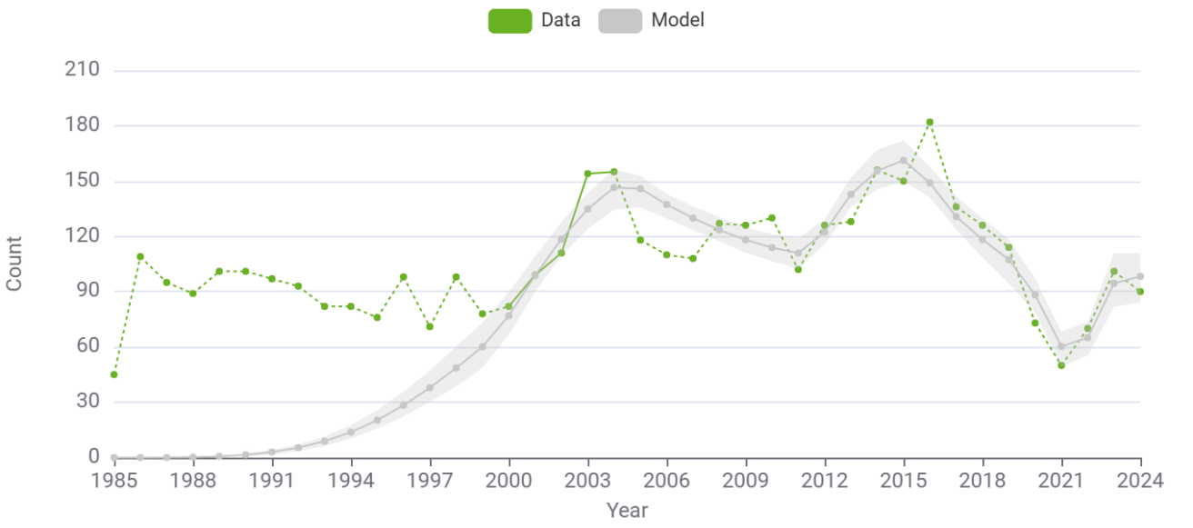
HIV diagnoses, CD4 >=500
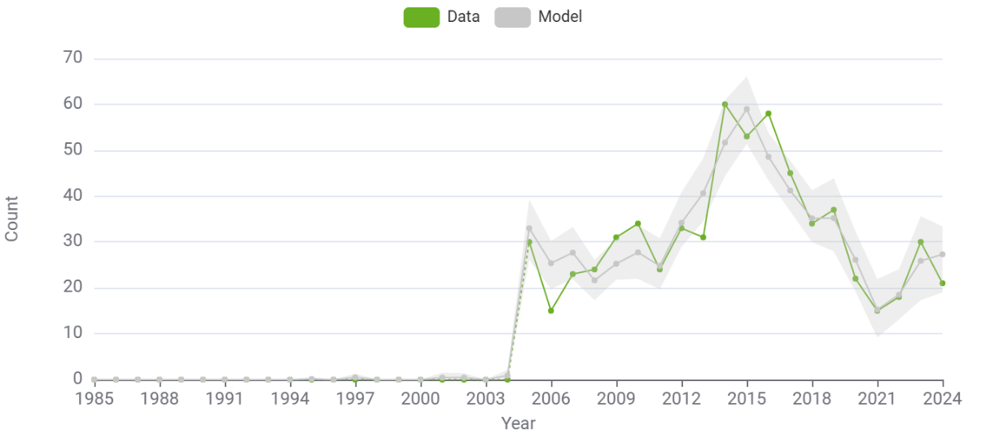

HIV diagnoses, CD4 350-499
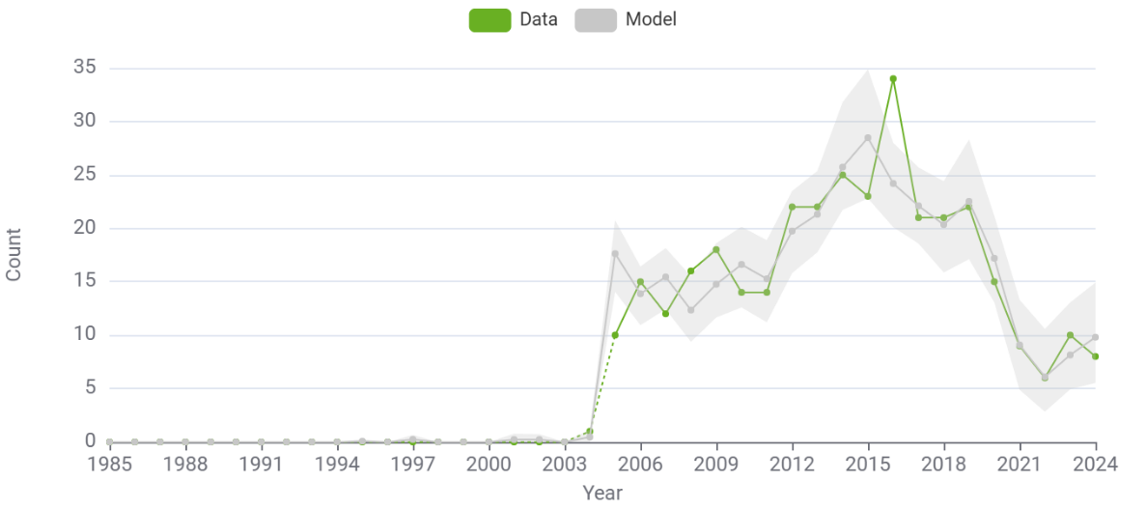
HIV diagnoses CD4 200-349
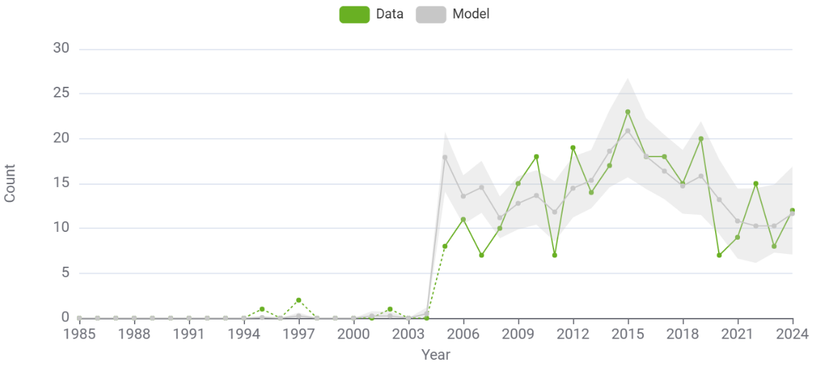
HIV diagnoses CD4 <200
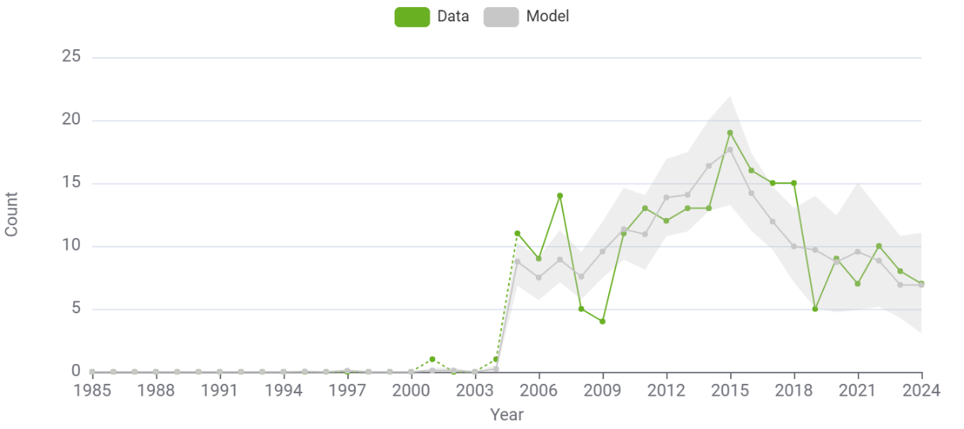

HIV/AIDS
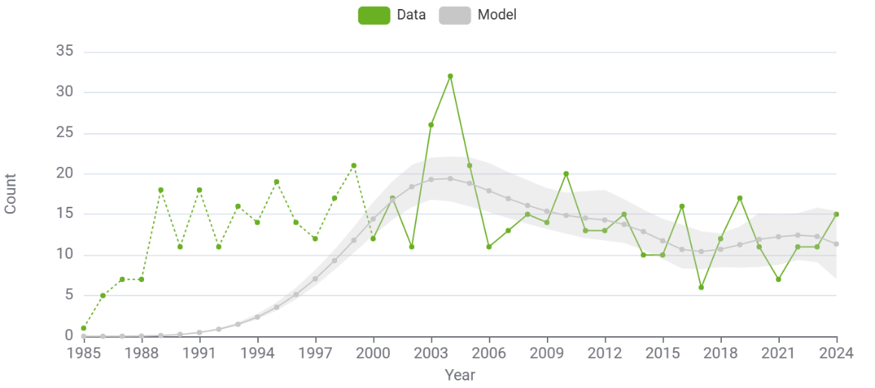

ECDC overall model findings

Total number of people living with HIV, proportion undiagnosed and infections per year, overall model (95% Cis) 1985-2024
Year | Number diagnosed from model | Cumulative migrants diagnosed | Number undiagnosed | Total PLWH | % undiagnosed | Incident infections per year | Total infections per year
1985 | 0.00 (0.00 - 0.00) | 0.00 (0.00 - 0.00) | 0.01 (0.01 - 0.02) | 0.01 (0.01 - 0.02) | 0.99 (0.98 - 1.00) | 0.01 (0.01 - 0.02) | 0.01 (0.01 - 0.02)
1986 | 0.01 (0.00 - 0.01) | 0.00 (0.00 - 0.00) | 0.22 (0.20 - 0.25) | 0.23 (0.20 - 0.26) | 0.97 (0.96 - 0.99) | 0.21 (0.19 - 0.24) | 0.21 (0.19 - 0.24)
1987 | 0.07 (0.02 - 0.09) | 0.00 (0.00 - 0.00) | 1.09 (0.98 - 1.23) | 1.15 (1.03 - 1.32) | 0.94 (0.93 - 0.98) | 0.93 (0.83 - 1.06) | 0.93 (0.83 - 1.06)
1988 | 0.31 (0.13 - 0.41) | 0.00 (0.00 - 0.00) | 3.34 (3.00 - 3.79) | 3.65 (3.27 - 4.17) | 0.92 (0.89 - 0.97) | 2.50 (2.23 - 2.85) | 2.50 (2.23 - 2.85)
1989 | 0.98 (0.50 - 1.28) | 0.00 (0.00 - 0.00) | 7.92 (7.11 - 8.95) | 8.91 (7.97 - 10.18) | 0.89 (0.86 - 0.95) | 5.26 (4.71 - 6.01) | 5.26 (4.71 - 6.01)
1990 | 2.52 (1.46 - 3.20) | 0.00 (0.00 - 0.00) | 15.95 (14.31 - 17.95) | 18.46 (16.53 - 21.10) | 0.86 (0.83 - 0.93) | 9.57 (8.56 - 10.93) | 9.57 (8.56 - 10.93)
1991 | 5.54 (3.50 - 6.98) | 0.00 (0.00 - 0.00) | 28.65 (25.71 - 32.14) | 34.20 (30.61 - 39.08) | 0.84 (0.80 - 0.90) | 15.75 (14.10 - 18.00) | 15.75 (14.10 - 18.00)
1992 | 10.94 (7.36 - 13.64) | 0.00 (0.00 - 0.00) | 47.39 (42.23 - 53.11) | 58.32 (52.21 - 66.66) | 0.81 (0.77 - 0.88) | 24.17 (21.63 - 27.62) | 24.17 (21.63 - 27.62)
1993 | 19.83 (13.64 - 24.53) | 1.00 (0.00 - 3.38) | 73.52 (65.16 - 82.35) | 94.35 (85.08 - 108.65) | 0.78 (0.74 - 0.84) | 35.09 (31.42 - 40.11) | 36.09 (32.12 - 42.13)
1994 | 33.63 (24.10 - 41.61) | 1.00 (0.00 - 3.38) | 107.91 (95.38 - 121.05) | 142.54 (128.04 - 163.23) | 0.76 (0.72 - 0.81) | 48.29 (43.25 - 55.15) | 48.29 (43.25 - 55.15)
1995 | 53.91 (40.02 - 66.88) | 1.00 (0.00 - 3.38) | 150.42 (133.12 - 168.71) | 205.33 (184.51 - 234.76) | 0.73 (0.69 - 0.79) | 62.95 (56.45 - 71.78) | 62.95 (56.45 - 71.78)
1996 | 82.26 (62.12 - 102.24) | 2.00 (0.00 - 5.00) | 200.08 (177.52 - 225.00) | 284.34 (255.10 - 323.71) | 0.70 (0.65 - 0.76) | 78.24 (70.30 - 88.97) | 79.24 (71.00 - 89.34)
1997 | 120.15 (91.60 - 148.32) | 4.00 (1.00 - 8.00) | 255.19 (227.29 - 287.64) | 379.34 (340.32 - 430.07) | 0.67 (0.62 - 0.73) | 93.30 (84.09 - 105.69) | 95.30 (86.13 - 106.59)
1998 | 168.75 (128.40 - 206.24) | 7.00 (2.63 - 13.00) | 313.48 (277.59 - 353.98) | 489.23 (440.02 - 554.52) | 0.64 (0.59 - 0.71) | 107.30 (97.08 - 120.91) | 110.30 (100.06 - 125.50)
1999 | 228.87 (174.77 - 278.98) | 48.00 (33.63 - 60.38) | 372.23 (327.34 - 420.86) | 649.10 (589.21 - 735.22) | 0.57 (0.52 - 0.64) | 119.39 (108.57 - 133.60) | 160.39 (144.94 - 177.78)
2000 | 296.83 (238.73 - 365.96) | 58.00 (42.58 - 71.43) | 423.34 (378.10 - 467.64) | 778.18 (716.79 - 888.24) | 0.54 (0.49 - 0.59) | 128.72 (118.80 - 144.96) | 138.72 (127.42 - 157.64)
2001 | 385.51 (323.44 - 462.14) | 69.00 (52.58 - 84.00) | 458.44 (411.99 - 505.55) | 912.95 (843.95 - 1,037.25) | 0.50 (0.45 - 0.55) | 134.51 (124.90 - 149.72) | 145.51 (133.95 - 162.46)
2002 | 495.05 (435.98 - 575.33) | 85.00 (66.58 - 100.85) | 475.83 (427.36 - 527.09) | 1,055.88 (975.24 - 1,193.76) | 0.45 (0.41 - 0.49) | 136.74 (127.85 - 150.14) | 152.74 (142.30 - 168.46)
2003 | 609.86 (544.91 - 695.15) | 105.00 (85.15 - 122.43) | 476.29 (425.06 - 531.01) | 1,191.15 (1,107.62 - 1,333.18) | 0.40 (0.37 - 0.43) | 136.12 (127.52 - 148.28) | 156.12 (146.30 - 169.79)
2004 | 734.30 (662.24 - 827.23) | 125.00 (105.15 - 145.00) | 462.44 (408.73 - 519.86) | 1,321.74 (1,233.70 - 1,469.57) | 0.35 (0.33 - 0.38) | 133.44 (124.54 - 143.35) | 153.44 (142.86 - 165.41)
2005 | 830.16 (758.00 - 929.57) | 205.00 (178.00 - 227.43) | 445.24 (394.39 - 502.04) | 1,480.40 (1,388.83 - 1,625.30) | 0.30 (0.28 - 0.33) | 129.49 (119.87 - 138.12) | 209.49 (190.96 - 231.50)
2006 | 924.48 (847.01 - 1,031.58) | 272.00 (238.73 - 297.85) | 432.18 (384.19 - 490.71) | 1,628.67 (1,531.46 - 1,777.69) | 0.27 (0.25 - 0.29) | 125.05 (113.09 - 134.90) | 192.05 (177.05 - 208.46)
2007 | 1,005.38 (922.49 - 1,121.78) | 328.00 (294.00 - 358.00) | 422.45 (381.98 - 477.69) | 1,755.83 (1,654.14 - 1,911.56) | 0.24 (0.22 - 0.26) | 120.91 (108.05 - 131.87) | 176.91 (159.34 - 193.22)
2008 | 1,091.86 (1,007.33 - 1,210.48) | 385.00 (347.58 - 413.00) | 416.12 (370.21 - 463.99) | 1,892.98 (1,790.07 - 2,044.84) | 0.22 (0.20 - 0.24) | 117.86 (105.03 - 129.76) | 174.86 (154.66 - 191.00)
2009 | 1,167.97 (1,074.27 - 1,289.22) | 425.00 (383.15 - 460.85) | 413.95 (355.90 - 460.12) | 2,006.92 (1,898.36 - 2,150.24) | 0.21 (0.19 - 0.23) | 116.62 (103.92 - 127.71) | 156.62 (139.85 - 172.37)
2010 | 1,239.88 (1,139.01 - 1,364.16) | 462.00 (420.73 - 497.43) | 416.66 (355.53 - 465.74) | 2,118.53 (2,006.87 - 2,261.69) | 0.20 (0.17 - 0.22) | 117.27 (105.88 - 127.16) | 154.27 (137.01 - 168.77)
2011 | 1,327.79 (1,229.93 - 1,450.66) | 485.00 (443.15 - 518.00) | 424.33 (359.00 - 474.90) | 2,237.12 (2,124.99 - 2,376.49) | 0.19 (0.17 - 0.21) | 119.23 (109.40 - 127.96) | 142.23 (128.36 - 153.05)
2012 | 1,416.16 (1,312.52 - 1,534.81) | 510.00 (469.15 - 542.00) | 423.21 (355.81 - 479.45) | 2,349.37 (2,239.39 - 2,476.73) | 0.18 (0.16 - 0.20) | 121.88 (112.23 - 130.16) | 146.88 (133.09 - 158.69)
2013 | 1,534.95 (1,434.26 - 1,660.45) | 541.00 (500.15 - 576.42) | 404.38 (341.87 - 462.45) | 2,480.34 (2,371.47 - 2,609.08) | 0.16 (0.14 - 0.18) | 124.58 (115.89 - 133.30) | 155.57 (142.91 - 168.93)
2014 | 1,645.47 (1,547.48 - 1,772.81) | 581.00 (540.58 - 615.85) | 374.99 (318.08 - 427.31) | 2,601.46 (2,490.76 - 2,724.92) | 0.14 (0.12 - 0.16) | 126.69 (116.75 - 137.09) | 166.69 (152.07 - 183.55)
2015 | 1,782.66 (1,689.04 - 1,907.58) | 614.00 (573.00 - 653.13) | 340.88 (283.85 - 385.58) | 2,737.54 (2,623.85 - 2,853.44) | 0.12 (0.10 - 0.14) | 127.59 (115.68 - 139.52) | 160.59 (144.48 - 175.23)
2016 | 1,889.65 (1,796.23 - 2,006.59) | 665.00 (619.58 - 705.43) | 318.06 (264.80 - 362.60) | 2,873.72 (2,767.18 - 2,979.74) | 0.11 (0.09 - 0.12) | 126.65 (113.19 - 139.28) | 178.65 (160.07 - 194.06)
2017 | 1,994.38 (1,900.78 - 2,111.64) | 706.00 (659.15 - 749.28) | 310.12 (259.63 - 353.98) | 3,010.51 (2,910.81 - 3,123.10) | 0.10 (0.09 - 0.12) | 123.25 (108.55 - 137.03) | 163.25 (145.25 - 181.67)
2018 | 2,096.63 (2,000.06 - 2,214.05) | 753.00 (708.30 - 797.00) | 308.43 (254.29 - 352.93) | 3,158.06 (3,051.79 - 3,276.48) | 0.10 (0.08 - 0.11) | 117.02 (101.67 - 132.08) | 164.02 (143.72 - 184.61)
2019 | 2,184.01 (2,090.17 - 2,296.60) | 817.00 (768.58 - 858.98) | 308.39 (241.62 - 359.26) | 3,310.40 (3,196.34 - 3,428.89) | 0.09 (0.08 - 0.11) | 107.84 (92.76 - 122.65) | 172.84 (152.66 - 195.54)
2020 | 2,265.24 (2,174.97 - 2,373.09) | 884.00 (831.58 - 921.00) | 315.24 (241.85 - 382.51) | 3,464.48 (3,340.63 - 3,584.21) | 0.09 (0.07 - 0.11) | 95.60 (81.65 - 109.29) | 161.60 (145.14 - 184.09)
2021 | 2,319.52 (2,225.01 - 2,430.93) | 934.00 (882.58 - 978.00) | 334.61 (257.90 - 404.99) | 3,588.13 (3,451.87 - 3,706.71) | 0.09 (0.07 - 0.11) | 80.20 (68.19 - 94.74) | 130.20 (113.97 - 149.75)
2022 | 2,378.60 (2,278.34 - 2,494.87) | 988.00 (938.58 - 1,039.28) | 330.52 (245.97 - 404.93) | 3,697.11 (3,552.60 - 3,823.09) | 0.09 (0.07 - 0.11) | 61.53 (52.28 - 73.33) | 115.53 (96.78 - 133.66)
2023 | 2,463.15 (2,361.17 - 2,576.53) | 1,101.00 (1,047.03 - 1,151.43) | 274.90 (181.09 - 362.53) | 3,839.05 (3,693.52 - 3,971.19) | 0.07 (0.05 - 0.09) | 39.48 (33.69 - 47.16) | 152.48 (134.20 - 178.22)
2024 | 2,559.45 (2,456.15 - 2,670.87) | 1,242.00 (1,179.58 - 1,295.85) | 190.04 (100.91 - 274.77) | 3,991.50 (3,849.19 - 4,115.82) | 0.05 (0.03 - 0.07) | 13.95 (11.93 - 17.43) | 154.95 (128.09 - 186.46)

ECDC subgroup model fits and findings

MSM: fits to data
HIV diagnoses, total
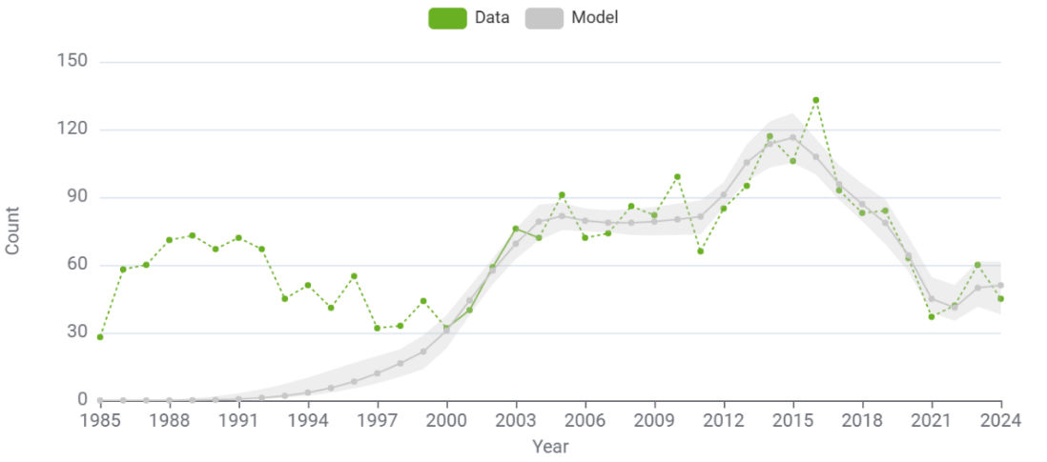
HIV diagnoses, CD4 >=500
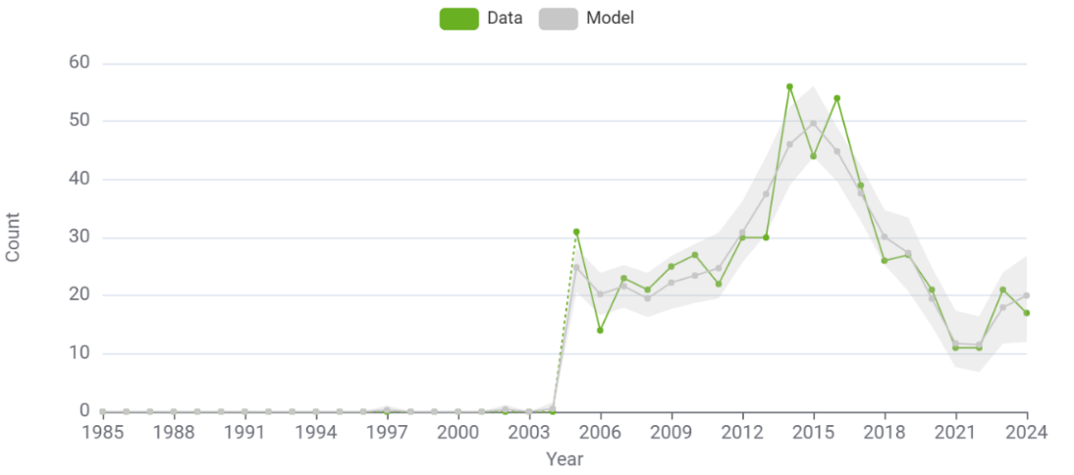
HIV diagnoses CD4 350-499
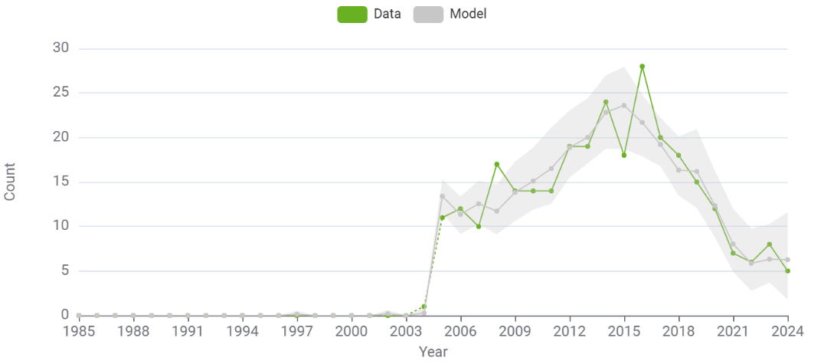

HIV diagnoses CD4 200-349
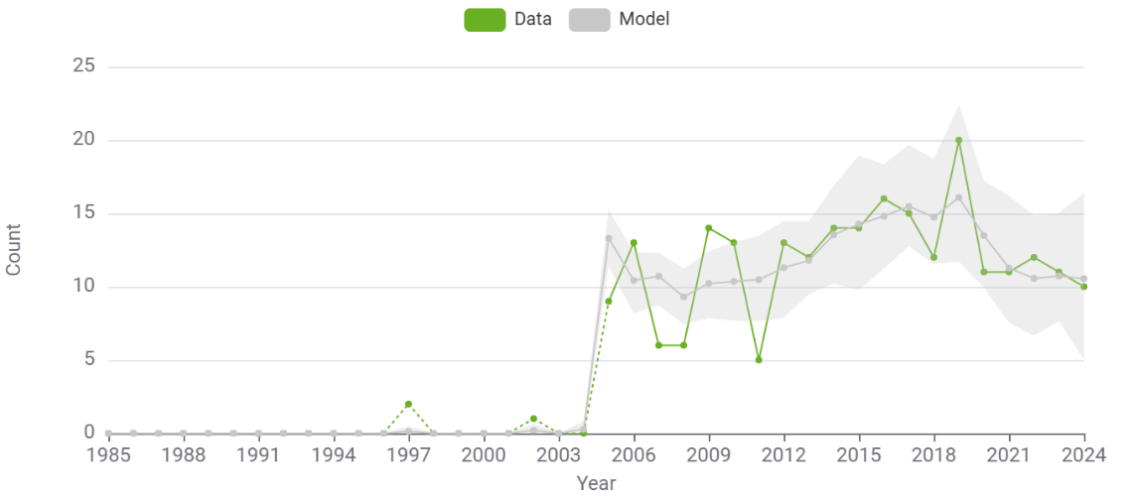
HIV diagnoses CD4 <200
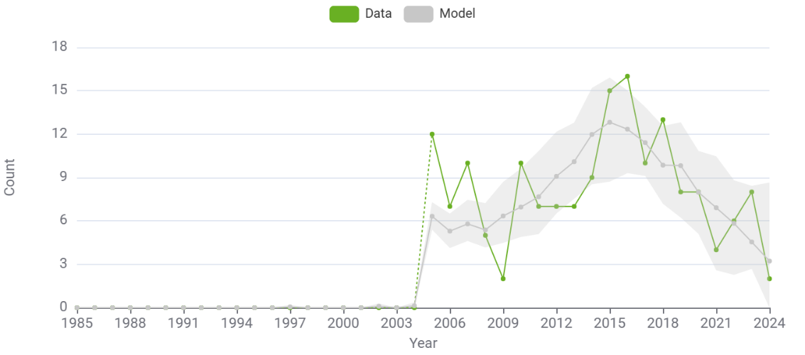
HIV/AIDS diagnoses
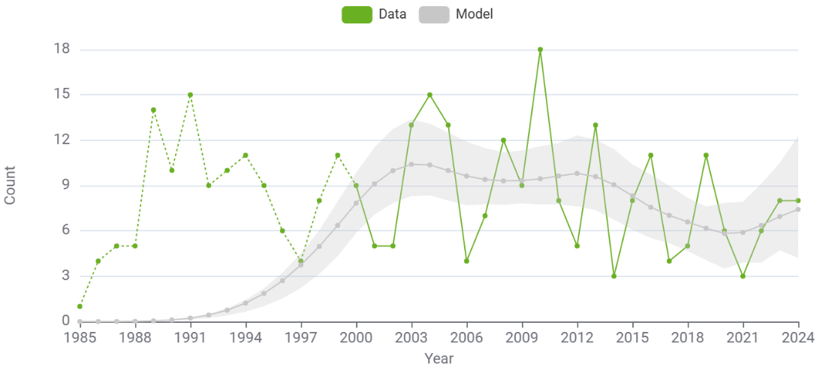

MSM: Findings

Total number MSM living with HIV, proportion undiagnosed and infections per year 2000-2024 (95% Cis)
Year | Number diagnosed from model | Cumulative migrants diagnosed | Number undiagnosed | Total PLWH | % undiagnosed | Incident infections per year | All infections per year
2000 | 96.19 (63.20 - 145.10) | 44.00 (32.00 - 57.00) | 216.10 (176.17 - 261.34) | 356.28 (310.40 - 410.85) | 0.61 (0.52 - 0.70) | 59.74 (53.30 - 68.31) | 65.74 (57.35 - 75.85)
2001 | 139.43 (103.80 - 185.93) | 53.00 (40.00 - 66.38) | 236.38 (197.81 - 285.79) | 428.80 (377.55 - 491.81) | 0.55 (0.48 - 0.63) | 64.92 (59.51 - 72.61) | 73.92 (66.18 - 84.79)
2002 | 191.92 (151.07 - 237.38) | 65.00 (48.63 - 82.75) | 247.66 (210.59 - 294.30) | 504.58 (447.02 - 574.24) | 0.49 (0.43 - 0.56) | 69.21 (64.00 - 76.38) | 81.21 (73.69 - 91.50)
2003 | 254.31 (210.72 - 299.13) | 78.00 (60.00 - 94.38) | 250.56 (213.34 - 292.28) | 582.87 (525.25 - 657.58) | 0.43 (0.38 - 0.48) | 72.76 (67.63 - 79.25) | 85.76 (78.06 - 95.29)
2004 | 325.46 (279.85 - 373.01) | 92.00 (72.63 - 109.38) | 246.65 (213.76 - 288.53) | 664.12 (599.68 - 743.22) | 0.37 (0.34 - 0.41) | 75.70 (69.98 - 81.91) | 89.70 (79.20 - 101.08)
2005 | 388.10 (346.11 - 440.40) | 105.00 (83.63 - 126.38) | 242.78 (211.30 - 280.36) | 735.88 (677.81 - 810.24) | 0.33 (0.30 - 0.36) | 78.21 (71.09 - 84.54) | 91.21 (81.83 - 103.60)
2006 | 454.65 (410.01 - 511.63) | 114.00 (91.63 - 138.38) | 243.24 (216.28 - 277.94) | 811.89 (747.93 - 887.72) | 0.30 (0.27 - 0.33) | 80.43 (72.15 - 88.00) | 89.43 (79.82 - 99.58)
2007 | 511.33 (464.77 - 572.35) | 119.00 (94.00 - 142.38) | 246.67 (219.31 - 279.55) | 877.00 (814.59 - 957.57) | 0.28 (0.25 - 0.31) | 82.52 (73.35 - 90.61) | 87.52 (77.80 - 97.82)
2008 | 568.97 (524.06 - 633.82) | 130.00 (108.75 - 152.38) | 252.26 (222.11 - 287.20) | 951.23 (889.99 - 1,044.41) | 0.27 (0.23 - 0.29) | 84.65 (74.70 - 92.95) | 95.65 (84.43 - 107.68)
2009 | 621.15 (571.83 - 680.20) | 133.00 (111.75 - 156.13) | 259.61 (221.89 - 294.85) | 1,013.76 (953.05 - 1,099.01) | 0.26 (0.22 - 0.28) | 86.94 (76.81 - 94.34) | 89.94 (79.81 - 97.42)
2010 | 676.28 (624.62 - 734.21) | 143.00 (122.63 - 166.00) | 268.40 (224.96 - 301.05) | 1,087.69 (1,023.96 - 1,170.04) | 0.25 (0.21 - 0.27) | 89.35 (80.17 - 96.22) | 99.35 (88.70 - 109.75)
2011 | 746.68 (693.82 - 804.31) | 151.00 (128.00 - 175.75) | 278.24 (228.36 - 314.68) | 1,175.92 (1,111.69 - 1,255.42) | 0.24 (0.20 - 0.26) | 91.65 (84.24 - 97.07) | 99.65 (90.59 - 107.00)
2012 | 815.78 (760.27 - 878.52) | 158.00 (133.63 - 183.75) | 280.31 (228.57 - 320.18) | 1,254.09 (1,186.74 - 1,334.26) | 0.22 (0.19 - 0.25) | 93.60 (86.03 - 98.10) | 100.60 (92.05 - 106.93)
2013 | 905.11 (850.32 - 970.81) | 164.00 (140.00 - 187.38) | 269.51 (222.19 - 305.92) | 1,338.62 (1,274.51 - 1,415.26) | 0.20 (0.17 - 0.22) | 94.96 (85.99 - 100.05) | 100.96 (91.61 - 107.95)
2014 | 987.63 (932.12 - 1,049.61) | 178.00 (155.13 - 202.13) | 251.06 (208.08 - 286.20) | 1,416.69 (1,350.73 - 1,496.08) | 0.18 (0.15 - 0.20) | 95.47 (83.38 - 102.30) | 109.47 (100.61 - 117.75)
2015 | 1,087.05 (1,028.76 - 1,150.41) | 199.00 (174.25 - 225.38) | 229.16 (188.88 - 263.16) | 1,515.21 (1,447.32 - 1,588.09) | 0.15 (0.13 - 0.17) | 94.89 (82.10 - 104.66) | 115.89 (100.03 - 128.71)
2016 | 1,168.88 (1,109.08 - 1,235.31) | 220.00 (195.25 - 245.88) | 213.98 (177.32 - 240.78) | 1,603.86 (1,532.65 - 1,679.32) | 0.13 (0.11 - 0.15) | 92.98 (80.66 - 105.10) | 114.98 (98.99 - 129.66)
2017 | 1,248.60 (1,192.55 - 1,313.57) | 242.00 (215.13 - 270.38) | 207.44 (172.92 - 237.33) | 1,698.04 (1,623.52 - 1,774.30) | 0.12 (0.10 - 0.14) | 89.49 (78.94 - 103.06) | 110.49 (98.78 - 126.65)
2018 | 1,328.51 (1,272.09 - 1,395.99) | 267.00 (241.25 - 298.38) | 204.49 (167.72 - 237.00) | 1,800.00 (1,726.96 - 1,878.22) | 0.11 (0.09 - 0.13) | 84.25 (74.36 - 98.37) | 109.25 (92.76 - 128.30)
2019 | 1,396.11 (1,341.51 - 1,465.14) | 308.00 (277.25 - 340.50) | 202.78 (162.92 - 242.88) | 1,906.88 (1,837.09 - 1,984.07) | 0.11 (0.09 - 0.13) | 77.15 (69.58 - 93.44) | 118.15 (105.21 - 137.02)
2020 | 1,459.33 (1,403.74 - 1,529.80) | 343.00 (311.63 - 380.38) | 206.37 (168.69 - 262.84) | 2,008.70 (1,937.04 - 2,086.20) | 0.10 (0.09 - 0.13) | 68.07 (61.60 - 89.52) | 103.07 (90.73 - 128.81)
2021 | 1,502.34 (1,443.96 - 1,577.75) | 371.00 (339.25 - 409.38) | 218.02 (181.15 - 287.55) | 2,091.36 (2,020.63 - 2,183.31) | 0.10 (0.09 - 0.13) | 56.92 (51.44 - 89.46) | 84.92 (75.11 - 115.90)
2022 | 1,539.45 (1,486.10 - 1,619.13) | 403.00 (367.63 - 442.75) | 220.19 (183.99 - 308.66) | 2,162.64 (2,092.07 - 2,281.28) | 0.10 (0.09 - 0.14) | 43.57 (39.34 - 90.11) | 75.57 (66.81 - 123.03)
2023 | 1,582.26 (1,529.59 - 1,662.86) | 461.00 (424.63 - 502.50) | 197.99 (151.36 - 345.68) | 2,241.25 (2,166.21 - 2,395.75) | 0.09 (0.07 - 0.15) | 27.92 (25.19 - 93.32) | 85.92 (74.15 - 152.38)
2024 | 1,631.23 (1,576.65 - 1,711.33) | 527.00 (493.63 - 569.00) | 156.55 (100.29 - 378.52) | 2,314.78 (2,247.50 - 2,536.92) | 0.07 (0.04 - 0.15) | 9.86 (8.90 - 95.99) | 75.86 (61.09 - 168.21)

Heterosexual men and women: fits to data
HIV diagnoses, total
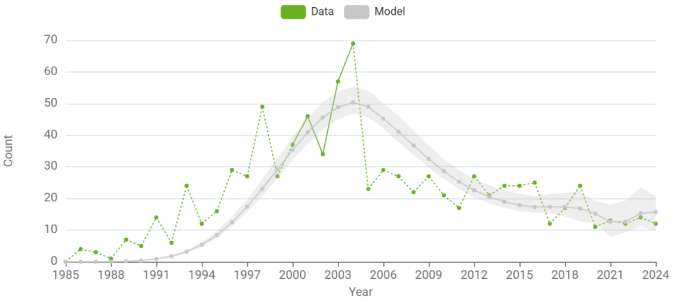
HIV diagnoses, CD4 >=500
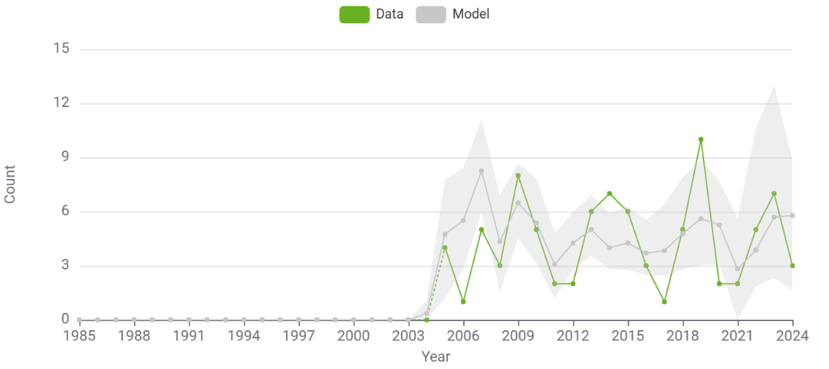
HIV diagnoses, CD4 350-499
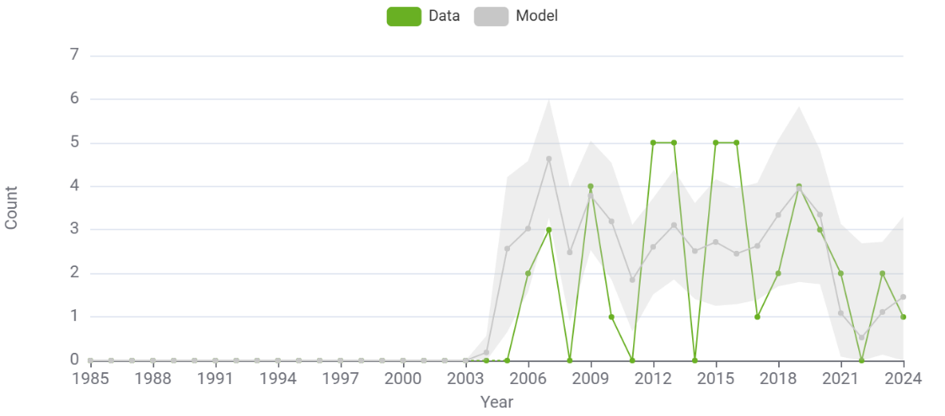

HIV diagnoses, CD4 200-349
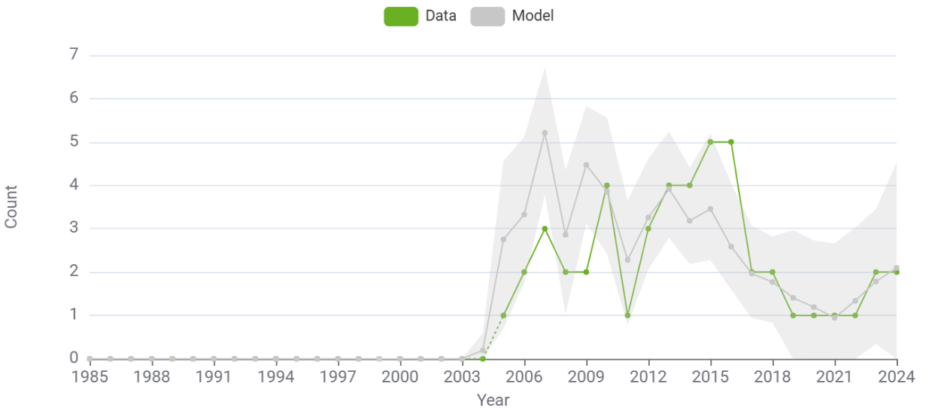

HIV diagnoses, CD4 <200
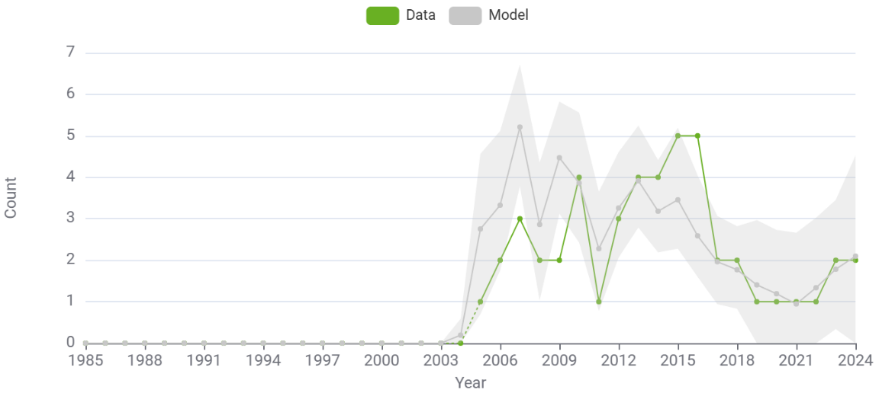
HIV/AIDS
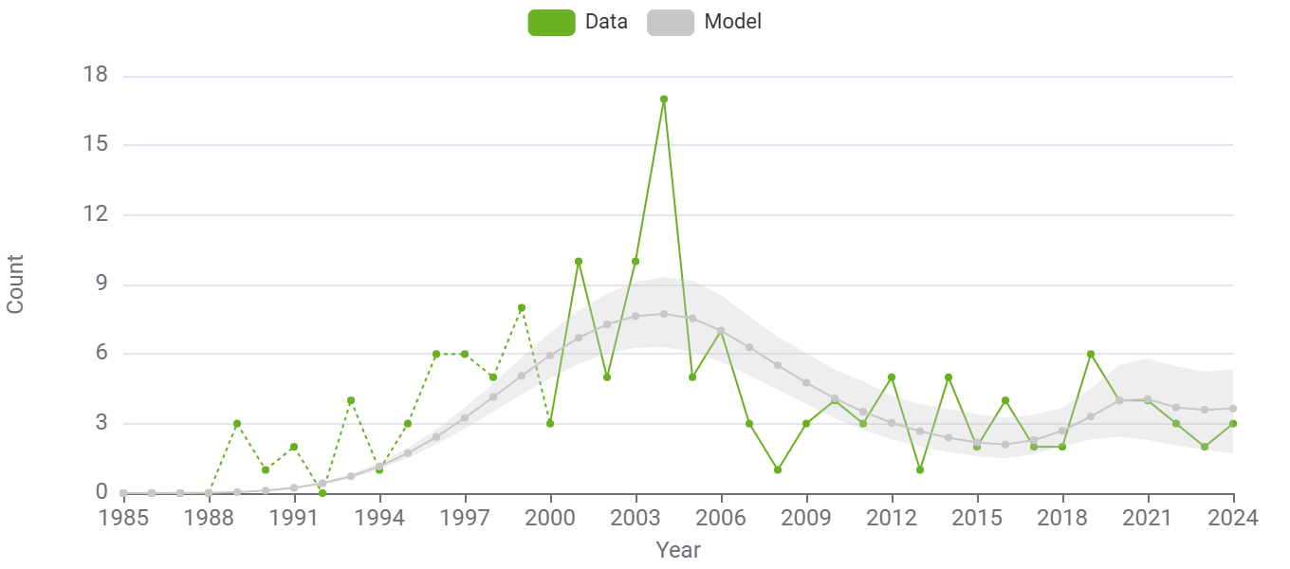

Heterosexual men and women: findings

Total number heterosexual people living with HIV, proportion undiagnosed and infections per year 2000-2024 (95% Cis)
Year | Number diagnosed from model | Cumulative migrants diagnosed | Number undiagnosed | Total PLWH | % undiagnosed | Incident infections per year | Total infections per year
2000 | 136.47 (122.02 - 154.25) | 10.00 (5.00 - 16.30) | 169.29 (145.72 - 193.75) | 315.76 (289.79 - 352.53) | 0.54 (0.50 - 0.57) | 51.55 (47.56 - 57.66) | 53.55 (49.59 - 59.43)
2001 | 171.41 (154.78 - 196.95) | 11.00 (6.00 - 17.00) | 180.06 (154.87 - 207.84) | 362.48 (333.69 - 403.36) | 0.50 (0.46 - 0.53) | 52.01 (48.23 - 58.21) | 53.01 (48.80 - 59.19)
2002 | 216.01 (196.48 - 246.97) | 14.00 (8.00 - 20.00) | 184.62 (158.84 - 213.78) | 414.63 (383.41 - 460.40) | 0.45 (0.41 - 0.48) | 50.47 (47.18 - 56.34) | 53.47 (49.50 - 59.12)
2003 | 256.82 (234.09 - 290.16) | 20.00 (11.00 - 29.00) | 182.80 (156.51 - 212.28) | 459.62 (425.49 - 507.28) | 0.40 (0.36 - 0.43) | 47.34 (44.37 - 52.58) | 53.34 (48.38 - 59.41)
2004 | 298.18 (272.72 - 334.63) | 24.00 (15.00 - 34.30) | 175.16 (149.36 - 203.75) | 497.34 (461.54 - 549.83) | 0.35 (0.31 - 0.39) | 43.05 (40.53 - 47.69) | 47.05 (42.66 - 52.58)
2005 | 323.13 (291.51 - 368.01) | 75.00 (57.80 - 92.00) | 163.95 (139.42 - 191.04) | 562.08 (520.23 - 613.26) | 0.29 (0.26 - 0.33) | 38.08 (35.81 - 42.33) | 89.08 (77.23 - 101.23)
2006 | 343.40 (306.14 - 395.19) | 124.00 (102.40 - 142.30) | 151.23 (128.83 - 176.12) | 618.63 (579.19 - 669.20) | 0.24 (0.22 - 0.28) | 32.86 (30.27 - 37.08) | 81.86 (68.26 - 95.06)
2007 | 362.50 (323.86 - 423.86) | 159.00 (136.40 - 177.30) | 137.70 (117.40 - 160.14) | 659.20 (618.12 - 709.55) | 0.21 (0.19 - 0.24) | 27.84 (25.06 - 32.02) | 62.84 (51.12 - 74.56)
2008 | 389.23 (350.23 - 456.32) | 189.00 (164.10 - 211.00) | 124.21 (106.79 - 144.84) | 702.44 (661.86 - 753.23) | 0.18 (0.16 - 0.20) | 23.48 (20.36 - 27.71) | 53.48 (43.10 - 64.64)
2009 | 410.71 (371.45 - 479.47) | 214.00 (186.00 - 234.30) | 111.72 (96.85 - 131.14) | 736.43 (693.94 - 791.33) | 0.15 (0.13 - 0.18) | 20.20 (16.91 - 24.46) | 45.20 (36.71 - 55.43)
2010 | 425.32 (383.99 - 493.37) | 234.00 (206.00 - 254.30) | 101.03 (86.67 - 120.25) | 760.34 (722.08 - 813.85) | 0.13 (0.12 - 0.16) | 18.10 (15.00 - 22.37) | 38.10 (29.58 - 47.22)
2011 | 442.61 (400.13 - 514.48) | 245.00 (216.00 - 267.30) | 92.56 (77.77 - 111.59) | 780.17 (738.09 - 832.51) | 0.12 (0.10 - 0.14) | 16.98 (13.94 - 21.12) | 27.98 (21.64 - 35.10)
2012 | 456.21 (414.15 - 529.13) | 258.00 (227.00 - 282.30) | 86.43 (71.75 - 105.05) | 800.65 (755.88 - 848.87) | 0.11 (0.09 - 0.13) | 16.61 (13.66 - 21.18) | 29.61 (22.61 - 37.42)
2013 | 471.73 (426.98 - 545.60) | 271.00 (238.70 - 299.00) | 82.56 (68.62 - 101.01) | 825.28 (782.03 - 875.29) | 0.10 (0.08 - 0.12) | 16.76 (13.93 - 21.27) | 29.76 (23.35 - 38.01)
2014 | 481.71 (439.04 - 554.31) | 283.00 (249.70 - 310.50) | 80.66 (66.40 - 99.08) | 845.36 (801.18 - 897.06) | 0.10 (0.08 - 0.12) | 17.19 (14.22 - 22.19) | 29.19 (22.89 - 37.11)
2015 | 493.60 (451.62 - 564.55) | 290.00 (257.70 - 320.30) | 80.33 (65.21 - 98.59) | 863.93 (819.25 - 912.27) | 0.09 (0.08 - 0.11) | 17.67 (14.35 - 22.96) | 24.67 (18.35 - 31.82)
2016 | 499.90 (455.29 - 570.80) | 303.00 (270.70 - 331.30) | 80.91 (64.42 - 100.75) | 883.81 (836.65 - 933.69) | 0.09 (0.07 - 0.11) | 17.96 (14.28 - 23.36) | 30.96 (23.64 - 38.24)
2017 | 511.23 (470.00 - 581.96) | 315.00 (283.70 - 341.30) | 81.33 (61.26 - 105.86) | 907.56 (860.14 - 961.81) | 0.09 (0.07 - 0.11) | 17.86 (13.66 - 23.20) | 29.86 (21.87 - 37.87)
2018 | 523.55 (483.91 - 595.99) | 331.00 (299.70 - 361.00) | 81.12 (56.43 - 110.67) | 935.67 (886.26 - 991.20) | 0.09 (0.06 - 0.12) | 17.23 (12.75 - 22.48) | 33.23 (25.69 - 42.81)
2019 | 535.38 (492.66 - 606.70) | 344.00 (312.40 - 373.00) | 80.22 (52.09 - 113.96) | 959.60 (909.20 - 1,014.63) | 0.08 (0.05 - 0.12) | 16.07 (11.60 - 21.07) | 29.07 (19.89 - 36.09)
2020 | 544.56 (501.68 - 617.08) | 362.00 (326.80 - 393.00) | 79.23 (48.15 - 115.86) | 985.79 (936.73 - 1,041.07) | 0.08 (0.05 - 0.11) | 14.37 (10.18 - 18.89) | 32.37 (23.66 - 42.45)
2021 | 554.17 (507.98 - 626.85) | 373.00 (337.10 - 402.60) | 78.56 (48.46 - 114.66) | 1,005.73 (955.54 - 1,061.82) | 0.08 (0.05 - 0.11) | 12.13 (8.48 - 16.00) | 23.13 (17.36 - 32.35)
2022 | 565.79 (519.73 - 638.26) | 385.00 (347.10 - 415.90) | 75.12 (43.58 - 110.65) | 1,025.91 (974.58 - 1,081.87) | 0.07 (0.04 - 0.11) | 9.34 (6.48 - 12.35) | 21.34 (14.90 - 28.70)
2023 | 580.06 (537.99 - 651.54) | 419.00 (383.70 - 450.30) | 65.70 (29.20 - 104.55) | 1,064.76 (1,012.56 - 1,125.83) | 0.06 (0.03 - 0.09) | 6.01 (4.14 - 8.40) | 40.01 (28.71 - 51.82)
2024 | 595.74 (556.35 - 664.02) | 485.00 (448.00 - 516.00) | 51.99 (19.03 - 90.72) | 1,132.72 (1,077.03 - 1,191.25) | 0.05 (0.02 - 0.08) | 2.13 (1.46 - 3.21) | 68.13 (50.61 - 84.33)

Men: fits to data
HIV diagnoses, total
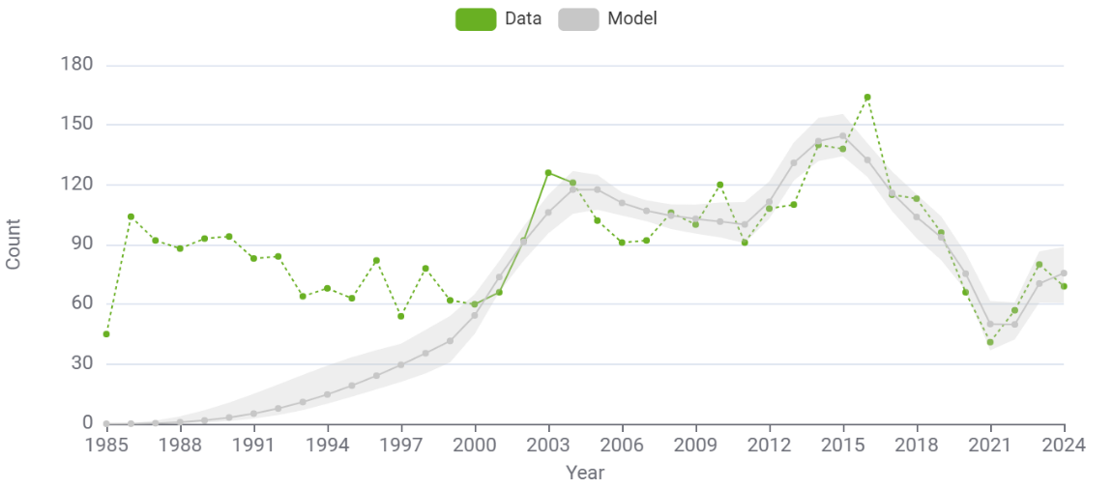
HIV diagnoses, CD4 >=500
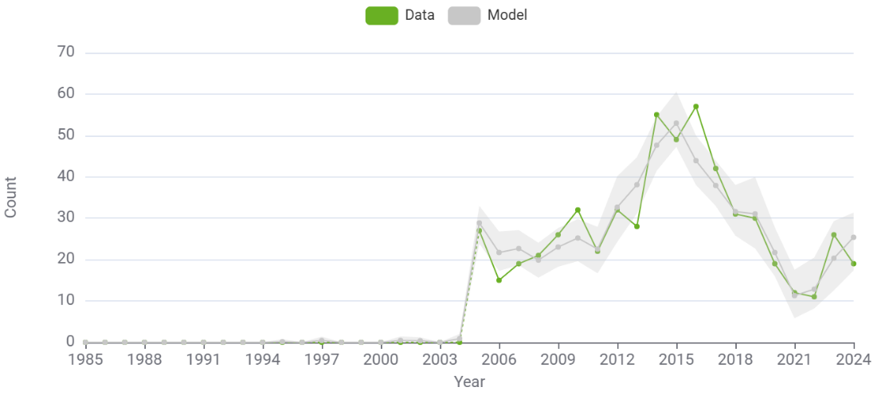
HIV diagnoses, CD4 350-499
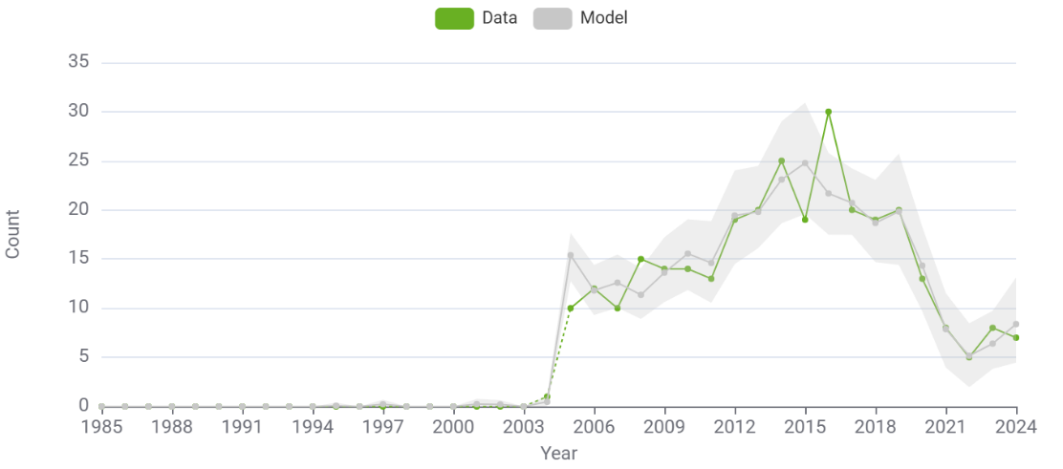

HIV diagnoses, CD4 200-349
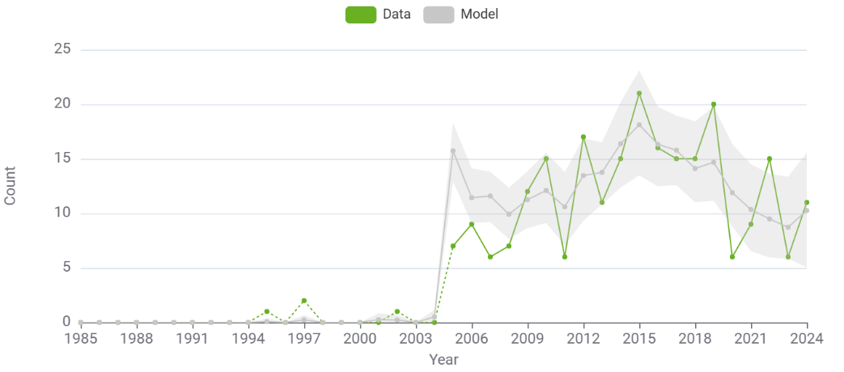
HIV diagnoses, CD4 <200
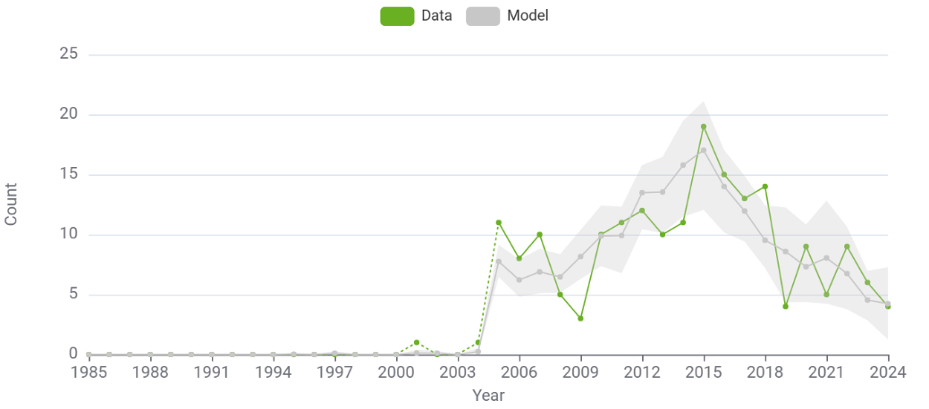
HIV/AIDS diagnoses
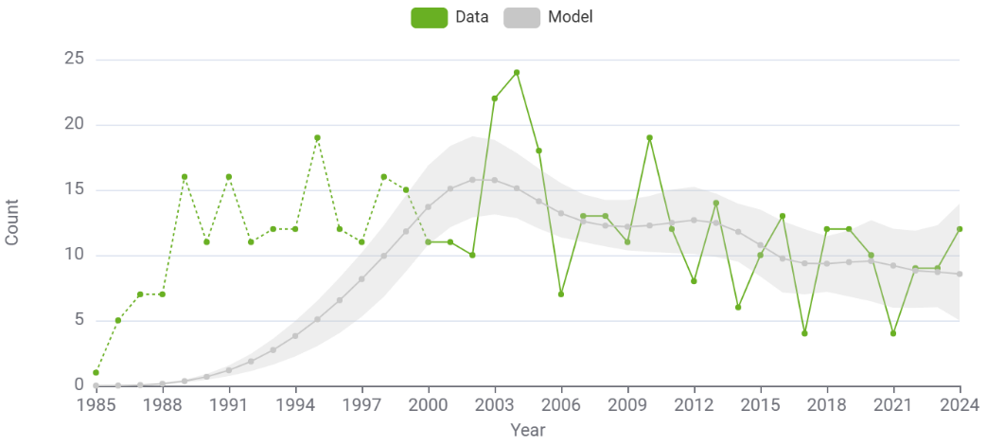

Men: findings

Total number men living with HIV 2000-2024 (95% Cis)
Year | Diagnosed from model | Cumulative migrants diagnosed | Number undiagnosed | Total PLWH | % undiagnosed | Incident infections per year | Total infections per year
2000 | 240.83 (177.67 - 344.80) | 49.00 (37.00 - 61.28) | 339.79 (291.18 - 389.24) | 629.63 (556.27 - 744.00) | 0.54 (0.46 - 0.61) | 85.81 (79.04 - 96.89) | 93.81 (85.67 - 104.63)
2001 | 309.47 (239.25 - 411.36) | 59.00 (45.00 - 72.83) | 357.09 (308.22 - 406.53) | 725.56 (644.13 - 848.33) | 0.49 (0.43 - 0.55) | 91.60 (84.52 - 101.21) | 101.60 (92.74 - 114.47)
2002 | 392.76 (323.82 - 496.92) | 73.00 (57.73 - 89.00) | 362.01 (318.31 - 408.55) | 827.78 (739.46 - 964.60) | 0.44 (0.39 - 0.48) | 96.91 (90.68 - 104.77) | 110.91 (102.00 - 122.51)
2003 | 482.89 (411.37 - 592.64) | 88.00 (73.00 - 103.00) | 356.91 (318.61 - 401.31) | 927.80 (842.02 - 1,077.17) | 0.38 (0.35 - 0.42) | 101.72 (95.55 - 108.68) | 116.72 (107.58 - 127.03)
2004 | 582.46 (514.32 - 698.59) | 105.00 (87.45 - 123.55) | 344.64 (309.19 - 386.75) | 1,032.10 (946.42 - 1,185.59) | 0.33 (0.31 - 0.36) | 105.97 (99.34 - 111.45) | 122.97 (113.00 - 134.55)
2005 | 665.01 (587.42 - 781.18) | 158.00 (136.73 - 178.28) | 336.10 (304.27 - 377.53) | 1,159.10 (1,072.48 - 1,311.62) | 0.29 (0.27 - 0.31) | 109.63 (101.45 - 114.23) | 162.63 (149.20 - 180.23)
2006 | 748.89 (665.34 - 867.28) | 197.00 (173.18 - 224.10) | 337.30 (307.67 - 376.35) | 1,283.19 (1,193.21 - 1,430.26) | 0.26 (0.24 - 0.28) | 112.67 (102.84 - 117.45) | 151.67 (137.07 - 164.39)
2007 | 813.80 (727.01 - 941.80) | 235.00 (209.45 - 267.00) | 344.88 (313.88 - 382.53) | 1,393.68 (1,294.85 - 1,537.57) | 0.25 (0.23 - 0.27) | 115.04 (103.86 - 120.13) | 153.04 (139.36 - 167.93)
2008 | 887.30 (797.89 - 1,021.44) | 280.00 (251.73 - 316.55) | 356.56 (325.23 - 392.43) | 1,523.86 (1,421.67 - 1,666.04) | 0.23 (0.22 - 0.25) | 116.72 (104.61 - 122.12) | 161.72 (146.67 - 174.78)
2009 | 959.18 (863.40 - 1,099.12) | 307.00 (272.73 - 344.83) | 370.80 (334.67 - 407.40) | 1,636.97 (1,534.63 - 1,771.30) | 0.23 (0.21 - 0.24) | 117.66 (105.24 - 123.48) | 144.66 (129.73 - 155.34)
2010 | 1,023.70 (930.33 - 1,158.82) | 330.00 (296.45 - 368.83) | 386.56 (347.68 - 424.93) | 1,740.25 (1,636.31 - 1,869.33) | 0.22 (0.20 - 0.24) | 117.82 (106.06 - 124.14) | 140.82 (123.79 - 153.68)
2011 | 1,103.76 (1,006.87 - 1,236.92) | 350.00 (316.00 - 392.83) | 403.12 (358.08 - 441.42) | 1,856.87 (1,747.92 - 1,983.97) | 0.22 (0.19 - 0.24) | 117.17 (106.20 - 124.16) | 137.17 (124.81 - 148.44)
2012 | 1,188.23 (1,088.26 - 1,325.03) | 370.00 (335.18 - 414.28) | 406.76 (355.77 - 448.70) | 1,964.99 (1,854.56 - 2,090.41) | 0.21 (0.18 - 0.23) | 115.68 (106.17 - 123.27) | 135.68 (122.09 - 145.34)
2013 | 1,299.20 (1,198.62 - 1,436.90) | 394.00 (359.73 - 436.10) | 388.56 (333.40 - 428.52) | 2,081.76 (1,977.03 - 2,204.48) | 0.19 (0.16 - 0.21) | 113.32 (105.27 - 121.23) | 137.32 (124.87 - 149.88)
2014 | 1,402.05 (1,299.24 - 1,532.84) | 426.00 (386.73 - 471.28) | 356.27 (298.91 - 397.21) | 2,184.32 (2,081.29 - 2,305.65) | 0.16 (0.14 - 0.18) | 110.08 (102.77 - 118.60) | 142.08 (128.43 - 156.00)
2015 | 1,524.60 (1,417.26 - 1,649.70) | 454.00 (419.45 - 500.83) | 317.19 (265.98 - 362.54) | 2,295.79 (2,197.19 - 2,414.29) | 0.14 (0.12 - 0.16) | 105.95 (98.61 - 114.24) | 133.95 (120.08 - 147.11)
2016 | 1,622.05 (1,516.59 - 1,742.28) | 497.00 (459.00 - 543.83) | 285.22 (240.85 - 328.31) | 2,405.27 (2,305.30 - 2,523.49) | 0.12 (0.10 - 0.14) | 100.91 (93.34 - 111.18) | 144.91 (131.55 - 159.92)
2017 | 1,714.93 (1,612.65 - 1,830.86) | 533.00 (500.00 - 581.55) | 263.87 (230.93 - 302.84) | 2,511.80 (2,411.94 - 2,627.96) | 0.11 (0.09 - 0.12) | 94.95 (87.37 - 109.45) | 129.95 (115.12 - 148.46)
2018 | 1,803.76 (1,705.79 - 1,922.89) | 570.00 (533.17 - 612.55) | 247.68 (207.65 - 292.65) | 2,621.44 (2,521.84 - 2,738.35) | 0.09 (0.08 - 0.11) | 88.05 (79.47 - 107.71) | 125.05 (109.94 - 151.59)
2019 | 1,881.39 (1,786.93 - 2,004.66) | 626.00 (585.73 - 675.00) | 233.84 (186.83 - 288.36) | 2,742.23 (2,636.30 - 2,860.77) | 0.09 (0.07 - 0.11) | 80.21 (70.78 - 106.58) | 137.21 (123.66 - 169.26)
2020 | 1,951.77 (1,854.69 - 2,075.62) | 682.00 (637.17 - 725.55) | 229.45 (178.49 - 305.64) | 2,863.21 (2,759.54 - 3,002.36) | 0.08 (0.06 - 0.10) | 71.40 (60.77 - 106.68) | 126.40 (105.77 - 161.58)
2021 | 1,996.83 (1,894.96 - 2,129.71) | 725.00 (680.00 - 775.83) | 240.60 (190.22 - 345.50) | 2,962.43 (2,850.95 - 3,125.22) | 0.08 (0.07 - 0.11) | 61.63 (49.57 - 106.76) | 104.63 (84.74 - 151.25)
2022 | 2,040.70 (1,940.25 - 2,174.08) | 771.00 (726.90 - 823.55) | 241.20 (175.35 - 386.77) | 3,052.90 (2,932.78 - 3,263.57) | 0.08 (0.06 - 0.12) | 50.86 (37.18 - 106.84) | 96.86 (79.69 - 152.69)
2023 | 2,102.13 (2,009.58 - 2,234.66) | 867.00 (813.73 - 918.00) | 209.48 (117.04 - 414.26) | 3,178.61 (3,047.48 - 3,449.07) | 0.07 (0.04 - 0.12) | 39.09 (23.34 - 106.93) | 135.09 (107.64 - 206.34)
2024 | 2,175.75 (2,082.09 - 2,315.52) | 977.00 (933.63 - 1,032.20) | 159.78 (54.05 - 439.21) | 3,312.53 (3,167.22 - 3,639.80) | 0.05 (0.02 - 0.12) | 26.30 (8.06 - 107.01) | 136.30 (104.37 - 211.49)

Women: fits to data
HIV diagnoses
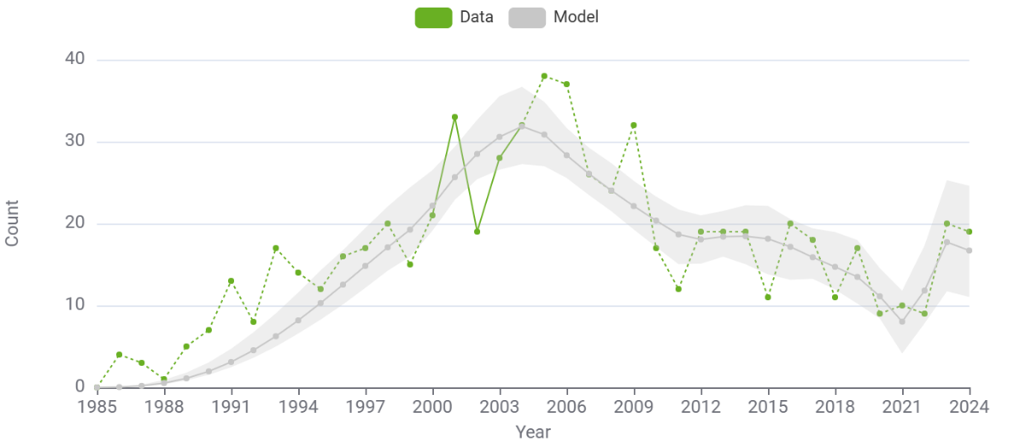
HIV diagnoses CD4 >=500
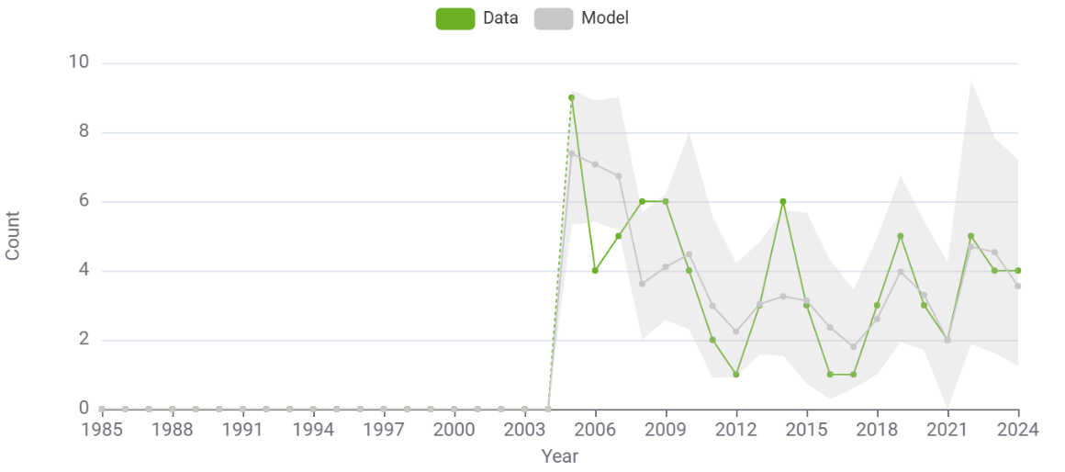
HIV diagnoses, CD4 350-499
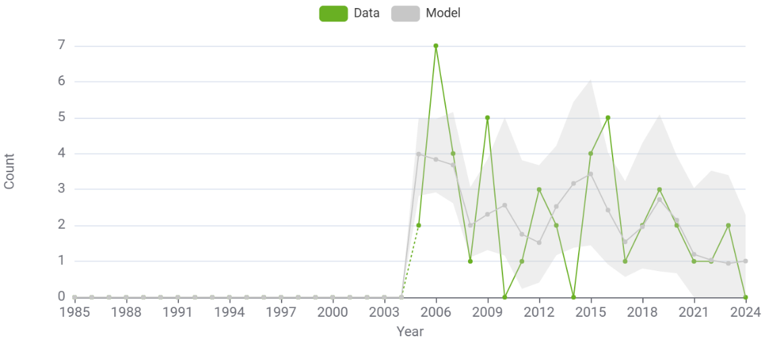
HIV diagnoses CD4 200-349
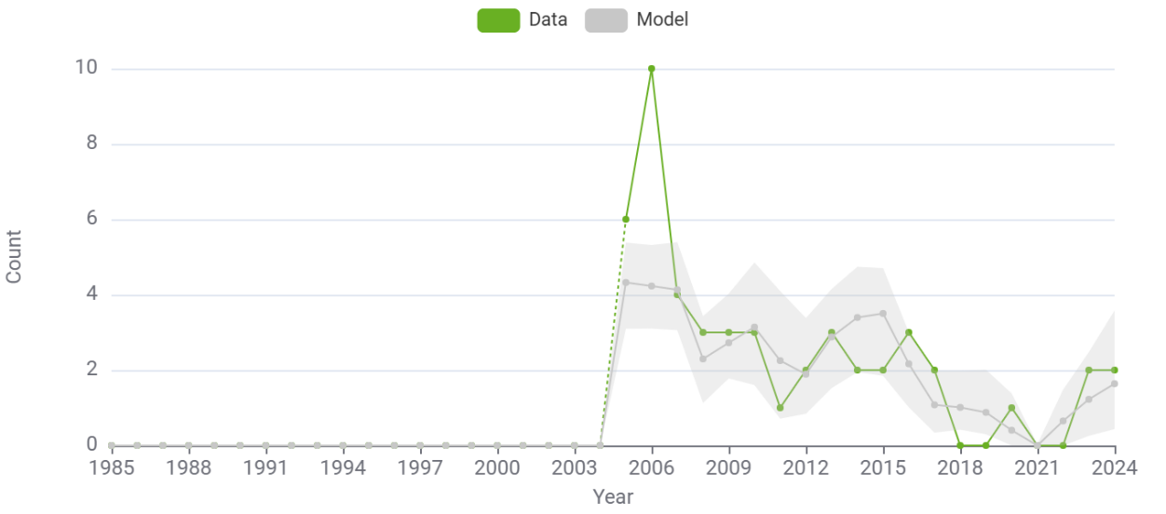
HIV diagnoses CD4 <200
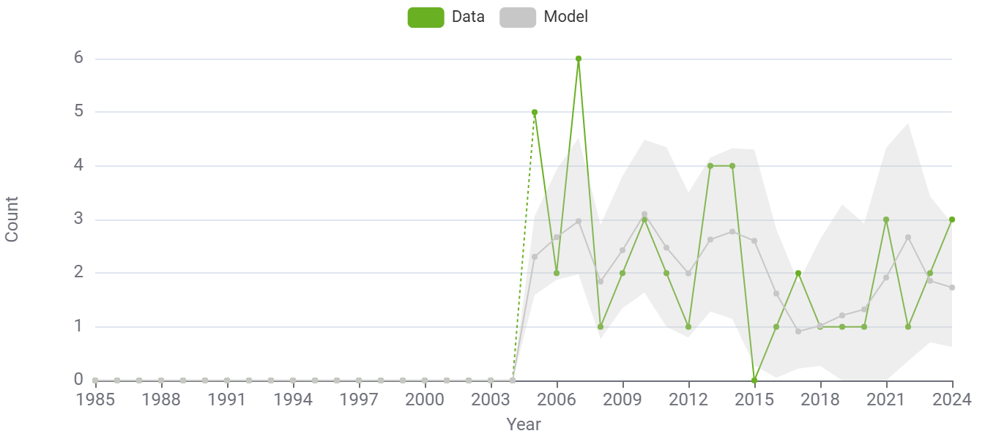
HIV/AIDS diagnoses
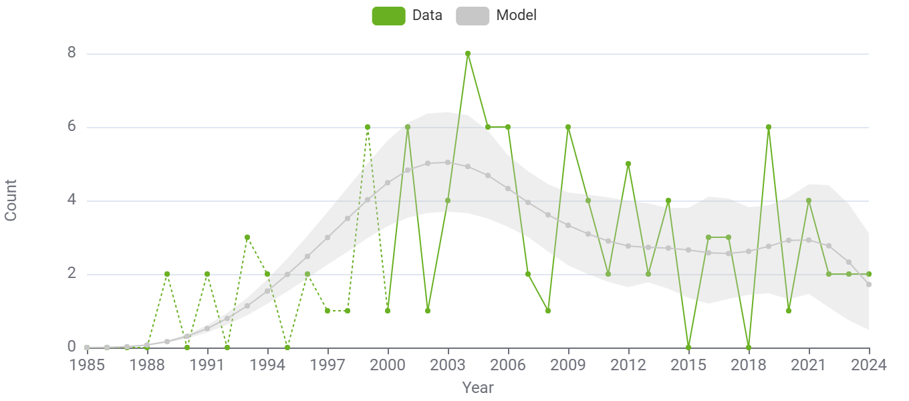

Women: findings

Total number women living with HIV 2000-2024 (95% Cis)
Year | Diagnosed from model | Cumulative migrants diagnosed | Number undiagnosed | Total PLWH | % undiagnosed | Incident infections per year | Total infections per year
2000 | 121.05 (99.94 - 159.98) | 9.00 (3.00 - 14.00) | 111.16 (88.90 - 132.24) | 241.21 (215.87 - 275.31) | 0.46 (0.37 - 0.54) | 28.64 (26.05 - 32.40) | 30.64 (27.13 - 35.57)
2001 | 141.70 (119.22 - 185.11) | 10.00 (4.00 - 16.00) | 114.10 (91.49 - 135.37) | 265.80 (240.03 - 302.36) | 0.43 (0.35 - 0.50) | 28.80 (26.36 - 32.33) | 29.80 (26.96 - 33.43)
2002 | 169.19 (147.45 - 213.52) | 12.00 (5.00 - 19.50) | 113.98 (92.33 - 134.59) | 295.17 (268.83 - 334.46) | 0.39 (0.32 - 0.45) | 28.59 (26.23 - 31.79) | 30.59 (27.71 - 34.61)
2003 | 195.76 (173.01 - 241.18) | 17.00 (10.00 - 25.00) | 111.26 (91.14 - 131.87) | 324.01 (296.39 - 364.52) | 0.34 (0.28 - 0.40) | 28.07 (25.62 - 30.69) | 33.07 (29.09 - 38.06)
2004 | 223.61 (198.59 - 268.19) | 20.00 (12.00 - 28.50) | 106.47 (87.64 - 123.35) | 350.08 (320.36 - 392.98) | 0.30 (0.25 - 0.35) | 27.28 (24.78 - 29.41) | 30.28 (26.69 - 34.27)
2005 | 239.46 (212.82 - 286.48) | 25.00 (16.00 - 34.00) | 101.68 (85.46 - 115.70) | 366.14 (335.10 - 407.39) | 0.28 (0.23 - 0.32) | 26.27 (23.78 - 28.30) | 31.27 (27.05 - 37.19)
2006 | 251.79 (222.18 - 297.12) | 34.00 (24.00 - 46.00) | 98.24 (82.31 - 110.88) | 384.03 (353.64 - 424.38) | 0.26 (0.22 - 0.29) | 25.08 (22.22 - 27.12) | 34.08 (27.56 - 39.48)
2007 | 270.85 (242.38 - 317.20) | 42.00 (31.00 - 55.00) | 95.75 (80.77 - 107.00) | 408.61 (374.52 - 450.50) | 0.23 (0.20 - 0.26) | 23.75 (20.69 - 25.91) | 31.75 (26.29 - 38.33)
2008 | 288.87 (258.71 - 335.00) | 49.00 (38.50 - 65.00) | 93.92 (79.83 - 104.39) | 431.79 (398.85 - 474.63) | 0.22 (0.18 - 0.24) | 22.35 (18.95 - 24.56) | 29.35 (23.69 - 34.90)
2009 | 301.00 (269.21 - 350.34) | 54.00 (42.50 - 70.00) | 92.55 (78.17 - 102.79) | 447.55 (411.79 - 491.50) | 0.21 (0.17 - 0.23) | 20.90 (17.03 - 23.24) | 25.90 (20.70 - 31.64)
2010 | 316.35 (282.19 - 369.56) | 60.00 (48.00 - 76.50) | 91.52 (75.86 - 103.96) | 467.87 (431.52 - 509.74) | 0.20 (0.16 - 0.22) | 19.46 (15.48 - 21.70) | 25.46 (19.73 - 30.73)
2011 | 332.02 (296.63 - 385.09) | 62.00 (50.00 - 80.00) | 90.79 (74.40 - 107.40) | 484.81 (448.62 - 528.46) | 0.19 (0.15 - 0.22) | 18.07 (14.11 - 20.44) | 20.07 (15.22 - 23.99)
2012 | 343.07 (305.89 - 394.86) | 66.00 (53.00 - 85.00) | 89.38 (70.92 - 108.35) | 498.46 (457.13 - 541.74) | 0.18 (0.14 - 0.21) | 16.77 (12.88 - 19.18) | 20.77 (15.65 - 26.82)
2013 | 357.47 (318.75 - 410.70) | 71.00 (55.00 - 90.50) | 86.42 (67.42 - 104.48) | 514.90 (472.66 - 561.19) | 0.17 (0.13 - 0.20) | 15.56 (11.90 - 17.98) | 20.56 (15.61 - 25.64)
2014 | 369.92 (330.68 - 421.97) | 76.00 (60.50 - 95.50) | 82.29 (63.57 - 99.52) | 528.21 (485.67 - 569.97) | 0.16 (0.12 - 0.18) | 14.43 (11.02 - 16.97) | 19.43 (14.14 - 24.33)
2015 | 386.06 (345.61 - 435.97) | 80.00 (63.50 - 100.50) | 77.40 (57.80 - 94.79) | 543.46 (499.84 - 585.70) | 0.14 (0.11 - 0.17) | 13.37 (10.19 - 16.19) | 17.36 (12.64 - 21.80)
2016 | 397.21 (356.86 - 448.28) | 85.00 (69.00 - 103.50) | 72.48 (52.74 - 88.27) | 554.69 (514.31 - 599.02) | 0.13 (0.09 - 0.16) | 12.35 (9.40 - 14.91) | 17.35 (12.97 - 22.08)
2017 | 410.09 (370.56 - 459.77) | 89.00 (72.00 - 107.00) | 67.84 (47.25 - 84.10) | 566.94 (527.59 - 611.49) | 0.12 (0.08 - 0.14) | 11.36 (8.84 - 14.44) | 15.36 (11.12 - 21.28)
2018 | 423.80 (383.72 - 471.62) | 97.00 (80.50 - 116.00) | 63.41 (41.20 - 81.50) | 584.21 (545.46 - 629.18) | 0.11 (0.07 - 0.13) | 10.39 (8.01 - 14.63) | 18.39 (12.54 - 24.96)
2019 | 434.28 (393.88 - 481.90) | 103.00 (86.50 - 122.00) | 59.24 (38.81 - 79.68) | 596.52 (559.74 - 645.06) | 0.10 (0.06 - 0.13) | 9.43 (7.18 - 14.61) | 15.43 (10.25 - 22.20)
2020 | 443.40 (402.87 - 493.14) | 112.00 (95.00 - 130.00) | 56.44 (36.76 - 78.32) | 611.84 (573.17 - 661.73) | 0.09 (0.06 - 0.12) | 8.45 (6.23 - 14.62) | 17.45 (12.67 - 27.37)
2021 | 450.43 (409.08 - 498.05) | 117.00 (100.50 - 134.50) | 55.73 (34.84 - 79.43) | 623.16 (585.43 - 673.32) | 0.09 (0.05 - 0.12) | 7.45 (5.05 - 15.23) | 12.45 (8.07 - 20.78)
2022 | 462.24 (418.22 - 507.61) | 123.00 (106.00 - 140.50) | 50.19 (30.26 - 77.68) | 635.44 (598.48 - 691.01) | 0.08 (0.05 - 0.12) | 6.40 (3.73 - 16.12) | 12.40 (7.11 - 23.78)
2023 | 478.97 (432.13 - 524.33) | 139.00 (122.00 - 159.50) | 37.66 (18.15 - 77.62) | 655.63 (618.74 - 715.44) | 0.06 (0.03 - 0.11) | 5.30 (2.38 - 17.03) | 21.30 (14.52 - 37.83)
2024 | 495.67 (451.98 - 546.53) | 166.00 (147.00 - 187.00) | 25.01 (8.68 - 71.64) | 686.68 (644.82 - 753.89) | 0.04 (0.01 - 0.10) | 4.12 (0.86 - 18.05) | 31.12 (22.42 - 47.02)

Māori: fits to data
HIV diagnoses, total
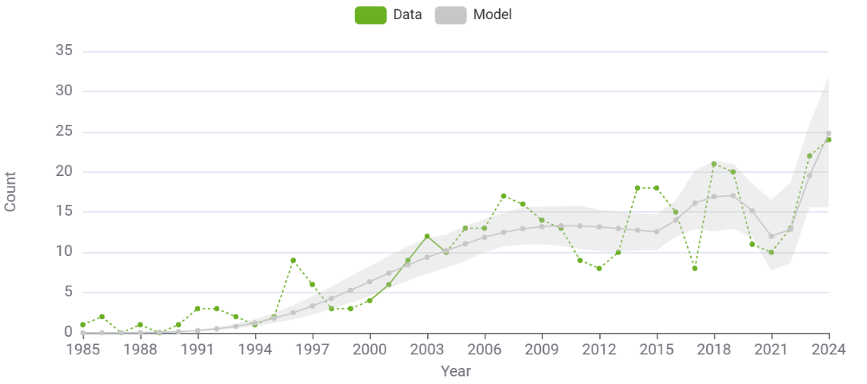
HV diagnoses, CD4 >=500
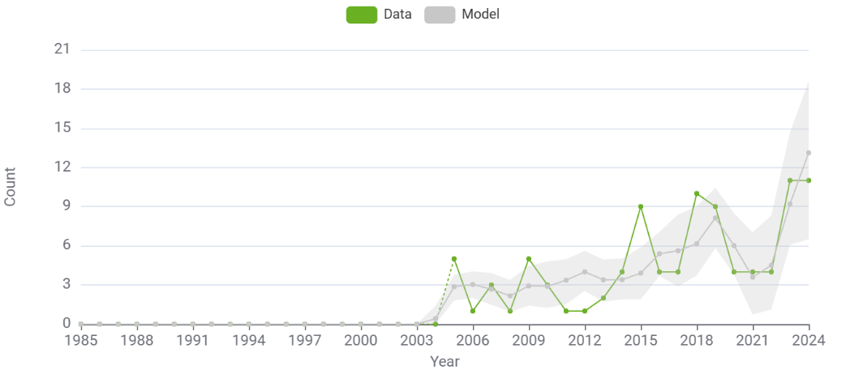
HIV diagnoses, CD4 350-499
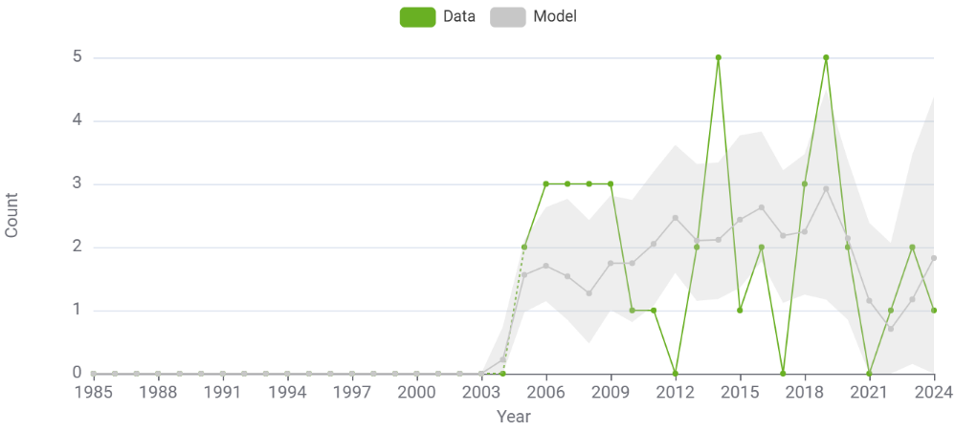
HIV diagnoses, CD4 200-349
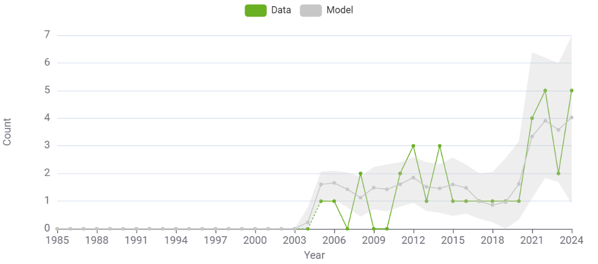
HIV diagnoses, CD4 <200
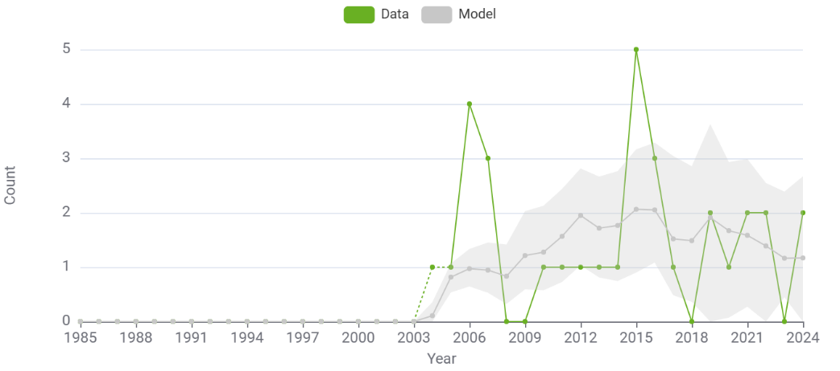
HIV/AIDS diagnoses
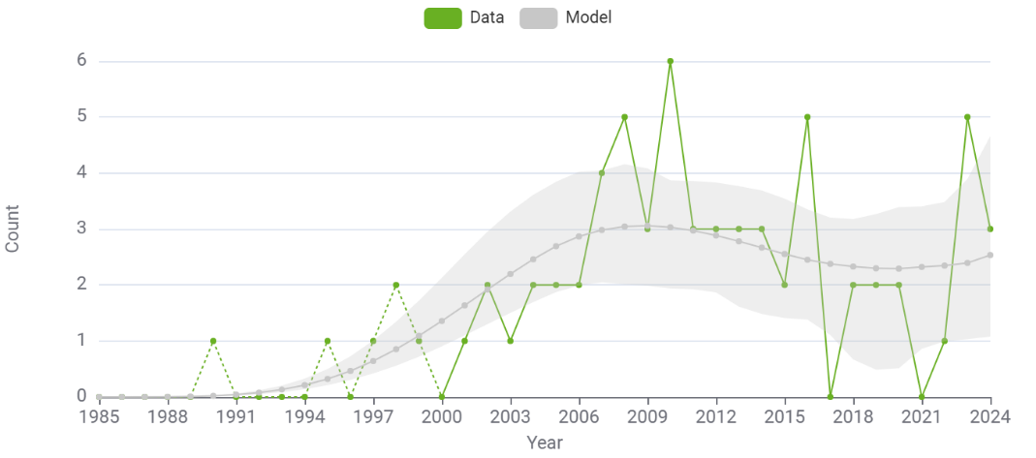

Māori: findings

Total number Māori living with HIV, proportion undiagnosed and infections per year 2000-2024 (95% Cis)
Year | Number diagnosed from model | Cumulative migrants diagnosed | Number undiagnosed | Total PLWH | % undiagnosed | Incident infections per year | Total infections per year
2000 | 24.58 (16.26 - 33.43) | 6.00 (2.00 - 10.00) | 40.55 (28.79 - 58.07) | 71.13 (51.73 - 95.54) | 0.57 (0.49 - 0.65) | 12.22 (9.24 - 15.47) | 13.22 (10.21 - 17.52)
2001 | 31.99 (21.88 - 43.38) | 6.00 (2.00 - 10.00) | 46.09 (32.85 - 64.79) | 84.08 (62.23 - 111.09) | 0.55 (0.47 - 0.62) | 13.02 (10.26 - 15.83) | 13.02 (10.26 - 15.83)
2002 | 39.43 (26.74 - 52.46) | 6.00 (2.00 - 10.00) | 51.13 (36.71 - 70.14) | 96.56 (73.17 - 125.44) | 0.53 (0.46 - 0.60) | 13.56 (11.04 - 16.02) | 13.56 (11.04 - 16.02)
2003 | 47.81 (33.66 - 63.51) | 6.00 (2.00 - 10.00) | 55.52 (40.53 - 73.80) | 109.33 (83.74 - 138.71) | 0.51 (0.43 - 0.58) | 13.86 (11.50 - 16.02) | 13.86 (11.50 - 16.02)
2004 | 57.02 (41.31 - 74.00) | 7.00 (3.00 - 11.00) | 59.15 (43.92 - 76.45) | 123.18 (97.09 - 152.67) | 0.48 (0.40 - 0.55) | 13.96 (10.90 - 16.09) | 14.96 (11.45 - 17.80)
2005 | 65.08 (48.84 - 84.04) | 7.00 (3.00 - 11.00) | 61.85 (46.94 - 76.81) | 133.94 (105.23 - 162.61) | 0.46 (0.38 - 0.54) | 13.88 (9.82 - 16.21) | 13.88 (9.82 - 16.21)
2006 | 74.96 (57.62 - 97.29) | 7.00 (3.00 - 11.00) | 63.52 (48.91 - 77.06) | 145.47 (116.16 - 173.58) | 0.44 (0.36 - 0.51) | 13.66 (8.47 - 16.26) | 13.66 (8.47 - 16.26)
2007 | 83.45 (63.79 - 104.81) | 7.00 (3.00 - 11.00) | 64.23 (47.91 - 79.02) | 154.68 (124.59 - 182.16) | 0.42 (0.33 - 0.49) | 13.34 (7.09 - 16.19) | 13.34 (7.09 - 16.19)
2008 | 94.39 (74.81 - 116.80) | 9.00 (4.00 - 14.00) | 64.11 (45.39 - 80.28) | 167.49 (138.03 - 190.77) | 0.38 (0.29 - 0.46) | 12.95 (6.14 - 16.06) | 14.95 (7.95 - 19.15)
2009 | 102.58 (83.11 - 126.59) | 9.00 (4.00 - 14.00) | 63.29 (42.35 - 80.95) | 174.87 (144.13 - 198.24) | 0.36 (0.24 - 0.44) | 12.52 (5.93 - 15.70) | 12.52 (5.93 - 15.70)
2010 | 112.89 (93.27 - 136.83) | 11.00 (5.00 - 16.00) | 61.94 (36.11 - 80.17) | 185.83 (153.93 - 211.96) | 0.33 (0.20 - 0.40) | 12.08 (6.46 - 15.07) | 14.08 (7.68 - 17.95)
2011 | 125.17 (104.69 - 148.28) | 13.00 (7.00 - 19.00) | 60.22 (32.63 - 78.76) | 198.38 (164.61 - 224.66) | 0.30 (0.18 - 0.36) | 11.69 (6.96 - 14.45) | 13.69 (8.77 - 17.91)
2012 | 135.32 (114.68 - 159.63) | 14.00 (7.73 - 21.00) | 58.31 (31.56 - 77.30) | 207.63 (173.95 - 235.34) | 0.28 (0.17 - 0.34) | 11.37 (7.93 - 14.08) | 12.37 (8.76 - 16.24)
2013 | 146.29 (124.39 - 168.22) | 14.00 (7.73 - 21.00) | 56.38 (31.44 - 72.87) | 216.67 (182.74 - 242.67) | 0.26 (0.16 - 0.32) | 11.16 (7.61 - 14.15) | 11.16 (7.61 - 14.15)
2014 | 155.04 (133.86 - 177.16) | 18.00 (11.00 - 25.28) | 54.62 (31.24 - 71.41) | 227.66 (195.63 - 256.84) | 0.24 (0.14 - 0.30) | 11.11 (7.16 - 14.94) | 15.11 (10.93 - 20.83)
2015 | 166.60 (144.01 - 188.19) | 20.00 (12.00 - 29.28) | 53.19 (31.10 - 70.86) | 239.79 (209.74 - 266.44) | 0.22 (0.13 - 0.28) | 11.24 (7.42 - 15.54) | 13.24 (9.23 - 18.99)
2016 | 178.60 (155.28 - 200.56) | 22.00 (13.00 - 31.28) | 50.69 (30.26 - 70.06) | 251.29 (222.60 - 278.08) | 0.20 (0.13 - 0.26) | 11.61 (7.31 - 16.62) | 13.61 (9.26 - 19.30)
2017 | 192.72 (171.50 - 215.79) | 25.00 (15.00 - 34.28) | 46.71 (28.39 - 68.85) | 264.43 (236.61 - 293.31) | 0.18 (0.11 - 0.24) | 12.24 (7.59 - 17.70) | 15.24 (9.00 - 22.20)
2018 | 206.65 (185.28 - 228.22) | 27.00 (17.00 - 38.00) | 42.84 (28.96 - 61.89) | 276.49 (246.95 - 307.86) | 0.16 (0.11 - 0.22) | 13.17 (9.14 - 18.77) | 15.17 (10.96 - 21.99)
2019 | 220.70 (200.68 - 242.20) | 27.00 (17.00 - 38.00) | 40.10 (28.09 - 63.43) | 287.80 (260.49 - 318.04) | 0.14 (0.10 - 0.21) | 14.41 (10.16 - 21.67) | 14.41 (10.16 - 21.67)
2020 | 235.86 (216.25 - 256.03) | 30.00 (20.00 - 40.28) | 40.82 (27.78 - 65.82) | 306.68 (284.45 - 340.07) | 0.13 (0.09 - 0.20) | 15.98 (10.62 - 26.47) | 18.98 (13.07 - 29.14)
2021 | 247.85 (227.18 - 267.29) | 35.00 (24.73 - 45.28) | 46.64 (31.79 - 77.87) | 329.49 (306.31 - 369.34) | 0.14 (0.10 - 0.21) | 17.92 (10.58 - 31.67) | 22.92 (13.89 - 37.75)
2022 | 259.71 (240.06 - 278.18) | 38.00 (26.73 - 48.28) | 53.91 (32.11 - 93.93) | 351.61 (323.23 - 400.33) | 0.15 (0.10 - 0.24) | 20.22 (10.22 - 39.38) | 23.22 (13.15 - 42.08)
2023 | 278.24 (261.62 - 298.66) | 40.00 (28.73 - 51.00) | 57.19 (24.07 - 119.67) | 375.43 (339.60 - 440.37) | 0.15 (0.07 - 0.28) | 22.92 (8.01 - 47.84) | 24.92 (9.66 - 49.90)
2024 | 302.03 (284.00 - 322.10) | 44.00 (33.00 - 56.28) | 58.32 (14.60 - 147.79) | 404.35 (352.38 - 499.39) | 0.14 (0.04 - 0.30) | 26.04 (5.49 - 59.23) | 30.04 (10.16 - 64.04)

Non-Māori, non-Pacific people: fits to data
Total HIV diagnoses
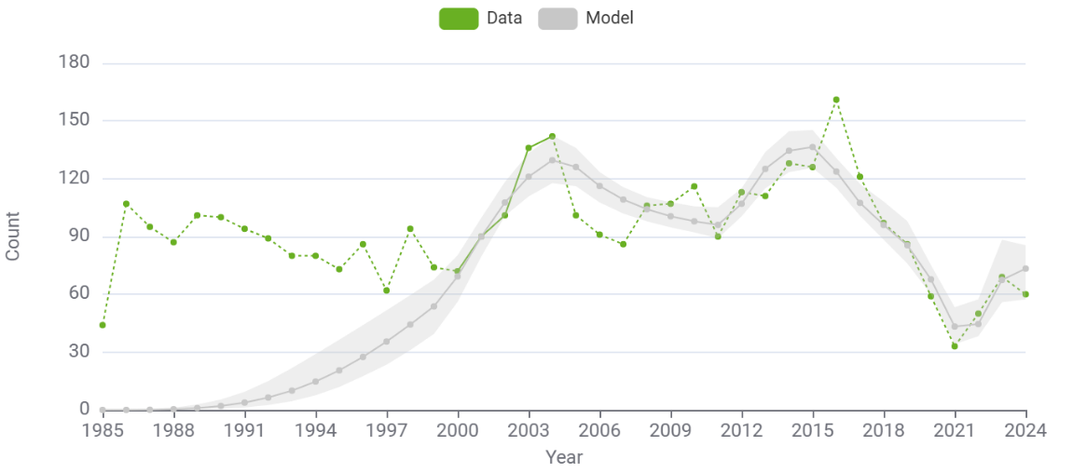
HIV diagnoses, CD4 >=500
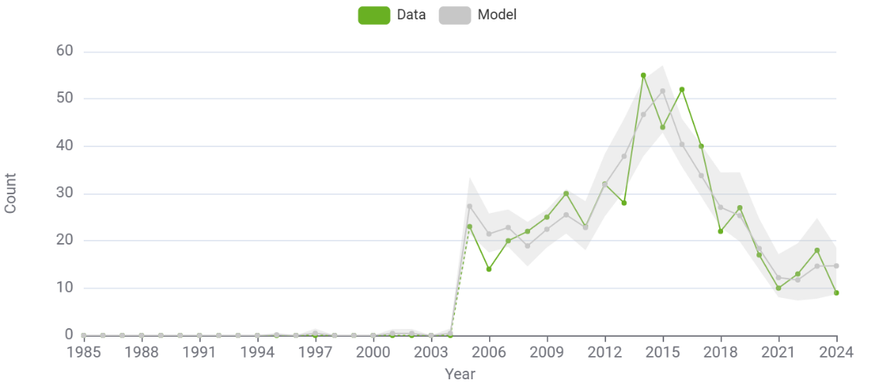
HIV diagnoses CD4 350-499
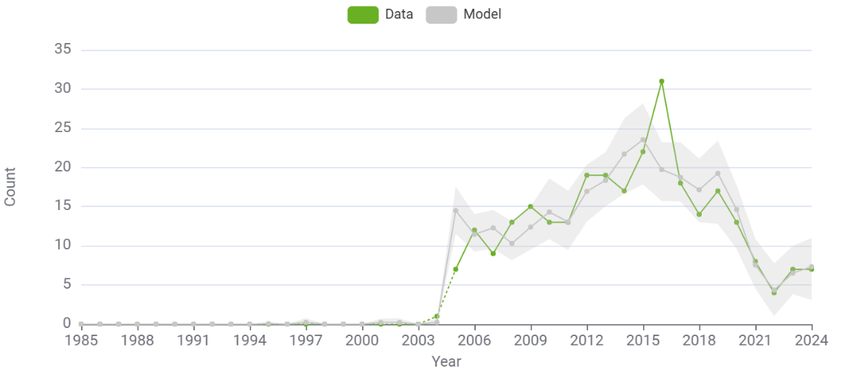

HIV diagnoses, CD4 200-349
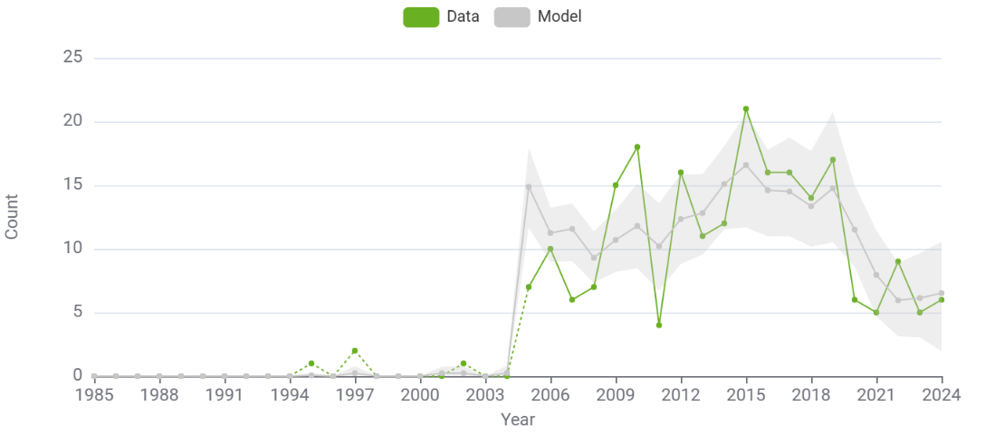
HIV diagnoses, CD4 <200
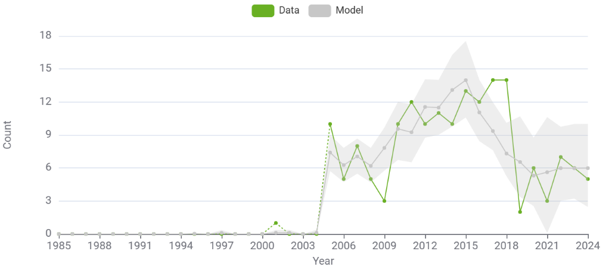

HIV/AIDS diagnoses
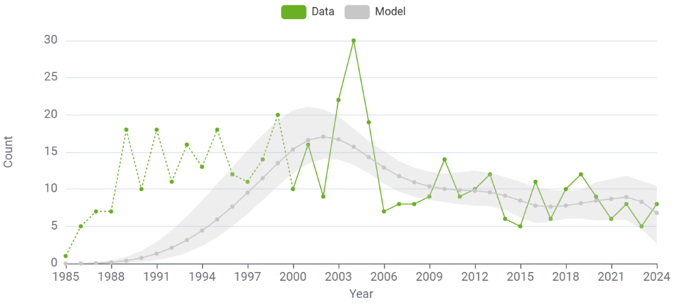

Non-Māori, non-Pacific people: findings

Total number living with HIV, non-Māori, non-Pacific, proportion undiagnosed and infections per year 2000-2024 (95% Cis)
Year | Number diagnosed from model | Cumulative migrants diagnosed | Number undiagnosed | Total PLWH | % undiagnosed | Incident infections per year | Total infections per year
2000 | 283.32 (196.54 - 411.66) | 51.00 (38.00 - 65.45) | 380.51 (330.25 - 430.40) | 714.83 (621.41 - 862.66) | 0.53 (0.44 - 0.61) | 98.84 (86.09 - 106.02) | 107.84 (92.50 - 116.50)
2001 | 363.24 (266.74 - 501.54) | 62.00 (46.00 - 77.45) | 392.95 (344.05 - 434.37) | 818.19 (718.51 - 949.78) | 0.48 (0.39 - 0.55) | 103.09 (88.45 - 110.97) | 114.09 (96.33 - 125.65)
2002 | 462.88 (364.29 - 600.40) | 78.00 (61.00 - 97.45) | 390.23 (342.24 - 429.37) | 931.12 (824.91 - 1,055.76) | 0.42 (0.34 - 0.48) | 105.68 (90.48 - 114.08) | 121.68 (104.00 - 134.46)
2003 | 564.91 (456.20 - 700.63) | 96.00 (78.00 - 116.90) | 375.38 (331.79 - 408.71) | 1,036.29 (932.44 - 1,148.98) | 0.36 (0.30 - 0.41) | 106.91 (93.57 - 115.09) | 124.91 (108.86 - 136.38)
2004 | 673.48 (564.61 - 804.55) | 112.00 (88.55 - 132.00) | 352.22 (306.97 - 385.93) | 1,137.70 (1,029.46 - 1,247.53) | 0.31 (0.26 - 0.35) | 107.11 (95.82 - 115.59) | 123.11 (110.56 - 135.35)
2005 | 752.55 (652.80 - 879.75) | 189.00 (160.20 - 216.45) | 332.13 (287.62 - 369.68) | 1,273.68 (1,171.83 - 1,384.42) | 0.26 (0.22 - 0.29) | 106.61 (97.28 - 115.95) | 183.61 (163.00 - 203.03)
2006 | 828.75 (733.91 - 957.79) | 254.00 (226.65 - 282.45) | 321.09 (278.81 - 355.47) | 1,403.84 (1,295.75 - 1,520.32) | 0.23 (0.20 - 0.26) | 105.73 (97.46 - 116.00) | 170.73 (154.98 - 188.22)
2007 | 894.95 (799.16 - 1,017.23) | 309.00 (278.00 - 338.35) | 316.18 (278.47 - 350.35) | 1,520.13 (1,414.72 - 1,649.72) | 0.21 (0.18 - 0.23) | 104.81 (97.30 - 116.80) | 159.81 (148.00 - 177.44)
2008 | 964.12 (858.23 - 1,090.41) | 362.00 (330.55 - 390.90) | 315.71 (279.23 - 350.66) | 1,641.83 (1,531.68 - 1,770.03) | 0.19 (0.17 - 0.21) | 104.18 (96.91 - 116.48) | 157.18 (145.62 - 175.95)
2009 | 1,027.63 (922.94 - 1,161.14) | 402.00 (371.85 - 435.90) | 318.89 (284.40 - 355.74) | 1,748.51 (1,635.88 - 1,884.34) | 0.18 (0.16 - 0.20) | 104.14 (98.11 - 115.59) | 144.14 (129.75 - 161.46)
2010 | 1,087.51 (980.18 - 1,223.62) | 437.00 (406.20 - 475.80) | 325.24 (290.00 - 365.08) | 1,849.75 (1,734.52 - 1,998.10) | 0.18 (0.16 - 0.20) | 104.68 (98.09 - 115.35) | 139.68 (127.77 - 155.51)
2011 | 1,162.54 (1,050.93 - 1,298.70) | 456.00 (425.55 - 493.35) | 334.30 (298.25 - 382.48) | 1,952.84 (1,837.68 - 2,101.99) | 0.17 (0.15 - 0.19) | 105.52 (98.55 - 115.36) | 124.52 (113.34 - 139.14)
2012 | 1,239.54 (1,130.05 - 1,381.57) | 479.00 (448.55 - 519.35) | 333.21 (294.19 - 384.09) | 2,051.75 (1,942.01 - 2,199.53) | 0.16 (0.14 - 0.18) | 106.34 (99.50 - 115.13) | 129.34 (118.30 - 143.84)
2013 | 1,344.63 (1,240.95 - 1,485.44) | 509.00 (477.10 - 551.45) | 314.51 (274.92 - 367.78) | 2,168.14 (2,051.65 - 2,320.81) | 0.15 (0.13 - 0.17) | 106.81 (98.79 - 115.36) | 136.81 (125.61 - 151.90)
2014 | 1,443.12 (1,341.98 - 1,590.22) | 545.00 (509.55 - 586.80) | 286.23 (242.73 - 341.76) | 2,274.36 (2,149.68 - 2,424.94) | 0.13 (0.11 - 0.15) | 106.62 (96.57 - 114.13) | 142.62 (129.34 - 154.32)
2015 | 1,559.57 (1,459.36 - 1,708.79) | 573.00 (536.00 - 614.90) | 254.84 (214.62 - 309.27) | 2,387.41 (2,266.37 - 2,545.77) | 0.11 (0.09 - 0.13) | 105.43 (93.06 - 112.75) | 133.43 (119.05 - 145.48)
2016 | 1,644.27 (1,538.28 - 1,795.99) | 621.00 (581.55 - 664.45) | 233.74 (196.27 - 282.97) | 2,500.00 (2,377.25 - 2,657.39) | 0.09 (0.08 - 0.11) | 102.93 (88.79 - 109.92) | 151.93 (133.02 - 167.01)
2017 | 1,727.71 (1,624.08 - 1,877.66) | 658.00 (619.10 - 702.45) | 224.77 (185.55 - 266.21) | 2,610.48 (2,479.13 - 2,763.87) | 0.09 (0.07 - 0.10) | 98.81 (83.04 - 105.79) | 134.81 (120.00 - 146.41)
2018 | 1,810.72 (1,705.43 - 1,953.69) | 703.00 (658.20 - 747.45) | 221.25 (175.69 - 260.41) | 2,734.97 (2,602.68 - 2,887.83) | 0.08 (0.07 - 0.09) | 92.84 (76.32 - 99.60) | 137.84 (117.28 - 149.55)
2019 | 1,880.18 (1,770.98 - 2,031.81) | 765.00 (717.65 - 807.25) | 220.31 (163.58 - 263.87) | 2,866.50 (2,725.29 - 3,013.57) | 0.08 (0.06 - 0.09) | 84.88 (68.36 - 91.19) | 147.88 (123.60 - 164.01)
2020 | 1,940.92 (1,826.41 - 2,092.93) | 824.00 (776.65 - 868.90) | 227.01 (158.14 - 273.17) | 2,991.93 (2,845.86 - 3,147.25) | 0.08 (0.05 - 0.09) | 74.81 (59.32 - 80.44) | 132.81 (115.34 - 147.58)
2021 | 1,979.21 (1,865.22 - 2,122.64) | 865.00 (815.10 - 913.00) | 245.84 (167.16 - 293.72) | 3,090.05 (2,953.79 - 3,243.70) | 0.08 (0.06 - 0.09) | 62.49 (49.00 - 67.33) | 103.49 (85.59 - 116.58)
2022 | 2,019.79 (1,906.49 - 2,161.54) | 914.00 (859.10 - 961.00) | 248.67 (160.41 - 295.16) | 3,182.46 (3,034.48 - 3,338.15) | 0.08 (0.05 - 0.09) | 47.81 (37.20 - 51.60) | 96.81 (81.38 - 111.34)
2023 | 2,078.24 (1,959.87 - 2,225.85) | 1,020.00 (966.10 - 1,079.45) | 211.47 (110.80 - 261.47) | 3,309.72 (3,156.80 - 3,452.73) | 0.06 (0.03 - 0.08) | 30.62 (23.72 - 33.09) | 136.62 (116.27 - 157.53)
2024 | 2,150.58 (2,025.23 - 2,290.10) | 1,150.00 (1,103.00 - 1,214.35) | 148.65 (55.46 - 199.29) | 3,449.23 (3,303.39 - 3,591.93) | 0.04 (0.02 - 0.06) | 10.81 (8.36 - 11.69) | 140.81 (118.29 - 160.46)

Sensitivity analyses
We ran three sensitivity analyses to test the recent incidence decline. In the first we increased knots to 5, and results were very close to knots 4, and incidence decline was the same (88% since 2010 and 89% since 2015, to 14 incident infections in 2024). In the second we used 5 knots and also set prevent sudden changes to no. This resulted in a more marked incidence decline of 97% since 2010 and 96% 2015, from 121 and 139 incident infections to 4 incident infections in 2024. We then increased knots to 6 and reverted prevent sudden changes to yes, and this also resulted in a greater incidence decline than the original estimate, of 92% since 2010 and 93% since 2015 (122 and 143 to 10).
Results are shown below, no confidence intervals were generated for these analyses

Total number living with HIV, proportion undiagnosed and infections per year 2000-2024, 5 knots
Year | Number diagnosed from model | Cumulative migrants diagnosed | Number undiagnosed | Total PLWH | % undiagnosed | Incident infections per year | Total infections per year
2000 | 296.83 | 58 | 423.34 | 778.18 | 0.54 | 128.72 | 138.72
2001 | 385.51 | 69 | 458.44 | 912.95 | 0.5 | 134.51 | 145.51
2002 | 495.05 | 85 | 475.83 | 1,055.88 | 0.45 | 136.74 | 152.74
2003 | 609.86 | 105 | 476.29 | 1,191.15 | 0.4 | 136.12 | 156.12
2004 | 734.3 | 125 | 462.44 | 1,321.74 | 0.35 | 133.44 | 153.44
2005 | 830.16 | 205 | 445.24 | 1,480.40 | 0.3 | 129.49 | 209.49
2006 | 924.48 | 272 | 432.18 | 1,628.67 | 0.27 | 125.05 | 192.05
2007 | 1,005.38 | 328 | 422.45 | 1,755.83 | 0.24 | 120.91 | 176.91
2008 | 1,091.86 | 385 | 416.12 | 1,892.98 | 0.22 | 117.86 | 174.86
2009 | 1,167.97 | 425 | 413.95 | 2,006.92 | 0.21 | 116.62 | 156.62
2010 | 1,239.88 | 462 | 416.66 | 2,118.53 | 0.2 | 117.27 | 154.27
2011 | 1,327.79 | 485 | 424.33 | 2,237.12 | 0.19 | 119.23 | 142.23
2012 | 1,416.16 | 510 | 423.21 | 2,349.37 | 0.18 | 121.88 | 146.88
2013 | 1,534.95 | 541 | 404.38 | 2,480.34 | 0.16 | 124.58 | 155.57
2014 | 1,645.47 | 581 | 374.99 | 2,601.46 | 0.14 | 126.69 | 166.69
2015 | 1,782.66 | 614 | 340.88 | 2,737.54 | 0.12 | 127.59 | 160.59
2016 | 1,889.65 | 665 | 318.06 | 2,873.72 | 0.11 | 126.65 | 178.65
2017 | 1,994.38 | 706 | 310.12 | 3,010.51 | 0.1 | 123.25 | 163.25
2018 | 2,096.63 | 753 | 308.43 | 3,158.06 | 0.1 | 117.02 | 164.02
2019 | 2,184.01 | 817 | 308.39 | 3,310.40 | 0.09 | 107.84 | 172.84
2020 | 2,265.24 | 884 | 315.24 | 3,464.48 | 0.09 | 95.6 | 161.6
2021 | 2,319.52 | 934 | 334.61 | 3,588.13 | 0.09 | 80.2 | 130.2
2022 | 2,378.60 | 988 | 330.52 | 3,697.11 | 0.09 | 61.53 | 115.53
2023 | 2,463.15 | 1,101.00 | 274.9 | 3,839.05 | 0.07 | 39.48 | 152.48
2024 | 2,559.45 | 1,242.00 | 190.04 | 3,991.50 | 0.05 | 13.95 | 154.95

Total number living with HIV, proportion undiagnosed and infections per year 2000-2024, 5 knots, prevent sudden changes no
Year | Number diagnosed from model | Cumulative migrants diagnosed | Number undiagnosed | Total PLWH | % undiagnosed | Incident infections per year | Total infections per year
2000 | 126.06 | 58 | 454.14 | 638.2 | 0.71 | 102.25 | 112.25
2001 | 215.85 | 69 | 462.75 | 747.61 | 0.62 | 109.33 | 120.33
2002 | 324.48 | 85 | 459.28 | 868.76 | 0.53 | 115.09 | 131.09
2003 | 436.38 | 105 | 445.87 | 987.26 | 0.45 | 119.42 | 139.42
2004 | 556.63 | 125 | 424.98 | 1,106.60 | 0.38 | 122.21 | 142.21
2005 | 647.03 | 205 | 407.19 | 1,259.21 | 0.32 | 123.41 | 203.41
2006 | 735.46 | 272 | 398.28 | 1,405.74 | 0.28 | 123.26 | 190.26
2007 | 811.51 | 328 | 394.88 | 1,534.38 | 0.26 | 122.34 | 178.34
2008 | 894.8 | 385 | 395.16 | 1,674.96 | 0.24 | 121.23 | 178.23
2009 | 969.42 | 425 | 398.45 | 1,792.87 | 0.22 | 120.55 | 160.55
2010 | 1,041.20 | 462 | 404.93 | 1,908.13 | 0.21 | 120.88 | 157.88
2011 | 1,129.95 | 485 | 415.4 | 2,030.36 | 0.2 | 122.84 | 145.84
2012 | 1,218.59 | 510 | 418.89 | 2,147.48 | 0.2 | 126.74 | 151.74
2013 | 1,336.66 | 541 | 407.94 | 2,285.60 | 0.18 | 131.71 | 162.71
2014 | 1,447.36 | 581 | 387.98 | 2,416.34 | 0.16 | 136.3 | 176.3
2015 | 1,587.33 | 614 | 362.52 | 2,563.85 | 0.14 | 139.02 | 172.02
2016 | 1,699.37 | 665 | 346.41 | 2,711.78 | 0.13 | 138.4 | 190.4
2017 | 1,809.51 | 706 | 342.77 | 2,858.28 | 0.12 | 132.96 | 172.96
2018 | 1,915.99 | 753 | 341.06 | 3,010.05 | 0.11 | 121.27 | 168.27
2019 | 2,004.70 | 817 | 334.88 | 3,157.59 | 0.11 | 103.07 | 168.07
2020 | 2,084.39 | 884 | 328.25 | 3,296.65 | 0.1 | 80.63 | 146.63
2021 | 2,136.08 | 934 | 326.73 | 3,396.80 | 0.1 | 56.74 | 106.74
2022 | 2,198.40 | 988 | 292.03 | 3,478.44 | 0.08 | 34.21 | 88.21
2023 | 2,285.43 | 1,101.00 | 210.32 | 3,596.75 | 0.06 | 15.85 | 128.85
2024 | 2,371.42 | 1,242.00 | 126.35 | 3,739.77 | 0.03 | 4.47 | 145.47

Total number living with HIV, proportion undiagnosed and infections per year 2000-2024, 6 knots
Year | Number diagnosed from model | Cumulative migrants diagnosed | Number undiagnosed | Total PLWH | % undiagnosed | Incident infections per year | Total infections per year
2000 | 300.66 | 58 | 438.87 | 797.53 | 0.55 | 133.42 | 143.42
2001 | 391.46 | 69 | 476.44 | 936.9 | 0.51 | 139.15 | 150.15
2002 | 502.37 | 85 | 494.57 | 1,081.94 | 0.46 | 138.88 | 154.88
2003 | 617.32 | 105 | 491.57 | 1,213.89 | 0.41 | 132.85 | 152.85
2004 | 739.61 | 125 | 469.73 | 1,334.34 | 0.35 | 123.35 | 143.35
2005 | 832.03 | 205 | 439.44 | 1,476.48 | 0.3 | 113 | 193
2006 | 922.14 | 272 | 409.92 | 1,604.06 | 0.26 | 104.4 | 171.4
2007 | 997.18 | 328 | 385.28 | 1,710.46 | 0.23 | 100.15 | 156.15
2008 | 1,076.78 | 385 | 370.45 | 1,832.23 | 0.2 | 102.47 | 159.47
2009 | 1,146.95 | 425 | 368.45 | 1,940.40 | 0.19 | 110.8 | 150.8
2010 | 1,216.33 | 462 | 379.03 | 2,057.36 | 0.18 | 122.57 | 159.57
2011 | 1,307.32 | 485 | 399.49 | 2,191.81 | 0.18 | 135.04 | 158.04
2012 | 1,398.96 | 510 | 418.78 | 2,327.74 | 0.18 | 145.52 | 170.52
2013 | 1,517.86 | 541 | 426.59 | 2,485.45 | 0.17 | 151.28 | 182.28
2014 | 1,629.17 | 581 | 420.09 | 2,630.25 | 0.16 | 150.36 | 190.36
2015 | 1,769.11 | 614 | 398.95 | 2,782.06 | 0.14 | 143.33 | 176.33
2016 | 1,882.41 | 665 | 374.95 | 2,923.36 | 0.13 | 131.79 | 183.79
2017 | 1,994.46 | 706 | 353.76 | 3,054.23 | 0.12 | 117.36 | 157.36
2018 | 2,101.13 | 753 | 332.22 | 3,186.35 | 0.1 | 101.63 | 148.63
2019 | 2,188.91 | 817 | 310.11 | 3,317.02 | 0.09 | 86.21 | 151.21
2020 | 2,267.01 | 884 | 296.33 | 3,447.35 | 0.09 | 71.89 | 137.89
2021 | 2,318.00 | 934 | 296.82 | 3,548.82 | 0.08 | 58.04 | 108.04
2022 | 2,378.94 | 988 | 273.06 | 3,640.00 | 0.08 | 43.73 | 97.73
2023 | 2,464.60 | 1,101.00 | 204.92 | 3,770.52 | 0.05 | 28.03 | 141.03
2024 | 2,551.99 | 1,242.00 | 125.12 | 3,919.11 | 0.03 | 10.02 | 151.02

