Supplementary document 2. People Living with HIV and Proportion Diagnosed in Aotearoa New Zealand: First Published National Estimates from Two Modelling Approaches

Spectrum model additional fits and findings
Contents
All model fits to data, male and female 2
All model findings, male and female 3
Model fits male and female, splines 4 4
Model findings male and female, splines 4 5
Model fits males, splines 4 8
Model findings males, splines 4 9
Model fits females, splines 4 12
Model findings females, splines 4 12
Model using 2000-2024 data 16
All model fits to data, male and female 16
All model findings, male and female 17
Model fits male and female 2000-2024, splines 5 18
Model findings male and female, 2000-2024, splines 5 18

All model fits to data, male and female
Akaike information criterion
Double logistic | 1402.9
Single logistic | 1413.5
Splines – 5 knots | 1402.5
Splines – 4 knots | 1388.7
Splines – 3 knots | 1407.7
rLogistic | 1425.5

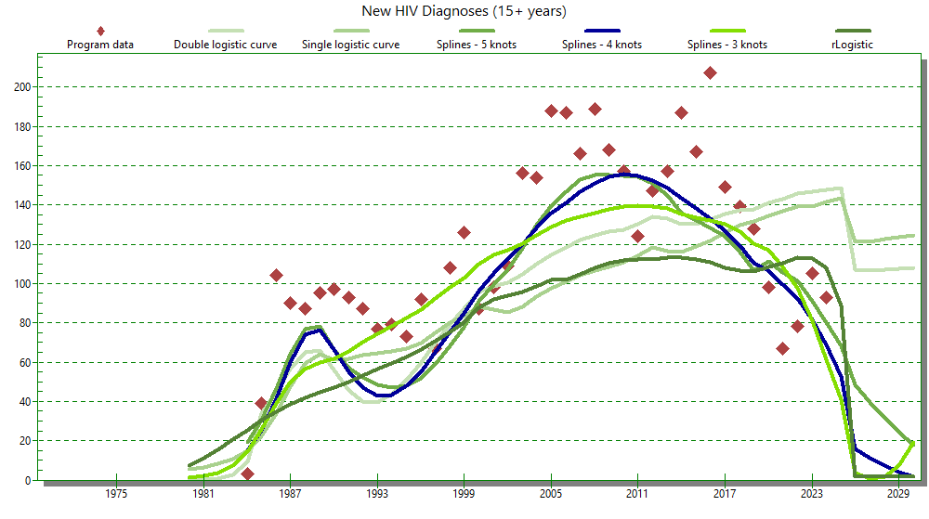
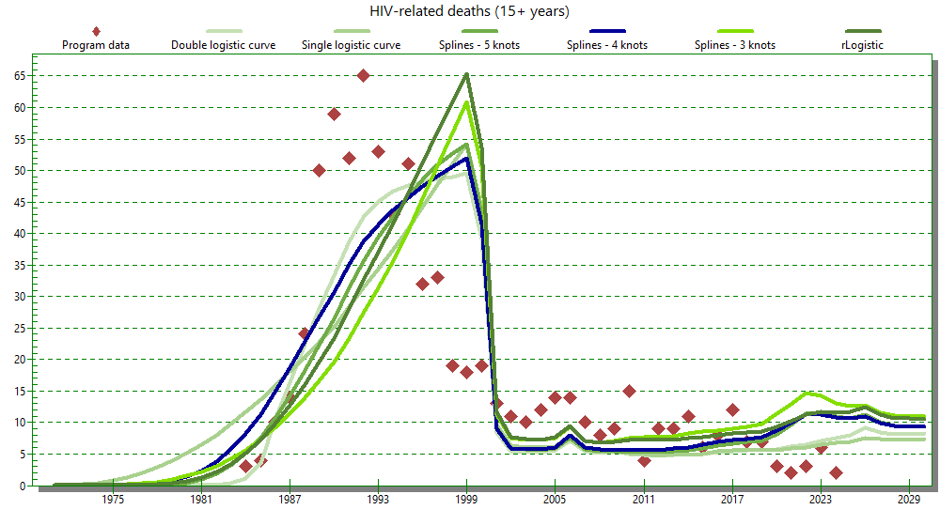

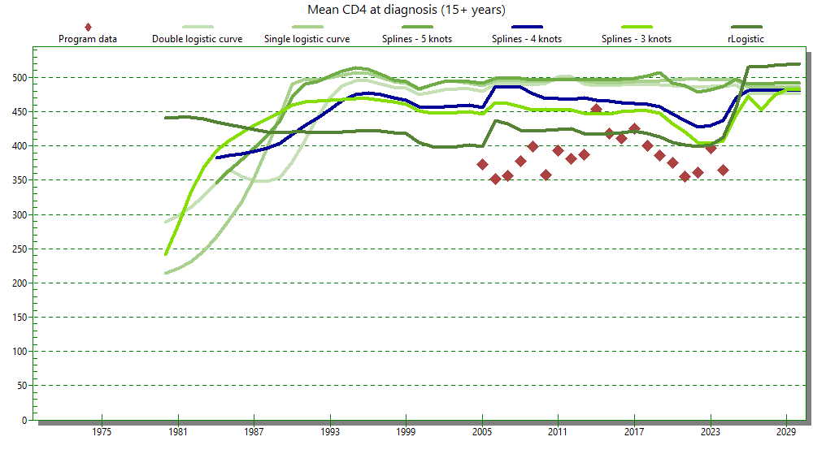

All model findings, male and female
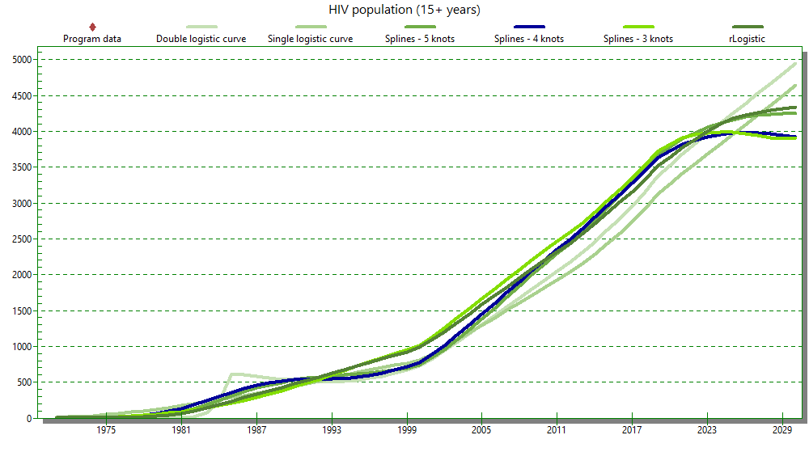
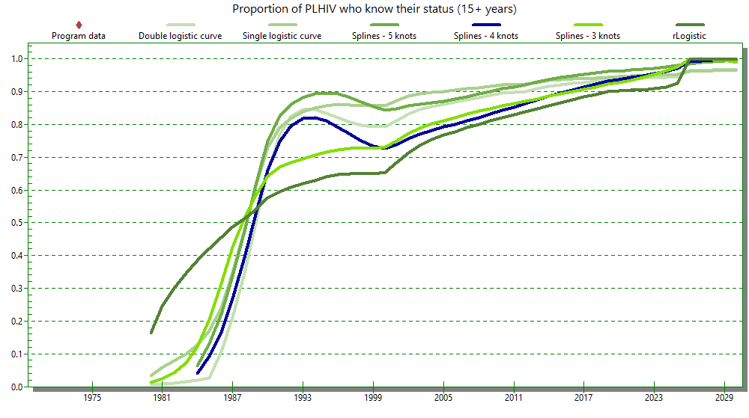
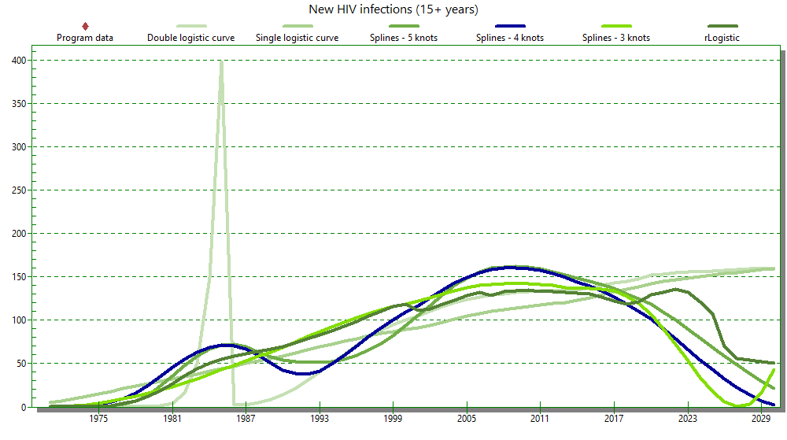

Model fits male and female, splines 4
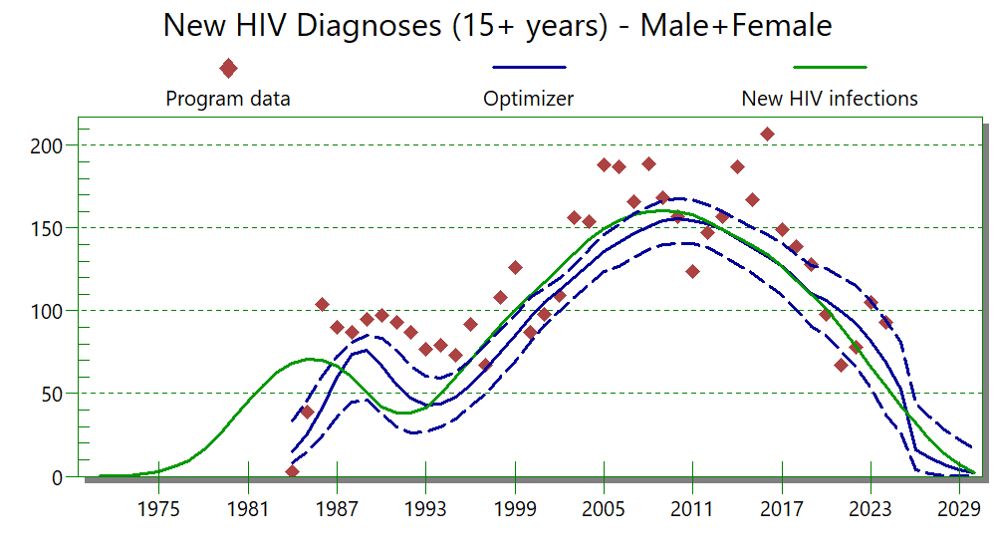
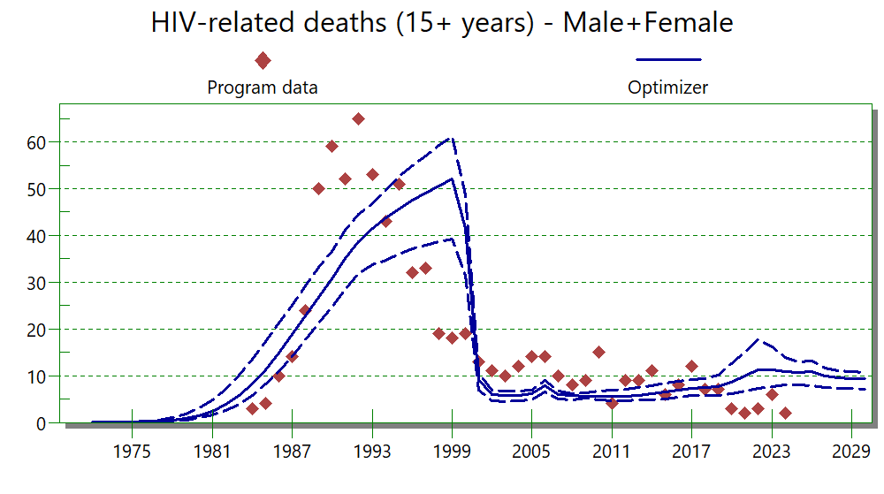

Model findings male and female, splines 4

Total people living with HIV 1985-2024 with 95% uncertainty bounds
Year | Point estimate PLWH | Lower bound | Upper bound
1985 | 352.36 | 253.52 | 453.08
1986 | 404.32 | 304.5 | 507.98
1987 | 448.46 | 350.85 | 553.84
1988 | 479.43 | 386.42 | 582.05
1989 | 499.16 | 403.74 | 611.5
1990 | 519.11 | 413.14 | 646.99
1991 | 525.57 | 400.18 | 660.54
1992 | 524.54 | 400.68 | 663.93
1993 | 525.32 | 388.96 | 659.01
1994 | 533.26 | 388.43 | 671.71
1995 | 551.14 | 397.56 | 686.1
1996 | 577.65 | 417.07 | 705.23
1997 | 610.31 | 442.34 | 732.16
1998 | 648.53 | 484.65 | 776.89
1999 | 692.75 | 532.62 | 830.07
2000 | 777.37 | 609.26 | 917.03
2001 | 887.06 | 701.59 | 1039.65
2002 | 1014.42 | 807.59 | 1180.84
2003 | 1151.31 | 929.38 | 1327.99
2004 | 1292.73 | 1048.14 | 1478.24
2005 | 1440.44 | 1180.54 | 1637.91
2006 | 1592.69 | 1318.7 | 1799.6
2007 | 1744.18 | 1453.72 | 1957.8
2008 | 1896.7 | 1576.54 | 2126.09
2009 | 2050.17 | 1697.75 | 2300.3
2010 | 2199.61 | 1820.08 | 2469.39
2011 | 2341.66 | 1930.65 | 2621.08
2012 | 2481.87 | 2053.01 | 2794.34
2013 | 2629.87 | 2175.97 | 2952.92
2014 | 2794.11 | 2303.89 | 3127.25
2015 | 2955.62 | 2432.77 | 3305.39
2016 | 3113.15 | 2569.85 | 3492.74
2017 | 3265.1 | 2709.49 | 3663.35
2018 | 3432.06 | 2851.3 | 3865.5
2019 | 3614.72 | 3001.16 | 4064.41
2020 | 3715.84 | 3097.26 | 4186.69
2021 | 3801.09 | 3176.16 | 4293.14
2022 | 3860.11 | 3221.31 | 4357.34
2023 | 3905.86 | 3273.63 | 4440.27
2024 | 3938.69 | 3286.4 | 4508.18

New HIV infections males and females 1985-2024 with 95% uncertainty bounds
Year | Point estimate new infections | Lower bound | Upper bound
1985 | 70.9288 | 55.55101 | 86.91539
1986 | 70.079 | 52.04214 | 88.93819
1987 | 66.41899 | 42.364 | 87.67628
1988 | 59.96967 | 30.3133 | 83.01442
1989 | 50.83861 | 23.83193 | 76.30115
1990 | 41.98815 | 20.69915 | 69.34633
1991 | 38.34468 | 19.62899 | 61.74644
1992 | 38.22728 | 20.19754 | 54.5297
1993 | 41.59025 | 23.69465 | 55.83928
1994 | 49.52414 | 31.12257 | 68.38446
1995 | 59.8831 | 39.58758 | 79.42207
1996 | 70.63432 | 49.76322 | 90.33633
1997 | 81.32369 | 60.35656 | 100.1279
1998 | 91.65916 | 69.93835 | 109.0987
1999 | 100.9055 | 77.38238 | 117.5198
2000 | 109.5528 | 86.29939 | 127.5219
2001 | 117.6151 | 93.4289 | 135.7302
2002 | 125.9696 | 99.66029 | 143.8817
2003 | 135.0945 | 107.5395 | 154.1805
2004 | 143.4504 | 114.1986 | 164.0006
2005 | 150.049 | 119.8499 | 173.7348
2006 | 155.3448 | 124.2562 | 181.1399
2007 | 158.7429 | 126.7349 | 187.3532
2008 | 160.615 | 127.4823 | 191.1519
2009 | 161.137 | 127.1884 | 193.4306
2010 | 160.6514 | 126.7855 | 194.5375
2011 | 158.4424 | 124.2304 | 191.0147
2012 | 154.6762 | 119.9744 | 185.3354
2013 | 149.5699 | 115.3385 | 180.5611
2014 | 144.337 | 112.4902 | 175.5364
2015 | 139.8658 | 108.429 | 170.8022
2016 | 134.086 | 102.3999 | 165.3175
2017 | 127.0274 | 94.42244 | 159.7265
2018 | 118.8598 | 87.41553 | 153.7615
2019 | 110.45 | 79.35529 | 144.9811
2020 | 101.6377 | 68.55249 | 136.6252
2021 | 90.26442 | 56.99886 | 124.9182
2022 | 78.61025 | 45.3572 | 114.007
2023 | 66.29414 | 33.77683 | 101.3457
2024 | 54.48888 | 23.70579 | 90.88097

Proportion males and females with HIV diagnosed 1985-2024 with upper and lower bounds
Year | Point estimate proportion diagnosed | Lower bound | Upper bound
1984 | 0.04008 | 0.02444 | 0.10507
1985 | 0.0918 | 0.05423 | 0.21115
1986 | 0.16597 | 0.09279 | 0.3274
1987 | 0.26857 | 0.15162 | 0.45454
1988 | 0.39316 | 0.23391 | 0.58038
1989 | 0.52617 | 0.33617 | 0.6947
1990 | 0.6595 | 0.46981 | 0.79534
1991 | 0.74696 | 0.58336 | 0.8626
1992 | 0.79476 | 0.65209 | 0.88907
1993 | 0.81833 | 0.6854 | 0.89537
1994 | 0.82104 | 0.70165 | 0.88846
1995 | 0.81017 | 0.70429 | 0.87992
1996 | 0.79162 | 0.68922 | 0.86301
1997 | 0.76936 | 0.67665 | 0.84713
1998 | 0.74887 | 0.65726 | 0.83285
1999 | 0.73428 | 0.64303 | 0.82439
2000 | 0.72564 | 0.63806 | 0.82028
2001 | 0.73781 | 0.6514 | 0.83692
2002 | 0.75597 | 0.67339 | 0.85404
2003 | 0.77041 | 0.68824 | 0.86394
2004 | 0.78185 | 0.70061 | 0.87084
2005 | 0.79236 | 0.71317 | 0.87785
2006 | 0.80055 | 0.72392 | 0.8848
2007 | 0.81029 | 0.73611 | 0.89182
2008 | 0.82074 | 0.75024 | 0.89917
2009 | 0.83174 | 0.76466 | 0.90671
2010 | 0.8429 | 0.77857 | 0.91307
2011 | 0.85323 | 0.79114 | 0.9188
2012 | 0.86357 | 0.80409 | 0.92525
2013 | 0.87453 | 0.821 | 0.9328
2014 | 0.88634 | 0.83393 | 0.9411
2015 | 0.89647 | 0.84623 | 0.94615
2016 | 0.9056 | 0.85951 | 0.95037
2017 | 0.91411 | 0.87178 | 0.95516
2018 | 0.92319 | 0.88469 | 0.96044
2019 | 0.93258 | 0.89799 | 0.96568
2020 | 0.93725 | 0.9076 | 0.96631
2021 | 0.94293 | 0.91631 | 0.96971
2022 | 0.94821 | 0.92516 | 0.97236
2023 | 0.95475 | 0.93485 | 0.97624
2024 | 0.96204 | 0.94367 | 0.9809

Model fits males, splines 4
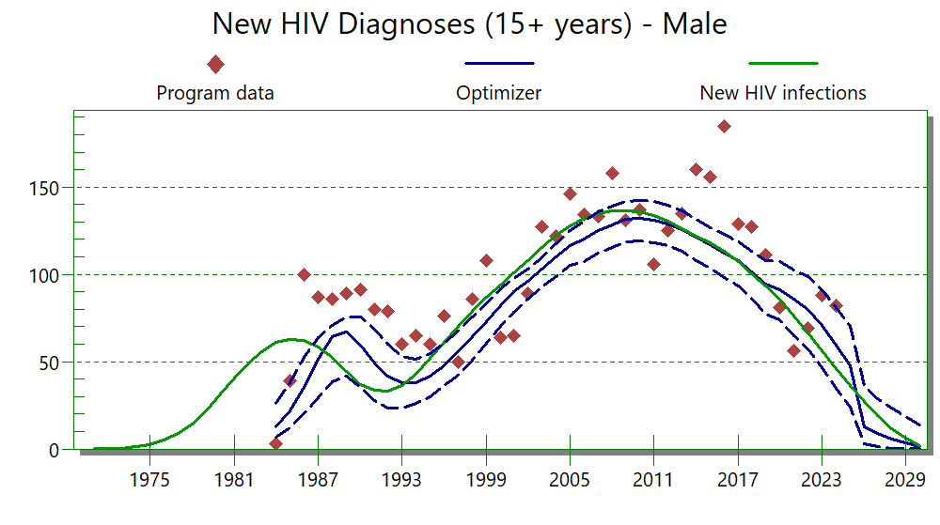
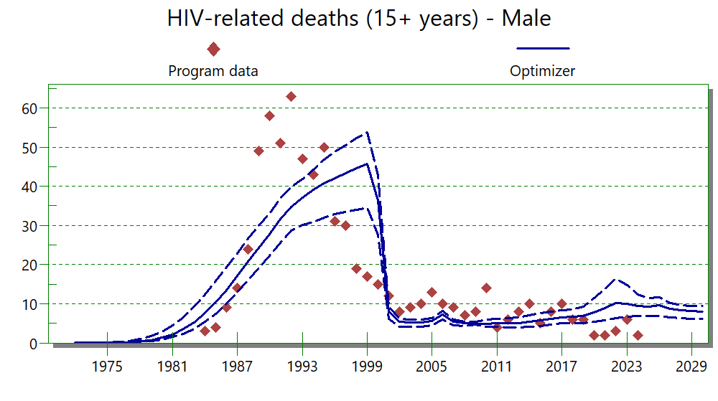

Model findings males, splines 4

Total males living with HIV 1985-2024 with 95% uncertainty bounds
Year | Total males living with HIV, point estimate | Lower bound | Upper bound
1985 | 313.01 | 222.84 | 405.95
1986 | 358.43 | 266.27 | 458.14
1987 | 396.6 | 305.54 | 499.46
1988 | 422.84 | 339.93 | 526.89
1989 | 439.09 | 348.68 | 541.19
1990 | 455.62 | 358.41 | 579.83
1991 | 460.14 | 346.26 | 586.87
1992 | 458.17 | 345.45 | 587.9
1993 | 457.67 | 337.96 | 584.1
1994 | 463.4 | 338.75 | 592.45
1995 | 477.76 | 344.23 | 597.53
1996 | 499.56 | 356.19 | 616.1
1997 | 526.64 | 379.11 | 635.13
1998 | 558.5 | 413.49 | 678.63
1999 | 595.44 | 452.71 | 716.93
2000 | 667.52 | 517.71 | 788.19
2001 | 761.04 | 595.05 | 903.43
2002 | 869.24 | 682.92 | 1025.64
2003 | 985.24 | 780.74 | 1150.99
2004 | 1104.95 | 889.15 | 1277.96
2005 | 1229.95 | 1000 | 1413.97
2006 | 1358.79 | 1108.25 | 1554.71
2007 | 1486.93 | 1220.01 | 1701.5
2008 | 1615.76 | 1318.07 | 1844.45
2009 | 1745.1 | 1413.89 | 1986.62
2010 | 1870.71 | 1512.55 | 2146.9
2011 | 1990 | 1614.4 | 2296.97
2012 | 2107.71 | 1703.81 | 2429.01
2013 | 2232.25 | 1785.81 | 2558.32
2014 | 2370.82 | 1891.17 | 2722.66
2015 | 2507.02 | 1996.67 | 2872.22
2016 | 2639.79 | 2116.82 | 3026.35
2017 | 2767.77 | 2221.63 | 3173.28
2018 | 2909.86 | 2336.73 | 3342.78
2019 | 3066.69 | 2485.01 | 3529.73
2020 | 3150.54 | 2562.5 | 3626.3
2021 | 3220.61 | 2625.58 | 3705.14
2022 | 3268.64 | 2662.27 | 3774.42
2023 | 3305.54 | 2703.42 | 3838.42
2024 | 3331.6 | 2719.93 | 3887.83

New HIV infections males 1985-2024 with 95% uncertainty bounds
Year | New infections in males, point estimate | Lower bound | Upper bound
1985 | 62.85068 | 48.75155 | 77.90977
1986 | 61.94781 | 44.76376 | 79.11733
1987 | 58.57567 | 37.06744 | 78.83091
1988 | 52.77695 | 26.53341 | 73.93063
1989 | 44.62547 | 20.90002 | 67.32844
1990 | 36.7683 | 18.06086 | 60.35695
1991 | 33.50336 | 16.89302 | 53.76419
1992 | 33.33226 | 17.55369 | 47.39182
1993 | 36.21214 | 20.47996 | 49.7082
1994 | 43.05817 | 26.48623 | 60.32136
1995 | 52.00061 | 34.58306 | 69.68984
1996 | 61.27311 | 43.0265 | 80.04374
1997 | 70.45709 | 51.91944 | 87.33453
1998 | 79.27749 | 58.91282 | 95.07021
1999 | 87.10773 | 65.45454 | 103.0546
2000 | 94.39349 | 72.70447 | 112.2836
2001 | 101.1727 | 78.69279 | 119.5016
2002 | 108.2141 | 84.8084 | 126.6398
2003 | 115.9189 | 90.1184 | 135.2546
2004 | 122.9344 | 94.87729 | 143.4446
2005 | 128.4105 | 99.25314 | 151.2692
2006 | 132.757 | 102.1453 | 159.3002
2007 | 135.4652 | 103.9571 | 162.541
2008 | 136.8801 | 102.6661 | 165.7708
2009 | 137.1671 | 103.9279 | 167.1514
2010 | 136.6036 | 102.6664 | 168.5798
2011 | 134.5851 | 100.3118 | 164.9789
2012 | 131.2525 | 97.07162 | 160.8461
2013 | 126.796 | 92.95497 | 155.576
2014 | 122.3058 | 89.80154 | 150.0212
2015 | 118.4928 | 87.19537 | 147.2828
2016 | 113.5687 | 83.50253 | 143.1609
2017 | 107.5601 | 78.2243 | 139.2663
2018 | 100.6257 | 71.59241 | 133.0031
2019 | 93.54428 | 65.10239 | 126.5327
2020 | 86.17674 | 57.07569 | 118.8853
2021 | 76.52771 | 46.91912 | 108.3745
2022 | 66.66736 | 37.95182 | 99.08487
2023 | 56.24258 | 28.20741 | 86.99461
2024 | 46.24312 | 19.58955 | 76.99581

Proportion males with HIV diagnosed 1985-2024 with upper and lower bounds
Year | Proportion males living with HIV, diagnosed  Point estimate | Lower bound | Upper bound
1985 | 0.08723 | 0.05118 | 0.19363
1986 | 0.15801 | 0.08771 | 0.30277
1987 | 0.25665 | 0.14185 | 0.4296
1988 | 0.37786 | 0.21338 | 0.5451
1989 | 0.50944 | 0.31952 | 0.66808
1990 | 0.64366 | 0.44641 | 0.78112
1991 | 0.73382 | 0.56806 | 0.85132
1992 | 0.78464 | 0.63201 | 0.88185
1993 | 0.81009 | 0.66457 | 0.8904
1994 | 0.81388 | 0.68562 | 0.8848
1995 | 0.80334 | 0.68732 | 0.87481
1996 | 0.78443 | 0.68495 | 0.85974
1997 | 0.76151 | 0.66561 | 0.84076
1998 | 0.74031 | 0.65571 | 0.82795
1999 | 0.72504 | 0.64241 | 0.81957
2000 | 0.71601 | 0.63568 | 0.81636
2001 | 0.72824 | 0.64557 | 0.83327
2002 | 0.74648 | 0.66307 | 0.85061
2003 | 0.76121 | 0.6764 | 0.86078
2004 | 0.77307 | 0.69319 | 0.86789
2005 | 0.78388 | 0.70585 | 0.87481
2006 | 0.79231 | 0.7167 | 0.88198
2007 | 0.80253 | 0.72868 | 0.88932
2008 | 0.81337 | 0.74184 | 0.89685
2009 | 0.82538 | 0.7566 | 0.90469
2010 | 0.8373 | 0.77221 | 0.91109
2011 | 0.84817 | 0.78754 | 0.91679
2012 | 0.85892 | 0.80272 | 0.92337
2013 | 0.87031 | 0.81806 | 0.93125
2014 | 0.88249 | 0.83369 | 0.94009
2015 | 0.89282 | 0.84719 | 0.94551
2016 | 0.90203 | 0.85844 | 0.94988
2017 | 0.91059 | 0.87004 | 0.95461
2018 | 0.91986 | 0.88252 | 0.95983
2019 | 0.92955 | 0.8963 | 0.96524
2020 | 0.93419 | 0.90396 | 0.96563
2021 | 0.93992 | 0.91317 | 0.96911
2022 | 0.94528 | 0.92147 | 0.97155
2023 | 0.95205 | 0.93194 | 0.97566
2024 | 0.9598 | 0.94053 | 0.97984

Model fits females, splines 4
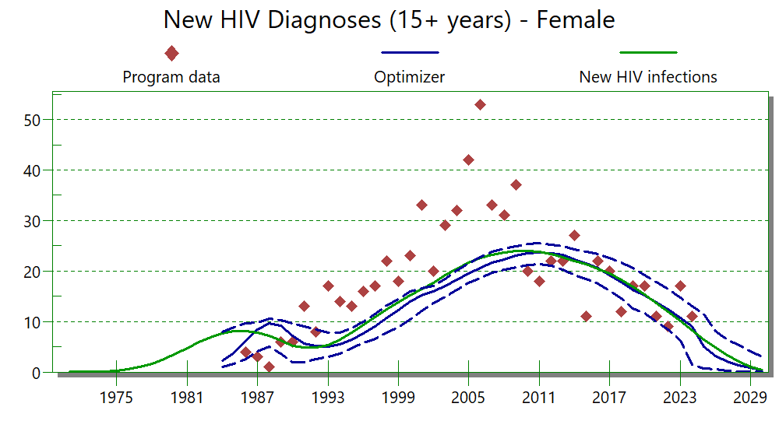
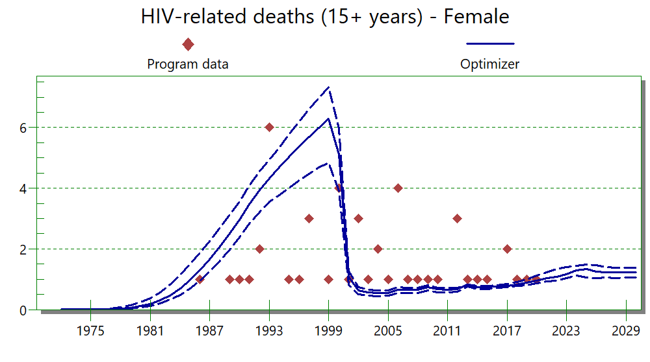

Model findings females, splines 4

Total females living with HIV 1985-2024 with 95% uncertainty bounds
Year | Females living with HIV, point estimate | Lower bound | Upper bound
1985 | 39.34412 | 29.66571 | 48.64095
1986 | 45.89539 | 36.3169 | 56.78909
1987 | 51.86398 | 42.14581 | 62.19553
1988 | 56.58269 | 46.1606 | 67.19191
1989 | 60.07557 | 48.08822 | 71.19872
1990 | 63.49065 | 49.04388 | 76.58321
1991 | 65.43274 | 49.81439 | 80.57254
1992 | 66.37598 | 49.27486 | 81.97776
1993 | 67.64329 | 49.74596 | 84.41691
1994 | 69.85898 | 51.68313 | 86.721
1995 | 73.38092 | 54.71564 | 89.97574
1996 | 78.09203 | 57.33327 | 94.94533
1997 | 83.66517 | 61.98394 | 100.1673
1998 | 90.02969 | 67.54086 | 107.4725
1999 | 97.30918 | 74.27236 | 116.2358
2000 | 109.843 | 85.32318 | 129.8266
2001 | 126.0246 | 99.76293 | 148.0553
2002 | 145.1778 | 118.4213 | 169.2466
2003 | 166.0634 | 137.1744 | 193.0063
2004 | 187.7823 | 158.3427 | 215.7494
2005 | 210.4907 | 180.1939 | 239.5599
2006 | 233.9032 | 202.7153 | 264.7719
2007 | 257.2456 | 225.884 | 291.4428
2008 | 280.943 | 247.4649 | 318.8055
2009 | 305.064 | 268.3374 | 344.0726
2010 | 328.896 | 290.225 | 370.2348
2011 | 351.6637 | 309.7011 | 394.325
2012 | 374.1632 | 328.6075 | 421.5945
2013 | 397.6242 | 349.1449 | 447.6285
2014 | 423.2919 | 371.5097 | 474.3255
2015 | 448.599 | 391.6944 | 501.1431
2016 | 473.3536 | 413.6484 | 531.1874
2017 | 497.3284 | 433.1082 | 554.8404
2018 | 522.2045 | 453.8144 | 584.056
2019 | 548.0266 | 476.6503 | 616.1484
2020 | 565.295 | 488.5667 | 635.5239
2021 | 580.4795 | 499.4964 | 656.046
2022 | 591.4675 | 507.3762 | 670.5576
2023 | 600.3257 | 512.7287 | 683.3937
2024 | 607.0897 | 518.2847 | 696.3623

New HIV infections females 1985-2024 with 95% uncertainty bounds
Year | New HIV infections, female, point estimate | Lower bound | Upper bound
1985 | 8.07812 | 6.19339 | 10.08741
1986 | 8.13119 | 5.88786 | 10.00964
1987 | 7.84332 | 4.71478 | 9.98589
1988 | 7.19272 | 3.58098 | 9.74256
1989 | 6.21314 | 3.01127 | 9.72503
1990 | 5.21985 | 2.40182 | 8.66633
1991 | 4.84132 | 2.41842 | 7.93911
1992 | 4.89501 | 2.44442 | 7.20516
1993 | 5.37811 | 3.14572 | 7.51714
1994 | 6.46597 | 4.134 | 8.75557
1995 | 7.88249 | 5.15124 | 10.53512
1996 | 9.36121 | 6.53574 | 11.94049
1997 | 10.8666 | 8.10629 | 13.66675
1998 | 12.38167 | 9.73584 | 15.21661
1999 | 13.79773 | 11.23029 | 16.58403
2000 | 15.15934 | 12.57312 | 17.96504
2001 | 16.44238 | 13.63306 | 19.3707
2002 | 17.75543 | 14.86152 | 20.43639
2003 | 19.17567 | 16.27604 | 22.20992
2004 | 20.51599 | 17.48442 | 24.158
2005 | 21.63852 | 18.43719 | 24.92517
2006 | 22.58785 | 18.89904 | 26.31736
2007 | 23.27774 | 19.63542 | 26.89306
2008 | 23.73497 | 19.76281 | 27.68228
2009 | 23.9699 | 19.91848 | 27.84959
2010 | 24.04783 | 19.99162 | 27.84922
2011 | 23.85729 | 19.88961 | 28.24832
2012 | 23.42366 | 18.79579 | 27.53565
2013 | 22.77386 | 19.00307 | 26.87206
2014 | 22.03113 | 17.73949 | 26.5342
2015 | 21.37305 | 17.20457 | 25.87864
2016 | 20.51732 | 16.30592 | 24.93889
2017 | 19.46729 | 15.16164 | 24.05787
2018 | 18.23412 | 13.77803 | 22.92137
2019 | 16.90575 | 11.81466 | 21.33882
2020 | 15.46096 | 10.67523 | 19.83782
2021 | 13.73671 | 8.53762 | 18.68116
2022 | 11.94289 | 6.79277 | 16.6937
2023 | 10.05156 | 5.16897 | 15.22309
2024 | 8.24575 | 3.43116 | 13.25962

Proportion females with HIV diagnosed 1985-2024 with upper and lower bounds
Year | Proportion females living with HIV, diagnosed. Point estimate | Lower bound | Upper bound
1985 | 0.12839 | 0.049 | 0.4771
1986 | 0.2285 | 0.08431 | 0.64255
1987 | 0.36031 | 0.13551 | 0.76429
1988 | 0.50822 | 0.20716 | 0.85609
1989 | 0.64928 | 0.29917 | 0.9109
1990 | 0.77391 | 0.40862 | 0.95581
1991 | 0.83995 | 0.5056 | 0.9583
1992 | 0.86513 | 0.58303 | 0.95127
1993 | 0.87449 | 0.63849 | 0.94479
1994 | 0.86885 | 0.66862 | 0.93167
1995 | 0.85497 | 0.6792 | 0.91727
1996 | 0.83788 | 0.6737 | 0.90859
1997 | 0.81903 | 0.65549 | 0.8942
1998 | 0.8022 | 0.63173 | 0.87818
1999 | 0.79106 | 0.60943 | 0.86703
2000 | 0.78416 | 0.5943 | 0.86039
2001 | 0.79564 | 0.60148 | 0.87368
2002 | 0.81292 | 0.61676 | 0.88768
2003 | 0.82524 | 0.63195 | 0.89443
2004 | 0.83377 | 0.64539 | 0.89853
2005 | 0.84215 | 0.65747 | 0.90408
2006 | 0.84855 | 0.66961 | 0.90896
2007 | 0.85526 | 0.68138 | 0.91357
2008 | 0.86324 | 0.69453 | 0.91936
2009 | 0.86822 | 0.70527 | 0.92442
2010 | 0.87484 | 0.71724 | 0.92917
2011 | 0.88191 | 0.73034 | 0.93354
2012 | 0.88984 | 0.74439 | 0.93867
2013 | 0.89822 | 0.78438 | 0.9441
2014 | 0.90791 | 0.79339 | 0.9502
2015 | 0.91691 | 0.8044 | 0.95477
2016 | 0.9255 | 0.81681 | 0.95945
2017 | 0.9337 | 0.82986 | 0.96437
2018 | 0.94175 | 0.84657 | 0.96941
2019 | 0.94955 | 0.86436 | 0.97412
2020 | 0.95431 | 0.8812 | 0.97607
2021 | 0.95961 | 0.89761 | 0.97983
2022 | 0.96438 | 0.913 | 0.98285
2023 | 0.9696 | 0.92733 | 0.98648
2024 | 0.97431 | 0.95213 | 0.99305

Model using 2000-2024 data

All model fits to data, male and female
Akaike information criterion
Double logistic | 847.8
Single logistic | 843.9
Splines – 5 knots | 826.4
Splines – 4 knots | 835.3
Splines – 3 knots | 845.6
rLogistic | 824.1

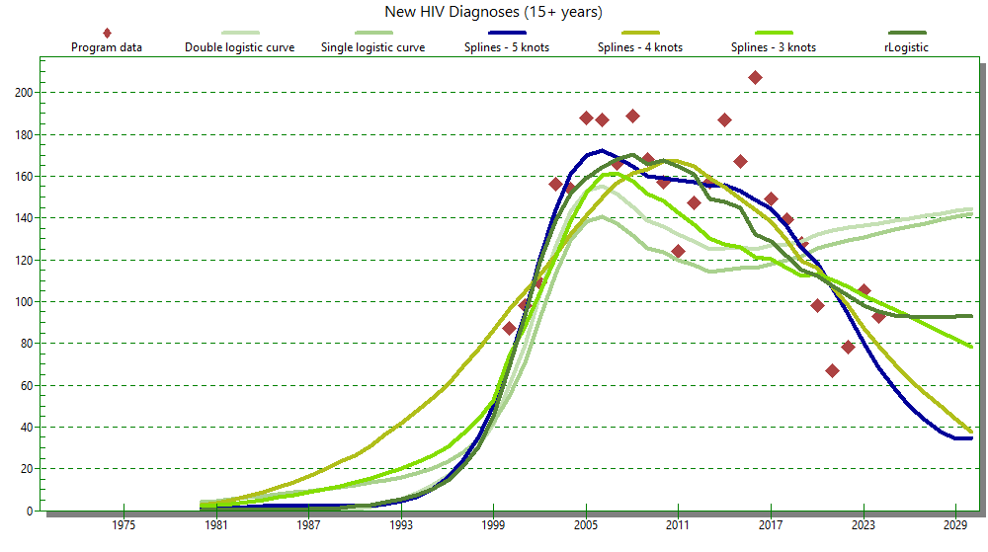
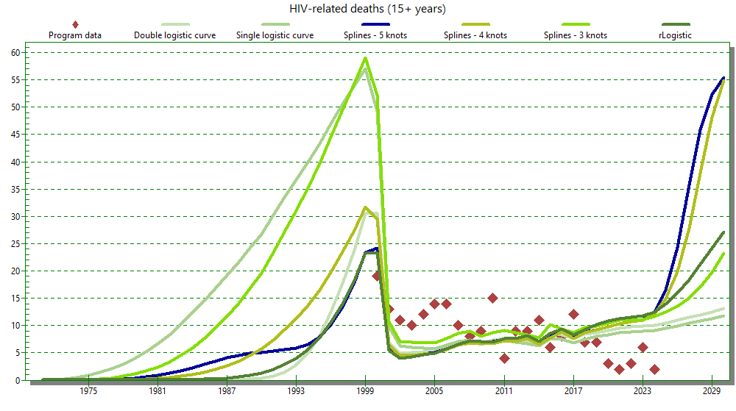
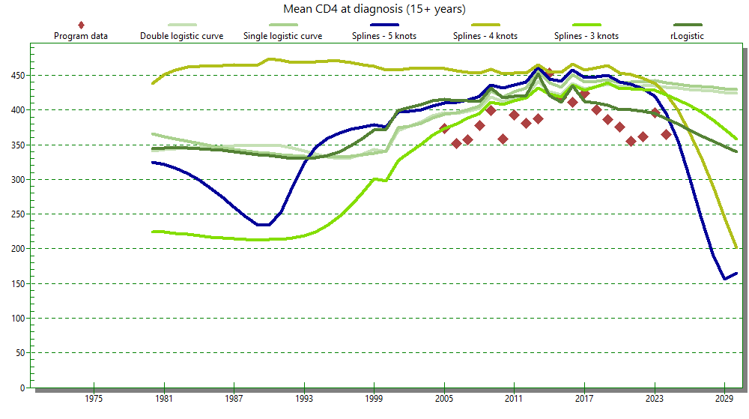

All model findings, male and female
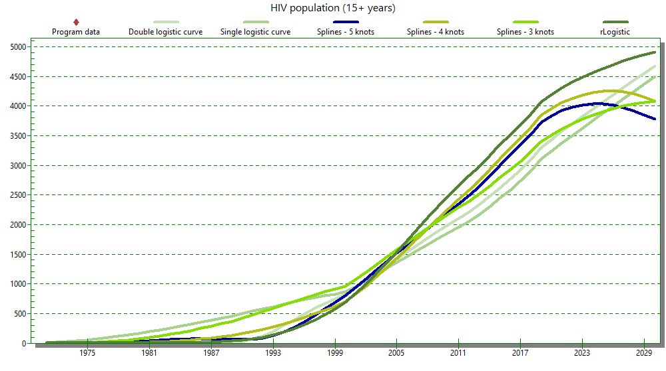
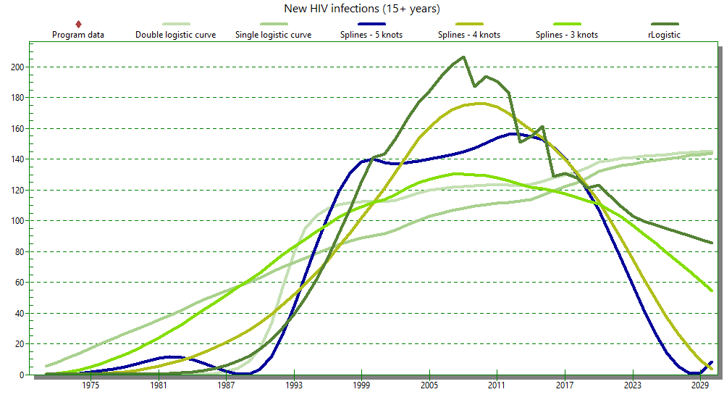

Model fits male and female 2000-2024, splines 5
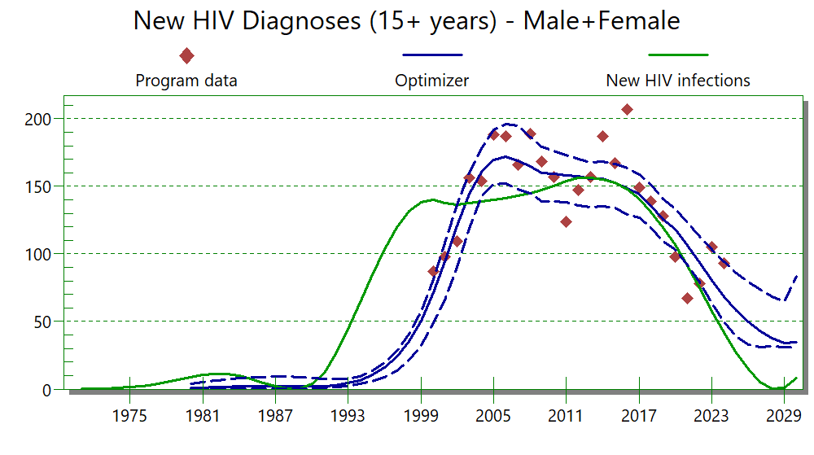
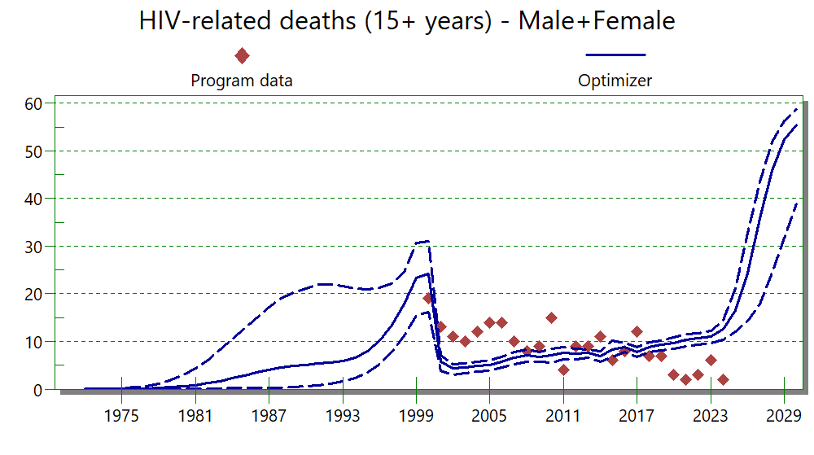

Model findings male and female, 2000-2024, splines 5

Total people living with HIV 2000-2024 with 95% uncertainty bounds
Year | Point estimate PLWH | Lower bound | Upper bound
2000 | 804.91 | 615. 83 | 1041. 98
2001 | 938.65 | 721.72 | 1181.74
2002 | 1080.46 | 837.83 | 1341.69
2003 | 1223.31 | 959.72 | 1497.03
2004 | 1364.50 | 1095.61 | 1636.45
2005 | 1504.63 | 1223.71 | 1791.44
2006 | 1645.45 | 1347.45 | 1935.61
2007 | 1784.49 | 1461.80 | 2083.59
2008 | 1922.69 | 1593.88 | 2219.11
2009 | 2064.23 | 1702.10 | 2377.62
2010 | 2205.44 | 1819.11 | 2565.22
2011 | 2344.48 | 1935.56 | 2742.88
2012 | 2487.85 | 2055.73 | 2899.46
2013 | 2643.38 | 2162.96 | 3059.58
2014 | 2820.54 | 2318.34 | 3256.95
2015 | 2998.58 | 2474.51 | 3453.87
2016 | 3172.03 | 2609.49 | 3649.69
2017 | 3341.52 | 2769.77 | 3844.43
2018 | 3524.84 | 2915.3 | 4041.61
2019 | 3720.40 | 3073.60 | 4250.90
2020 | 3826.97 | 3171.89 | 4371.91
2021 | 3912.23 | 3268.77 | 4472.30
2022 | 3964.64 | 3281.53 | 4513.08
2023 | 3998.53 | 3346.74 | 4554.66
2024 | 4016.36 | 3359.17 | 4568.96

New HIV infections males and females 2000-2024 with 95% uncertainty bounds
Year | Point estimate new infections | Lower bound | Upper bound
2000 | 141.21 | 110.90 | 178.86
2001 | 138.83 | 108.18 | 176.79
2002 | 137.66 | 107.20 | 173.18
2003 | 138.57 | 109.89 | 171.77
2004 | 139.89 | 109.50 | 172.14
2005 | 140.01 | 110.35 | 177.97
2006 | 142.48 | 107.90 | 178.18
2007 | 144.01 | 107.75 | 181.98
2008 | 145.48 | 107.89 | 186.56
2009 | 148.10 | 108.70 | 190.39
2010 | 151.39 | 111.07 | 192.18
2011 | 155.02 | 116.23 | 196.09
2012 | 157.31 | 121.90 | 195.08
2013 | 157.27 | 118.44 | 193.68
2014 | 155.87 | 120.19 | 192.02
2015 | 153.63 | 117.89 | 193.54
2016 | 148.84 | 115.25 | 188.62
2017 | 141.52 | 110.55 | 179.67
2018 | 131.68 | 102.31 | 166.19
2019 | 120.45 | 92.24 | 151.10
2020 | 107.87 | 82.24 | 136.47
2021 | 91.15 | 68.67 | 121.23
2022 | 75.67 | 51.91 | 107.17
2023 | 58.53 | 35.69 | 91.19
2024 | 42.55 | 18.49 | 77.50

Proportion males and females with HIV diagnosed 2000-2024 with upper and lower bounds
Year | Point estimate proportion diagnosed | Lower bound | Upper bound
2000 | 0.20174 | 0.13106 | 0.27502
2001 | 0.26993 | 0.1806 | 0.35015
2002 | 0.34849 | 0.2311 | 0.43882
2003 | 0.43435 | 0.29109 | 0.52769
2004 | 0.51985 | 0.3604 | 0.60586
2005 | 0.59864 | 0.43594 | 0.6755
2006 | 0.66686 | 0.51504 | 0.73126
2007 | 0.72141 | 0.59121 | 0.77284
2008 | 0.76299 | 0.65849 | 0.81004
2009 | 0.79321 | 0.70984 | 0.83445
2010 | 0.81415 | 0.75125 | 0.85044
2011 | 0.82985 | 0.78346 | 0.86459
2012 | 0.84247 | 0.80545 | 0.87381
2013 | 0.85316 | 0.8196 | 0.88058
2014 | 0.86473 | 0.83384 | 0.88852
2015 | 0.8758 | 0.84457 | 0.8958
2016 | 0.88495 | 0.85434 | 0.90301
2017 | 0.89499 | 0.86389 | 0.91152
2018 | 0.90614 | 0.87488 | 0.92114
2019 | 0.91773 | 0.88658 | 0.93099
2020 | 0.92545 | 0.89599 | 0.93724
2021 | 0.93461 | 0.90701 | 0.94681
2022 | 0.94363 | 0.91845 | 0.95697
2023 | 0.95269 | 0.93022 | 0.96732
2024 | 0.9607 | 0.93797 | 0.97567

