Additional File:Chikungunya Virus Dynamics and Persistence in Body Fluids—Nanning, Guangxi Province, China, 2025

Table A1 The results of GEE under different correlation structures
Specimen | Correlation structure | Estimate | Standard error | P value | QIC
Serum | exchangeable | -0.748 | 0.1596 | 2.76e-06 | 96.53
Serum | ar1 | -0.7312 | 0.1609 | 5.5e-06 | 96.36
Serum | unstructured | -0.8557 | 0.1937 | 1e-05 | 98.33
Plasma | exchangeable | -0.6916 | 0.1598 | 1.52e-05 | 81.18
Plasma | ar1 | -0.6916 | 0.1598 | 1.52e-05 | 81.18
Saliva | exchangeable | -0.8516 | 0.2091 | 4.67e-05 | 82.71
Saliva | ar1 | -0.8624 | 0.2059 | 2.82e-05 | 82.66
Saliva | unstructured | -0.8253 | 0.2068 | 6.59e-05 | 82.62
Urine | exchangeable | -0.281 | 0.3149 | 3.72e-01 | 57.7
Urine | ar1 | -0.4115 | 0.2605 | 1.14e-01 | 57.28
Urine | unstructured | -0.7908 | 0.2824 | 5.1e-03 | 57.62
Note: We used the Generalized Estimating Equation (GEE) by R package 'geepack' to analyze the relationship between the probability of positive test results and the number of days after symptom onset, in order to understand the dynamic trend of the positive rate of CHIKV detection in different body fluids. The "Estimate" and "Standard error" in the table represent the estimated results of the number of days after the symptoms appeared. Since the data of this study are individual repeated measurement data, the "independence" related structure was not taken into account.

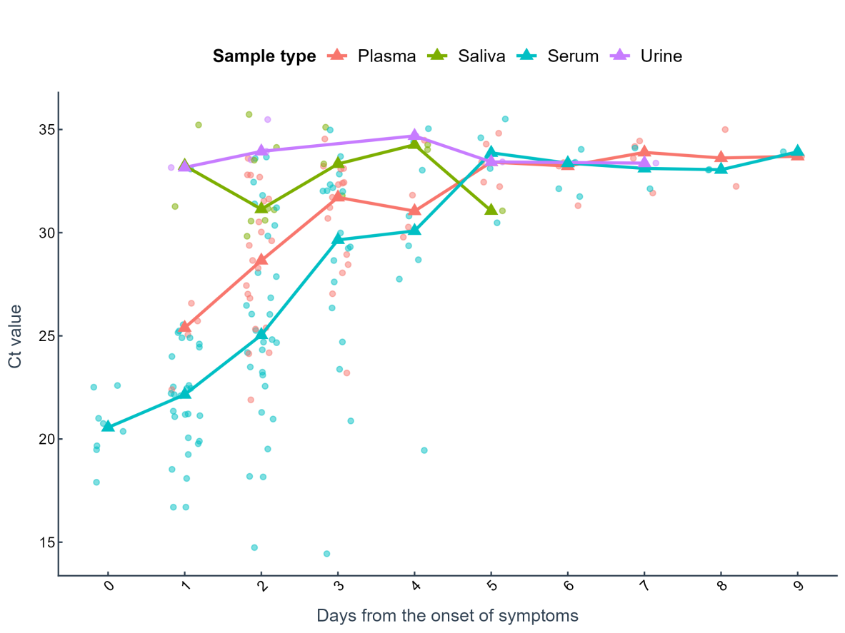
Figure A1 The changes in CT values of serum, plasma, saliva and urine after the onset of symptoms.

Figure A2 Sample sizes of different specimen types collected at the onset of symptoms, stratified by age groups (age ≥ 60 vs. age < 60)
Table A2 Compared with the serum, the sensitivity of other specimen
 | Sensitivity%（95%CI）
 | Saliva | Urine | Plasma
All | 28.3(16.8-42.3) | 7.8(2.2-18.9) | 94.3(84.3-98.8)
Age
<60 | 20.5(9.3-36.5) | 10.8(3-25.4) | 92.9(66.1-99.8)
≥60 | 50.0(23.0-77.0) | - | 94.9(82.7-99.4)
Sex
Female | 18.5(6.3-38.1) | 11.1(2.4-29.2) | 88.9(70.8-97.6)
Male | 38.5(20.2-59.4) | 4.2(0.1-21.1) | 100(86.8-100)
Number of symptoms
≥3 | 30.4(13.2-52.9) | 8.7(1.1-28) | 87(66.4-97.2)
<3 | 26.7(12.3-45.9) | 7.1(0.9-23.5) | 100(88.4-100)
Days from the onset of symptoms
≤4 | 32.6(19.1-48.5) | 9.5(2.7-22.6) | 97.7(87.7-99.9)
＞4 | 10.0(0.3-44.5) | - | 80(44.4-97.5)
Note: '-' indicates that no positive results have been found in this category.

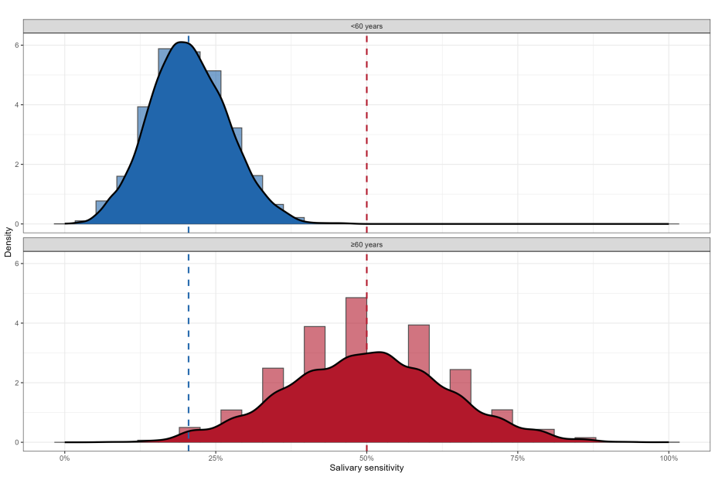
Figure A3. Distribution of salivary diagnostic sensitivity derived from 1,000 bootstrap resampling replicates stratified by age group. Vertical dashed lines represent the observed sensitivity estimates from the primary analysis.

Figure A4 (A) The correlation between paired serum and saliva CT values obtained from the same patient on the same day. (B) The median trend changes of saliva sample CT values within 1 to 3 days of symptom onset, stratified by age groups (≥60 vs. <60).
Table A3 Analysis of influencing factors of saliva positivity rate based on GEE
Model | Variable | Estimate | OR（95%CI） | P
Model 1 | DSO | -0.943 | 0.389 (0.231-0.656) | <0.001
Model 1 | Age group(≥60 vs <60) | 1.176 | 3.24 (1.038-10.115) | 0.043
Model 1 | Sex(Female vs Male) | -0.608 | 0.545 (0.161-1.842) | 0.3283
Model 1 | Number of symptoms (<3 vs ≥3) | -0.695 | 0.499 (0.148-1.682) | 0.2622
Model 2 | DSO | -0.708 | 0.493 (0.295-0.822) | 0.0068
Model 2 | DSO:Age group | -0.989 | 0.372 (0.106-1.308) | 0.1233
Model 2 | Age group(≥60 vs <60) | 0.242 | 1.273 (0.198-8.171) | 0.799
Model 2 | Sex(Female vs Male) | -0.576 | 0.562 (0.161-1.966) | 0.3669
Model 2 | Number of symptoms (<3 vs ≥3) | -0.748 | 0.474 (0.128-1.751) | 0.2626
Note: DOS denotes the number of days elapsed since the onset of symptoms and is treated as a continuous variable.

Figure A5 The estimated probability of positive saliva test results was presented across different time points following symptom onset, stratified by age groups (≥60 years vs. <60 years).

