Additional file 2
Figure S1. Leading organisms among orthopedic-service culture-positive isolate records.
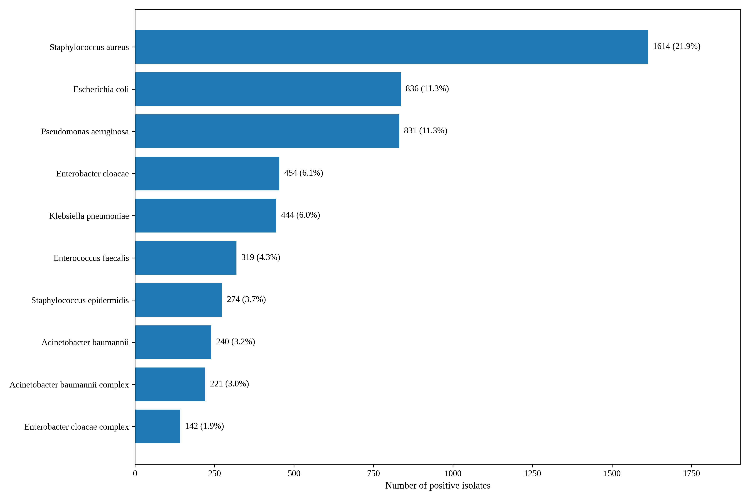
Note. The bar chart shows the ten most frequent organisms. Percentages use all positive isolate records as the denominator (n=7,385). A. baumannii and A. baumannii complex are displayed separately because the historical laboratory system exported them as separate labels.

