Additional file 1
Catheter-associated urinary tract infections in the intensive care setting: a five-year surveillance, microbiological and antibiotic-resistance study
Azize Yetişgen, Osman Kurt, Esra Erdoğan
Contents
Figure S1. Case-selection flow diagram.
Figure S2. Receiver-operating-characteristic (ROC) curve of the primary multivariable model.
Table S1. Sensitivity analysis: multivariable Firth model including all univariable-significant variables.

Figure S1.
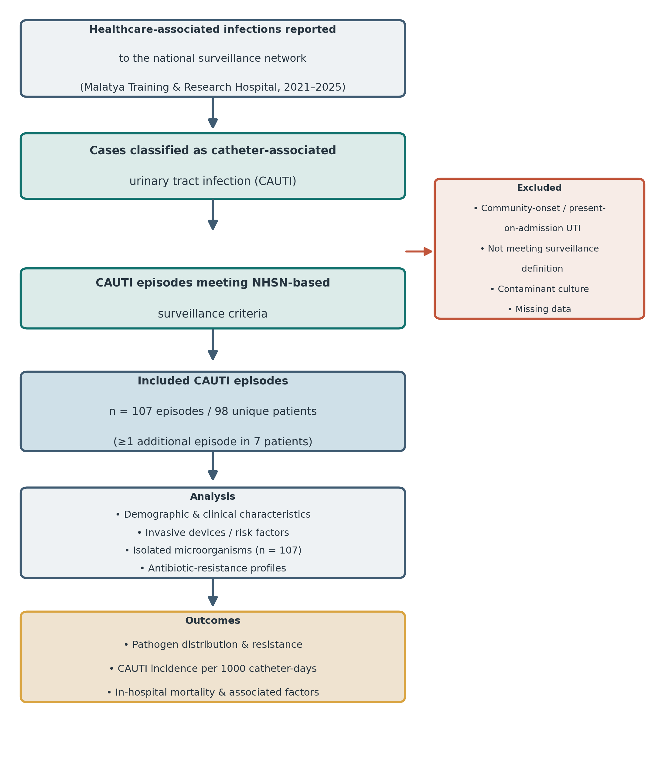
Figure S1. Case-selection flow diagram. Cases reported to the national healthcare-associated infection surveillance network at Malatya Training and Research Hospital (2021–2025) were screened against NHSN-based surveillance criteria for catheter-associated urinary tract infection. After exclusion of community-onset or present-on-admission infections, cases not meeting the surveillance definition, contaminant or clinically insignificant cultures, and cases with missing data, 107 episodes in 98 unique patients were included; seven patients contributed more than one episode.

Figure S2.
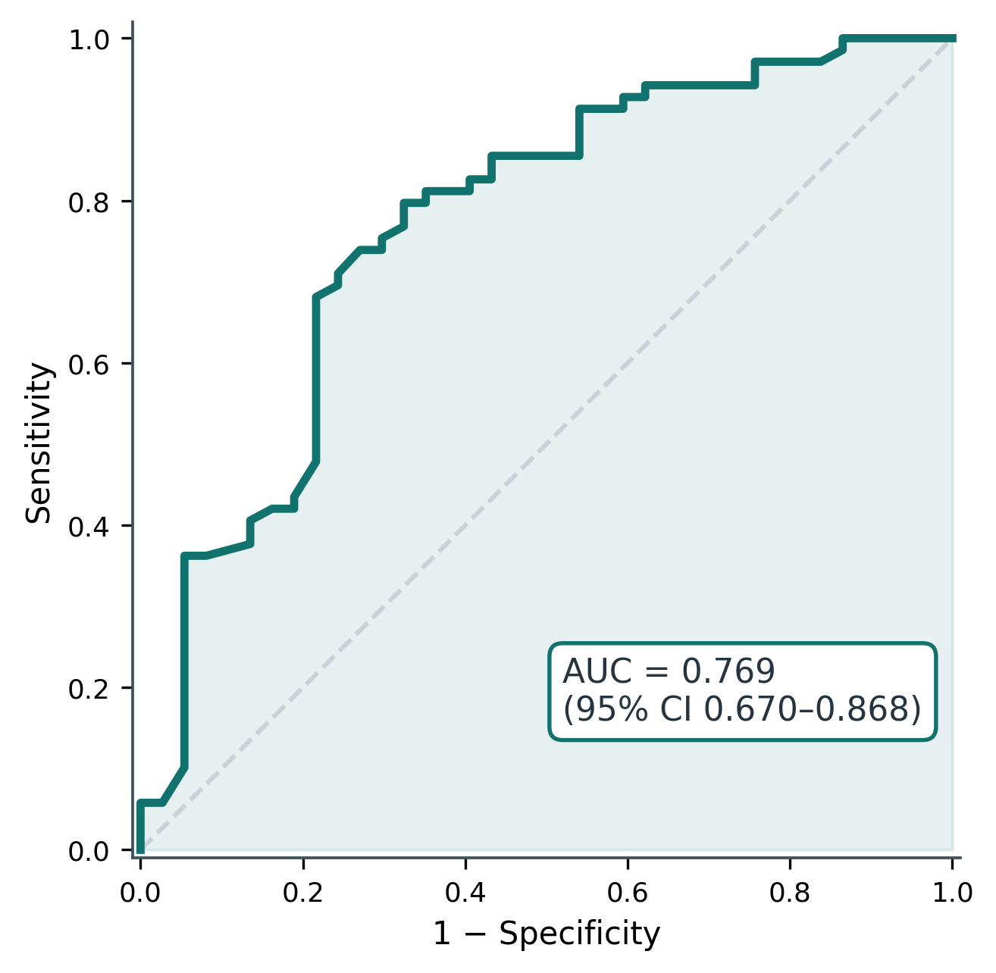
Figure S2. Receiver-operating-characteristic (ROC) curve of the primary multivariable Firth logistic-regression model (age, hypertension, impaired consciousness) for in-hospital mortality. The area under the curve (AUC) with its 95% confidence interval is shown; the dashed diagonal denotes the line of no discrimination.

Table S1. Sensitivity analysis: multivariable Firth penalised-likelihood model including all variables significant in univariable analysis.
Variable | Adjusted OR (95% CI) | p
Age (per 10-year increase) | 1.23 (0.96–1.58) | 0.102
Hypertension | 1.95 (0.50–7.59) | 0.333
Mechanical ventilation | 0.27 (0.01–6.09) | 0.412
Endotracheal intubation | 0.51 (0.11–2.48) | 0.405
Central venous catheter | 1.87 (0.52–6.69) | 0.339
Impaired consciousness | 23.50 (0.89–622.60) | 0.059
Firth penalised-likelihood logistic regression (n = 106, deaths = 69). No individual variable remained statistically significant when all six univariable-significant variables were modelled simultaneously, and confidence intervals widened markedly, consistent with strong collinearity among these severity markers and a limited events-per-variable ratio; overall discrimination was similar to the primary model (AUC 0.798 vs 0.769). These results support the parsimonious primary model reported in the main text. CI confidence interval, OR odds ratio.

