Lipid Profile Alterations in Pulmonary Tuberculosis Patients with and without Diabetes Mellitus: A Systematic Review and Meta-Analysis

POOLED LIPID CONCENTRATIONS
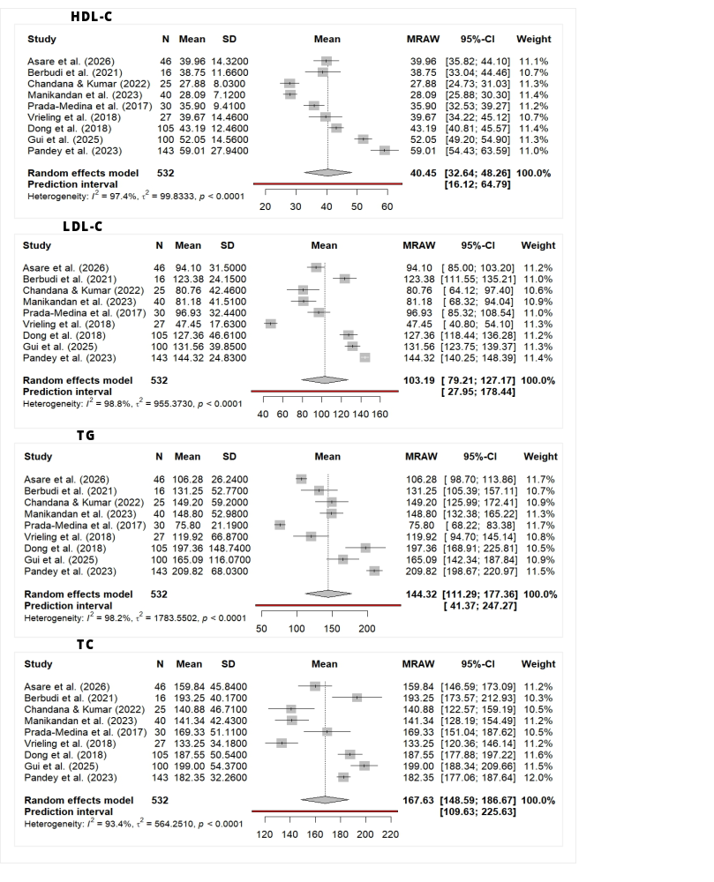
Figure S1A: Pooled mean concentrations among the TB-DM group
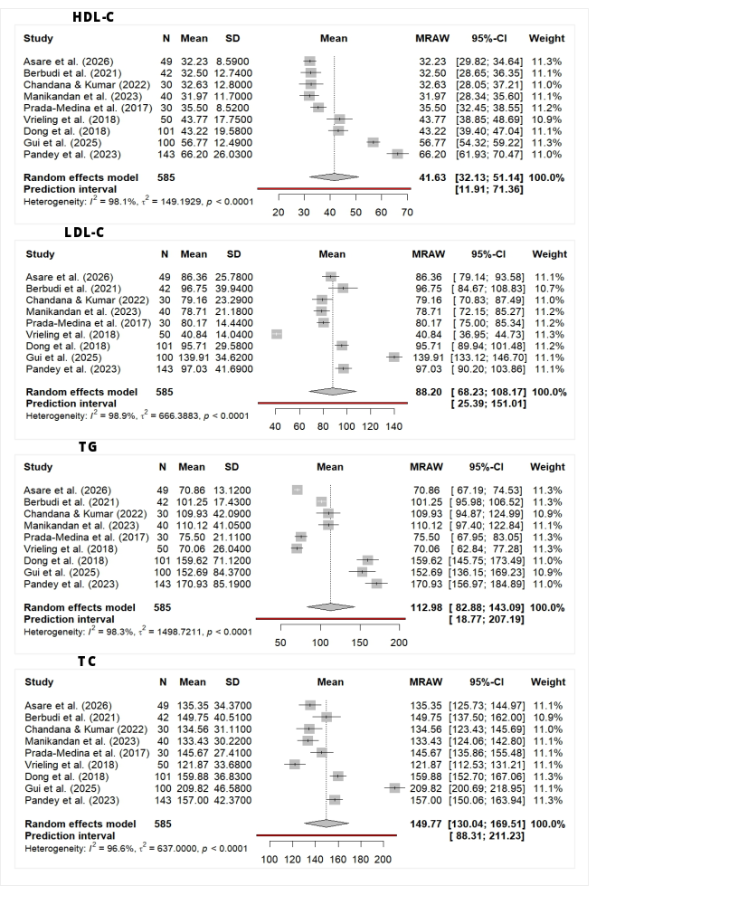
Figure S1B: Pooled mean concentrations among the TB-only group
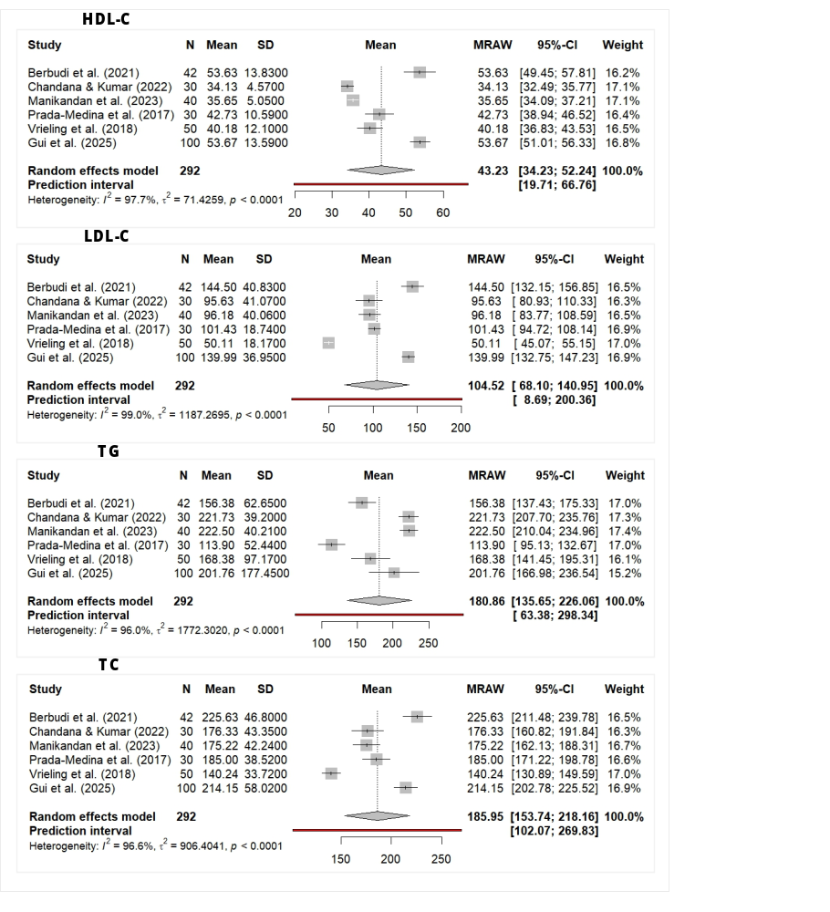
Figure S1C: Pooled mean concentrations among the DM-only group

CERTAINTY ASSESSMENT

Table S1A: Summary of findings for the Primary Comparison (TB-DM vs. TB-only)
Lipid Profile Alterations in Pulmonary Tuberculosis Patients with and without Diabetes Mellitus: A Systematic Review and Meta-Analysis
Patient or population: Pulmonary tuberculosis
Exposure: TB-DM
Comparison: TB-only
Outcomes | Anticipated absolute effects* (95% CI) |  | Relative effect  (95% CI) | № of participants  (studies) | Certainty of the evidence  (GRADE) | Comments
Outcomes | Risk with TB-only | Risk with TB-DM
HDL-C concentration in the primary comparison (TB-DM vs. TB-only) | The mean HDL-C concentration in the primary comparison was 41.63 mg/dL | MD 1.15 mg/dL lower  (5.07 lower to 2.77 higher) | - | 1102  (9 non-randomised studies) | ⨁◯◯◯  Very low^{a,b,c} | TB-DM may reduce/have little to no effect on HDL-C concentration compared to TB-only, but the evidence is very uncertain.
LDL-C concentration in the primary comparison (TB-DM vs TB-only) | The mean LDL-C concentration in the primary comparison was 88.20 mg/dL | MD 14.99 mg/dL higher  (1.28 higher to 28.71 higher) | - | 1102  (9 non-randomised studies) | ⨁◯◯◯  Very low^{d,e,f} | TB-DM may increase/have little to no effect on LDL-C concentration compared to TB-only, but the evidence is very uncertain.
Triglyceride concentration in the primary comparison (TB-DM vs. TB-only) | The mean triglyceride concentration in the primary comparison was 112.98 mg/dL | MD 30.13 mg/dL higher  (17.58 higher to 42.67 higher) | - | 1102  (9 non-randomised studies) | ⨁◯◯◯  Very low^{g,h,i} | TB-DM may increase/have little to no effect on triglyceride concentration compared to TB-only, but the evidence is very uncertain.
Total cholesterol concentration in the primary comparison (TB-DM vs. TB-only) | The mean total cholesterol concentration in the primary comparison was 149.77 mg/dL | MD 17.29 mg/dL higher  (5.42 higher to 29.16 higher) | - | 1102  (9 non-randomised studies) | ⨁◯◯◯  Very low^{j,k,l} | TB-DM may increase/have little to no effect on total cholesterol concentration compared to TB-only, but the evidence is very uncertain.
*The mean difference in the exposure group (and its 95% confidence interval) is based on the pooled mean in the comparison group and the relative effect of the exposure (and its 95% CI). CI: confidence interval; MD: mean difference
GRADE Working Group grades of evidence
High certainty: we are very confident that the true effect lies close to that of the estimate of the effect.
Moderate certainty: we are moderately confident in the effect estimate: the true effect is likely to be close to the estimate of the effect, but there is a possibility that it is substantially different.
Low certainty: our confidence in the effect estimate is limited: the true effect may be substantially different from the estimate of the effect.
Very low certainty: we have very little confidence in the effect estimate: the true effect is likely to be substantially different from the estimate of effect.
Explanations
a, d, g, j. Five out of the nine included studies had no score for comparability, despite their NOS scores.
b. The primary comparison (TB-DM vs. TB-only) for HDL-C shows high heterogeneity (72.6%).
c. The result is not statistically significant, and the 95% CI is wide.
e. The primary comparison (TB-DM vs. TB-only) for LDL-C shows high heterogeneity (92.2%).
f, i, l. While the result is statistically significant, the 95% CI is wide, suggesting that the true effect could be clinically negligible, leading to uncertainty in the absolute estimate.
h. The primary comparison (TB-DM vs. TB-only) for TG shows high heterogeneity (77.7%).
k. The primary comparison (TB-DM vs. TB-only) for TC shows high heterogeneity (73.5%).

Table S1B: Summary of findings for the Secondary Comparison (TB-DM vs. DM-only)
Lipid Profile Alterations in Pulmonary Tuberculosis Patients with and without Diabetes Mellitus: A Systematic Review and Meta-Analysis
Patient or population: Pulmonary tuberculosis
Exposure: TB-DM
Comparison: DM-only
Outcomes | Anticipated absolute effects* (95% CI) |  | Relative effect  (95% CI) | № of participants  (studies) | Certainty of the evidence  (GRADE) | Comments
Outcomes | Risk with DM-only | Risk with TB-DM
HDL-C concentration in the secondary comparison (TB-DM vs. DM-only) | The mean HDL-C concentration in the secondary comparison was 43.23 mg/dL | MD 6.03 mg/dL lower  (10.82 lower to 1.24 lower) | - | 824  (6 non-randomised studies) | ⨁◯◯◯  Very low^{a,b,c} | TB-DM may reduce/have little to no effect on HDL-C concentration compared to DM-only, but the evidence is very uncertain.
LDL-C concentration in the secondary comparison (TB-DM vs. DM-only) | The mean LDL-C concentration in the secondary comparison was 104.52 mg/dL | MD 8.03 mg/dL lower  (14.99 lower to 1.07 lower) | - | 824  (6 non-randomised studies) | ⨁◯◯◯  Very low^{d,e} | TB-DM may reduce/have little to no effect on LDL-C concentration compared to DM-only, but the evidence is very uncertain.
Triglyceride concentration in the secondary comparison (TB-DM vs. DM-only) | The mean triglyceride concentration in the secondary comparison was 180.86 mg/dL | MD 51.07 mg/dL lower  (72.68 lower to 29.46 lower) | - | 824  (6 non-randomised studies) | ⨁◯◯◯  Very low^{f,g,h} | TB-DM may reduce/have little to no effect on triglyceride concentration compared to DM-only, but the evidence is very uncertain.
Total cholesterol concentration in the secondary comparison (TB-DM vs. DM-only) | The mean total cholesterol concentration in the secondary comparison was 185.95 mg/dL | MD 21.61 mg/dL lower  (34.48 lower to 8.73 lower) | - | 824  (6 non-randomised studies) | ⨁◯◯◯  Very low^{i,j} | TB-DM may reduce/have little to no effect on total cholesterol concentration compared to DM-only, but the evidence is very uncertain.
*The mean difference in the exposure group (and its 95% confidence interval) is based on the pooled mean in the comparison group and the relative effect of the exposure (and its 95% CI). CI: confidence interval; MD: mean difference
GRADE Working Group grades of evidence
High certainty: we are very confident that the true effect lies close to that of the estimate of the effect.
Moderate certainty: we are moderately confident in the effect estimate: the true effect is likely to be close to the estimate of the effect, but there is a possibility that it is substantially different.
Low certainty: our confidence in the effect estimate is limited: the true effect may be substantially different from the estimate of the effect.
Very low certainty: we have very little confidence in the effect estimate: the true effect is likely to be substantially different from the estimate of effect.
Explanations
a, d, f, i. Three out of the six included studies had no score for comparability, despite their NOS scores.
b. The secondary comparison (TB-DM vs. DM-only) for HDL-C shows substantial heterogeneity (66.9%).
c, h, j. Although the result is statistically significant, the 95% CI is relatively wide. Additionally, the analysis relies on only 6 studies, which can reduce the overall precision of the pooled estimate.
e. Although the result is statistically significant, the 95% CI is relatively wide.
g. The secondary comparison (TB-DM vs. DM-only) for TG shows substantial heterogeneity (56.5%).

PUBLICATION BIAS
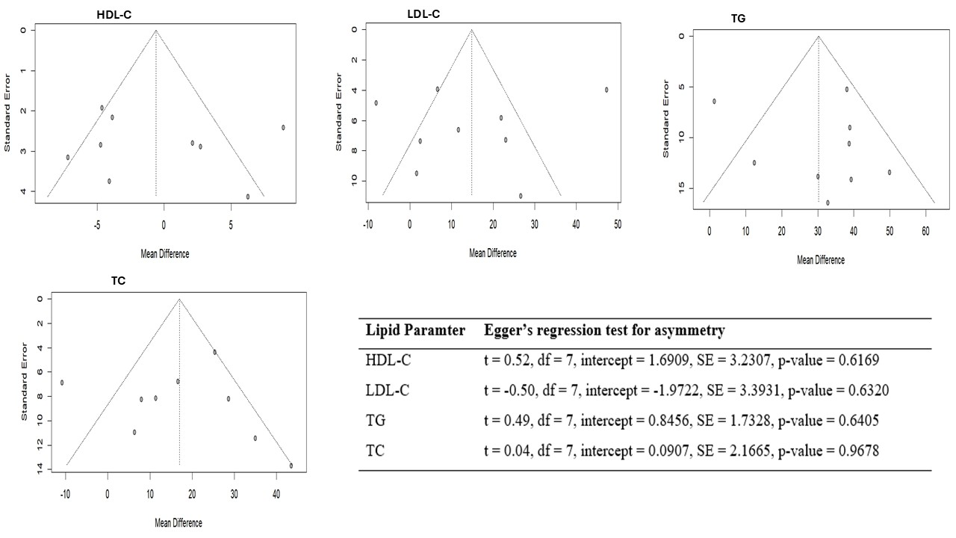
Figure S3: Funnel plots and Egger’s regression test for publication bias (n = 9)

