Supplementary Methods 1

Search overview
Database / platform | Publication coverage | Records retrieved or retained
PubMed | 1 Jan 2014-30 Sep 2024 | 427
Google Scholar | 1 Jan 2014-30 Sep 2024 | 720
EBSCOhost | 1 Jan 2014-30 Sep 2024 | 413
Total records retrieved across the three sources: 1,560. Deduplication was performed after export, as described in the main Methods.

Conceptual structure
Concept block | Free-text terms
Malaria / parasite | malaria; "Plasmodium vivax"; vivax
Resistance markers | resistance; mutation; polymorphism; SNP; "mutant allele"; mutant; "allele change"; "allelic changing"; pvdhfr; pvdhps; pvk12; pvmdr1; pvcrt-o; kelch12
Antimalarial drugs | drug; quinolone; quinine; quinidine; amodiaquine; mefloquine; lumefantrine; halofantrine; dihydroartemisinin; dihydroartemisinin-piperaquine; artemisinin; artemether; artesunate; pyrimethamine; sulphadoxine; trimethoprim; antifolates; primaquine; artemether-lumefantrine; ACT; "Artemisinin Combination Therapy"
Southeast Asia | Indonesia; Philippines; Vietnam; Thailand; Myanmar; Malaysia; Cambodia; Laos; Singapore; "Timor Leste"; Brunei
The four blocks were combined with AND; synonyms within each block were combined with OR. No language, study-design, article-type, or human-subject filter was applied during the electronic search. These eligibility criteria were applied during screening.

PubMed
Date restriction. Publication date from 1 January 2014 through 30 September 2024
Records retrieved. 427.

Exact search string
(Malaria[Title/Abstract] OR "Plasmodium vivax"[Title/Abstract] OR "vivax"[Title/Abstract]) AND (Resistance[Title/Abstract] OR mutation[Title/Abstract] OR polymorphism[Title/Abstract] OR SNP[Title/Abstract] OR "mutant allele"[Title/Abstract] OR mutant[Title/Abstract] OR "allele change"[Title/Abstract] OR "allelic changing"[Title/Abstract] OR Pvdhfr[Title/Abstract] OR Pvdhps[Title/Abstract] OR PvK12[Title/Abstract] OR Pvmdr1[Title/Abstract] OR Pvcrt-o[Title/Abstract] OR Kelch12[Title/Abstract]) AND (Drug[Title/Abstract] OR Quinolone[Title/Abstract] OR quinine[Title/Abstract] OR quinidine[Title/Abstract] OR amodiaquine[Title/Abstract] OR mefloquine[Title/Abstract] OR lumefantrine[Title/Abstract] OR halofantrine[Title/Abstract] OR dihydroartemisinin[Title/Abstract] OR "dihydroartemisinin–piperaquine"[Title/Abstract] OR artemisinin[Title/Abstract] OR artemether[Title/Abstract] OR artesunate[Title/Abstract] OR "pyrimethamine"[Title/Abstract] OR sulphadoxine[Title/Abstract] OR trimethoprim[Title/Abstract] OR pyrimethamine[Title/Abstract] OR sulphadoxine[Title/Abstract] OR antifolates[Title/Abstract] OR primaquine[Title/Abstract] OR artemether[Title/Abstract] OR "artemether lumefantrine"[Title/Abstract] OR ACT[Title/Abstract] OR "Artemisinin Combination Therapy"[Title/Abstract]) AND ((Indonesia[Title/Abstract]) OR (Philippines[Title/Abstract]) OR (Vietnam[Title/Abstract]) OR (Thailand[Title/Abstract]) OR (Myanmar[Title/Abstract]) OR (Malaysia[Title/Abstract]) OR (Cambodia[Title/Abstract]) OR (Laos[Title/Abstract]) OR (Singapore[Title/Abstract]) OR (Timor-Leste[Title/Abstract]) OR (Brunei[Title/Abstract]))

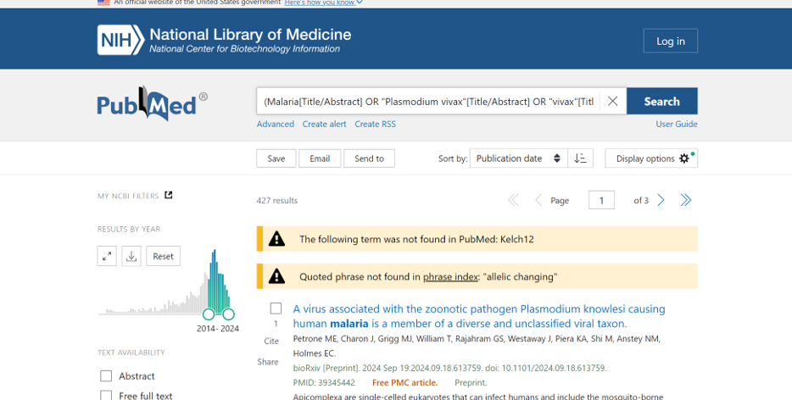

Google Scholar
Records retained for screening. The first 720 results returned by relevance were exported.

Exact search string
allintitle: (Malaria OR "Plasmodium vivax" OR "vivax") AND (Resistance OR mutation OR polymorphism OR SNP OR "mutant allele" OR mutant OR "allele change" OR "allelic changing" OR Pvdhfr OR Pvdhps OR PvK12 OR Pvmdr1 OR Pvcrt-o OR Kelch12 OR Pfdhfr OR Pfdhps OR PfK13 OR Pfmdr1 OR Pfcrt-o OR Kelch13) AND (Drug OR Quinolone OR quinine OR quinidine OR amodiaquine OR mefloquine OR lumefantrine OR halofantrine OR dihydroartemisinin OR "dihydroartemisinin–piperaquine" OR artemisinin OR artemether OR artesunate OR "pyrimethamine" OR sulphadoxine OR trimethoprim OR pyrimethamine OR sulphadoxine OR antifolates OR primaquine OR artemether OR "artemether lumefantrine" OR ACT OR “Artemisinin Combination Therapy”) AND (Indonesia OR Philippines OR Vietnam OR Thailand OR Myanmar OR Malaysia OR Cambodia OR Laos OR Singapore OR “Timor Leste” OR Brunei)

EBSCOhost
Date restriction. Published Date from 1 January 2014 through 30 September 2024
Records retrieved. 413.

Exact search string
(Malaria OR "Plasmodium vivax" OR vivax) [ABSTRACT]
AND
(Resistance OR mutation OR polymorphism OR SNP OR "mutant allele" OR mutant OR "allele change" OR "allelic changing" OR Pvdhfr OR Pvdhps OR PvK12 OR Pvmdr1 OR Pvcrt-o OR Kelch12) [ABSTRACT]
AND
(Drug OR Quinolone OR quinine OR quinidine OR amodiaquine OR mefloquine OR lumefantrine OR halofantrine OR dihydroartemisinin OR "dihydroartemisinin-piperaquine" OR artemisinin OR artemether OR artesunate OR pyrimethamine OR sulphadoxine OR trimethoprim OR antifolates OR primaquine OR "artemether lumefantrine" OR ACT OR "Artemisinin Combination Therapy") [ABSTRACT]
AND
(Indonesia OR Philippines OR Vietnam OR Thailand OR Myanmar OR Malaysia OR Cambodia OR Laos OR Singapore OR "Timor-Leste" OR Brunei) [ABSTRACT]
