Supplementary Material
Supplementary Table S1. Covariate balance between the tuberculosis and matched non-tuberculosis groups after propensity score matching.
Covariate | TB group (n=31,175) | Non-TB group (n=84,522) | SMD
Sex, male | 17,240 (55.3%) | 47,077 (55.7%) | 0.008
Age ≥ 50 years | 19,876 (63.8%) | 53,386 (63.2%) | 0.012
Socioeconomic status, low | 18,732 (60.1%) | 50,891 (60.2%) | 0.003
Region, metropolitan | 6,679 (21.4%) | 18,719 (22.1%) | 0.018
Hypertension | 9,405 (30.2%) | 23,972 (28.4%) | 0.039
Diabetes mellitus | 6,203 (19.9%) | 12,072 (14.3%) | 0.098
Chronic kidney disease | 3,213 (10.3%) | 8,021 (9.5%) | 0.027
SMD, standardized mean difference. Values are n (%).
Propensity score matching was performed on age, sex, socioeconomic status, and residential region; comorbidities (hypertension, diabetes mellitus, and chronic kidney disease) were additionally adjusted for in the Cox models and are shown here as baseline characteristics. All covariates achieved an SMD below 0.1 after matching (the largest SMD was 0.098, for diabetes mellitus), indicating acceptable post-matching balance according to the conventional SMD < 0.1 criterion. Pre-matching covariate distributions were not retained in the analytic dataset available for this study; therefore, only post-matching values are reported.

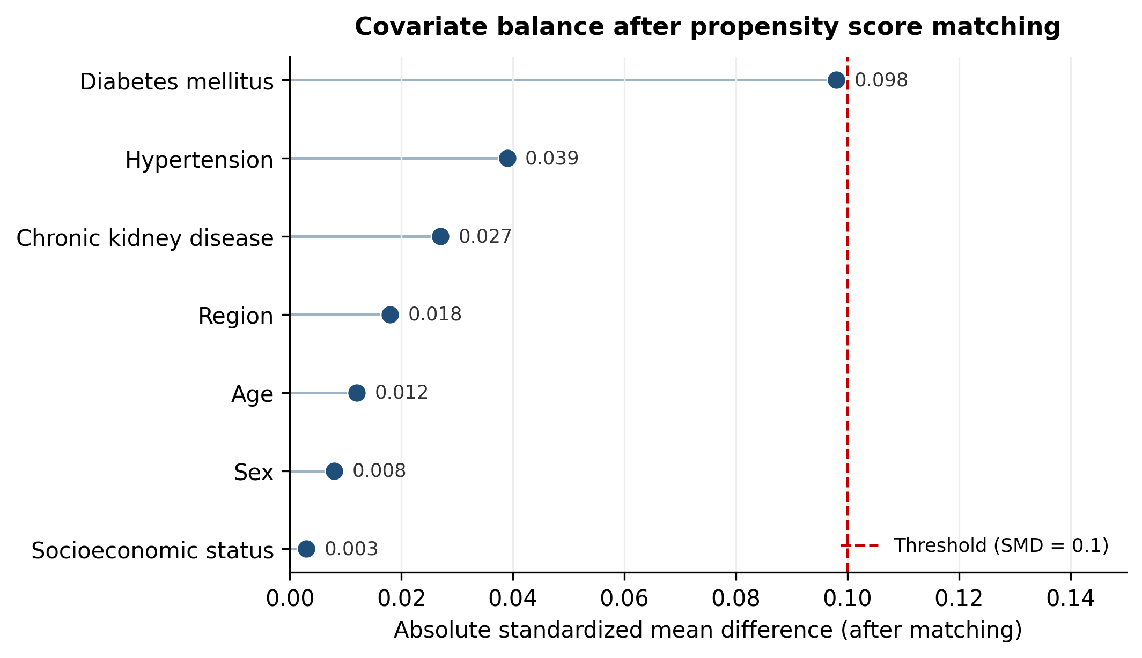
Supplementary Figure S1. Love plot of covariate balance after propensity score matching. Each point represents the absolute standardized mean difference (SMD) for a covariate after matching. The dashed red line denotes the conventional threshold of 0.1, below which post-matching balance is considered acceptable. All covariates fell below this threshold. As pre-matching distributions were not available in the analytic dataset, only post-matching SMDs are displayed.

