Supplementary Data
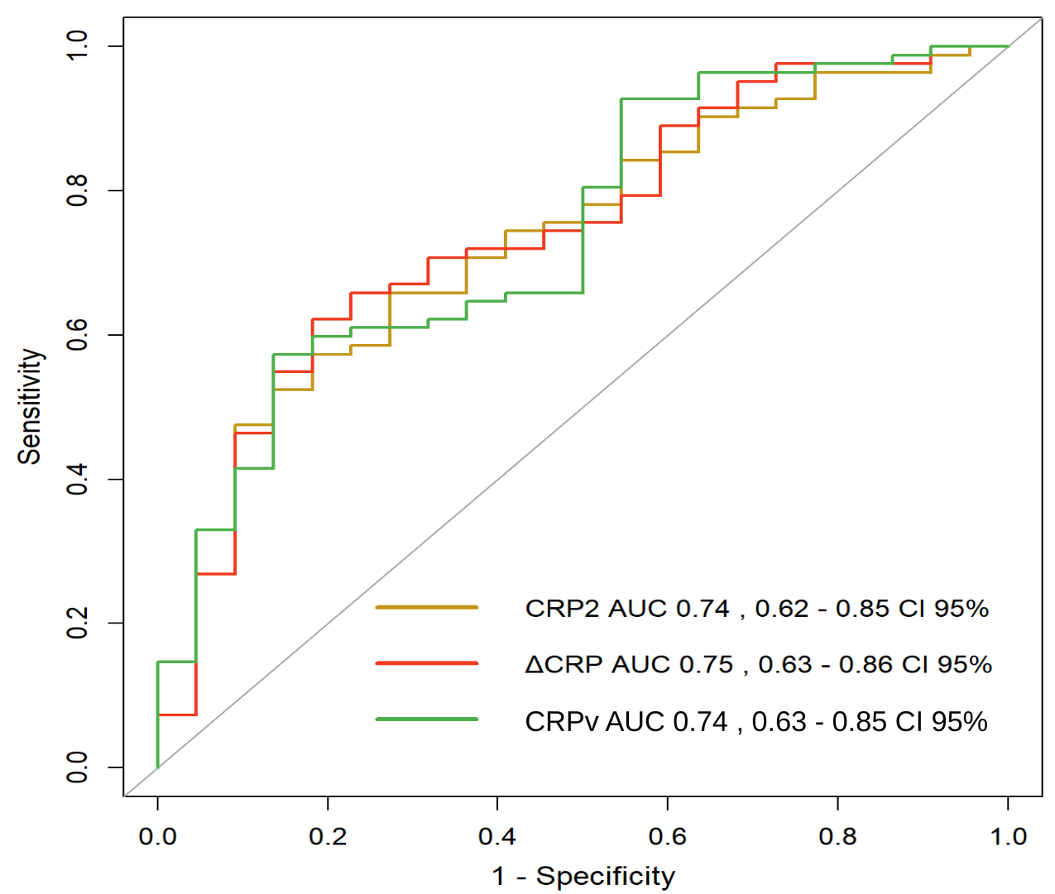
Supplementary Figure 1: Performance of CRP2, ΔCRP, and CRPv in classifying the Appropriate and Discordant groups, conducted on a cohort of n= 104 (82 and 22, respectively).
The area under the receiver operating characteristic curve (ROC-AUC) is shown for the second C- reactive protein (CRP) measurement from admission (CRP2 mg/L; yellow); the difference between the first CRP measurement from admission (CRP1) and CRP2 (ΔCRP mg/L; red); and ΔCRP, divided by the time difference between the measurements (CRPv mg/L/hour; green). The Appropriate group comprises patients who received an antibiotic regimen with in vitro activity against the isolated pathogen between CRP1 and CRP2. The Discordant group comprises patients who received an antibiotic regimen without in vitro activity against the isolated pathogen between CRP1 and CRP2.

Supplementary Figure 2: Performance of CRP2, ΔCRP, and CRPv in classifying the Appropriate and Inappropriate groups, conducted on a cohort of n= 122 (82 and 40, respectively).
The area under the receiver operating characteristic curve (ROC-AUC) of the second C- reactive protein (CRP) measurement from admission (CRP2 mg/L; yellow); the difference between the first CRP measurement from admission (CRP1) and CRP2 (ΔCRP mg/L; red); and ΔCRP, divided by the time difference between the measurements (CRPv mg/L/hour; green). The Appropriate group comprises patients who received an antibiotic regimen with in vitro activity against the isolated pathogen between CRP1 and CRP2. The Inappropriate group comprises patients who received either an antibiotic regimen without in vitro activity against the isolated pathogen or no antibiotic therapy between CRP1 and CRP2.

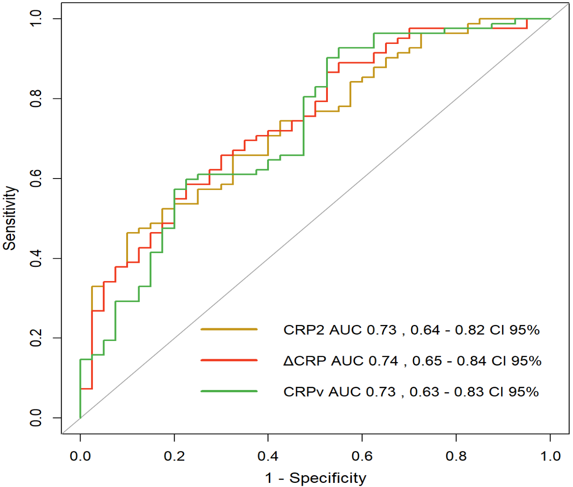

Supplementary Table 1. Empiric antibiotics, bacterial species, and antibiotic appropriateness among 104 treated patients
Bacterial species | Empiric antibiotic therapy
  Antibiotic appropriateness
Aeromonas sobria | Ceftriaxoneª | Discordant
Citrobacter freundii | Ceftriaxone | Discordant
Citrobacter koseri | Ceftriaxone | Appropriate
Citrobacter koseri | Cefazolinª | Discordant
Citrobacter koseri | Ceftriaxone | Appropriate
Escherichia coli | Amikacin | Appropriate
Escherichia coli | Ceftriaxone | Appropriate
Escherichia coli | Ceftriaxone | Appropriate
Escherichia coli | Amikacin | Appropriate
Escherichia coli | Ceftriaxone | Appropriate
Escherichia coli | Ceftriaxone | Appropriate
Escherichia coli | Ceftriaxone | Appropriate
Escherichia coli | Ceftriaxone | Appropriate
Escherichia coli | Ceftriaxone | Appropriate
Escherichia coli | Ceftriaxone | Appropriate
Escherichia coli | Ceftriaxone | Discordant
Escherichia coli | Ceftriaxone | Appropriate
Escherichia coli | Ceftriaxone | Appropriate
Escherichia coli | Amikacin | Appropriate
Escherichia coli | Ceftriaxone | Appropriate
Escherichia coli | Ceftriaxone | Appropriate
Escherichia coli | Ceftriaxone | Discordant
Escherichia coli | Ceftriaxone | Appropriate
Escherichia coli | Ceftriaxone | Discordant
Escherichia coli | Ceftriaxone | Appropriate
Escherichia coli | Ceftriaxone | Appropriate
Escherichia coli | Ceftriaxone | Appropriate
Escherichia coli | Ceftriaxone | Appropriate
Escherichia coli | Imipenemª | Appropriate
Escherichia coli | Ceftriaxone | Discordant
Escherichia coli | Ceftriaxone | Appropriate
Escherichia coli | Ceftriaxone | Discordant
Escherichia coli | Ceftriaxone | Appropriate
Escherichia coli | Ceftriaxone | Appropriate
Escherichia coli | Ceftriaxone | Appropriate
Escherichia coli | Ceftriaxone | Appropriate
Escherichia coli | Ceftriaxone | Appropriate
Escherichia coli | Ceftriaxone | Appropriate
Escherichia coli | Ceftriaxone | Appropriate
Escherichia coli | Ceftriaxone | Appropriate
Escherichia coli | Ceftriaxone | Appropriate
Escherichia coli | Ceftriaxone | Discordant
Escherichia coli | Ceftriaxone | Discordant
Escherichia coli | Gentamicin | Appropriate
Escherichia coli | Ceftriaxone | Appropriate
Escherichia coli | Ceftriaxone | Appropriate
Escherichia coli | Ceftriaxone | Appropriate
Escherichia coli | Ceftriaxone | Appropriate
Escherichia coli | Ceftriaxone | Appropriate
Escherichia coli | Gentamicin | Appropriate
Escherichia coli | Ceftriaxone | Appropriate
Escherichia coli | Ceftriaxone | Appropriate
Escherichia coli | Ceftriaxone | Appropriate
Enterobacter cloacae complex | Gentamicin | Appropriate
Enterococcus faecium | Ceftriaxoneª | Discordant
Enterococcus casseliflavus | Piperacillinª | Appropriate
Enterococcus faecalis | Ampicillin | Appropriate
Enterococcus faecalis | Ceftriaxoneª | Discordant
Enterococcus faecalis | Ceftriaxoneª | Discordant
Enterococcus faecalis | Piperacillin | Appropriate
Enterococcus faecalis | Ceftriaxoneª | Discordant
Klebsiella oxytoca | Ceftriaxone | Appropriate
Klebsiella pneumoniae | Ceftriaxone | Discordant
Klebsiella pneumoniae | Ceftriaxone | Appropriate
Klebsiella pneumoniae | Ceftriaxone | Appropriate
Klebsiella pneumoniae | Ceftriaxone | Appropriate
Klebsiella pneumoniae | Ceftriaxone | Appropriate
Klebsiella pneumoniae | Meropenem | Appropriate
Klebsiella pneumoniae | Ceftriaxone | Appropriate
Klebsiella pneumoniae | Roxithromycinª | Discordant
Klebsiella pneumoniae | Ceftriaxone | Appropriate
Klebsiella pneumoniae | Ceftriaxone | Appropriate
Proteus mirabilis | Ceftriaxone | Appropriate
Proteus mirabilis | Ampicillin | Appropriate
Proteus mirabilis | Ceftriaxone | Appropriate
Proteus mirabilis | Ceftriaxone | Appropriate
Pseudomonas stutzeri | Ceftriaxoneª | Discordant
Pseudomonas aeruginosa | Ceftriaxoneª | Discordant
Pseudomonas aeruginosa | Ceftriaxoneª | Discordant
Pseudomonas aeruginosa | Ceftriaxoneª | Discordant
Pseudomonas aeruginosa | Piperacillin | Appropriate
Pseudomonas spp | Ceftriaxone | Discordant
Shewanella algae | Ceftriaxoneª | Appropriate
Staphylococcus aureus | Ceftriaxone | Discordant
Staphylococcus aureus | Ceftriaxone | Appropriate
Staphylococcus aureus | Vancomycin | Appropriate
Staphylococcus aureus | Ceftriaxone | Appropriate
Staphylococcus aureus | Ceftriaxone | Appropriate
Streptococcus agalactiae | Ceftriaxoneª | Appropriate
Streptococcus agalactiae | Ceftriaxoneª | Appropriate
Streptococcus agalactiae | Ceftriaxoneª | Appropriate
Streptococcus agalactiae | Ceftriaxoneª | Appropriate
Streptococcus dysgalactiae | Ceftriaxoneª | Appropriate
Streptococcus dysgalactiae | Ceftriaxoneª | Appropriate
Streptococcus dysgalactiae | Cefazolinª | Appropriate
Streptococcus dysgalactiae | Cefazolinª | Appropriate
Streptococcus dysgalactiae | Ceftriaxoneª | Appropriate
Streptococcus dysgalactiae | Ceftriaxoneª | Appropriate
Streptococcus gallolyticus | Ceftriaxone | Appropriate
Streptococcus pneumoniae | Ceftriaxoneª | Appropriate
Streptococcus pneumoniae | Ceftriaxoneª | Appropriate
Streptococcus pyogenes | Ceftriaxoneª | Appropriate
Streptococcus pyogenes | Ceftriaxoneª | Appropriate
Streptococcus pyogenes | Cefazolin | Appropriate
ª Infectious disease specialists determined antibiotic therapy appropriateness among patients who received empiric antibiotics not included in the antimicrobial susceptibility testing report.

Supplementary Table 2: Characteristics of the Appropriate and the Discordant groups.
Variables ^{a,b} | Discordant group ^{c} (n=22) | Appropriate  group ^{d} (n=82) | SMD | p-value ^{e}
Age (years) | 79±13 | 81.5±11.5 | 0.2 | 0.37
Women | 6 (27.3%) | 35 (42.7%) | 0.33 | 0.22
Gram-positive | 5 (22.7%) | 23 (28%) | 0.12 | 0.78
Δt_Symptoms_CRP1 (hours) | 22.5±19.4 | 20.3±19.4 | 0.11 | 0.3
CRP1 (mg/L) | 14.5±8.53 | 15±8.68 | 0.05 | 0.89
eCRPv (mg/L/hour) | 1±0.816 | 1.24±1.08 | 0.25 | 0.47
Δt_CRP1_Ab (hours) | 3.86±4.38 | 3.13±3.26 | 0.19 | 0.79
Δt_Ab_CRP2 (hours) | 9.03±5.03 | 10.3±6.36 | 0.23 | 0.42
Δt_CRP1_ CRP2 (hours) | 12.9±6.64 | 13.5±6.17 | 0.09 | 0.78
Δt_CRP1_CRP2, median [IQR] (hours) | 12.3 [6.9–19.2] | 14.5 [7.7–18.7] | - | -
CRP2 (mg/L) | 44.1±38 | 83.3±49.9 | 0.88 | 0.0007
ΔCRP (mg/L) | 29.6±38.1 | 68.4±48.9 | 0.88 | 0.0004
CRPv (mg/L /hour) | 2.59±2.44 | 4.86±2.54 | 0.91 | 0.0004
Abbreviations: SMD - standardized mean difference; CRP1 & CRP2- the first and second C- reactive protein (CRP) consecutive measurements from admission; Δt_Symptoms_CRP1- the time difference between symptoms' onset and CRP1; eCRPv (estimated CRP velocity)- CRP1 divided by Δt_Symptoms_CRP1; Δt_CRP1_Ab- the time difference between CRP1 and antibiotic administration; Δt_Ab_CRP2- the time difference between antibiotic administration and CRP2 ;Δt_CRP1_ CRP2- the time difference between CRP1 and CRP2; ΔCRP the difference between CRP1 and CRP2; CRPv (CRP velocity)- ΔCRP divided by Δt_CRP1_ CRP2.
ª Continuous variables are presented as mean±sd, and their p-values were derived from the Mann–Whitney test.
^{b} Categorical variables are presented as a percentage, and their p-values were derived from Fisher's exact test.
^{c} The Discordant group comprises patients who received an antibiotic regimen without in vitro activity against the isolated pathogen between CRP1 and CRP2.
^{d} The Appropriate group comprises patients who received an antibiotic regimen with in vitro activity against the isolated pathogen between CRP1 and CRP2.
^{e} P-values under 5% were considered significant.

Supplementary Table 3: Characteristics of the Appropriate and No-Ab-Treatment groups.
Variables ^{a,b} | No-Ab-Treatment Group ^{c} (n=18) | Appropriate Group ^{d} (n=82) | SMD | p-value ^{e}
Age (years) | 72.9±19.4 | 81.5±11.5 | 0.2 | 0.1
Women | 7 (38.9%) | 35 (42.7%) | 0.33 | 0.89
Gram-positive | 6 (33.3%) | 23 (28.0%) | 0.12 | 0.77
Δt_Symptoms_CRP1 (hours) | 17.4±10.5 | 20.3±19.4 | 0.11 | 0.66
CRP1 (mg/L) | 12.3±10.7 | 14.9±8.68 | 0.11 | 0.22
eCRPv (mg/L/hour) | 1.1±1.54 | 1.2±1.08 | 0.05 | 0.21
Δt_CRP1_ CRP2 (hours) | 8.4±6.06 | 13.5±6.17 | 0.19 | 0.002
Δt_CRP1_CRP2, median [IQR] (hours) | 7.6 [2.9–13.1] | 14.5 [7.7–18.7] | - | -
CRP2 (mg/L) | 44.6±36.9 | 83.3±49.9 | 0.25 | 0.002
ΔCRP (mg/L) | 32.3±35.7 | 68.4±48.9 | 0.88 | 0.001
CRPv (mg/L /hour) | 2.74±2.77 | 4.86±2.54 | 0.23 | 0.006
Abbreviations: SMD - standardized mean difference; CRP1 & CRP2- the first and second C- reactive protein (CRP) consecutive measurements from admission; Δt_Symptoms_CRP1- the time difference between symptoms' onset and CRP1; eCRPv (estimated CRP velocity)- CRP1 divided by Δt_Symptoms_CRP1; Δt_CRP1_CRP2- the time difference between CRP1 and CRP2; ΔCRP- the difference between CRP1 and CRP2; CRPv (CRP velocity)- ΔCRP divided by Δt_CRP1_ CRP2.
ª Continuous variables are presented as mean±sd, and their p-values were derived from the Mann–Whitney test.
^{b} Categorical variables are presented as a percentage, and their p-values were derived from Fisher's exact test.
^{c} The No-Ab-Treatment group comprises patients who received no antibiotic therapy between CRP1 and CRP2.
^{d} The Appropriate group comprises patients who received an antibiotic regimen with in vitro activity against the isolated pathogen between CRP1 and CRP2.
^{e} P-values under 5% were considered significant.
Supplementary Table 4: Bacterial species summary.
Type | Bacterial Species | Total Number
Gram-negative  N=88 | Acinetobacter baumannii | 1
Gram-negative  N=88 | Acinetobacter lwoffii | 2
Gram-negative  N=88 | Aeromonas sobria | 1
Gram-negative  N=88 | Citrobacter freundii | 1
Gram-negative  N=88 | Citrobacter koseri | 3
Gram-negative  N=88 | E. coli | 55
Gram-negative  N=88 | Enterobacter cloacae complex | 1
Gram-negative  N=88 | Klebsiella oxytoca | 1
Gram-negative  N=88 | Klebsiella pneumoniae | 10
Gram-negative  N=88 | Proteus mirabilis | 5
Gram-negative  N=88 | Pseudomonas stutzeri | 1
Gram-negative  N=88 | Pseudomonas aeruginosa | 4
Gram-negative  N=88 | Pseudomonas spp | 1
Gram-negative  N=88 | Shewanella algae | 1
Gram-negative  N=88 | Stenotrophomonas maltophilia | 1
Gram-positive  N=34 | Enterococcus faecium | 1
Gram-positive  N=34 | Enterococcus casseliflavus | 1
Gram-positive  N=34 | Enterococcus faecalis | 5
Gram-positive  N=34 | Group D Streptococcus | 1
Gram-positive  N=34 | Staphylococcus aureus | 7
Gram-positive  N=34 | Streptococcus agalactiae | 5
Gram-positive  N=34 | Streptococcus dysgalactiae | 6
Gram-positive  N=34 | Streptococcus gallolyticus | 1
Gram-positive  N=34 | Streptococcus pneumoniae | 3
Gram-positive  N=34 | Streptococcus pyogenes | 4
Supplementary Table 5: Characteristics of the Discordant and the No-Ab-Treatment groups.
Variables ^{a,b} | No-Ab-Treatment Group ^{c} (n=18) | Discordant Group ^{d} (n=22) | SMD | p-value ^{e}
Age (years) | 72.9±19.4 | 79±13.0 | 0.37 | 0.4
Women | 7 (38.9%) | 6 (27.3%) | 0.25 | 0.5
Gram-positive | 6 (33.3%) | 5 (22.7%) | 0.24 | 0.57
Δt_Symptoms_CRP1 (hours) | 17.4±10.5 | 22.5±19.4 | 0.33 | 0.6
CRP1 (mg/L) | 12.3±10.7 | 14.5±8.53 | 0.23 | 0.39
eCRPv (mg/L/hour) | 1.1±1.54 | 1±0.82 | 0.11 | 0.56
Δt_CRP1_CRP2 (hours) | 8.4±6.06 | 12.9±6.64 | 0.7 | 0.03
Δt_CRP1_CRP2, median [IQR] (hours) | 7.6 [2.9–13.1] | 12.3 [6.9–19.2] | - | -
CRP2 (mg/L) | 44.6±36.9 | 44.1±37.97 | 0.01 | 1
ΔCRP (mg/L) | 32.3±35.7 | 29.6±38.1 | 0.07 | 0.8
CRPv (mg/L /hour) | 2.7±2.77 | 2.6±2.44 | 0.06 | 0.7
Abbreviations: SMD - standardized mean difference; CRP1 & CRP2- the first and second C- reactive protein (CRP) consecutive measurements from admission; Δt_Symptoms_CRP1- the time difference between symptoms' onset and CRP1; eCRPv (estimated CRP velocity)- CRP1 divided by Δt_Symptoms_CRP1; Δt_CRP1_ CRP2- the time difference between CRP1 and CRP2; ΔCRP- the difference between CRP1 and CRP2; CRPv (CRP velocity)- ΔCRP divided by Δt_CRP1_ CRP2.
ª Continuous variables are presented as mean±sd, and their p-values were derived from the Mann–Whitney test.
^{b} Categorical variables are presented as a percentage, and their p-values were derived from Fisher's exact test.
^{c} The No-Ab-Treatment group comprises patients who received no antibiotic therapy between CRP1 and CRP2.
^{d} The Discordant group comprises patients who received an antibiotic regimen without in vitro activity against the isolated pathogen between CRP1 and CRP2.
^{e} P-values under 5% were considered significant.
Supplementary Table 6: Multivariable Logistic Regression Model Summary. Examination of CRP2 and potential confounding variables as predictors of antibiotic appropriateness (Appropriate ª Vs. Inappropriate ^{b} groups).
Parameter | OR | CI 95% | p-value ^{c}
CRP2 (mg/L) ^{d} | 2.63 | (1.57, 4.42) | < 0.001
Sex (female) | 1.59 | (0.67, 3.79) | 0.29
Age (years/10) | 1.24 | (0.92, 1.68) | 0.16
Gram type (positive) | 1.07 | (0.42, 2.69) | 0.89
Abbreviations: CRP2- the second C- reactive protein (CRP) measurement from admission; OR- odds ratio; CI-confidence interval of the odds ratio.
ª The Appropriate group comprises patients who received an antibiotic regimen with in vitro activity against the isolated pathogen between CRP1 and CRP2.
^{b} The Inappropriate group comprises patients who received either an antibiotic regimen without in vitro activity against the isolated pathogen or no antibiotic therapy between CRP1 and CRP2.
^{c} P-values were derived from the Wald tests and were considered significant under 5%.
^{d} CRP2 (mg/L) was standardized by subtracting the mean value of CRP2 from its respective raw values and then dividing it by the standard deviation of CRP2.

Supplementary Table 7: Multivariable Logistic Regression Model Summary. Examination of ΔCRP and the potential confounding variables as predictors of antibiotic appropriateness (Appropriate ª Vs. Inappropriate ^{b} groups).
Parameter | OR | CI 95% | p-value ^{c}
ΔCRP (mg/L) ^{d} | 2.64 | (1.55, 4.49) | < 0.001
Sex (female) | 1.57 | (0.66, 3.72) | 0.31
Age (years/10) | 1.24 | (0.91, 1.68) | 0.17
Gram type (positive) | 1.09 | (0.43, 2.75) | 0.86
Abbreviations: ΔCRP- the difference between the first and second and C- reactive protein consecutive measurements from admission; OR- odds ratio; CI-confidence interval of the odds ratio.
ª The Appropriate group comprises patients who received an antibiotic regimen with in vitro activity against the isolated pathogen between CRP1 and CRP2.
^{b} The Inappropriate group comprises patients who received either an antibiotic regimen without in vitro activity against the isolated pathogen or no antibiotic therapy between CRP1 and CRP2.
^{c} P-values were derived from the Wald tests and were considered significant under 5%.
^{d} ΔCRP (mg/L) was standardized by subtracting the mean value of ΔCRP from its respective raw values and then dividing it by the standard deviation of ΔCRP.

Supplementary Table 8: Sensitivity Analysis- Multivariable Logistic Regression Models for CRPv, CRP2, and ΔCRP as Predictors of Antibiotic Appropriateness (Appropriate ª Vs. Inappropriate ^{b} groups), with and without Δt_CRP1_CRP2 ^{c} as a Covariate.
Predictor | Original OR (95% CI) | Original p-value^{d} | Sensitivity ^{c} OR (95% CI) | Sensitivity p-value^{d} | Δt_CRP1_CRP2 OR (95% CI) | Δt_CRP1_CRP2 p-value^{d}
CRP2 (mg/L) | 2.63 (1.57, 4.42) | < 0.001 | 3.04 (1.65, 5.60) | < 0.001 | 0.79 (0.47, 1.33) | 0.377
ΔCRP (mg/L) | 2.64 (1.55, 4.49) | < 0.001 | 3.04 (1.62, 5.70) | < 0.001 | 0.80 (0.48, 1.34) | 0.392
CRPv (mg/L/hour) | 2.58 (1.59, 4.20) | < 0.001 | 2.48 (1.52, 4.06) | < 0.001 | 1.20 (0.77, 1.85) | 0.420
Abbreviations: CRP1 & CRP2- the first and second C- reactive protein (CRP) consecutive measurements from admission; ΔCRP- the difference between CRP1 and CRP2; Δt_CRP1_CRP2- the time difference (hours) between CRP1 and CRP2; CRPv- CRP velocity (ΔCRP divided by Δt_CRP1_CRP2); OR- odds ratio; CI- confidence interval.
ª The Appropriate group comprises patients who received an antibiotic regimen with in vitro activity against the isolated pathogen between CRP1 and CRP2 (n=82).
^{b} The Inappropriate group comprises patients who received either an antibiotic regimen without in vitro activity against the isolated pathogen or no antibiotic therapy between CRP1 and CRP2 (n=40).
^{c} The sensitivity model includes the original covariates (age, sex, gram type) with the addition of Δt_CRP1_CRP2 as a covariate. All the predictors (CRP2, ΔCRP, CRPv) were standardized by subtracting the mean value of the predictor from its respective raw values and then dividing it by its standard deviation.
^{d} P-values were derived from Wald tests and were considered significant under 5%.

Supplementary Table 9: Performance ª of CRP2, ΔCRP, and CRPv in classifying the Appropriate ^{c} and Discordant ^{b} groups at different Δt _Ab_CRP2.
Δt _Ab_CRP2 (hours) | Discordant Group ^{b} (n) | Appropriate Group ^{c} (n) | CRP2 (mg/L) | ΔCRP (mg/L) | CRPv  (mg/L /hour)
8 | 12 | 33 | 0.56 | 0.44 | 0.62
12 | 17 | 45 | 0.63 | 0.66 | 0.69
16 | 20 | 66 | 0.67 | 0.69 | 0.7
20 | 22 | 76 | 0.73 | 0.74 | 0.75
24 | 22 | 82 | 0.74 | 0.75 | 0.74
Abbreviations: CRP2- the second C- reactive protein (CRP) consecutive measurement from admission; ΔCRP- the difference between the first and the second consecutive CRP measurements from admission; CRPv- ΔCRP divided by the time difference between the measurements. Δt _Ab_CRP2- the time difference between antibiotic administration and CRP2.
ª The area under the receiver operating characteristic curve (ROC-AUC) of the second C- Reactive Protein (CRP) measurements from admission (CRP2 mg/L), the difference between the first CRP measurement from admission (CRP1) and CRP2 (ΔCRP mg/L); and ΔCRP divided by the time difference between the measurements (CRPv mg/L/hour)
^{b} The Discordant group comprises patients who received an antibiotic regimen without in vitro activity against the isolated pathogen between CRP1 and CRP2.
^{c} The Appropriate group comprises patients who received an antibiotic regimen with in vitro activity against the isolated pathogen between CRP1 and CRP2.

