Supplementary Information

Explainable Machine Learning-Based Forecasting of COVID-19 Cases: A Comparative Analysis of Maharashtra and Kerala, India
Dr. Archana Patel¹, Roshan Wathore^{2*}, Devishree Jadhao², Sharvari Wanjari³, Alka Dafare¹, Asha Lalwani²

¹Lata Medical Research Foundation, Vasant Nagar, Nagpur 440022, India
²CSIR-National Environmental Engineering Research Institute, CSIR-NEERI, Nehru Marg, Nagpur 440020, India
³Department of Computer Science and Engineering, Indian Institute of Technology Kharagpur, Kharagpur 721302, West Bengal, India

*Corresponding author Email address: r.wathore@neeri.res.in

Table S1. The table summarizes compliance with the EPIFORGE (Epidemic Forecasting Reporting Guidelines) reporting recommendations for the present study, and indicates where each item is addressed in the main manuscript and supplementary information. [1]
Section of manuscript | # | Checklist item | Reported in section
Title/Abstract | 1 | Describe the study as forecast or prediction research in at least the title or abstract | Title and Abstract
Introduction | 2 | Define the purpose of study and forecasting targets | Introduction: Section 1 Last Paragraph
Methods | 3 | Fully document the methods | Methods: Section 2.4, 2.5 and 2.6
Methods | 4 | Identify whether the forecast was performed prospectively, in real time, and/or retrospectively | Methods: Section 2.4 Data Pre-processing and Model Development
Methods | 5 | Explicitly describe the origin of input source data, with references | Methods: Section 2.3 Explanatory Variables
Methods | 6 | Provide source data with publication, or document reasons as to why this was not possible | Methods: Sections 2.2-2.3
Methods | 7 | Describe input data processing procedures in detail | Methods: Section 2.4 Data Pre-processing and Model Development
Methods | 8 | State and describe the model type, and document model assumptions, including references | Methods: Section 2.4 Data Pre-processing and Model Development
Methods | 9 | Make the model code available, or document the reasons why this was not possible | Provided in Declaration Section
Methods | 10 | Describe the model validation, and justify the approach | Methods: Section 2.4 Data Pre-processing and Model Development
Methods | 11 | Describe the forecast accuracy evaluation method used, with justification | Methods: Section 2.4 Data Pre-processing and Model Development
Methods | 12 | Where possible, compare model results to a benchmark or other comparator model, with justification of comparator choice | Models have been compared in Results: Section 3.1. Benchmark is N/A
Methods | 13 | Describe the forecast horizon, with justification of its length | Methods: Section 2.4 Data Pre-processing and Model Development
Results | 14 | Present and explain uncertainty of forecasting results | Results: Section 3.1
Results | 15 | Briefly summarize the results in nontechnical terms, including a nontechnical interpretation of forecast uncertainty | Results: Section 3
Results | 16 | If results are published as a data object, encourage a time-stamped version number | N/A
Discussion | 17 | Describe the weaknesses of the forecast, including weaknesses specific to data quality and methods | Fully addressed in the Limitations section
Discussion | 18 | If the research is applicable to a specific epidemic, comment on its potential implications and impact for public health action and decision making | Addressed in the Conclusion section
Discussion | 19 | If the research is applicable to a specific epidemic, comment on how generalizable it may be across populations | Addressed in the Conclusion section

Table S2. Districts with respective population [2, 3]

S.No. | District | Population
Kerala
1 | Alappuzha | 2,121,943
2 | Ernakulam | 3,279,860
3 | Idukki | 1,107,453
4 | Kannur | 2,525,637
5 | Kasaragod | 1,302,600
6 | Kollam | 2,629,703
7 | Kottayam | 1,979,384
8 | Kozhikode | 3,089,543
9 | Malappuram | 4,110,956
10 | Palakkad | 2,810,829
11 | Pathanamthitta | 1,195,537
12 | Thiruvananthapuram | 3,307,284
13 | Thrissur | 3,110,327
14 | Wayanad | 816,558
Maharashtra
1 | Ahmednagar | 4,543,159
2 | Akola | 1,813,906
3 | Amravati | 2,888,445
4 | Aurangabad | 3,701,282
5 | Beed | 2,585,049
6 | Bhandara | 1,200,334
7 | Buldhana | 2,586,258
8 | Chandrapur | 2,204,307
9 | Dhule | 2,050,862
10 | Gadchiroli | 1,072,842
11 | Gondia | 1,322,507
12 | Hingoli | 1,177,345
13 | Jalgaon | 4,229,917
14 | Jalna | 1,959,046
15 | Kolhapur | 3,876,001
16 | Latur | 2,454,196
17 | Mumbai | 12,442,373
18 | Nagpur | 4,653,570
19 | Nanded | 3,361,292
20 | Nandurbar | 1,648,295
21 | Nashik | 6,107,187
22 | Osmanabad | 1,657,576
23 | Parbhani | 1,836,086
24 | Pune | 9,429,408
25 | Raigad | 2,634,200
26 | Ratnagiri | 1,615,069
27 | Sangli | 2,822,143
28 | Satara | 3,003,741
29 | Sindhudurg | 849,651
30 | Solapur | 4,317,756
31 | Thane | 11,060,148
32 | Wardha | 1,300,774
33 | Washim | 1,197,160

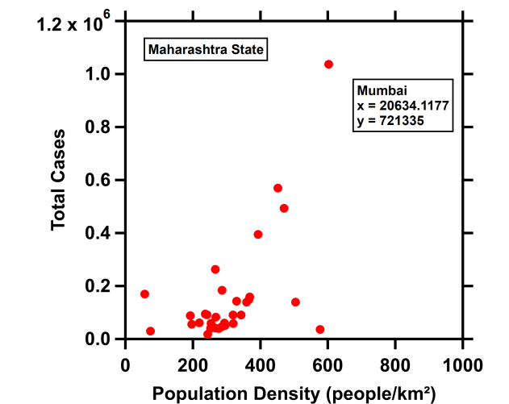
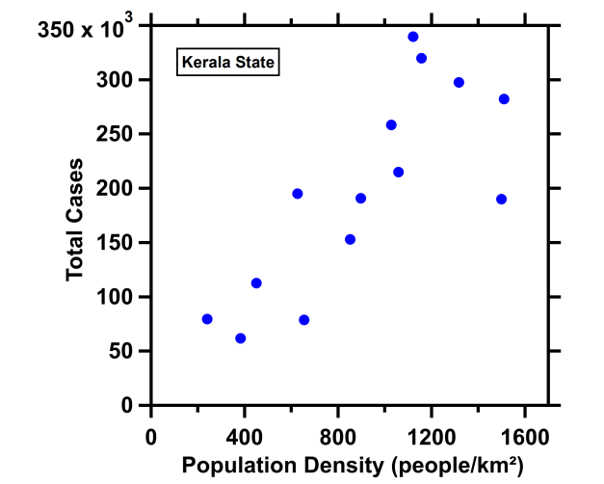
Figure S1 Scatter plots between district wise total COVID-19 cases and population density across Kerala (Left) and Maharashtra (Right). For Maharashtra; the data point corresponding to Mumbai is shown in the textbox.)

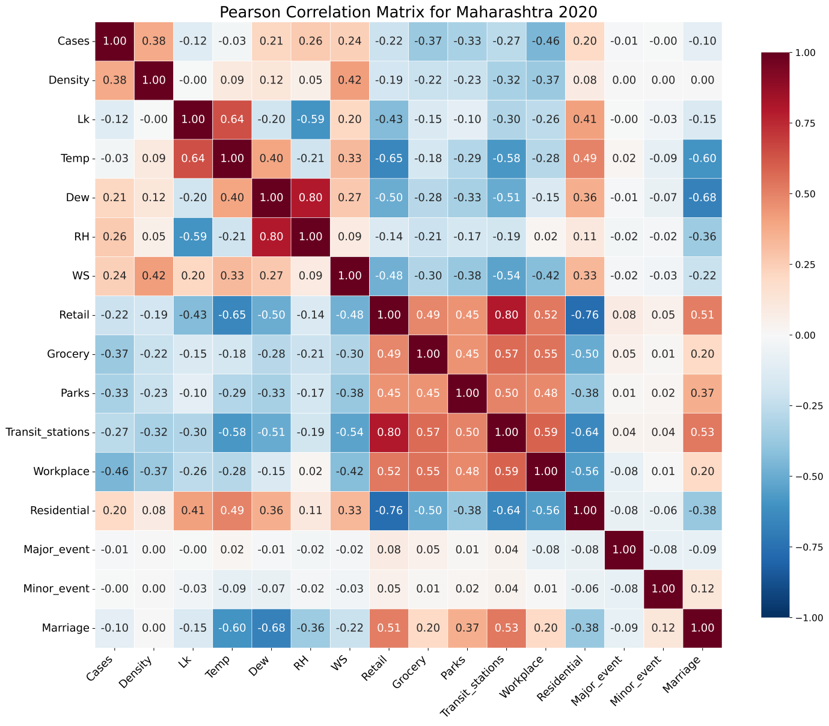
Figure S2 Pearson correlation matrix of the predictor variables and daily COVID-19 cases for the Maharashtra 2020 dataset. Vaccination variables (FDoseDaily and SDoseDaily) were excluded because vaccination had not yet commenced during the study period.

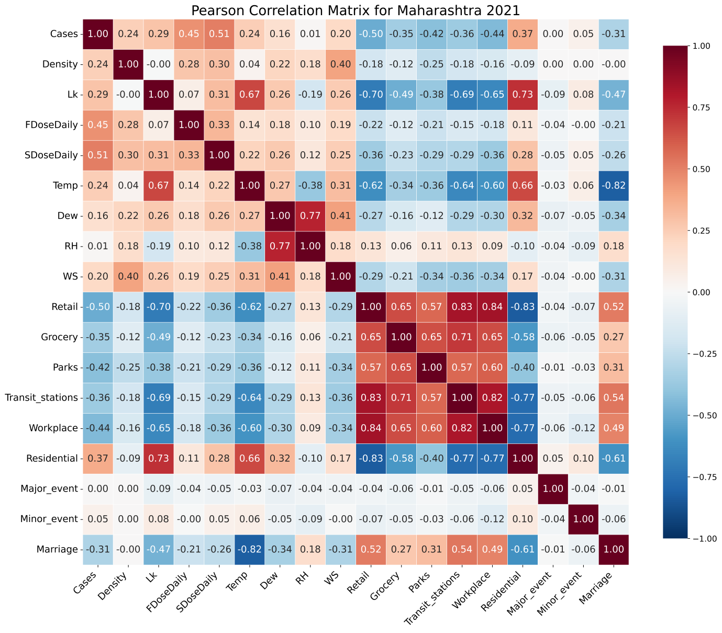
Figure S3 Pearson correlation matrix of the predictor variables and daily COVID-19 cases for the Maharashtra 2021 dataset.

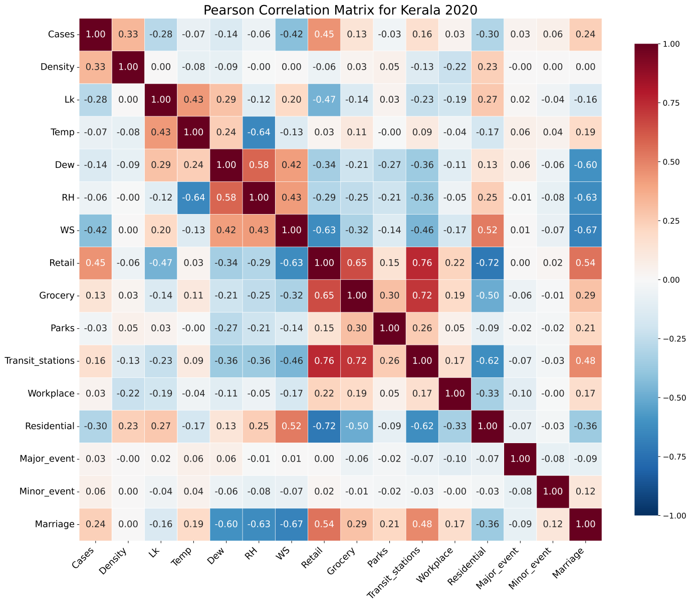
Figure S4 Pearson correlation matrix of the predictor variables and daily COVID-19 cases for the Kerala 2020 dataset. Vaccination variables (FDoseDaily and SDoseDaily) were excluded because vaccination had not yet commenced during the study period.

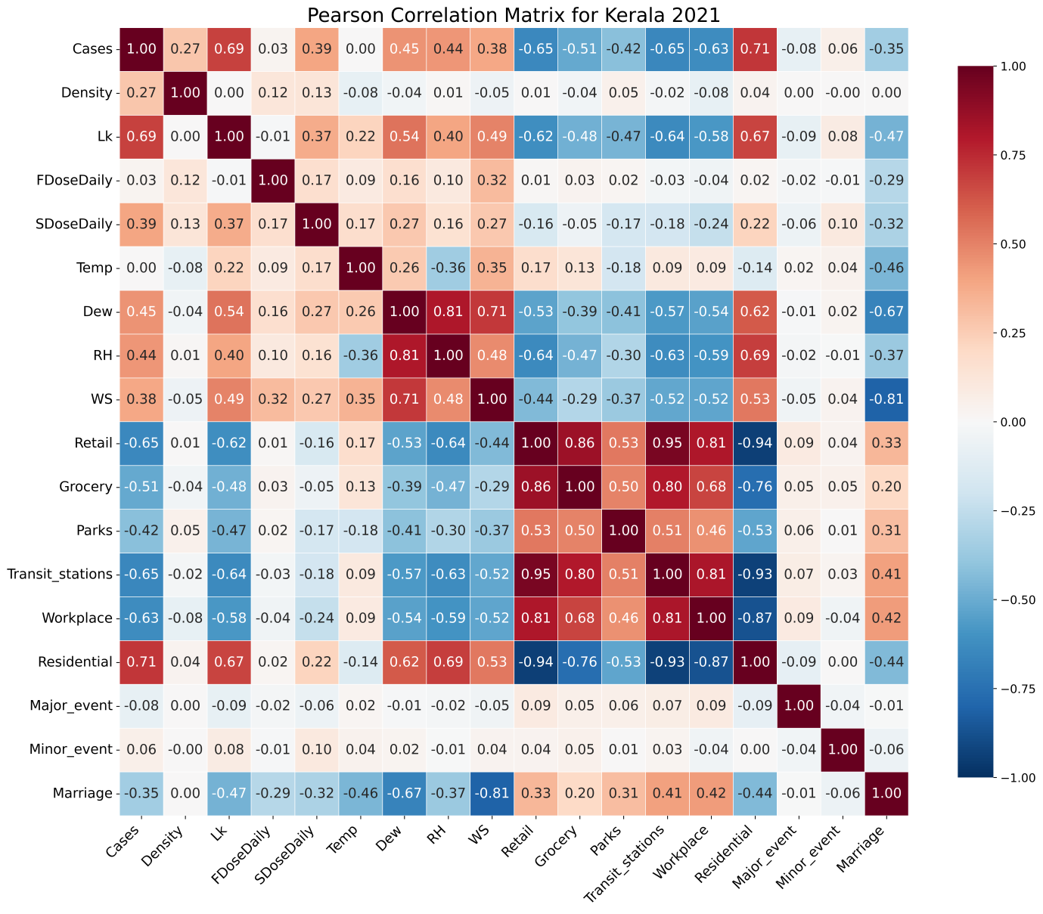
Figure S5 Pearson correlation matrix of the predictor variables and daily COVID-19 cases for the Kerala 2021 dataset.

Table S3. Descriptive statistics of the predictor variables and target variable for the Kerala 2020 dataset (N=3220)

Variable | Mean | Median | Standard Deviation | Minimum | Maximum
Cases | 228.22 | 119.0 | 270.14 | 0.00 | 1632.00
Density (people/km²) | 914.15 | 962.4 | 387.52 | 240.12 | 1510.87
First Dose (FDoseDaily) | 0.00 | 0.00 | 0.00 | 0.00 | 0.00
Second Dose (SDoseDaily) | 0.00 | 0.00 | 0.00 | 0.00 | 0.00
Temperature (℃) | 28.13 | 28.1 | 0.93 | 22.30 | 33.60
Dew point (℃) | 24.43 | 24.7 | 0.90 | 18.60 | 26.90
Relative Humidity (%) | 81.14 | 81.3 | 4.98 | 59.50 | 98.90
Wind Speed (m/s) | 4.09 | 4.4 | 1.77 | 0.00 | 15.60
Retail and  Recreation (%) | -48.49 | -48.0 | 16.90 | -92.00 | 7.00
Grocery and Pharmacy (%) | 7.63 | 8.0 | 23.24 | -75.00 | 86.00
Parks (%) | -10.74 | -9.0 | 32.71 | -83.00 | 68.00
Transit stations (%) | -29.88 | -30.0 | 12.13 | -71.00 | 28.00
Workplaces (%) | -18.84 | -19.0 | 12.43 | -72.00 | 33.00
Residential (%) | 18.21 | 18.0 | 5.41 | 3.00 | 37.00

Table S4. Descriptive statistics of the predictor variables and target variable for the Kerala 2021 dataset (N=2352)
Variable | Mean | Median | Standard Deviation | Minimum | Maximum
Cases | 855.87 | 425.0 | 1057.52 | 20.00 | 6558.00
Density (people/km²) | 914.15 | 962.4 | 387.55 | 240.12 | 1510.87
First Dose (FDoseDaily) | 4043.98 | 1567.0 | 9007.63 | 0.00 | 195317.00
Second Dose (SDoseDaily) | 1016.61 | 173.5 | 2104.31 | 0.00 | 22882.00
Temperature (℃) | 28.90 | 29.2 | 0.90 | 22.80 | 30.90
Dew point (℃) | 23.71 | 23.7 | 1.47 | 17.30 | 27.20
Relative Humidity (%) | 74.65 | 73.9 | 6.57 | 54.40 | 98.40
Wind Speed (m/s) | 3.44 | 3.4 | 1.69 | 0.00 | 10.80
Retail and  Recreation (%) | -32.43 | -24.0 | 24.06 | -88.00 | 13.00
Grocery and Pharmacy (%) | 20.48 | 26.0 | 33.44 | -76.00 | 131.00
Parks (%) | -7.33 | -7.0 | 29.74 | -81.00 | 74.00
Transit stations (%) | -27.39 | -20.0 | 21.88 | -80.00 | 19.00
Workplaces (%) | -20.27 | -13.0 | 20.93 | -78.00 | 17.00
Residential (%) | 17.72 | 13.0 | 10.98 | 1.00 | 49.00

Table S5. Descriptive statistics of the predictor variables and target variable for the Maharashtra 2020 dataset (N=7590)
Variable | Mean | Median | Standard Deviation | Minimum | Maximum
Cases | 239.00 | 60.0 | 491.80 | 0.00 | 7230.00
Density (people/km²) | 969.63 | 293.7 | 3487.15 | 57.04 | 20634.12
First Dose (FDoseDaily) | 0.00 | 0.00 | 0.00 | 0.00 | 0.00
Second Dose (SDoseDaily) | 0.00 | 0.00 | 0.00 | 0.00 | 0.00
Temperature (℃) | 27.02 | 27.2 | 3.20 | 14.20 | 39.30
Dew point (℃) | 20.41 | 22.3 | 4.58 | -1.20 | 27.30
Relative Humidity (%) | 71.22 | 74.0 | 14.41 | 10.60 | 99.50
Wind Speed (m/s) | 2.48 | 1.8 | 1.88 | 0.00 | 15.00
Retail and  Recreation (%) | -43.13 | -45.0 | 20.84 | -92.00 | 16.00
Grocery and Pharmacy (%) | 9.12 | 7.0 | 28.89 | -79.00 | 121.00
Parks (%) | -36.38 | -39.0 | 30.18 | -96.00 | 99.00
Transit stations (%) | -30.51 | -32.0 | 21.06 | -92.00 | 58.00
Workplaces (%) | -18.49 | -15.0 | 16.40 | -84.00 | 23.00
Residential (%) | 17.09 | 17.0 | 6.06 | 0.00 | 40.00

Table S6. Descriptive statistics of the predictor variables and target variable for the Maharashtra 2021 dataset (N=5544)
Variable | Mean | Median | Standard Deviation | Minimum | Maximum
Cases | 700.80 | 229.0 | 1420.83 | 0.00 | 12825.00
Density (people/km²) | 969.63 | 293.7 | 3487.24 | 57.04 | 20634.12
First Dose (FDoseDaily) | 3759.58 | 1152.5 | 11506.16 | 0.00 | 526000.00
Second Dose (SDoseDaily) | 937.16 | 205.0 | 2515.24 | 0.00 | 41742.00
Temperature (℃) | 28.17 | 28.6 | 3.79 | 17.20 | 37.80
Dew point (℃) | 14.43 | 13.2 | 4.77 | 0.90 | 27.20
Relative Humidity (%) | 48.76 | 46.1 | 13.94 | 15.60 | 95.60
Wind Speed (m/s) | 2.69 | 2.4 | 1.73 | 0.00 | 19.10
Retail and  Recreation (%) | -34.87 | -30.0 | 20.24 | -87.00 | 24.00
Grocery and Pharmacy (%) | 10.24 | 11.0 | 31.01 | -76.00 | 113.00
Parks (%) | -21.45 | -25.0 | 25.45 | -87.00 | 113.00
Transit stations (%) | -22.97 | -21.0 | 22.89 | -77.00 | 57.00
Workplaces (%) | -22.17 | -20.0 | 17.25 | -82.00 | 19.00
Residential (%) | 18.10 | 16.0 | 8.30 | 1.00 | 46.00

References
1. Pollett S, Johansson MA, Reich NG, Brett-Major D, Valle SYD, Venkatramanan S, et al. Recommended reporting items for epidemic forecasting and prediction research: The EPIFORGE 2020 guidelines. PLOS Med. 2021;18:e1003793. https://doi.org/10.1371/journal.pmed.1003793.
2. Census Maharashtra. List of districts of Maharashtra. 2011. https://www.census2011.co.in/census/state/districtlist/maharashtra.html. Accessed 31 Mar 2026.
3. Census Kerala. List of districts of Kerala. 2011. https://www.census2011.co.in/census/state/districtlist/kerala.html. Accessed 31 Mar 2026.

