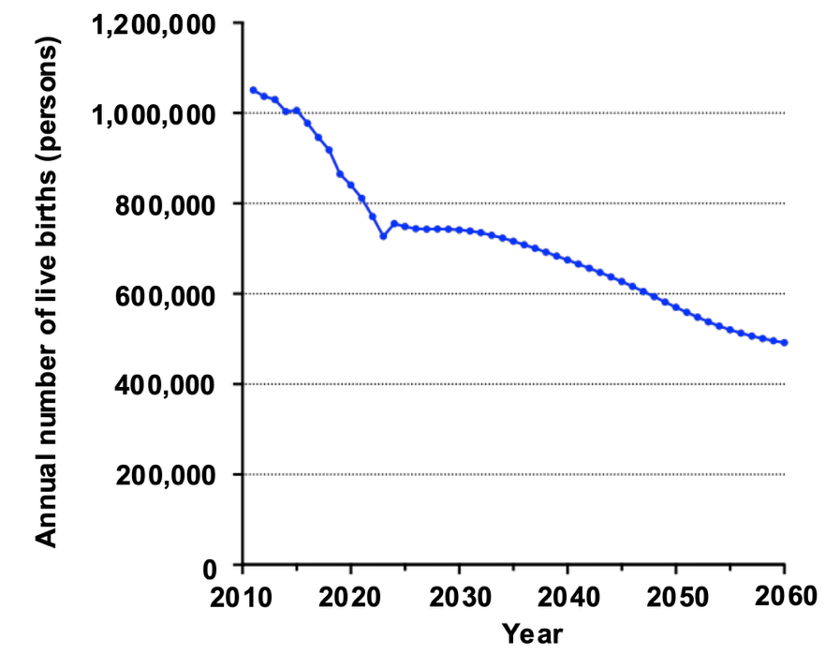
Supplementary Figure 1. Annual numbers of live births used in the projection model
Annual numbers of live births in Japan from 2011 to 2060 used to estimate new HTLV-1 infections through MTCT. Observed annual numbers of live births through 2023 were obtained from national vital statistics, whereas projected numbers for 2024–2060 were based on the medium-fertility and medium-mortality population projections published by the National Institute of Population and Social Security Research.

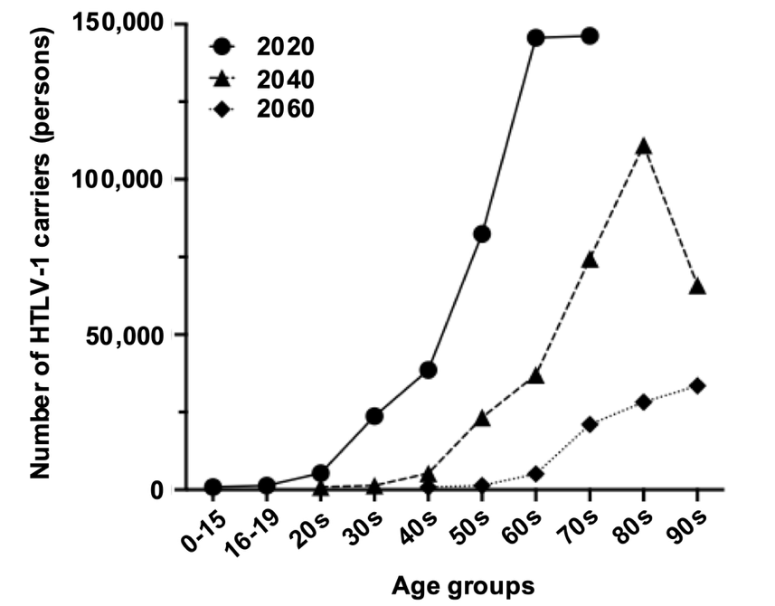
Supplementary Figure 2. Projected age distribution of surviving HTLV-1 carriers from the 2020 baseline population
Age-specific distributions of surviving HTLV-1 carriers projected from the 2020 baseline carrier population are shown for 2020, 2040, and 2060. Age-specific mortality was applied annually to the baseline carrier population to estimate the number of surviving carriers over time.

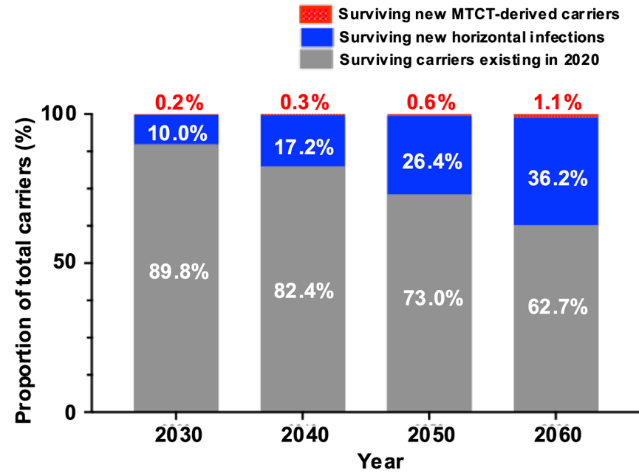
Supplementary Figure 3. Projected composition of the HTLV-1 carrier population through 2060
The projected proportions of surviving carriers originating from the 2020 baseline population, newly generated horizontal infections, and newly generated MTCT-derived infections are shown for 2030, 2040, 2050, and 2060. Age-specific survival probabilities were applied to each carrier population through the corresponding projection year. The proportion of surviving horizontally infected carriers increased from 10.0% in 2030 to 36.2% in 2060, whereas the proportion originating from the 2020 baseline population decreased from 89.8% to 62.7%. Surviving MTCT-derived carriers accounted for 0.2% and 1.1% of the total carrier population in 2030 and 2060, respectively.

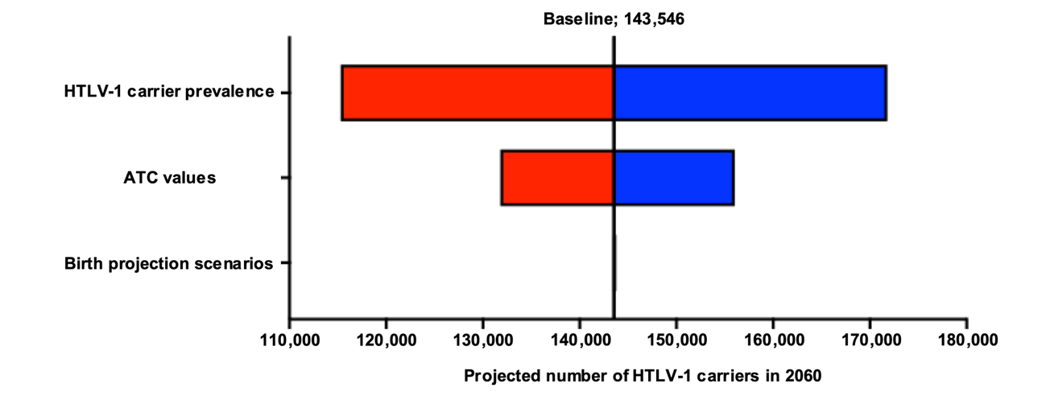
Supplementary Figure 4. One-way sensitivity analysis of the projected HTLV-1 carrier population in 2060
Horizontal bars indicate the ranges of projected HTLV-1 carrier numbers obtained by varying baseline carrier prevalence and age-specific horizontal transmission coefficient values by ±20% and by applying alternative future birth projection scenarios. The dashed vertical line indicates the baseline estimate of 143,546 carriers. Baseline carrier prevalence had the greatest influence on the projected carrier population, followed by ATC values, whereas future birth projections had the smallest impact.

