Additional Vignettes and Associated Images Used in the Survey:

- 35 year-old man presenting with acute shortness of breath and pleuritic chest pain
Courtesy of Prof Frank Gaillard, Radiopaedia.org, rID: 15374
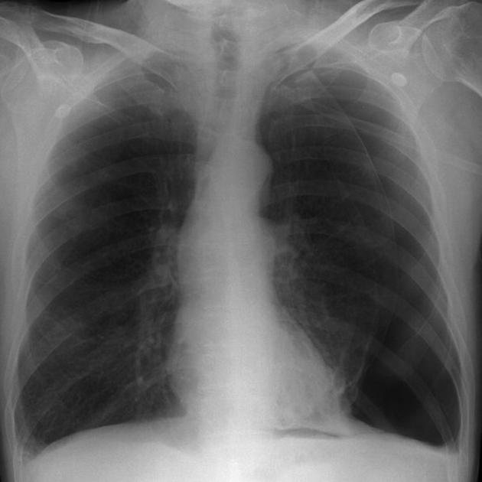

Diagnosis: Pneumothorax

- 75 year-old man with end-stage renal disease but no prior heart disease presenting with gradual onset dyspnea
Available at: http://chestatlas.com/gallery/Pericardium/008PericeffuslargePA
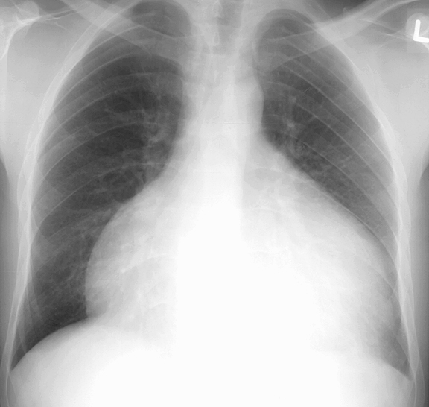

Diagnosis: Pericardial effusion

- 26 year-old woman presenting with a 1-week history of intermittent minor hemoptysis
Courtesy of Dr. Ian Bickle, Radiopaedia.org, rID: 30197
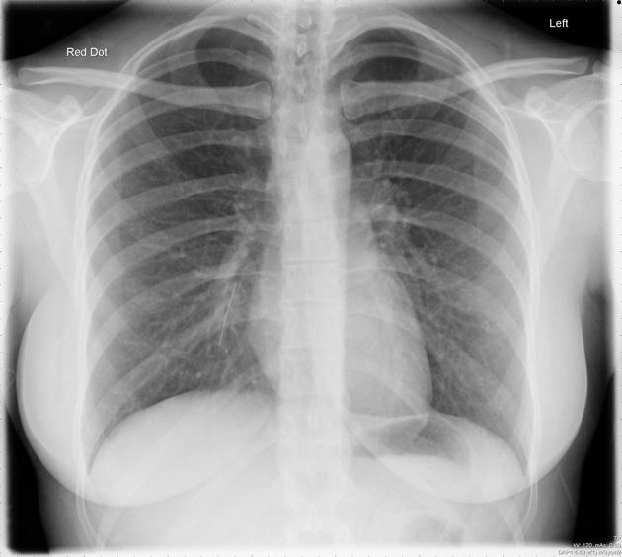
Diagnosis: Foreign body aspiration

- 42 year-old man with acute abdominal pain one month after motor vehicle accident
Available at: http://chestatlas.com/gallery/Rupt-HD/Case_9a
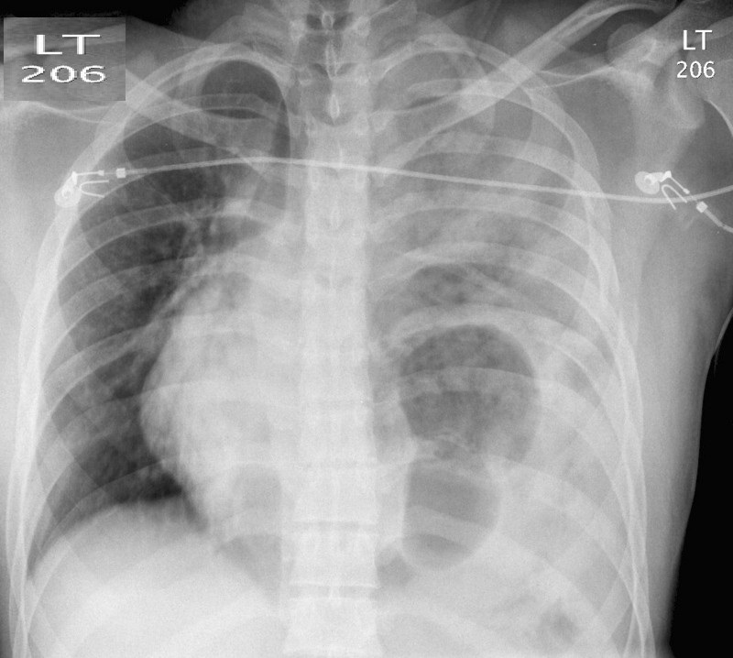
Diagnosis: Diaphragmatic herniation

- 68 year-old man with a history of hypertension found hypotensive and unconscious in nursing home
Courtesy of Dr. Hanisalam, Radiopaedia.org, rID: 9279
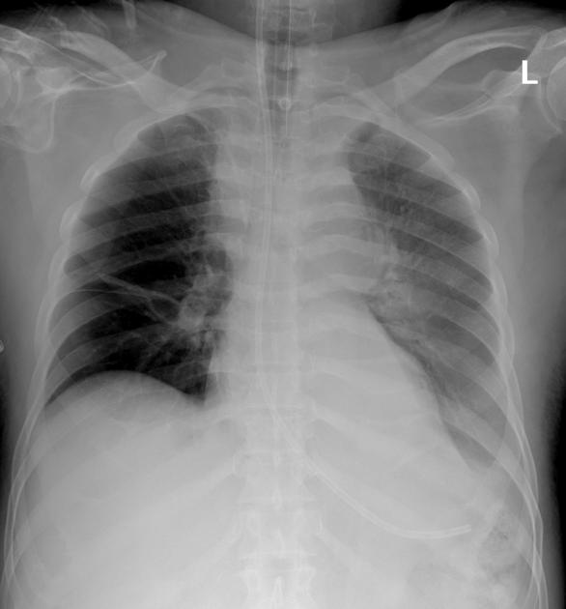
Diagnosis: Aortic dissection

- 66 year-old man with severe dyspnea and hypoxemia 1 week after acute severe pancreatitis
Patil, V. Complicated falciparum Malaria in western Maharashtra, Trop Parasitol. , 2(1), pp. 49-54. Available at: http://www.ncbi.nlm.nih.gov/pmc/articles/PMC3593511/figure/F1/
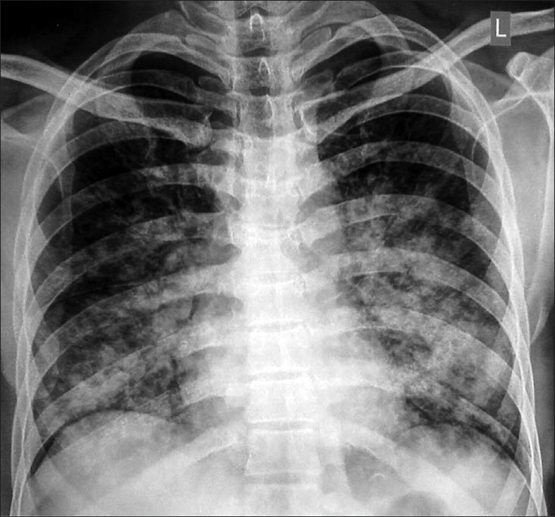
Diagnosis: Acute respiratory distress syndrome (ARDS)

- 42 year-old man presenting with acute lower chest and epigastric pain
Image available at: http://radiologymasterclass.co.uk/tutorials/chest/chest_pathology/chest_pathology_page7.html
Diagnosis: Pneumoperitoneum

