Additional File 1

Description: This file contains all manually created errors that are introduced to the ground truth segmentation of an example patient. Please refer to Table 1 in the publication for an overview of all errors.
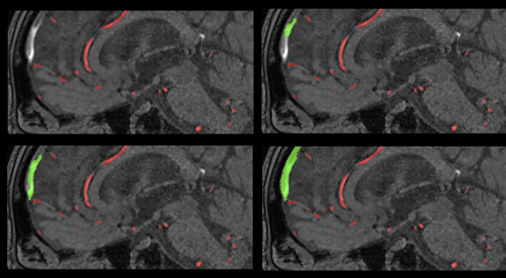
Error 1: Sinus Sagittalis Superior (SSS) error
Gradually increasing number of false positive voxels within the SSS were introduced to the ground truth. Sagittal view. Top left: Ground truth, Top right: subtle SSS error, Bottom left: moderate SSS error, Bottom right: severe SSS error. Red: True positive voxels, Green: False positive voxels.

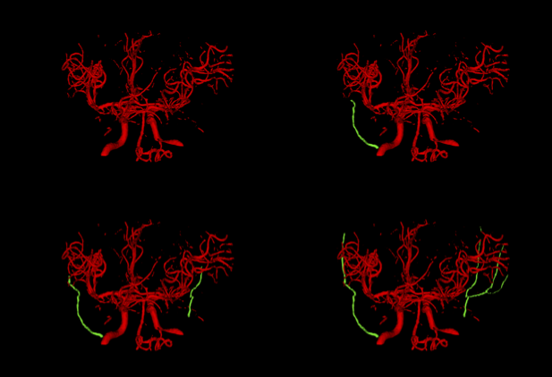
Error 2: Middle meningeal artery (MMA) error
Top left: Ground truth, Top right: subtle MMA error, Bottom left: moderate MMA error, Bottom right: severe MMA error. Red: True positive voxels, Green: False positive voxels

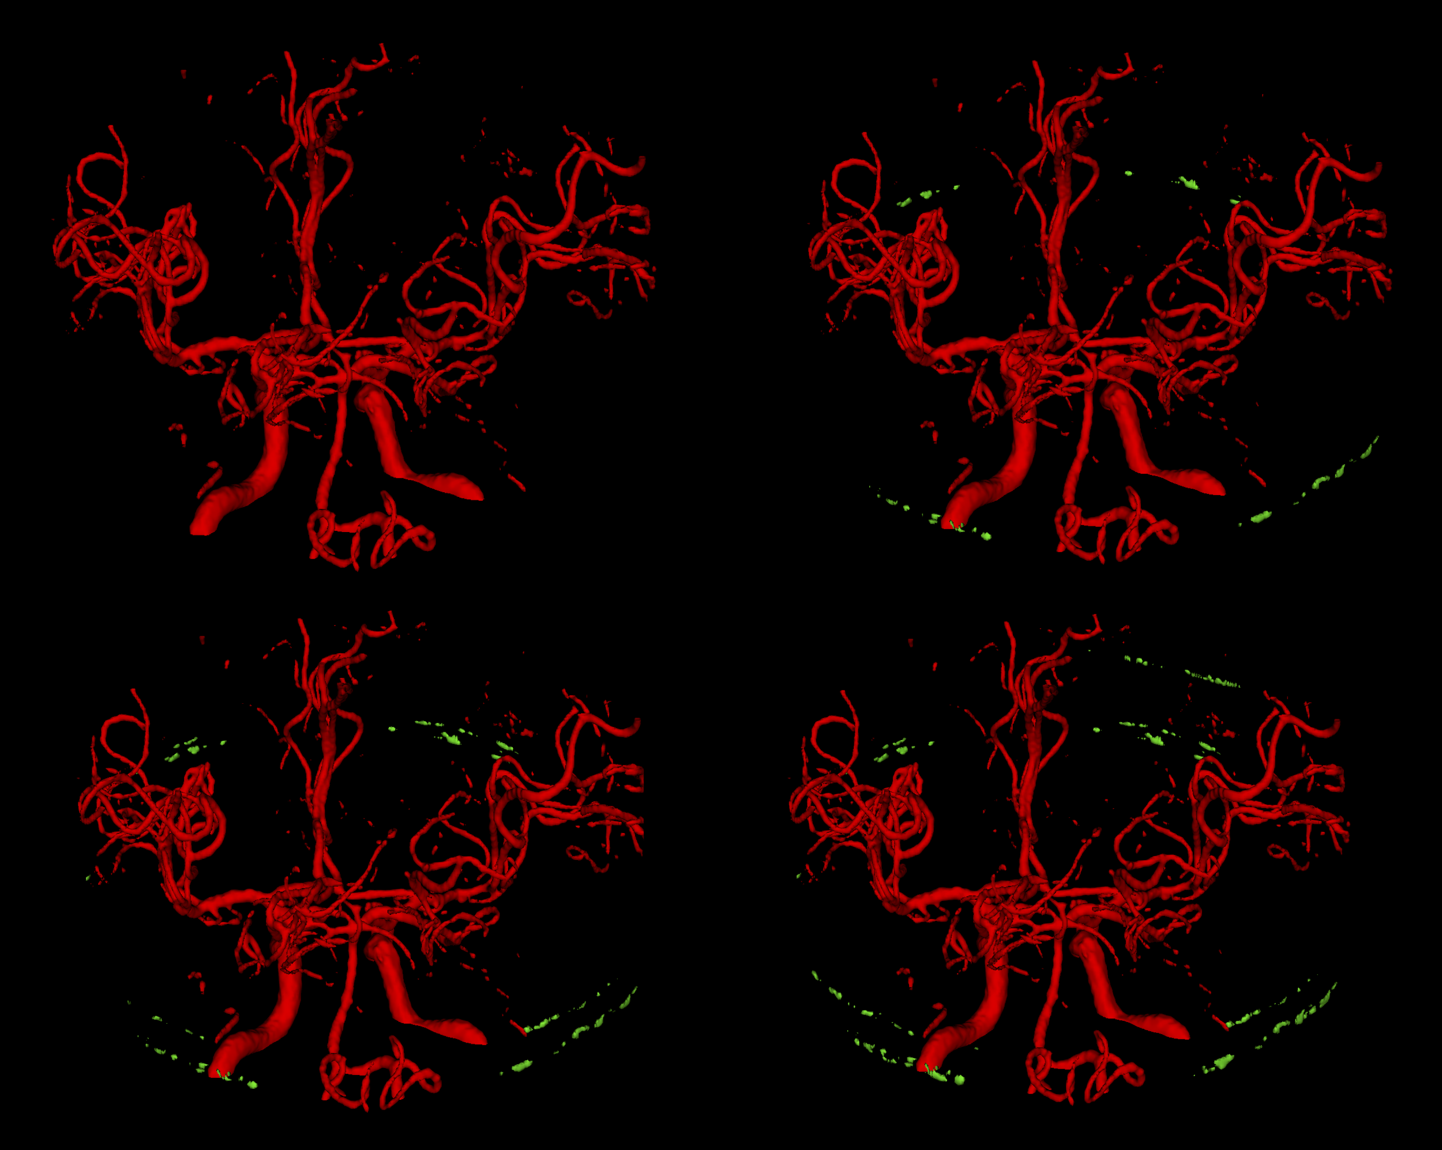
Error 3: Hyperintense meninges error
Top left: Ground truth, Top right: subtle hyperintense meninges error, Bottom left: moderate hyperintense meninges error, Bottom right: severe hyperintense meninges error. Red: True positive voxels, Green: False positive voxels
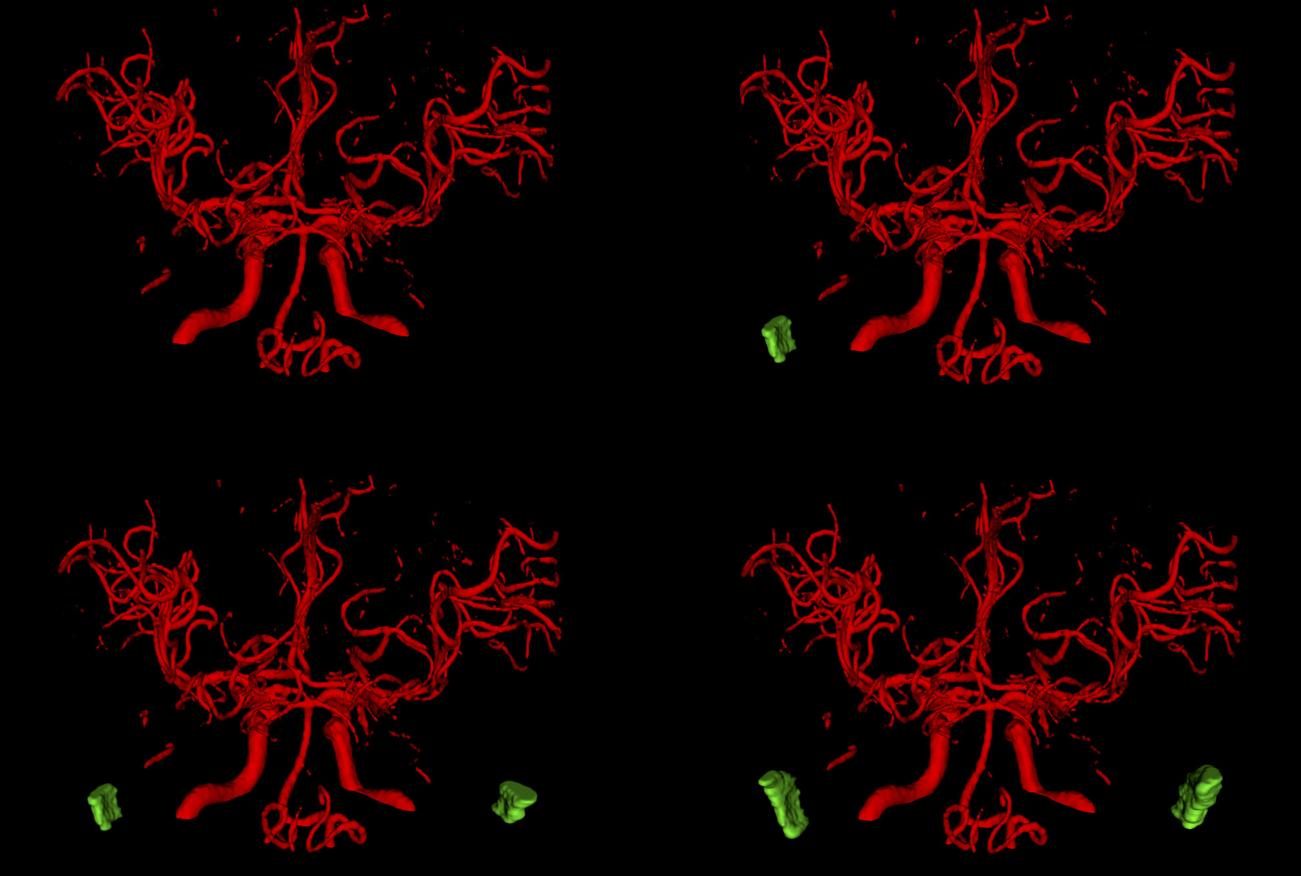
Error 4: Sigmoid sinus error
Top left: Ground truth, Top right: subtle sigmoid sinus error, Bottom left: moderate sigmoid sinus error, Bottom right: severe sigmoid sinus error. Red: True positive voxels, Green: False positive voxels
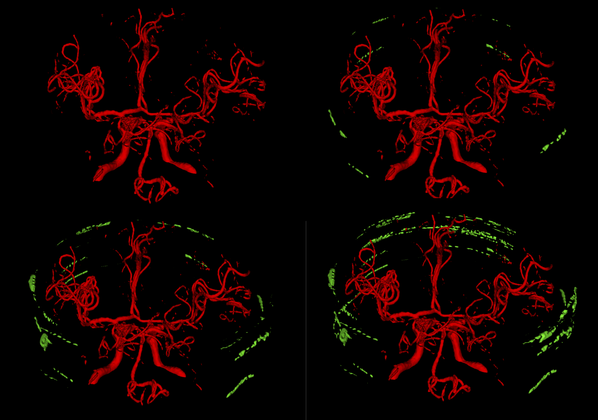
Error 5: Skull error
Top left: Ground truth, Top right: subtle skull error, Bottom left: moderate skull error, Bottom right: severe skull error. Red: True positive voxels, Green: False positive voxels
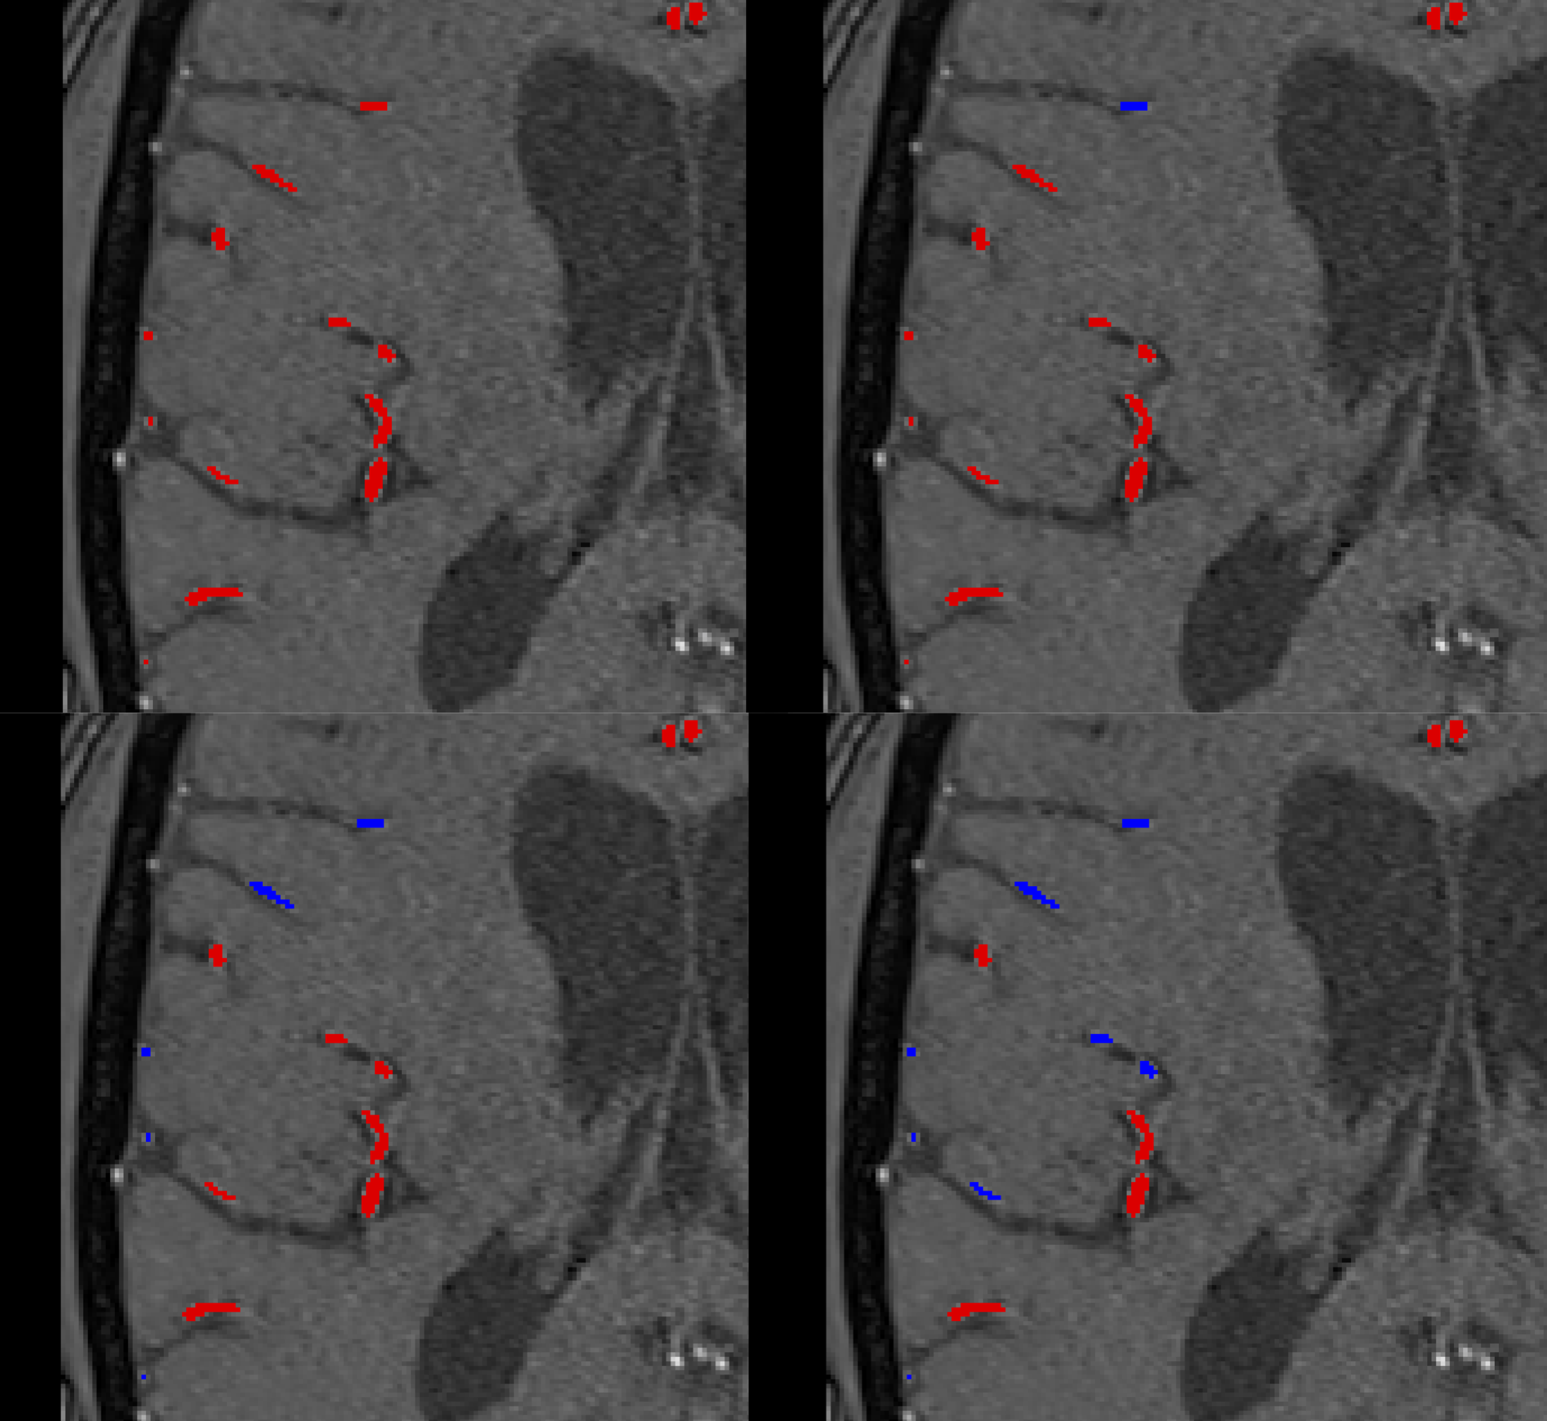
Error 6: Small vessel error
Top left: Ground truth, Top right: subtle small vessel error, Bottom left: moderate small vessel error, Bottom right: severe small vessel error. Red: True positive voxels, Blue: False negative voxels

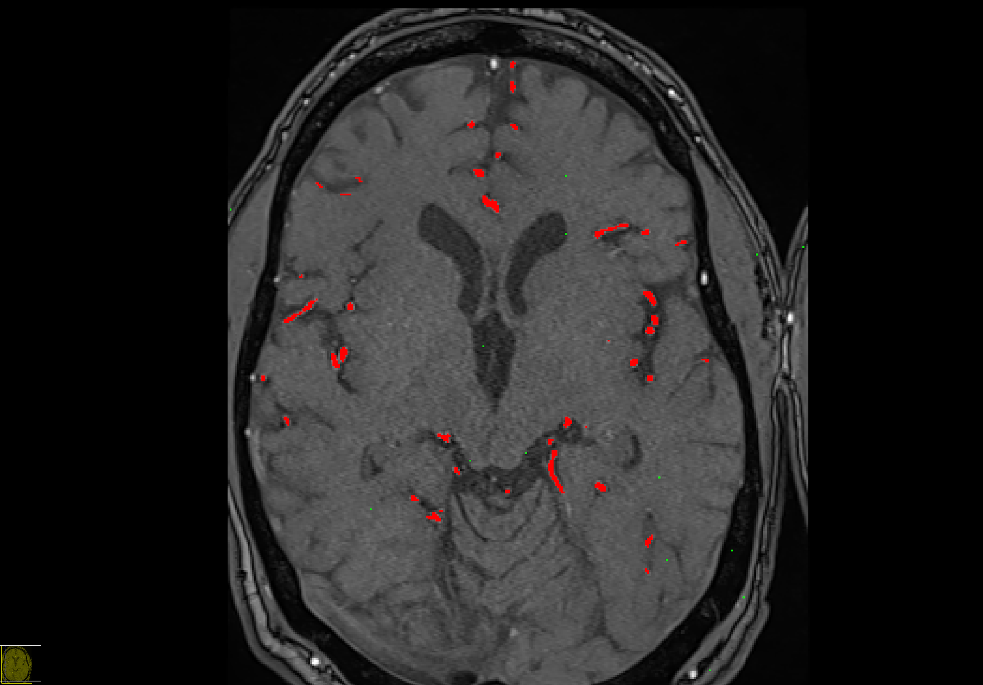
Error 7: Random voxel error
Random voxel error selects voxels (Subtle: 1%, Moderate: 2%, Severe: 3% of all ground truth voxels) from the original TOF MRA and adds them randomly scattered to the ground truth image. Red: True positive voxels, Green: False positive voxels

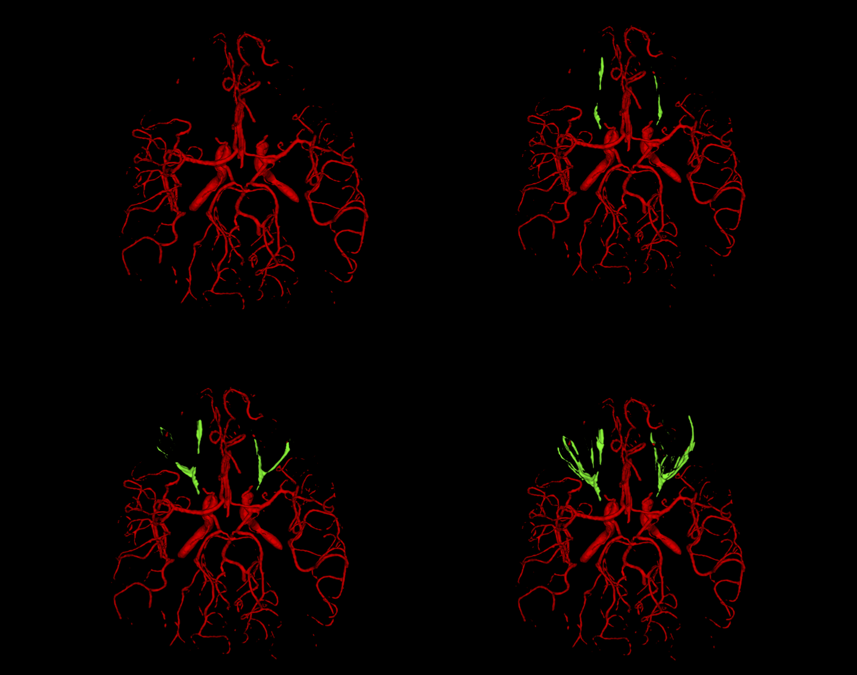
Error 8: Orbit error
Top left: Ground truth, Top right: subtle orbit error, Bottom left: moderate orbit error, Bottom right: severe orbit error. Red: True positive voxels, Green: False positive voxels

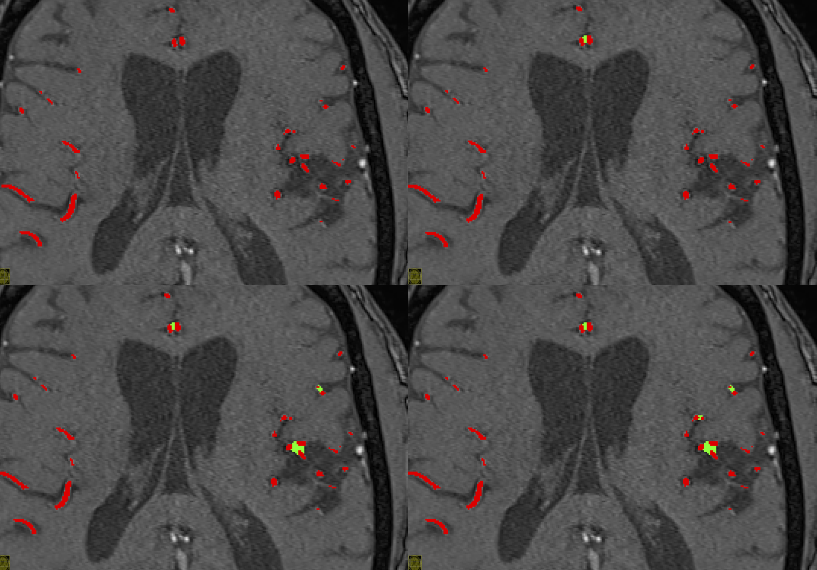
Error 9: Merge/Separation Error
Vessels in close proximity to each other were merged by adding false positive voxels near A2 segments or M3-M4 segments. Top left: Ground truth, Top right: subtle merge error, Bottom left: moderate merge error, Bottom right: severe merge error. Red: True positive voxels, Green: False positive voxels
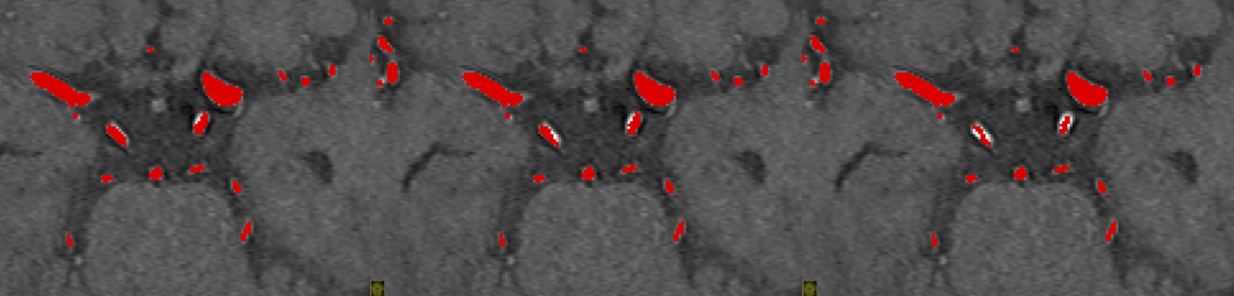
Error 10: Pcom under-segmentation
Left: Pcom under-segmentation subtle error, Middle: Pcom under-segmentation moderate error, Right: Pcom under-segmentation severe error, Red: True positive voxels
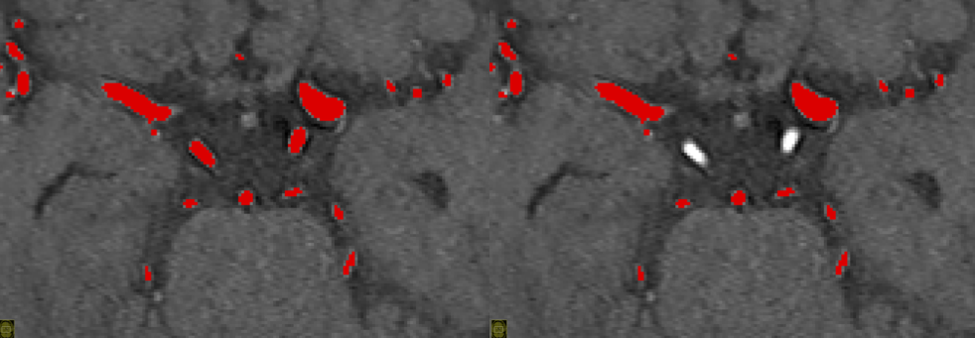
Error 11: Pcom missing
Left: Ground truth, Right: Pcom segment omitted. Red: True positive voxels
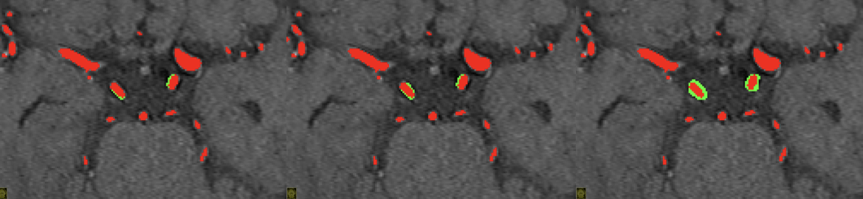Error 12: Pcom over-segmentation
Left: Pcom over-segmentation subtle error, Middle: Pcom over-segmentation moderate error, Right: Pcom over-segmentation severe error. Red: True positive voxels, Green: False positive voxels
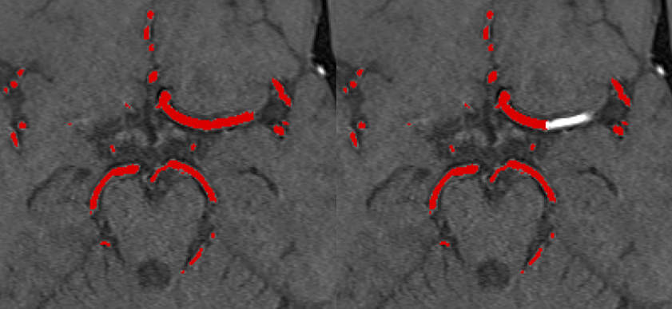
Error 13: M1 missing
Left: Ground truth, Right: M1 segment is omitted bilaterally (not shown in this image).
Red: True positive voxels
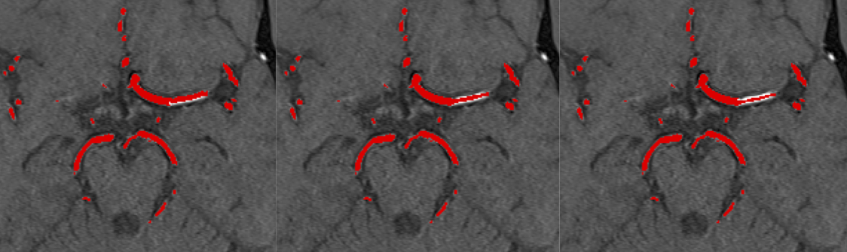
Error 14: M1 under-segmentation
Left: M1 under-segmentation subtle error, Middle: M1 under-segmentation moderate error, Right: M1 under-segmentation severe error. Red: True positive voxels
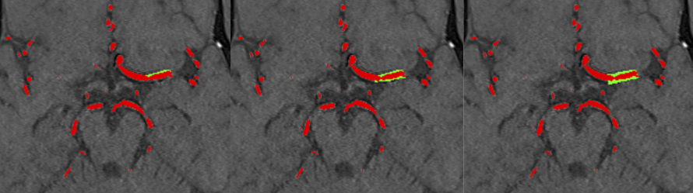
Error 15: M1 over segmentation
Left: M1 over-segmentation subtle error, Middle: M1 over-segmentation moderate error, Right: M1 over-segmentation severe error. Red: True positive voxels, Green: False positive voxels
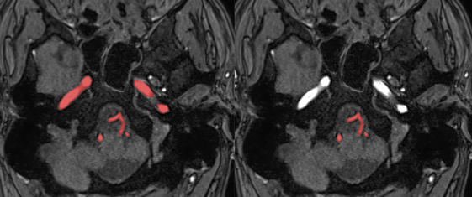
Error 16: Internal carotid artery(ICA) missing error
Left: Ground truth, Right: ICA is omitted bilaterally. Red: True positive voxels,
ICA under-segmentation
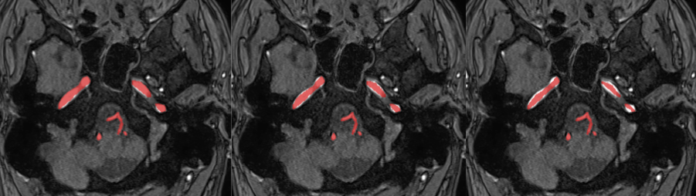
Error 17: Internal carotid artery (ICA) under-segmentation
Left: ICA under-segmentation subtle error, Middle: ICA under-segmentation moderate error, Right: ICA under-segmentation severe error. Red: True positive voxels

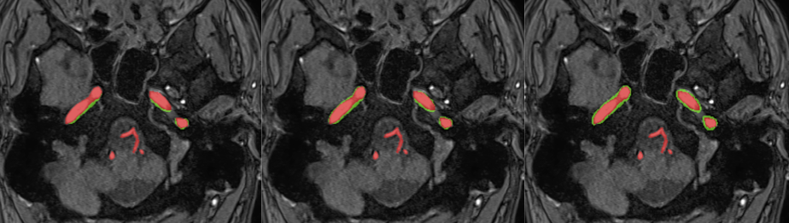
Error 18: Internal carotid artery (ICA) over-segmentation
Left: ICA over-segmentation subtle error, Middle: ICA over-segmentation moderate error, Right: ICA over-segmentation severe error. Red: True positive voxels Green: False positive voxels

