Additional File 10: Pre-processing method for public datasets testing and training results

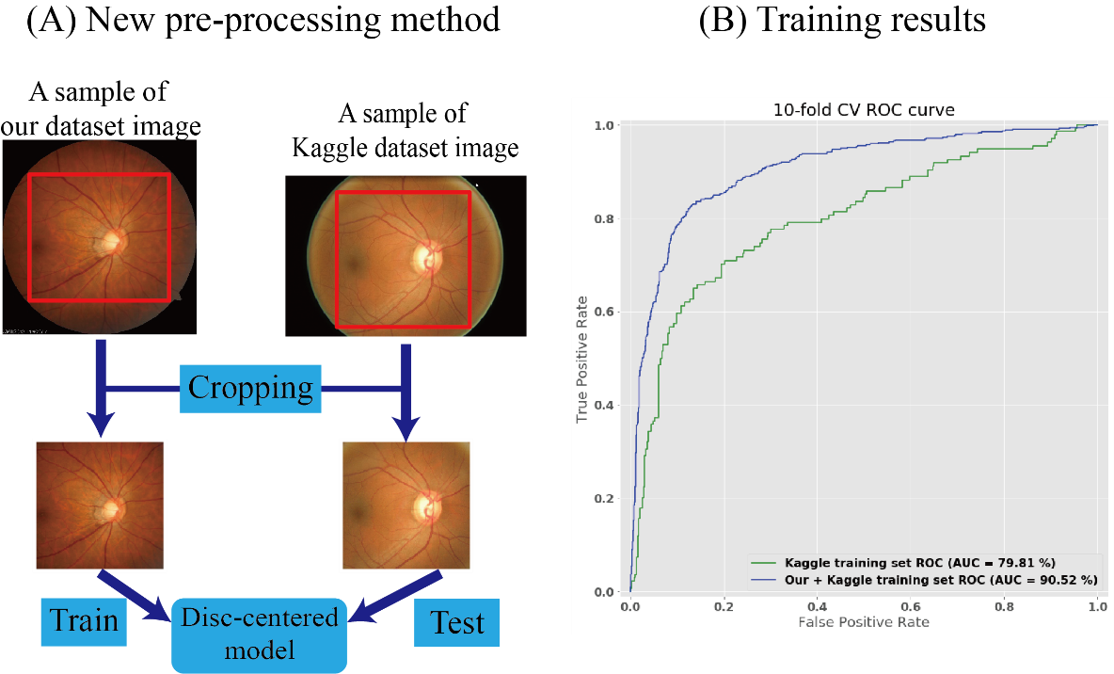

Additional File Table 7. The 10-fold cross validation results of Kaggle public datasets
Metrics (%) | Our dataset + Kaggle (Adapted model) | Kaggle only model
AUROCª, % | 90.52 | 79.81
Accuracy, % | 84.01 | 73.65
Precision, % | 74.61 | 49.25
Recall, % | 83.95 | 73.88
ªAUROC: area under receiver operating characteristic curve,

