Supplementary materials

Materials and methods
The radiomics features of PCAT

Table S1. List of radiomic features
Classification | Features (n=95)
 | Mesh Volume/mm3, fat attenuation index (FAI)
First Order Statistics | Energy, total energy, entropy, minimum, 10th percentile, 90th percentile, maximum, mean, median, interquartile range, range, Mean Absolute Deviation (MAD) , rMAD, Root mean squared, skewness, kurtosis, variance, uniformity
Gray Level Co-occurrence Matrix (GLCM) | Autocorrelation, joint average, cluster prominence, cluster tendency, cluster shade, contrast1, correlation, difference average, difference entropy, difference variance, joint energy, joint entropy, informational measure of correlation 1, informational measure of correlation 2, inverse difference moment, inverse difference moment normalized, inverse difference, inverse difference normalized, MCC, inverse variance, maximum probability, sum average, sum entropy, sum of squares
Gray Level Size Zone Matrix (GLSZM) | Small area emphasis, large area emphasis, gray level non-uniformity, gray level non-uniformity normalized, size zone non-uniformity, size zone non-uniformity normalized, zone percentage, gray level variance, zone variance, zone entropy, low gray level zone emphasis, high gray level zone emphasis, small area low gray level emphasis, small area high gray level emphasis, large area low gray level emphasis, large area high gray level emphasis
Gray Level Run Length Matrix (GLRLM) | Short run emphasis, Long run emphasis, gray level non-uniformity, gray level non-uniformity normalized, run length non-uniformity, run length non-uniformity normalized, run percentage, gray level variance, run variance, run entropy, low gray level run emphasis, high gray level run emphasis, short run low gray level emphasis, short run high gray level emphasis, long run low gray level emphasis, long run high gray level run emphasis
Neigbouring Gray Tone Difference Matrix (NGTDM) | Coarseness, contrast2, busyness, complexity, strength
Gray Level Dependence Matrix (GLDM) | Small dependence emphasis, Large dependence emphasis, gray level non-uniformity, dependence non-uniformity, dependence non-uniformity normalized, gray level variance, dependence variance, dependence entropy, low gray level emphasis, high gray level emphasis, small dependence low gray level emphasis, small dependence high gray level emphasis, large dependence low gray level emphasis, large dependence high gray level emphasis

Results
After the LASSO analysis, 15, 9, 7, and 15 features remained for RCA, LAD, LCX, and PCAT respectively (Figure.1).

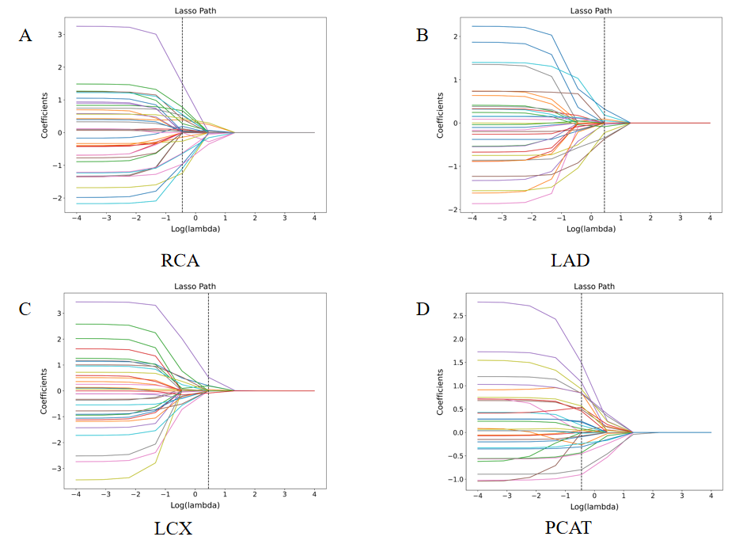

Table S2. The performance metrics of the different modeling techniques.

The performance of RCA-model in different machine learning algorithms.
ML algorithm | Accuracy |  |  | AUC (95%CI) |  |  | Sensitivity |  |  | Specificity |  |  | PPV |  |  | NPV
ML algorithm | Train | Test |  | Train | Test |  | Train | Test |  | Train | Test |  | Train | Test |  | Train | Test
LR | 0.671 | 0.649 |  | 0.708 (0.641, 0.775) | 0.666 (0.518, 0.813) |  | 0.531 | 0.500 |  | 0.813 | 0.793 |  | 0.741 | 0.700 |  | 0.632 | 0.622
SVM | 0.662 | 0.684 |  | 0.706 (0.638, 0.773) | 0.675 (0.531, 0.820) |  | 0.584 | 0.571 |  | 0.741 | 0.793 |  | 0.695 | 0.727 |  | 0.639 | 0.657
SGD | 0.671 | 0.667 |  | 0.699 (0.631, 0.767) | 0.669 (0.521, 0.817) |  | 0.637 | 0.500 |  | 0.705 | 0.828 |  | 0.686 | 0.737 |  | 0.658 | 0.632
LinearSVC | 0.684 | 0.649 |  | 0.705 (0.638, 0.773) | 0.674 (0.529, 0.819) |  | 0.655 | 0.571 |  | 0.714 | 0.724 |  | 0.698 | 0.667 |  | 0.672 | 0.636

The performance of LAD-model in different machine learning algorithms.
ML algorithm | Accuracy |  |  | AUC (95%CI) |  |  | Sensitivity |  |  | Specificity |  |  | PPV |  |  | NPV
ML algorithm | Train | Test |  | Train | Test |  | Train | Test |  | Train | Test |  | Train | Test |  | Train | Test
LR | 0.636 | 0.579 |  | 0.674 (0.604, 0.743) | 0.638 (0.489, 0.787) |  | 0.699 | 0.750 |  | 0.571 | 0.414 |  | 0.622 | 0.553 |  | 0.653 | 0.632
SVM | 0.662 | 0.649 |  | 0.679 (0.609, 0.748) | 0.664 (0.517, 0.811) |  | 0.699 | 0.785 |  | 0.625 | 0.517 |  | 0.653 | 0.611 |  | 0.673 | 0.714
SGD | 0.640 | 0.632 |  | 0.659 (0.588, 0.730) | 0.680 (0.539, 0.821) |  | 0.566 | 0.571 |  | 0.714 | 0.689 |  | 0.667 | 0.640 |  | 0.620 | 0.625
LinearSVC | 0.662 | 0.632 |  | 0.677 (0.607, 0.747) | 0.660 (0.514, 0.807) |  | 0.681 | 0.750 |  | 0.643 | 0.517 |  | 0.658 | 0.600 |  | 0.667 | 0.682

The performance of LCX-model in different machine learning algorithms.
ML algorithm | Accuracy |  |  | AUC (95%CI) |  |  | Sensitivity |  |  | Specificity |  |  | PPV |  |  | NPV
ML algorithm | Train | Test |  | Train | Test |  | Train | Test |  | Train | Test |  | Train | Test |  | Train | Test
LR | 0.640 | 0.561 |  | 0.649 (0.577, 0.720) | 0.613 (0.465, 0.762) |  | 0.620 | 0.571 |  | 0.661 | 0.552 |  | 0.648 | 0.552 |  | 0.633 | 0.571
SVM | 0.636 | 0.614 |  | 0.651 (0.580, 0.723) | 0.623 (0.474, 0.773) |  | 0.664 | 0.643 |  | 0.607 | 0.586 |  | 0.630 | 0.600 |  | 0.642 | 0.630
SGD | 0.618 | 0.632 |  | 0.637 (0.565, 0.709) | 0.589 (0.435, 0.742) |  | 0.593 | 0.571 |  | 0.643 | 0.690 |  | 0.626 | 0.640 |  | 0.610 | 0.625
LinearSVC | 0.631 | 0.597 |  | 0.656 (0.585, 0.727) | 0.622 (0.473, 0.771) |  | 0.779 | 0.750 |  | 0.482 | 0.448 |  | 0.603 | 0.568 |  | 0.684 | 0.650

The performance of PCAT-model in different machine learning algorithms.
ML algorithm | Accuracy |  |  | AUC (95%CI) |  |  | Sensitivity |  |  | Specificity |  |  | PPV |  |  | NPV
ML algorithm | Train | Test |  | Train | Test |  | Train | Test |  | Train | Test |  | Train | Test |  | Train | Test
LR | 0.729 | 0.632 |  | 0.775 (0.715, 0.834) | 0.703 (0.564, 0.843) |  | 0.885 | 0.786 |  | 0.571 | 0.483 |  | 0.676 | 0.595 |  | 0.831 | 0.700
SVM | 0.702 | 0.649 |  | 0.764 (0.703, 0.825) | 0.723 (0.589, 0.857) |  | 0.797 | 0.714 |  | 0.607 | 0.586 |  | 0.672 | 0.625 |  | 0.747 | 0.680
SGD | 0.707 | 0.614 |  | 0.767 (0.706, 0.828) | 0.692 (0.551, 0.833) |  | 0.920 | 0.821 |  | 0.491 | 0.414 |  | 0.646 | 0.575 |  | 0.859 | 0.706
LinearSVC | 0.729 | 0.632 |  | 0.775 (0.716, 0.835) | 0.707 (0.568, 0.846) |  | 0.876 | 0.786 |  | 0.580 | 0.483 |  | 0.678 | 0.595 |  | 0.823 | 0.700

The performance of Cli-model in different machine learning algorithms.
ML algorithm | Accuracy |  |  | AUC (95%CI) |  |  | Sensitivity |  |  | Specificity |  |  | PPV |  |  | NPV
ML algorithm | Train | Test |  | Train | Test |  | Train | Test |  | Train | Test |  | Train | Test |  | Train | Test
LR | 0.702 | 0.684 |  | 0.726 (0.660, 0.792) | 0.683 (0.535, 0.832) |  | 0.522 | 0.500 |  | 0.884 | 0.862 |  | 0.819 | 0.778 |  | 0.647 | 0.641
SVM | 0.702 | 0.667 |  | 0.752 (0.689, 0.815) | 0.706 (0.564, 0.847) |  | 0.460 | 0.464 |  | 0.946 | 0.862 |  | 0.897 | 0.765 |  | 0.635 | 0.625
SGD | 0.702 | 0.719 |  | 0.726 (0.660, 0.792) | 0.692 (0.546, 0.838) |  | 0.496 | 0.500 |  | 0.911 | 0.931 |  | 0.849 | 0.875 |  | 0.642 | 0.659
LinearSVC | 0.707 | 0.684 |  | 0.725 (0.659, 0.791) | 0.685 (0.538, 0.832) |  | 0.522 | 0.500 |  | 0.893 | 0.862 |  | 0.831 | 0.778 |  | 0.649 | 0.641

The performance of Overall-model in different machine learning algorithms.
ML algorithm | Accuracy |  |  | AUC (95%CI) |  |  | Sensitivity |  |  | Specificity |  |  | PPV |  |  | NPV
ML algorithm | Train | Test |  | Train | Test |  | Train | Test |  | Train | Test |  | Train | Test |  | Train | Test
LR | 0.756 | 0.702 |  | 0.827 (0.774, 0.879) | 0.791 (0.671, 0.911) |  | 0.779 | 0.607 |  | 0.732 | 0.793 |  | 0.746 | 0.739 |  | 0.766 | 0.677
SVM | 0.760 | 0.719 |  | 0.828 (0.776, 0.881) | 0.797 (0.679, 0.915) |  | 0.770 | 0.643 |  | 0.750 | 0.793 |  | 0.757 | 0.750 |  | 0.764 | 0.697
SGD | 0.760 | 0.719 |  | 0.828 (0.776, 0.881) | 0.799 (0.682, 0.916) |  | 0.779 | 0.679 |  | 0.741 | 0.759 |  | 0.752 | 0.731 |  | 0.769 | 0.710
LinearSVC | 0.760 | 0.702 |  | 0.827 (0.775, 0.880) | 0.796 (0.677, 0.914) |  | 0.761 | 0.643 |  | 0.760 | 0.759 |  | 0.761 | 0.720 |  | 0.759 | 0.688

Table S3. ROC values of LAD-model, LCX-model and RCA-model at different tube voltages.
ROC | KVp |  | p value
ROC | 100 | 120 | p value
LAD-model | 0.721 | 0.680 | 0.709
LCX-model | 0.545 | 0.667 | 0.328
RCA-model | 0.597 | 0.722 | 0.317

