Supplementary Figures
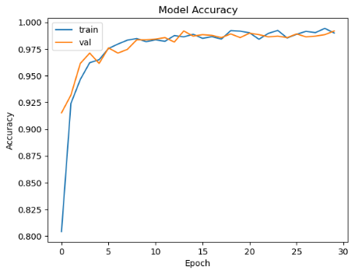 | 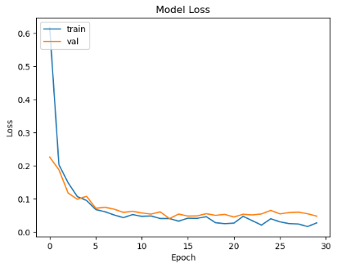
(a) GWO-VGG16
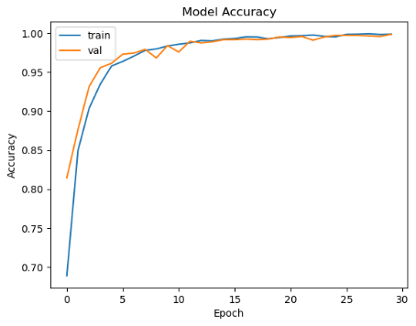 | 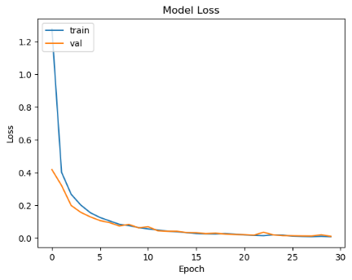
(b) GWO-DenseNet
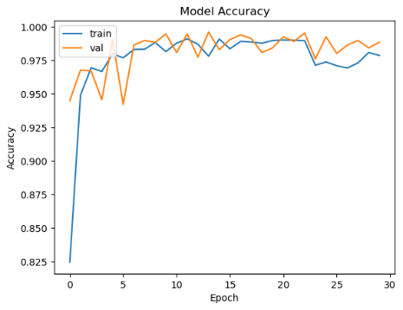 | 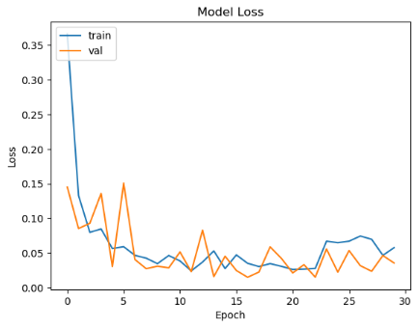
(c) GWO-DenseNet+LSTM
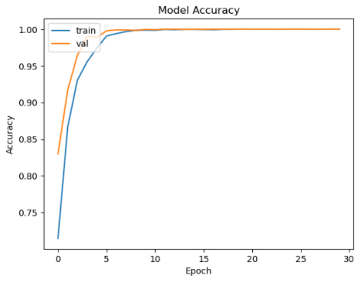 | 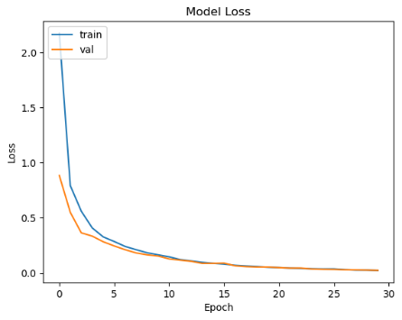
(d) GWO-Inception V3
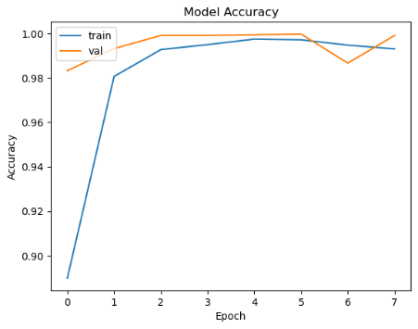 | 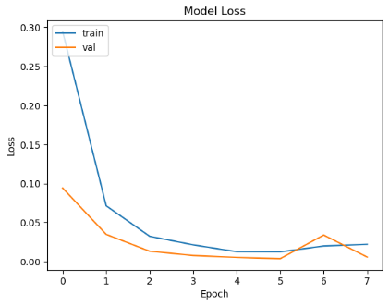
(e) GWO-VGG16+InceptionV3
Supplementary Fig. 1: Plots for accuracy/loss during training and validation of all the proposed models (a) GWO-VGG16, (b) GWO-DenseNet, (c) GWO-DenseNet-LSTM, (d) GWO-InceptionV3 and (e) Hybrid model (GWO-VGG16+InceptionV3) using T1,T2-weighted MRI dataset
Training/Validation accuracy/loss for SPECT DaTscan Dataset
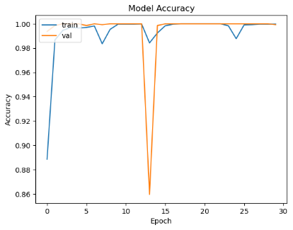 | 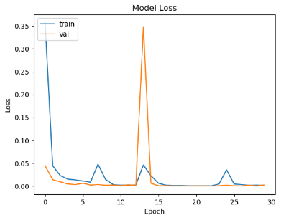
(a) GWO-VGG16
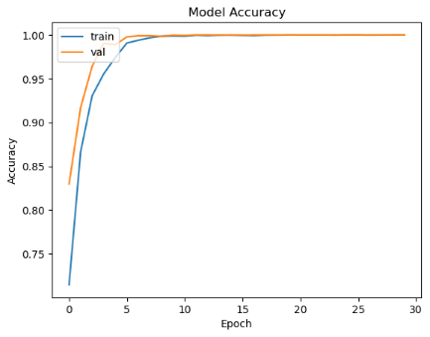 | 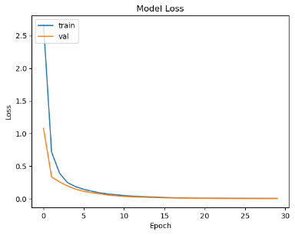
(b) GWO-DenseNet
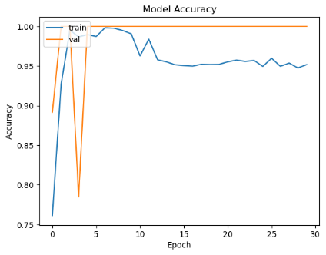 | 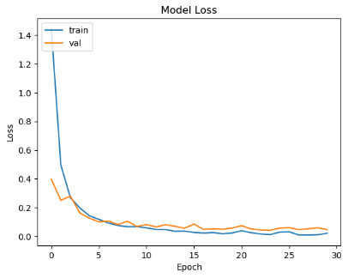
(c) GWO-DenseNet+LSTM
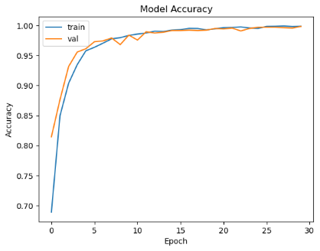 | 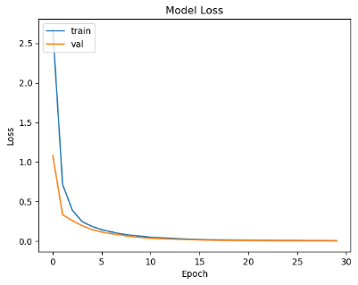
(d) GWO-Inception V3
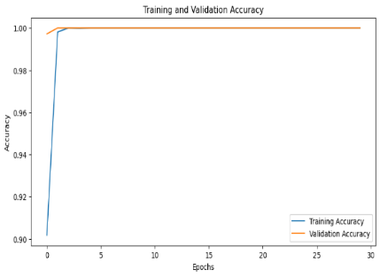 | 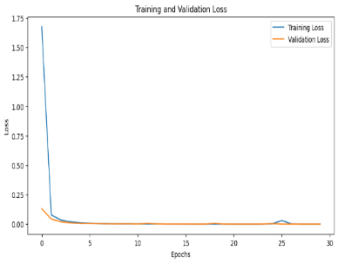
(e) GWO-VGG16+InceptionV3
Supplementary Fig. 2: Plots for accuracy/loss during training and validation of all the proposed models (a) GWO-VGG16, (b) GWO-DenseNet, (c) GWO-DenseNet-LSTM, (d) GWO-InceptionV3 and (e) Hybrid model (GWO-VGG16+InceptionV3) using SPECT DaTscan dataset

