Supplementary Information
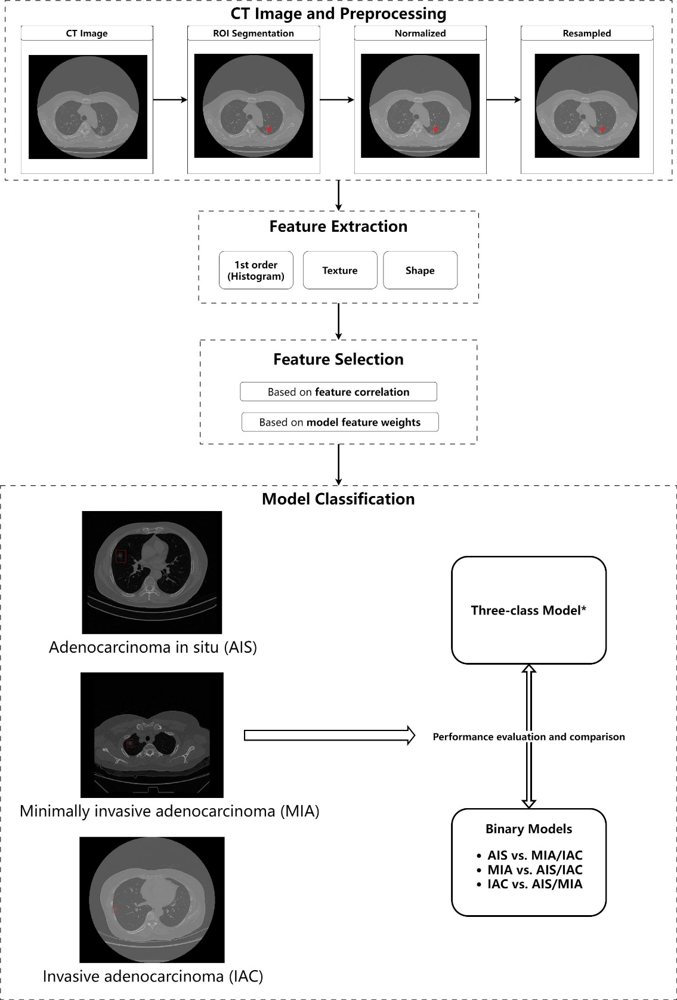
Supplemental Fig. 1 The overall procedure of this study. The details are given in text. Abbreviations: CT, computed tomography; AIS, adenocarcinoma in situ; MIA, minimally invasive adenocarcinoma; IAC, invasive adenocarcinoma cancer.

Supplemental Table 1 CT scanning and reconstruction parameters
Parameter type | Parameter setting
Scan mode | Helical
Detector width | 0.625mm×64
Tube rotation time | 0.5s
Pitch | 0.984 : 1
Tube voltage | 120kV
Tube current | Auto 120-500mA
Noise index | 12
Scan FOV | Large Body
Reconstruction mode | Plus
Reconstruction matrix | 512×512
Reconstruction layer thickness | 0.625mm
Reconstruction algorithm | Stnd/Bone

Supplemental Table 2 Selected feature list by correlation results. The feature index corresponds to those in the heatmap (Figure 2).
Index | Feature name
1 | original_shape_Elongation
2 | original_shape_Flatness
3 | original_shape_LeastAxisLength
4 | original_shape_Sphericity
5 | original_firstorder_10Percentile
6 | original_firstorder_90Percentile
7 | original_firstorder_Energy
8 | original_firstorder_InterquartileRange
9 | original_firstorder_Kurtosis
10 | original_firstorder_Maximum
11 | original_firstorder_Mean
12 | original_glcm_Autocorrelation
13 | original_glcm_ClusterShade
14 | original_glcm_Imc1
15 | original_glrlm_LongRunEmphasis
16 | original_glrlm_LongRunHighGrayLevelEmphasis
17 | original_glrlm_LongRunLowGrayLevelEmphasis
18 | original_glrlm_RunLengthNonUniformity
19 | original_glrlm_RunLengthNonUniformityNormalized
20 | original_glrlm_ShortRunHighGrayLevelEmphasis
21 | original_glszm_GrayLevelNonUniformity
22 | original_glszm_HighGrayLevelZoneEmphasis
23 | original_glszm_LargeAreaEmphasis
24 | original_glszm_ZonePercentage
25 | original_glszm_ZoneVariance
26 | original_ngtdm_Busyness
27 | original_ngtdm_Strength
28 | original_gldm_DependenceVariance
29 | original_gldm_SmallDependenceLowGrayLevelEmphasis
Abbreviations: glcm, gray-level co-occurrence matrices; glrlm, gray-level run length matrices; glszm, gray-level size zone matrices; ngtdm, neighboring gray tone difference matrices; gldm, gray level dependence matrices.

Supplemental Table 3 Selected feature list by feature weights for training each new model. Feature ranking was sorted in descending order based on feature weights.
Feature ranking | 3-class model | AIS vs. others model | MIA vs. others model | IAC vs. others model
1 | original_firstorder_Maximum | original_firstorder_Energy | original_firstorder_Maximum | original_firstorder_Energy
2 | original_firstorder_Energy | original_glszm_LargeAreaEmphasis | original_firstorder_Energy | original_firstorder_Maximum
3 | original_shape_LeastAxisLength | original_firstorder_90Percentile | original_firstorder_InterquartileRange | original_glrlm_RunLengthNonUniformity
4 | original_glrlm_RunLengthNonUniformity | original_firstorder_Maximum | original_glrlm_RunLengthNonUniformity | original_glrlm_LongRunHighGrayLevelEmphasis
5 | original_gldm_DependenceVariance | original_ngtdm_Strength | original_glszm_ZoneVariance | original_firstorder_90Percentile
6 | original_firstorder_Mean | original_firstorder_InterquartileRange | original_firstorder_90Percentile | original_glszm_ZonePercentage
7 | original_firstorder_InterquartileRange | original_shape_LeastAxisLength | original_shape_LeastAxisLength | original_shape_Sphericity
8 | original_firstorder_90Percentile | original_glrlm_ShortRunHighGrayLevelEmphasis | original_shape_Sphericity | original_shape_Flatness
9 | original_glrlm_LongRunHighGrayLevelEmphasis | original_shape_Elongation | original_glszm_ZonePercentage | original_glrlm_RunLengthNonUniformityNormalized
10 | original_glcm_Autocorrelation | original_glcm_Autocorrelation | original_firstorder_Kurtosis | original_glrlm_ShortRunHighGrayLevelEmphasis
11 | original_shape_Flatness | original_glrlm_RunLengthNonUniformity | original_gldm_DependenceVariance | original_glcm_Imc1
12 | original_glszm_LargeAreaEmphasis | original_glszm_ZoneVariance | original_glrlm_LongRunHighGrayLevelEmphasis | original_glcm_ClusterShade
13 | original_firstorder_10Percentile |  | original_glcm_ClusterShade | original_gldm_DependenceVariance
14 | original_glrlm_LongRunEmphasis |  | original_glrlm_LongRunLowGrayLevelEmphasis
15 | original_shape_Sphericity |  | original_glcm_Imc1
16 | original_glrlm_ShortRunHighGrayLevelEmphasis |  | original_glszm_GrayLevelNonUniformity
17 | original_ngtdm_Busyness |  | original_ngtdm_Strength
18 | original_ngtdm_Strength
19 | original_firstorder_Kurtosis
20 | original_glszm_HighGrayLevelZoneEmphasis
Abbreviations: AIS, adenocarcinoma in situ; MIA, minimally invasive adenocarcinoma; IAC, invasive adenocarcinoma cancer; glcm, gray-level co-occurrence matrices; glrlm, gray-level run length matrices; glszm, gray-level size zone matrices; ngtdm, neighboring gray tone difference matrices; gldm, gray level dependence matrices.

