S1. AN Brain regions
15 | -35.98 | 30.71 | -12.11 | 3 | 3 | ORBinf.L
16 | 41.22 | 32.23 | -11.91 | 3 | 3 | ORBinf.R
23 | -4.8 | 49.17 | 30.89 | 4 | 3 | SFGmed.L
24 | 9.1 | 50.84 | 30.22 | 4 | 3 | SFGmed.R
25 | -5.17 | 54.06 | -7.4 | 4 | 3 | ORBsupmed.L
26 | 8.16 | 51.67 | -7.13 | 4 | 3 | ORBsupmed.R
29 | -35.13 | 6.65 | 3.44 | 1 | 3 | INS.L
30 | 39.02 | 6.25 | 2.08 | 1 | 3 | INS.R
31 | -4.04 | 35.4 | 13.95 | 4 | 3 | ACG.L
32 | 8.46 | 37.01 | 15.84 | 4 | 3 | ACG.R
33 | -5.48 | -14.92 | 41.57 | 5 | 3 | DCG.L
34 | 8.02 | -8.83 | 39.79 | 5 | 3 | DCG.R
35 | -4.85 | -42.92 | 24.67 | 4 | 3 | PCG.L
36 | 7.44 | -41.81 | 21.87 | 4 | 3 | PCG.R
37 | -25.03 | -20.74 | -10.13 | 5 | 3 | HIP.L
38 | 29.23 | -19.78 | -10.33 | 5 | 3 | HIP.R
41 | -23.27 | -0.67 | -17.14 | 5 | 3 | AMYG.L
42 | 27.32 | 0.64 | -17.5 | 5 | 3 | AMYG.R
73 | -23.91 | 3.86 | 2.4 | 5 | 3 | PUT.L
74 | 27.78 | 4.91 | 2.46 | 5 | 3 | PUT.R

S2. BN Brain regions
3 | -18.45 | 34.81 | 42.2 | 4 | 3 | SFGdor.L
4 | 21.9 | 31.12 | 43.82 | 4 | 3 | SFGdor.R
5 | -16.56 | 47.32 | -13.31 | 4 | 3 | ORBsup.L
6 | 18.49 | 48.1 | -14.02 | 4 | 3 | ORBsup.R
9 | -30.65 | 50.43 | -9.62 | 3 | 3 | ORBmid.L
10 | 33.18 | 52.59 | -10.73 | 3 | 3 | ORBmid.R
15 | -35.98 | 30.71 | -12.11 | 3 | 3 | ORBinf.L
16 | 41.22 | 32.23 | -11.91 | 3 | 3 | ORBinf.R
23 | -4.8 | 49.17 | 30.89 | 4 | 3 | SFGmed.L
24 | 9.1 | 50.84 | 30.22 | 4 | 3 | SFGmed.R
25 | -5.17 | 54.06 | -7.4 | 4 | 3 | ORBsupmed.L
26 | 8.16 | 51.67 | -7.13 | 4 | 3 | ORBsupmed.R
29 | -35.13 | 6.65 | 3.44 | 1 | 3 | INS.L
30 | 39.02 | 6.25 | 2.08 | 1 | 3 | INS.R
41 | -23.27 | -0.67 | -17.14 | 5 | 3 | AMYG.L
42 | 27.32 | 0.64 | -17.5 | 5 | 3 | AMYG.R
73 | -23.91 | 3.86 | 2.4 | 5 | 3 | PUT.L
74 | 27.78 | 4.91 | 2.46 | 5 | 3 | PUT.R

S3. BED Brain regions
3 | -18.45 | 34.81 | 42.2 | 4 | 3 | SFGdor.L
4 | 21.9 | 31.12 | 43.82 | 4 | 3 | SFGdor.R
5 | -16.56 | 47.32 | -13.31 | 4 | 3 | ORBsup.L
6 | 18.49 | 48.1 | -14.02 | 4 | 3 | ORBsup.R
9 | -30.65 | 50.43 | -9.62 | 3 | 3 | ORBmid.L
10 | 33.18 | 52.59 | -10.73 | 3 | 3 | ORBmid.R
19 | -5.32 | 4.85 | 61.38 | 3 | 3 | SMA.L
20 | 8.62 | 0.17 | 61.85 | 1 | 3 | SMA.R
29 | -35.13 | 6.65 | 3.44 | 1 | 3 | INS.L
30 | 39.02 | 6.25 | 2.08 | 1 | 3 | INS.R
31 | -4.04 | 35.4 | 13.95 | 4 | 3 | ACG.L
32 | 8.46 | 37.01 | 15.84 | 4 | 3 | ACG.R
35 | -4.85 | -42.92 | 24.67 | 4 | 3 | PCG.L
36 | 7.44 | -41.81 | 21.87 | 4 | 3 | PCG.R
37 | -25.03 | -20.74 | -10.13 | 5 | 3 | HIP.L
38 | 29.23 | -19.78 | -10.33 | 5 | 3 | HIP.R
41 | -23.27 | -0.67 | -17.14 | 5 | 3 | AMYG.L
42 | 27.32 | 0.64 | -17.5 | 5 | 3 | AMYG.R

Figure 8. supplementary materials
ROI1 | ROI2 | Type | Study
dACC | SN | increasing | Stopyra et al.2019
right supramarginal gyrus | medial prefrontal cortex | increasing | Holstajn Zemankova et al.2021
left rectus | left middle occipital gyrus. | decreasing | Lai et al.2020
Sensorimotor Network, SMN | Visual network | decreasing | Phillipou et al.2016
Hippocampus | Left superior frontal gyrus | increasing | Lai et al.2020
Visual network | auditory resting state networks (RSNS) | decreasing | Scaife et al.2017
gray matter | gray matter | decreasing | Scaife et al.2017
dACC | dACC | increasing | Stopyra et al.2019
ventral striatum | ventral striatum | increasing | Seidel et al.2018
Parieto-occipital region | Parieto-occipital region | increasing | Seitz et al.2016
DMN | DMN | decreasing | Seitz et al.2016
mOFC | mOFC | decreasing | Steding et al.2019
rPFC | rPFC | increasing | Suda et al.2014
temporal lobe | greater occipital lobe | decreasing | Donnelly et al.2022
right IPL | left middle occipital gyrus | increasing | Donnelly et al.2022
left insula | left insula | decreasing | Wang et al.2022
inferior parietal lobule | inferior parietal lobule | increasing | Wang et al.2022
left insula | right insula | decreasing | Wang et al.2022
left inferior occipital gyrus | left ACC | decreasing | Wang et al.2022
left IPL | left IPL | decreasing | Wang et al.2022
left medial orbitofrontal cortex | left PCC | decreasing | Wang et al.2022
right IPL | the right mOFC | decreasing | Wang et al.2022
the right IPL | left middle occipital gyrus (MOG) | increasing | Wang et al.2022
right middle occipital cortex | right middle occipital cortex | decreasing | Doose et al.2020
DMN | medial prefrontal cortex | increasing | Doose et al.2020
DMN | posterior cingulate | increasing | Doose et al.2020
DMN | inferior parietal lobule | increasing | Doose et al.2020
ECN | anterior cingulate cortex | decreasing | Gaudio et al.2015
DMPFC | right frontal pole | decreasing | Woodside et al.2021
DMPFC | left angular gyrus | decreasing | Woodside et al.2021
DMN | dorsolateral prefrontal cortex | increasing | Felicity A et al.2014
DMN | inferior frontal gyrus | increasing | Felicity A et al.2014
VTA | VTA | decreasing | Jiang et al.2019
anterior ventral pallidum | insula | decreasing | Jiang et al.2019

data-decreasing
ID lMOG visual network RSNS gray matter DMN mOFC GOL left insula right insula lACC lIPL lPCC rmOFC rMOC ACC rFP lAG VTA insula
left rectus 1 0 0 0 0 0 0 0 0 0 0 0 0 0 0 0 0 0 0
SMN 0 1 0 0 0 0 0 0 0 0 0 0 0 0 0 0 0 0 0
visual network 0 0 1 0 0 0 0 0 0 0 0 0 0 0 0 0 0 0 0
gray matter 0 0 0 1 0 0 0 0 0 0 0 0 0 0 0 0 0 0 0
DMN 0 0 0 0 1 0 0 0 0 0 0 0 0 0 0 0 0 0 0
mOFC 0 0 0 0 0 1 0 0 0 0 0 0 0 0 0 0 0 0 0
temporal lobe 0 0 0 0 0 0 1 0 0 0 0 0 0 0 0 0 0 0 0
left insula 0 0 0 0 0 0 0 1 1 0 0 0 0 0 0 0 0 0 0
lIOG 0 0 0 0 0 0 0 0 0 1 0 0 0 0 0 0 0 0 0
lIPL 0 0 0 0 0 0 0 0 0 0 1 0 0 0 0 0 0 0 0
lMOC 0 0 0 0 0 0 0 0 0 0 0 1 0 0 0 0 0 0 0
rIPL 0 0 0 0 0 0 0 0 0 0 0 0 1 0 0 0 0 0 0
rMOC 0 0 0 0 0 0 0 0 0 0 0 0 0 1 0 0 0 0 0
ECN 0 0 0 0 0 0 0 0 0 0 0 0 0 0 1 0 0 0 0
DMPFC 0 0 0 0 0 0 0 0 0 0 0 0 0 0 0 1 1 0 0
VTA 0 0 0 0 0 0 0 0 0 0 0 0 0 0 0 0 0 1 0
AVP 0 0 0 0 0 0 0 0 0 0 0 0 0 0 0 0 0 0 1

data-increasing
ROI SN MPC lSFG dACC ventral striatum parieto-occipital rPFC lMOG PC IPL DPC IFG
dACC 1 0 0 1 0 0 0 0 0 0 0 0
rSMG 0 1 0 0 0 0 0 0 0 0 0 0
hippocampus 0 0 1 0 0 0 0 0 0 0 0 0
ventral striatum 0 0 0 0 1 0 0 0 0 0 0 0
parieto-occipital 0 0 0 0 0 1 0 0 0 0 0 0
rPFC 0 0 0 0 0 0 1 0 0 0 0 0
rIPL 0 0 0 0 0 0 0 1 0 0 0 0
IPL 0 0 0 0 0 0 0 0 0 1 0 0
DMN 1 0 0 0 0 0 0 0 1 1 1 1

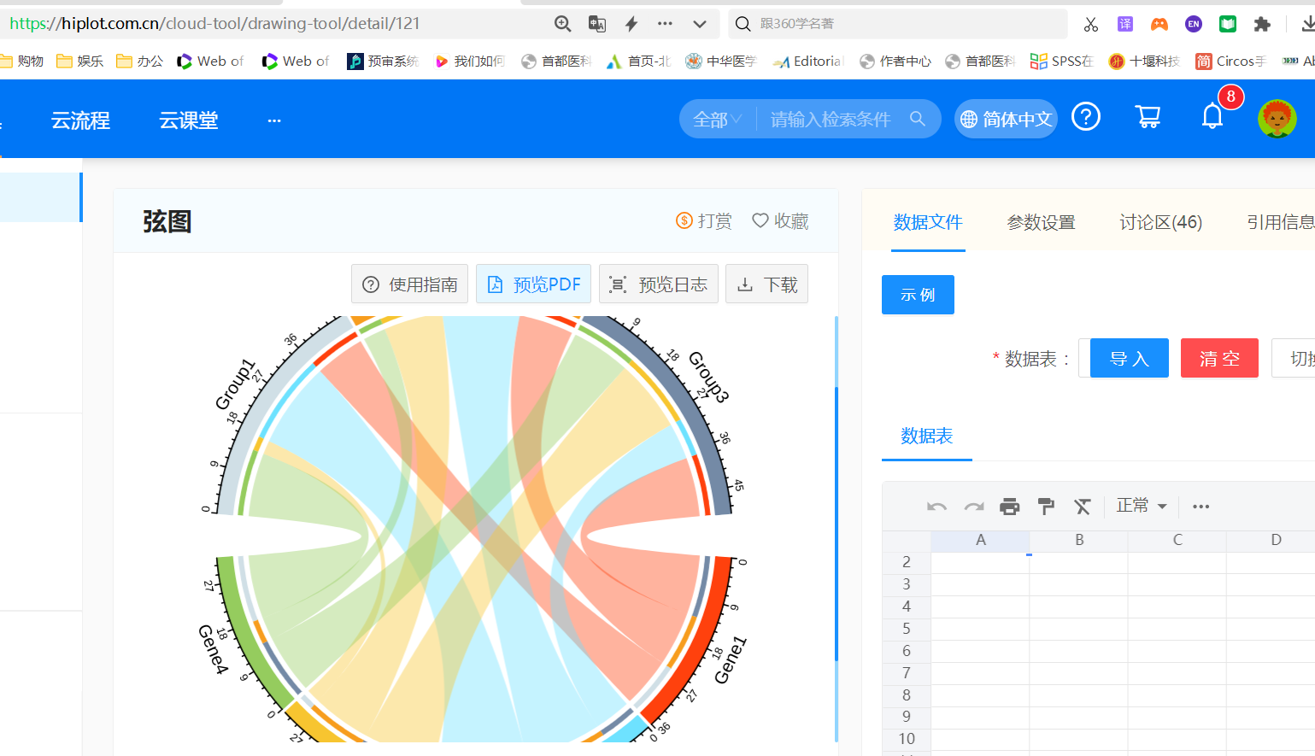

Enter the supplementary material into the online drawing tool （https://hiplot.com.cn/cloud-tool/drawing-tool/detail/121）and draw the string diagram.

