Supplementary
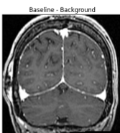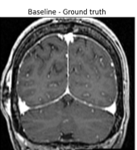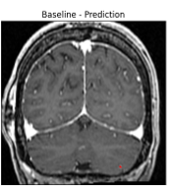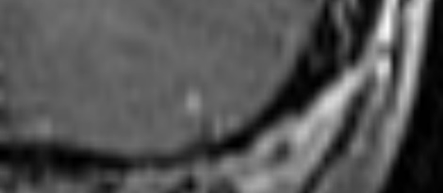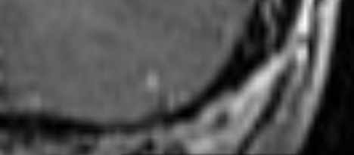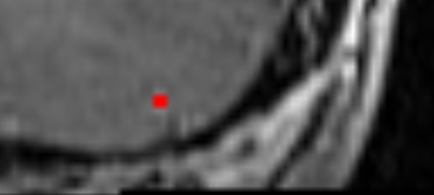
A
Figure 6 A: Visual example of the case where the models detected a tumor that was missed in the reference segmentation. The tumor was missed in the baseline reference segmentation but present in the model prediction. The second row is a zoomed-in version of the segmentations in the first row.
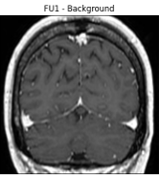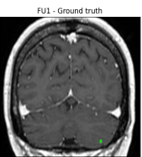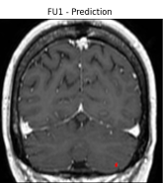
B
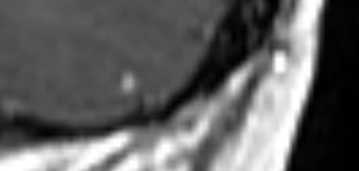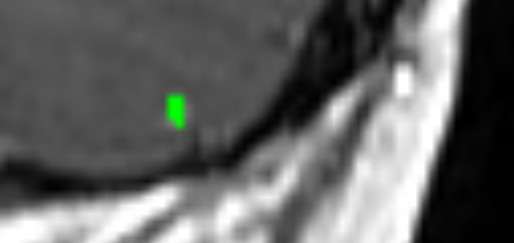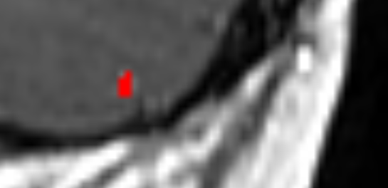
Figure 6 B: Visual example of the same case in Figure 6A where both the model prediction and the reference segmentation for FU1 contained the tumor that was missed in the baseline reference segmentation. The second row is a zoomed-in version of the segmentations in the first row.

