Supplemental Materials
Supplementary Note 1. CT Examination and Image Reconstruction
The participants were placed in a supine position and images were acquired with inspiratory breath-hold. All participants underwent standard-dose CT (SDCT) followed by ultra‐low-dose CT (ULDCT). The participants did not exit the scanner between the two examinations. The scanning range was from the pulmonary apex to the costophrenic angle, including the entire lung parenchyma. The other scanning parameters of SDCT and ULDCT are presented in Table S1.

Supplementary Note 2. Principle of Deep Learning Reconstruction (DLR)
The deep learning reconstruction (DLR) algorithm used in this study—Advanced Intelligent Clear-IQ Engine (AiCE), Canon Medical Systems—is the latest reconstruction method. It was developed in 2018 using the training scheme detailed in Fig. S1, which aims to reduce noise and artefacts to the same extent as model-based iterative reconstruction (MBIR). DLR requires only a small increase in reconstruction time compared to hybrid-iterative reconstruction (HIR), and it produces a more natural, less plastic-like and blotchy appearance than MBIR (which is set to maximize image quality, but takes a long time to compute). As shown in Fig. S1, the DLR algorithm is based on a deep convolutional neural network (DCNN) trained with data consisting of low-dose HIR images as input and high-dose MBIR images as ground truth. During the training process, both noise-contaminated and noise-free training samples are provided to the network as training pairs so that the network can learn the difference between signal and noise. The network is used to incorporate advanced physics models through learning from the MBIR target because of its ability to model system optics, system physics, scanner statistical properties, and human anatomy. Details of DCNN structure and parameters are described in a previous study ^{[1]}.

Supplementary Note 3. Radiation Dose Parameters
The volume CT dose index (CTDI_{vol}) and dose-length product (DLP) were recorded for each CT acquisition, which respectively refer to an estimate of the average X-ray tube output and the total X-ray output integrated throughout the entire scan, respectively. The effective dose (ED) was calculated as the DLP multiplied by the conversion coefficient for the chest (k = 0.014 mSv/mGy·cm) (Equation 1).
ED = DLP × 0.014 mSv·mGy⁻¹·cm⁻¹ ^{[2]} (1)

Supplementary Note 4. Image Postprocessing and Evaluation of Objective Image Quality
The image noise of the whole lung parenchymal volume was evaluated. The lung parenchymal volume was three-dimensionally segmented through the traditional image processing method, excluding pulmonary vessels, the mediastinum, and thoracic wall. After the whole lung volume segmentation ^{[3]}, the lung parenchyma was defined as Hounsfield Units (HUs) ranging from −1000 HU to −700 HU to remove the blood vessels and bronchi ^{[4]}. The image noise of the air background outside the human body (only the upper part, for the lower part was the scanning bed, which was segmented using the seed-mediated growth method) was also assessed. This method first selected the voxel of the top left corner in the air background (with a CT value of approximately 150 HU) as the seed point. Then, growth selection on voxels of CT values within this range between 100 HU and 200 HU was performed. These three-dimensional segmentation procedures were applied to all five CT image groups and exported to data analysis software (Python, 3.6.13) (Figure S2).

Supplementary Note 5. Automated Nodule Segmentation and Quantitative Evaluation
In our study, a commercially available deep learning–based nodule evaluation AI system ^{[5]} (Yitu AICare CT Chest system, Deepwise Inc.) was used to detect and segment nodules and then automatically calculate their diameters and volumes. The core algorithm of the system consisted of two steps: candidate nodule identification and classification of proposed nodules. In the first step, a fully connected network was trained on annotated CT images to generate a confidence score for nodule segmentation. Nodules meeting or exceeding the confidence score threshold were selected for binary classification. In the second step, the algorithm generated a heat map to identify regions of interest (ROIs) that may contain nodules, and then cropped these ROIs for classification. A soft max classifier was used to calculate the probability of identifying true nodules and reduce false positives. Moreover, this system has been officially approved by the National Medical Products Administration (NMPA) in China (Registration No. 20213211094) for clinical use. Notably, this system was trained on low/standard-dose CT scans and tested on the ultra-low-dose CT scans in this study.
After detection, a senior chest radiologist (L.S.) with 19 years of experience in chest imaging checked and confirmed the detected nodules annotated with a bounding box on a computer screen and reviewed the outlined nodules layer by layer on transverse CT sections. The automatic segmentation line of each layer was located just on the nodule-lung interface, which was regarded as accurate segmentation. Only the top-most or lowest layer of the nodule was also regarded as accurate segmentation when outlined inaccurately, because its area was very small. The resolution of the image evaluation display screen should be greater than 2M. We recorded the automatically generated nodule indices by this system, including long diameter, volume, lobe position, and nodule type (subsolid, solid, and calcified nodules).

Supplemental References
[1] Tatsugami F, T Higaki, Y Nakamura et al (2019) Deep learning-based image restoration algorithm for coronary CT angiography. Eur Radiol 29(10): 5322-5329
[2] Deak P D, Y Smal, and W A Kalender (2010) Multisection CT protocols: sex- and age-specific conversion factors used to determine effective dose from dose-length product. Radiology 257(1): 158-66
[3] Y. Bai, X. Wang, Z. Zhou, Z. Wu, Q. Feng and J. Qi, Pulmonary Segments Segmentation with Hierarchical Weak Labels, 2023 IEEE 20th International Symposium on Biomedical Imaging (ISBI), Cartagena, Colombia, 2023, doi: 10.1109/ISBI53787.2023.10230614.
[4] Coxson HO. Quantitative Imaging of the Lung. In: Barnes PJ, Drazen JM, Rennard SI, Thomson, NC, eds. Asthma COPD. 2nd ed. 2009; 559–568.
[5] Cui S, S Ming, Y Lin et al (2020) Development and clinical application of deep learning model for lung nodules screening on CT images. Sci Rep 10(1): 13657

Supplementary Tables
Table S1. CT Acquisition Parameters
Variable | Standard-Dose CT | Ultra-low-dose CT
Acquisition mode | Helical | Helical
Tube voltage, kV | 120 | 100
Tube current, mA | Auto mA with a noise index of 8.8 | 20
Dose modulation | On | Off
Collimation, mm | 0.5 × 80 | 0.5 × 80
Pitch | 0.813 | 0.813
Rotation time, s | 0.5 | 0.5
Reconstruction kernel | FC 52 | AiCE lung
Field of view, mm | 350 | 350
Matrix size | 512 × 512 | 512 × 512
Reconstruction thickness, mm | 1.0 | 1.0
Reconstruction interval, mm | 0.8 | 0.8
Abbreviations: AiCE, Advanced Intelligent Clear-IQ Engine.

Table S2. False Positive Rate of Ultra-Low-Dose CT on Different Reconstruction Settings
Variable | Total | BMI (kg/m²) |  | Nodule size |  | Nodule type
Variable | Total | <25 | ≥25 | 3-6 mm | ≥6 mm | Subsolid | Solid | Calcified
ULDCT HIR-Str | 6 | 3 (50.0) | 3 (50.0) | 2 (33.3) | 4 (66.7) | 1 (16.7) | 4 (66.7) | 1 (16.7)
ULDCT DLR-Str | 9 | 8 (88.9) | 1 (11.1) | 7 (77.8） | 2 (22.2) | 4 (44.4) | 4 (44.4) | 1 (11.1)
Note: Unless otherwise specified, data are numbers of nodules, with percentages in parentheses.
Abbreviations: ULDCT, ultra-low-dose CT; BMI, body mass index; HIR, hybrid iterative reconstruction; DLR, deep learning reconstruction; Str, strong setting.

Supplementary Figures

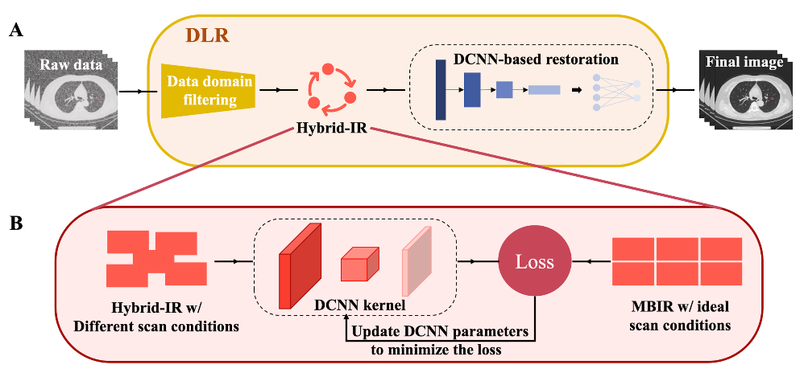
Fig. S1. Training and inference flowchart of DLR (i.e., AiCE). (A) DLR for data inference includes three main parts: data domain filtering, hybrid iterative reconstruction, and DCNN-based restoration module. (B) When the difference (loss) between the DCNN output and the ideal MBIR image is stably minimized, the parameters in the DCNN core are optimized during the training procedure. Abbreviations: AiCE, advanced intelligent clear-IQ engine; DLR, deep learning reconstruction; MBIR, model-based iterative reconstruction; DCNN, deep convolution neural network.

Fig. S2. Original images of each sequence of SDCT and ULDCT and the corresponding segmentation of the lung tissue and air background. Abbreviations: HIR, hybrid iterative reconstruction; DLR, deep learning reconstruction; SDCT, standard-dose CT; ULDCT, ultra-low-dose CT; Std, standard setting; Str, strong setting.

Fig. S3. Bland–Altman plots of systematic percentage error in nodule long diameter and volume calculated by ULDCT and SDCT in different participant BMI, nodule size, and nodule type subgroups. (A) Participant BMI <25 (a-d), and participant BMI ≥25 (e-h). (B) Nodule size of 3–6 mm (a-d), and ≥6 mm (e-h). (C) Nodule type of subsolid (a-d), solid (e-h), and calcified (i-l). Abbreviations: SDCT, standard-dose CT; ULDCT, ultra-low-dose CT; HIR, hybrid iterative reconstruction; DLR, deep learning reconstruction; BMI, body mass index.

