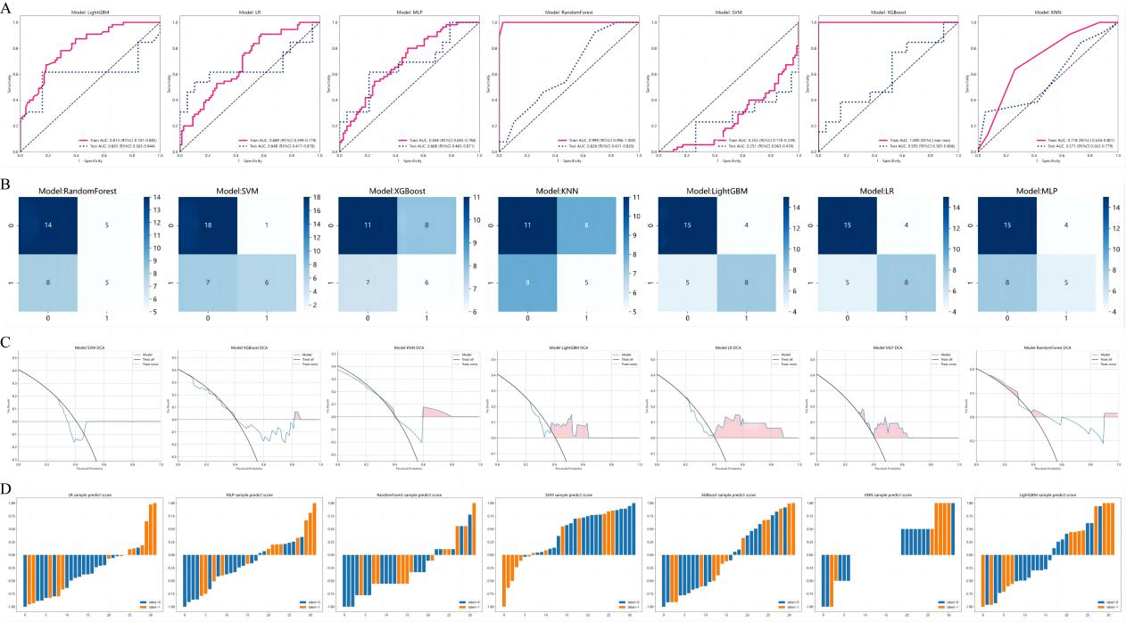Figure S1
Evaluation results of predictive power of all machine learning models except ExtraTrees. A: ROC curve to evaluate the predictive power of the model. B: Confusion matrix to evaluate model specificity and sensitivity. C: The DCA curve is used to evaluate the clinical benefit of patients based on this model. D: Histograms are used to visually evaluate the prediction of each test set sample.
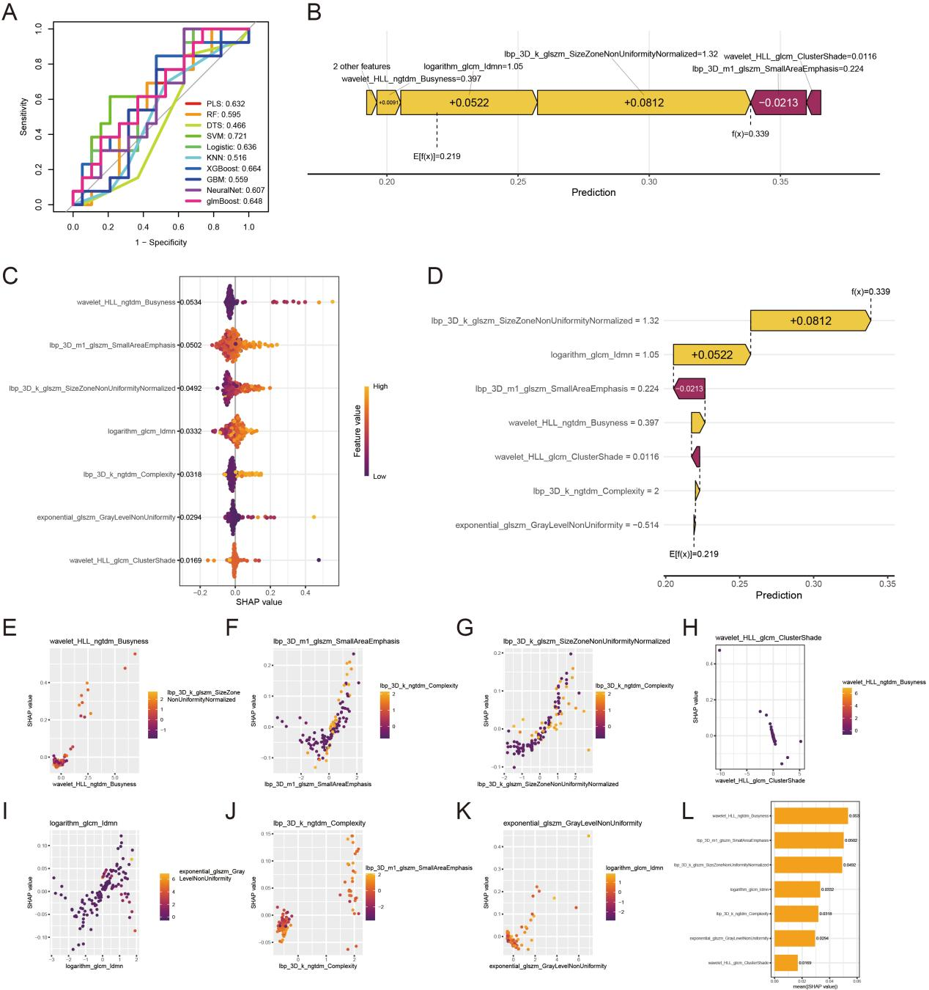Figure S2
The multi-machine learning model is built using an 8:2 ratio. The excellent models are selected based on the ROC curve. The SHAP algorithm is employed to calculate the SHAP values of all features under this model as well as their importance.(A) ROC curves of all models along with their corresponding AUC values. (B) Feature importance plots for individual samples illustrate the contribution of each feature to the model's judgment in the first sample of the SVM model. (C) Distribution of SHAP values of each feature in the SVM model across all samples. (D) Waterfall plots show the contribution degree of each feature in the calculation of the SVM model. (E-K) Scatter plots showing the correlation between the distribution of feature values and SHAP value values for all samples in the SVM model. (L) Mean SHAP values of each feature in the SVM model.

