Supplemental Figures
Supplemental Figure S1. Bland-Altman plots. (A) SNR (T2WI) plot. (B) SNR (T2WI+DLR) plot. (C) CNR (T2WI) plot. (D) CNR (T2WI+DLR) plot. The solid blue line indicated the mean difference in measurements between two radiologists. The dashed red lines indicated the limits of the agreements.

Supplemental Figure S2. Bland-Altman plots. (A) SNR (DWI) plot. (B) SNR (DWI+DLR) plot. (C) CNR (DWI) plot. (D) CNR (DWI+DLR) plot. The solid blue line indicated the mean difference in measurements between two radiologists. The dashed red lines indicated the limits of the agreements.

Supplemental Figure S3. Bland-Altman plots. (A) SNR (CE-T1WI) plot. (B) SNR (CE-T1WI+DLR) plot. (C) CNR (CE-T1WI) plot. (D) CNR (CE-T1WI+DLR) plot. The solid blue line indicated the mean difference in measurements between two radiologists. The dashed red lines indicated the limits of the agreements.

Supplemental Figure S4. ROC curves. (a) The ROC curves for distinguishing T1-2 from T3-4 by different readers. (b) The ROC curves for distinguishing N- from N+ by different readers.

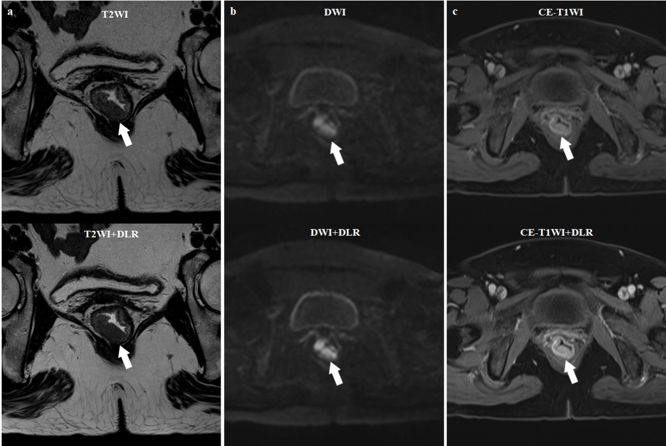
Supplemental Figure S5. A female with rectal adenocarcinoma, pT3N2. Comparison of the original and DLR image sets. White arrow indicated the location of rectal lesion. (A) were original T2WI (SNR and CNR were 47.1 and 28.1, respectively) and T2WI+DLR (SNR and CNR were 54.8 and 33.6, respectively); (B) were original DWI (SNR and CNR were 154.8 and 138.4, respectively) and DWI+DLR (SNR and CNR were 170.5 and 147.8, respectively); (C) were original CE-T1WI (SNR and CNR were 407.2 and 166.5, respectively) and CE-T1WI+DLR (SNR and CNR were 507.3 and 214.2, respectively). The scores of original T2WI, DWI, and CE-T1WI for the lesion display performance were 4, 4, and 4. The scores of DLR T2WI, DWI, and CE-T1WI for the lesion display performance were 5, 4, and 4. The scores of original T2WI, DWI, and CE-T1WI for the overall image quality were 4, 4, and 4. The scores of DLR T2WI, DWI, and CE-T1WI for the overall image quality were 5, 4, and 4. T- and N-stage of original image set from the three readers were mrT3aN1, mrT2N0, and mrT2N1, respectively. T- and N-stage of the DLR image set from the three readers were mrT3aN2, mrT3aN1, and mrT2N1, respectively.
Supplemental Figure S6. A male with rectal adenocarcinoma, pT2N0. Comparison of the original and DLR image sets. White arrow indicated the location of rectal lesion. (A) were original T2WI (SNR and CNR were 45.0 and 30.0, respectively) and T2WI+DLR (SNR and CNR were 93.5 and 64.3, respectively); (B) were original DWI (SNR and CNR were 165.4 and 140.8, respectively) and DWI+DLR (SNR and CNR were 187.0 and 158.0, respectively); (C) were original CE-T1WI (SNR and CNR were 248.6 and 121.2, respectively) and CE-T1WI+DLR (SNR and CNR were 840.4 and 391.6, respectively). The scores of original T2WI, DWI, and CE-T1WI for the lesion display performance were 4, 4, and 4. The scores of DLR T2WI, DWI, and CE-T1WI for the lesion display performance were 5, 4, and 5. The scores of original T2WI, DWI and CE-T1WI for the overall image quality were 4, 3, and 4. The scores of DLR T2WI, DWI and CE-T1WI for the overall image quality were 5, 4, and 5. T- and N-stage of the original image set from the three readers were mrT2N0, T3aN0, and T3aN0, respectively. T- and N-stage of the DLR image set from the three readers were mrT2N0, T2N0, and T3aN0, respectively.
Supplemental Figure S7. DCA in the test set. Blue and red curves represent the DLR-model and original-model, respectively. (a) showed that with a large probability range, utilizing the developed DLR-model to evaluate T-stage conferred a positive net benefit versus the original-model and the all-or-none scheme. (b) showed that the DLR-model and original-model had similar clinical benefit for N-staging.

