Supplementary materials

1.1 Specific parameter settings used in feature extraction and the rationale for selecting particular feature groups or transformation techniques
Parameter setting of feature extraction：In the process of feature extraction, we adopted some key parameter Settings to ensure the accuracy and consistency of the data. Here are some key parameters in the configuration file: ①Intensity Discretization: In intensity discretization, we select a specific bin width (such as 5 gray levels) to segment continuous intensity values into discrete bins. This method helps reduce the impact of noise on feature extraction and enables features to better capture important information in images. ②ROI Cropping: An OKT-crop_max_roi method is used for ROI cropping, which ensures that the ROI area extracted includes the largest lesion information and excludes irrelevant areas to improve the feature extraction efficiency of the model. ③Texture Features: Gray co-existence matrix (GLCM), gray run matrix (GLRLM), gray difference matrix (GLDM) and other methods are used to extract texture features. These texture features can effectively describe the internal structure of the focal area, thus providing rich information for the downstream model.

The basic principle of feature selection technique. ①Statistical tests: We use a variety of statistical tests to assess the significant relationship between the feature and the target variable. This method can effectively screen out features that are significantly associated with disease prognosis or treatment response, thereby reducing the complexity of the model and improving its predictive performance. ②Correlation coefficient: We also used correlation coefficient to measure the linear relationship between the feature and the target variable. By screening out features with high correlation coefficients, we can ensure that the input features of the model have a strong correlation with the target variables, thus improving the explanatory ability and stability of the model. ③Lasso regression: To further reduce redundant features, we use Lasso regression. By introducing L1 regularization into the regression model, Lasso regression can automatically select the features that contribute more to the model, while reducing the insignificant feature coefficients to zero. This method is especially suitable for processing high-dimensional data, which can effectively reduce the complexity of the model and prevent overfitting.
The basic principle of feature conversion technology：In the process of feature conversion, we mainly use z-score standardization method. z-score standardization converts feature data into a standard normal distribution with a mean of 0 and a standard deviation of 1. This standardized method helps to eliminate dimensional differences among features and ensure the balanced influence of different features on the predicted results during model training, thus improving the convergence speed and stability of the model.
1.2 The methods used to prevent overfitting and the hyperparameter tuning process，details on the specific hyperparameters chosen for each machine learning model
Methods to prevent overfitting. ①Cross-validation techniques: We use a 5-fold cross-validation during training. This method works by dividing the training data into five subsets, using four of them for training at a time and the remaining one for validation. In this way, we can evaluate the model's performance under different data distributions, thereby reducing the model's dependence on specific data sets and improving its ability to generalize. ②Regularization method: During model training, L1 regularization method in Lasso regression is used to reduce the complexity of the model and prevent overfitting. In addition, for specific machine learning models, such as XGBoost and RandomForest, we also set relevant parameters to control the complexity of the model (e.g., max_depth and min_child_weight) to further prevent overfitting.
Hyperparameter tuning procedure：We used the grid-search algorithm to tune the hyperparameters. The specific steps are as follows: ①Parameter search: For each model, we define different combinations of parameters and search for the best hyperparameter Settings among these combinations. ②Cross-validation: Use 5-fold cross-validation in the training set to evaluate the performance of each parameter combination. Finally, we choose the parameter combination with the best median performance as the final parameter of the model. ③Final model training: The optimal parameters selected are applied to the entire training set for final model training to ensure that the model can perform the best performance on the complete data set.
Specific hyperparameter Settings for each model: ①SVM:Polynomial kernel (kernel='poly') is selected and probability estimation (probability=True) is enabled. ②RandomForest: 100 decision trees were set (n_estimators=100) with a maximum depth of 5 (max_depth=5) and a minimum split sample of 3 (min_samples_split=3), and random seeds were set to ensure repeatability of the results (random_state=0). ③XGBoost: Set 10 estimators (n_estimators=10), maximum depth is 3 (max_depth=3), minimum child weight is 0.2 (min_child_weight=0.2), The binary logistic regression objective function (objective='binary:logistic') and error rate evaluation index (eval_metric='error') are used. ④LightGBM:Set 10 estimators (n_estimators=10) with a maximum depth of 4 (max_depth=4). ⑤ExtraTrees:80 decision trees are set (n_estimators=80), the maximum depth is 5 (max_depth=5), the minimum split sample number is 2 (min_samples_split=2), and the random seed is set (random_state=0).
2. The hyperparameters of the machine learning algorithm and specific metrics for each mode
2.1 In this study, various machine learning models with specific parameters were configured to optimize performance. SVM is set to have polynomial kernel and probability estimation is enabled. The random forest classifier is configured with 100 estimators, with a maximum depth of 5 and a minimum sample segmentation of 3. For the XGBoost model, 10 estimators are used, a binary logic target is used, the maximum depth is 3, the minimum subweight is 0.2, the label encoder is disabled, and the evaluation metric is set to "error". The LightGBM model is implemented using 10 estimators with a maximum depth of 4. Finally, the extra tree is set to have 80 estimators with a maximum depth of 5 and a minimum sample split of 2. These parameter choices are made in order to customize each model in the analysis environment for optimal performance.
2.2 Specific indicators for each mode
The following pictures and tables supplement the specific indicators of T1-CE and FLAIR respectively.
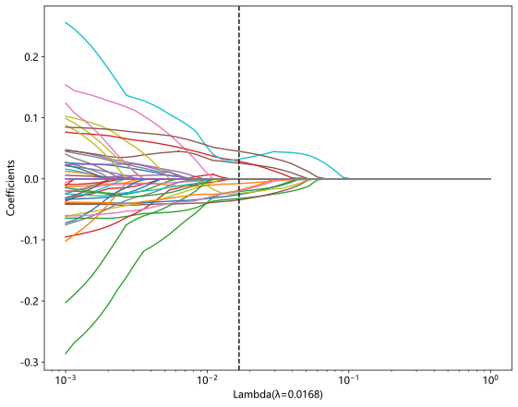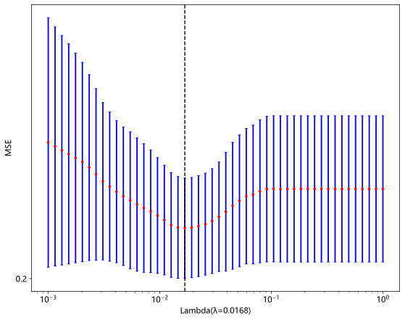

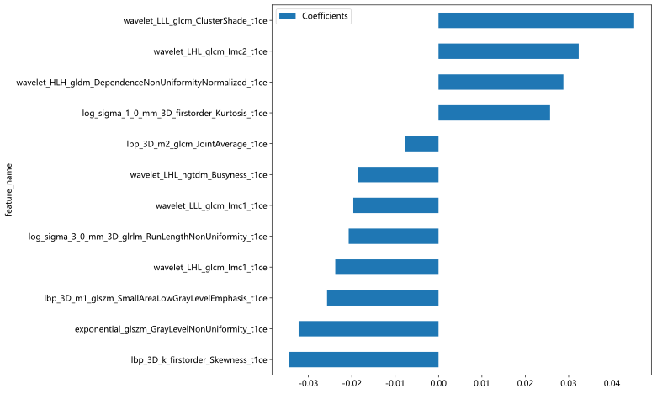
Figure 1. shows the coefficients, MSE and weights of 10x cross-validation of T1-CE

Table 1 Comparison of performance indicators of T1-CE machine learning models
Model name | accuracy | AUC | 95% CI | sensitivity | specificity | PPV | NPV
SVM | 0.824 | 0.865 | 0.826 - 0.904 | 0.848 | 0.781 | 0.879 | 0.733
SVM | 0.710 | 0.789 | 0.679 - 0.900 | 0.681 | 0.880 | 0.970 | 0.324
RandomForest | 0.802 | 0.918 | 0.892 - 0.944 | 0.746 | 0.905 | 0.936 | 0.656
RandomForest | 0.840 | 0.863 | 0.785 - 0.940 | 0.847 | 0.800 | 0.961 | 0.476
ExtraTrees | 0.781 | 0.830 | 0.789 - 0.871 | 0.852 | 0.650 | 0.820 | 0.701
ExtraTrees | 0.704 | 0.862 | 0.789 - 0.935 | 0.660 | 0.960 | 0.990 | 0.329
XGBoost | 0.763 | 0.848 | 0.809 - 0.887 | 0.738 | 0.810 | 0.879 | 0.624
XGBoost | 0.669 | 0.793 | 0.704 - 0.882 | 0.639 | 0.840 | 0.958 | 0.288
LightGBM | 0.812 | 0.869 | 0.833 - 0.905 | 0.816 | 0.803 | 0.886 | 0.701
LightGBM | 0.817 | 0.856 | 0.781 - 0.930 | 0.812 | 0.840 | 0.967 | 0.437
* Area under the receiver operating characteristic curve，AUC;Confidence Interval，CI； Positive predictive value, PPV;Negative predictive value, NPV

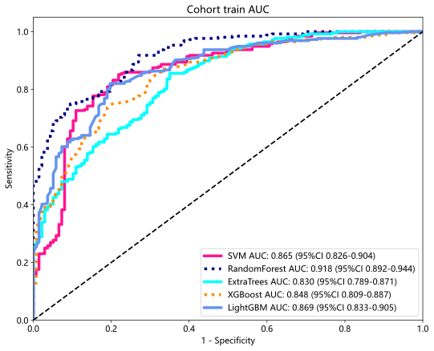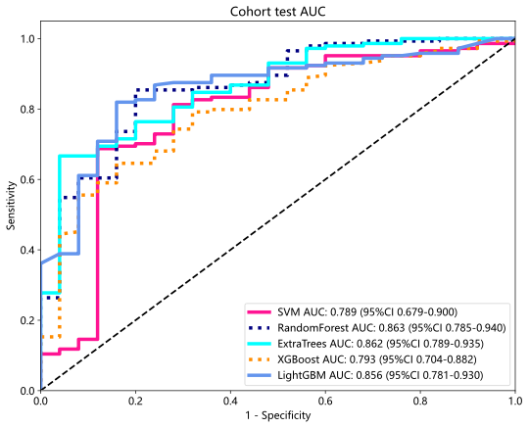
Figure 2 . ROC curves of T1-CE training set and test set

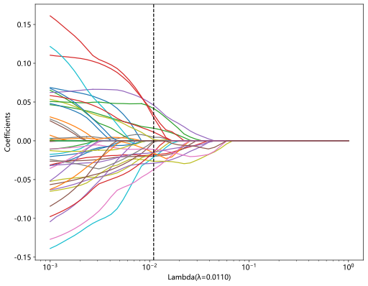

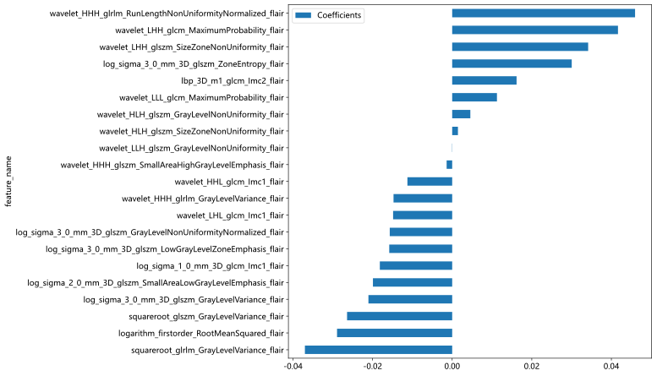
Figure 3. shows the coefficients, MSE and weights of 10x cross-validation of FLAIR

Table 2 Comparison of performance indicators of FLAIR machine learning models
Model name | accuracy | AUC | 95% CI | sensitivity | specificity | PPV | NPV
SVM | 0.743 | 0.833 | 0.791 - 0.875 | 0.684 | 0.854 | 0.897 | 0.591
SVM | 0.704 | 0.787 | 0.712 - 0.862 | 0.687 | 0.800 | 0.952 | 0.308
RandomForest | 0.837 | 0.917 | 0.890 - 0.945 | 0.828 | 0.854 | 0.914 | 0.727
RandomForest | 0.657 | 0.757 | 0.662 - 0.852 | 0.625 | 0.840 | 0.957 | 0.280
ExtraTrees | 0.758 | 0.812 | 0.767 - 0.856 | 0.816 | 0.650 | 0.813 | 0.654
ExtraTrees | 0.675 | 0.746 | 0.642 - 0.850 | 0.646 | 0.840 | 0.959 | 0.292
XGBoost | 0.789 | 0.828 | 0.785 - 0.872 | 0.855 | 0.664 | 0.826 | 0.711
XGBoost | 0.550 | 0.718 | 0.610 - 0.826 | 0.493 | 0.880 | 0.959 | 0.232
LightGBM | 0.781 | 0.873 | 0.837 - 0.908 | 0.738 | 0.861 | 0.909 | 0.638
LightGBM | 0.651 | 0.738 | 0.646 - 0.831 | 0.618 | 0.840 | 0.957 | 0.276
* Area under the receiver operating characteristic curve，AUC; Confidence Interval，CI； Positive predictive value, PPV;Negative predictive value, NPV

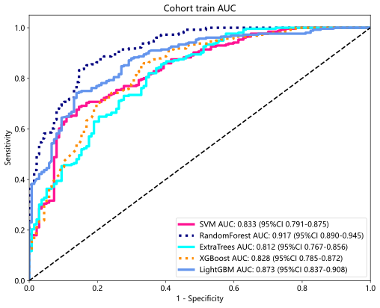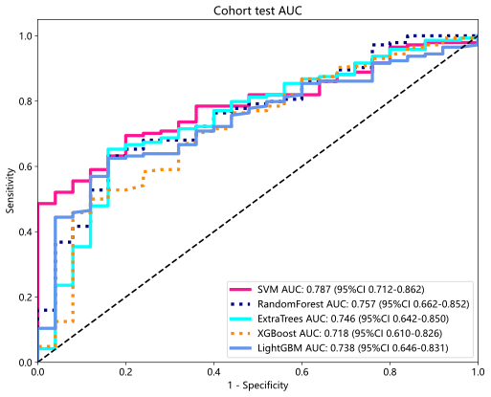
Figure 4 . ROC curves of FLAIR training set and test set

