Table S1 Regression coefficients of clinicoradiological features
 | coef | exp  (coef) | se  (coef) | coef  lower 95% | coef  upper 95% | exp(coef) lower 95% | exp(coef) upper 95%
Supradiaphragmatic lymphadenopathy | 0.16 | 1.18 | 0.19 | -0.21 | 0.54 | 0.81 | 1.72
CA125 | 0.26 | 1.30 | 0.18 | -0.09 | 0.61 | 0.91 | 1.84
HE4 | 0.32 | 1.37 | 0.17 | -0.02 | 0.66 | 0.98 | 1.93
Residual tumor | 0.38 | 1.46 | 0.17 | 0.04 | 0.71 | 1.05 | 2.04
FIGO stage | 0.21 | 1.23 | 0.13 | -0.04 | 0.46 | 0.96 | 1.58

Rad-score formula:
Rad-score = -0.317645 * intra_wavelet_HLL_glcm_Correlation
-0.229768 * intra_log_sigma_3_0_mm_3D_firstorder_Range
-0.222679 * intra_wavelet_HHL_glcm_Idn
-0.182191 * intra_wavelet_HHH_glcm_Idn
-0.116086 * intra_lbp_3D_m2_glszm_SmallAreaEmphasis
-0.073067 * intra_lbp_3D_m2_firstorder_Range
-0.063041 * intra_lbp_3D_m1_glszm_SmallAreaHighGrayLevelEmphasis
-0.051742 * intra_lbp_3D_m1_glszm_HighGrayLevelZoneEmphasis
-0.040741 * intra_exponential_glszm_ZoneEntropy
+0.000272 * intra_log_sigma_3_0_mm_3D_firstorder_Maximum
+0.032377 * intra_square_glcm_Idn
+0.043730 * intra_log_sigma_1_0_mm_3D_glcm_Idn
+0.168587 * intra_lbp_3D_m2_glszm_HighGrayLevelZoneEmphasis
+0.329536 * intra_wavelet_HLL_glcm_Idn

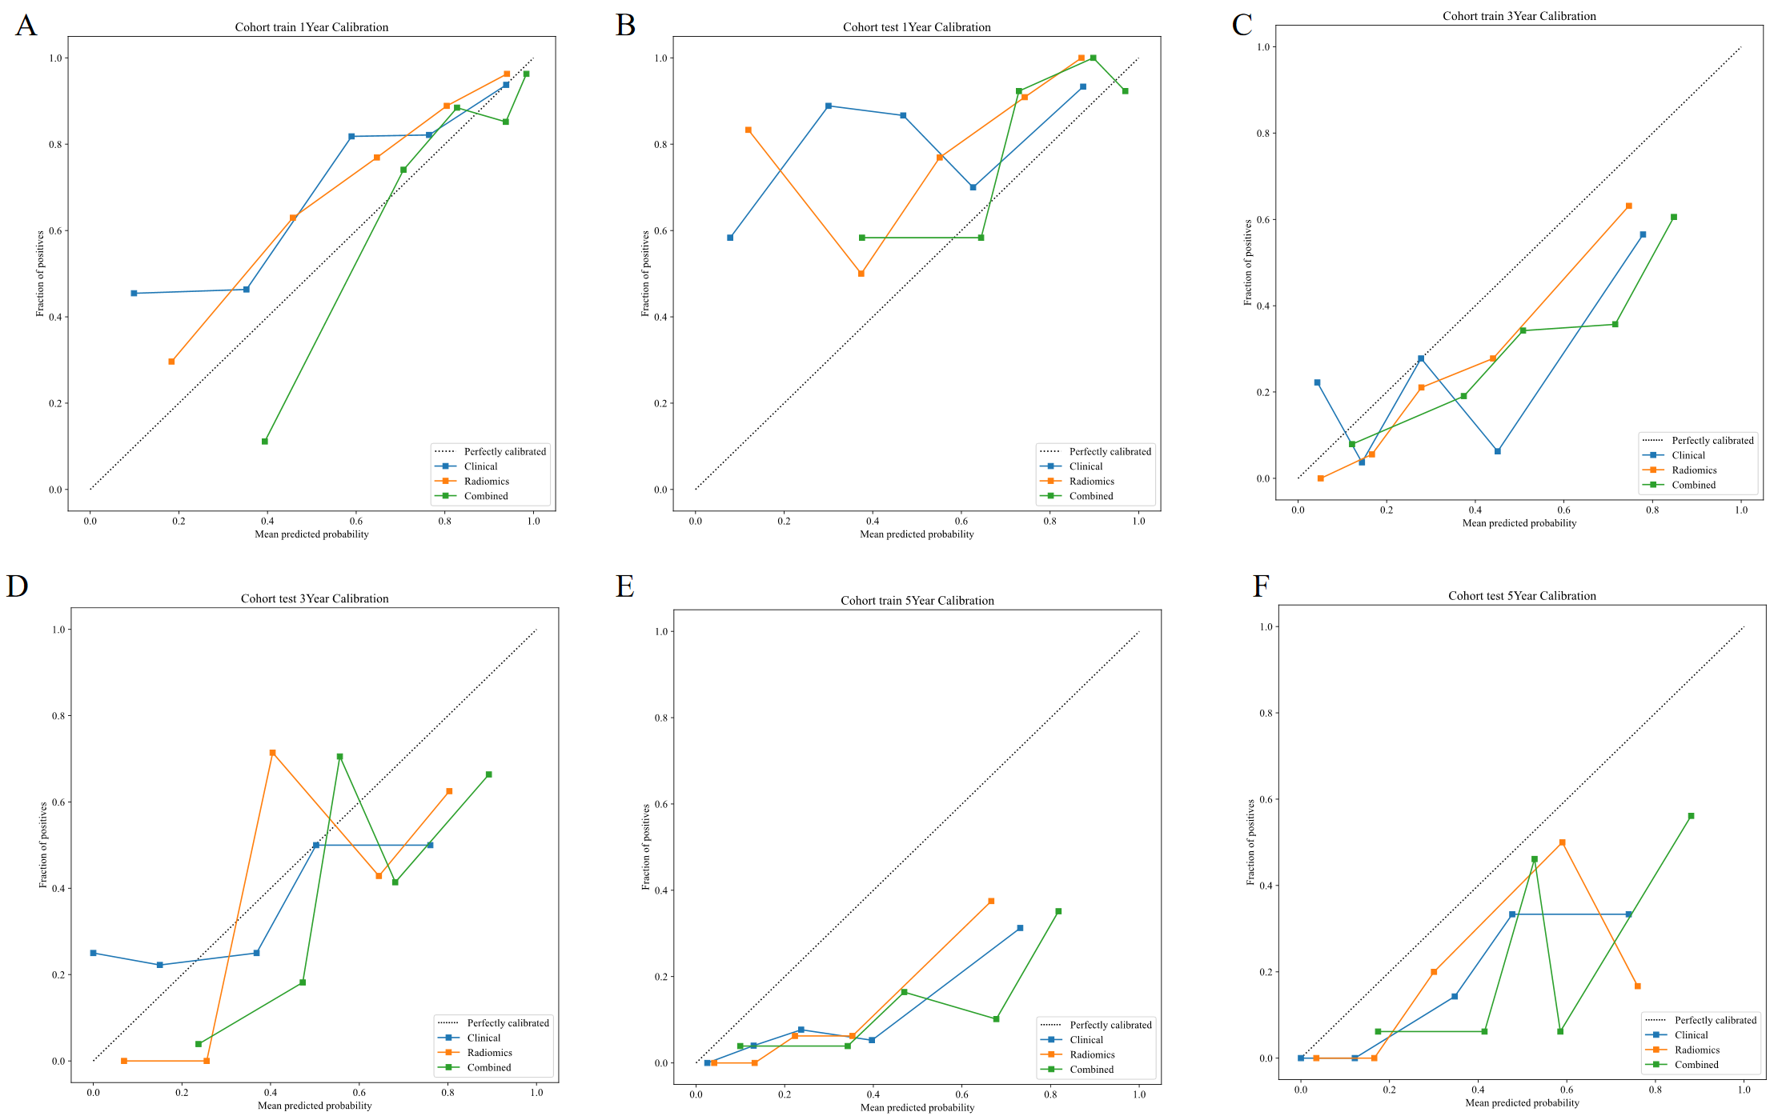
Figure S1. The calibration curves of three models for predicting 1-year, 3-year, and 5-year PFS in the train (A, B, C) and test cohorts(D, E, F).

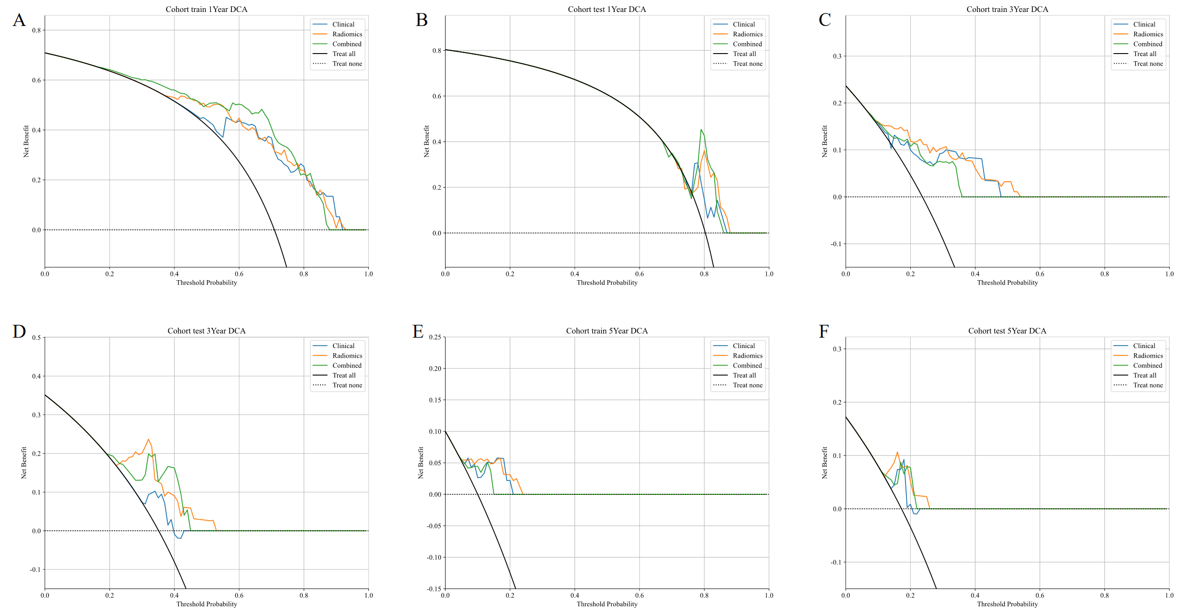
Figure S2. Decision curve analysis of three models for predicting 1-year, 3-year, and 5-year PFS in the train (A, B, C) and test cohorts(D, E, F).

