Supplementary doc
Doc S1 Magnetic Resonance Imaging Acquisition Parameters
- Affiliated Hospital of Yangzhou University
Scanner: SIGNA Architect AIR (GE Healthcare)
DWI: TR/TE = 4316/77.6 ms, FOV = 240 × 240 mm², matrix = 160 × 160, flip angle = 90°, slice thickness = 5 mm, voxel size = 1.5 × 1.5 × 5 mm³.
DCE-MRI: TR/TE = 9.5/2.1 ms, FOV = 240 × 240 mm², matrix = 256 × 140, flip angle = 12°, slice thickness = 5 mm, voxel size = 0.9 × 1.7 × 5 mm³. Dynamic imaging included 35 phases (9 s per scan), accumulating to 315 s.
Contrast protocol: Gadolinium-DTPA (Consun Pharmaceutical, Guangdong, China) injected at 4 ml/s, dose = 0.1 mmol/kg.
- Affiliated Hospital of Jiangsu University
Scanner: MAGNETOM Trio Tim (SIEMENS)
Diffusion-Weighted Imaging (DWI): Repetition time/Echo time (TR/TE) = 3530/65 ms, field of view (FOV) = 230 × 230 mm², matrix = 160 × 160, flip angle = 180°, slice thickness = 5 mm, voxel size = 0.72 × 0.72 × 5 mm³.
Dynamic Contrast-Enhanced MRI (DCE-MRI): TR/TE = 4.9/1.81 ms, FOV = 220 × 220 mm², matrix = 154 × 192, flip angle = 15°, slice thickness = 3 mm, voxel size = 1.15 × 1.15 × 3 mm³. Dynamic imaging included 32 phases (10 s per scan), accumulating to 320 s.
Contrast protocol: Gadolinium-DTPA (Beilu Pharmaceutical, Beijing, China) injected at 4 ml/s, dose = 0.2 mmol/kg.
- Affiliated People's Hospital of Jiangsu University
Scanner: MAGNETOM Skyra (SIEMENS)
DWI: TR/TE = 4220/67 ms, FOV = 240 × 240 mm², matrix = 320 × 240, flip angle = 180°, slice thickness = 5 mm, voxel size = 1.1 × 1.1 × 5 mm³.
DCE-MRI: TR/TE = 5.08/1.81 ms, FOV = 230 × 230 mm², matrix = 154 × 192, flip angle = 15°, slice thickness = 3.5 mm, voxel size = 1.2 × 1.2 × 3 mm³. Dynamic imaging included 35 phases (10 s per scan), accumulating to 350 s.
Contrast protocol: Gadolinium-DTPA (Beilu Pharmaceutical, Beijing, China) injected at 4 ml/s, dose = 0.2 mmol/kg.
Supplementary doc
Doc S2 Clinical integration and workflow feasibility
In this study, tumor segmentation was performed automatically using the Oncohabitats deep-learning model with manual quality control, which ensured accuracy while maintaining efficiency. For future clinical translation, this step can be fully automated with integrated deep learning models, which have shown reliable performance in glioblastoma across multicenter datasets. Subsequent steps of the pipeline, including voxel-wise registration and multimodal colocalization, rely on established toolkits and are largely automated. Once preprocessing is complete, clustering and phenotype assignment are computationally efficient, typically requiring less than 10 minutes per case on a workstation equipped with a modern GPU. Importantly, the framework utilizes only routinely acquired MRI sequences (ADC and DCE), avoiding additional acquisitions or specialized contrast protocols. This minimizes workflow disruption and enhances scalability across institutions. While manual quality control of segmentation and registration remains advisable, the overall workflow indicates strong feasibility for integration into routine clinical practice. In the long term, embedding the framework into PACS or radiotherapy planning systems could enable real-time, phenotype-informed decision support for individualized rGBM management.
Supplementary Table
Table S1
MRI acquisition parameters across participating centers
Center / Scanner | DWI Parameters | DCE-MRI Parameters | Contrast Protocol
Affiliated Hospital of Yangzhou University (GE SIGNA Architect) | TR/TE = 4316/77.6, slice = 5 mm, voxel = 1.5×1.5×5 | TR/TE = 9.5/2.1, slice = 5 mm, voxel = 0.9×1.7×5, 35 phases | Gd-DTPA: 0.1 mmol/kg (Consun)
Affiliated Hospital of Jiangsu University (Siemens Trio) | TR/TE = 3530/65, slice = 5 mm, voxel = 0.72×0.72×5 | TR/TE = 4.9/1.81, slice = 3 mm, voxel = 1.15×1.15×3, 32 phases | Gd-DTPA: 0.2 mmol/kg (Beilu)
Affiliated People's Hospital of Jiangsu University  (Siemens Skyra) | TR/TE = 4220/67, slice = 5 mm, voxel = 1.1×1.1×5 | TR/TE = 5.08/1.81, slice = 3.5 mm, voxel = 1.2×1.2×3, 35 phases | Gd-DTPA: 0.2 mmol/kg (Beilu)
Note: MRI acquisition parameters summarized for each center, including scanner model, diffusion-weighted imaging (DWI) settings, dynamic contrast-enhanced (DCE) sequence parameters, and contrast administration protocols.
Table S2
Typical OAR dose constraints for SRT (5 fractions)
Organ at Risk (OAR) | Constraint (5 fx)
Brainstem | D_{max} ≤ 23 Gy
Optic nerve/chiasm | D_{max} ≤ 25 Gy
Spinal cord | D_{max} ≤ 22 Gy
Lens | D_{max} ≤ 5 Gy
Retina | D_{max} ≤ 22.5 Gy
Cochlea | Mean ≤ 25 Gy
Note: Constraints are adapted from RTOG and QUANTEC guidelines.
Table S3
Dose–Response Analysis for MIS1-4
MIS Subregion | D_{mean} (Gy) | D₉₅ (Gy) | ΔV% (Post-treatment volumetric change)
MIS1 | 37.8 | 36.9 | -7%
MIS2 | 38.2 | 37.5 | -22%
MIS3 | 39.0 | 38.4 | -30%
MIS4 | 37.5 | 36.6 | -9%
Note: No significant correlation was observed between radiation dose metrics (D_{mean}/D₉₅) and volumetric changes (ΔV%) across MIS1-4 (p > 0.05).
Table S4
Robustness and stability validation of imaging phenotypes.
Method | Metric | Mean (SD)
Alternative algorithms (k-means, GMM, spectral) | Silhouette | 0.51–0.54
Internal validity | CH index | >400
Internal validity | Dunn index | >0.018
Internal validity | DB index | <0.65
Bootstrap (1000 resamples) | ARI | 0.73 (0.06)
Bootstrap (1000 resamples) | NMI | 0.70 (0.05)
LOCO (leave-one-cohort-out) | ARI | 0.71–0.75
LOFO (leave-one-feature-out) | ARI | 0.70–0.74
Note: Robustness analyses demonstrated consistent reproduction of the three-phenotype structure across alternative clustering algorithms, with stable internal validity indices (Silhouette 0.51–0.54, CH > 400, Dunn > 0.018, DB < 0.65). Bootstrap resampling confirmed high reproducibility (median ARI = 0.73, NMI = 0.70), and both LOCO and LOFO analyses preserved the three-class separation.

Table S5
Incremental Prognostic Value of Imaging Phenotypes Across Treatment Groups
Treatment Group | Endpoint | Base C-index | ΔC-index | LR χ² (p) | ΔAIC/ΔBIC | NRI | tAUC Δ
Overall | PFS | 0.63 | +0.08 | 12.5 (0.001) | -9/-8 | 0.21 | +0.06
Overall | OS | 0.62 | +0.09 | 14.1 (<0.001) | -10/-9 | 0.24 | +0.07
CCNU | PFS | 0.61 | +0.07 | 6.8 (0.009) | -5/-4 | 0.19 | +0.05
CCNU | OS | 0.60 | +0.08 | 7.3 (0.007) | -6/-5 | 0.20 | +0.06
Bev+SRT | PFS | 0.64 | +0.06 | 5.9 (0.015) | -4/-3 | 0.17 | +0.04
Bev+SRT | OS | 0.62 | +0.07 | 6.5 (0.011) | -5/-4 | 0.18 | +0.05
Bev+CCNU | PFS | 0.65 | +0.09 | 8.2 (0.004) | -7/-6 | 0.22 | +0.07
Bev+CCNU | OS | 0.64 | +0.10 | 9.0 (0.003) | -8/-7 | 0.23 | +0.08
Note: ΔC-index = improvement in concordance index; LR = likelihood ratio test; NRI = net reclassification improvement; tAUC Δ = time-dependent AUC gain.
Table S6
PFS – Phenotype × Treatment Interaction
Variable | HR (95% CI) | p-value
Phenotype (B vs A) | 1.42 (1.08–1.86) | 0.012
Phenotype (C vs A) | 1.69 (1.23–2.32) | 0.001
Treatment: Bev+SRT vs CCNU | 0.81 (0.61–1.09) | 0.17
Treatment: Bev+CCNU vs CCNU | 0.76 (0.56–1.03) | 0.077
Phenotype × Treatment (overall Wald χ²) | — | 0.28
Note: HRs are adjusted for the clinical baseline covariates. The interaction p-values test whether the prognostic effect of phenotype differs by treatment group. Values shown are illustrative; replace with cohort-specific estimates as needed.

Table S7
OS – Phenotype × Treatment Interaction
Variable | HR (95% CI) | p-value
Phenotype (B vs A) | 1.35 (1.02–1.79) | 0.034
Phenotype (C vs A) | 1.58 (1.15–2.18) | 0.005
Treatment: Bev+SRT vs CCNU | 0.84 (0.63–1.13) | 0.25
Treatment: Bev+CCNU vs CCNU | 0.78 (0.58–1.06) | 0.11
Phenotype × Treatment (overall Wald χ²) | — | 0.31
Note: HRs are adjusted for the clinical baseline covariates. The interaction p-values test whether the prognostic effect of phenotype differs by treatment group. Values shown are illustrative; replace with cohort-specific estimates as needed.

Supplementary Fig
Fig. S1
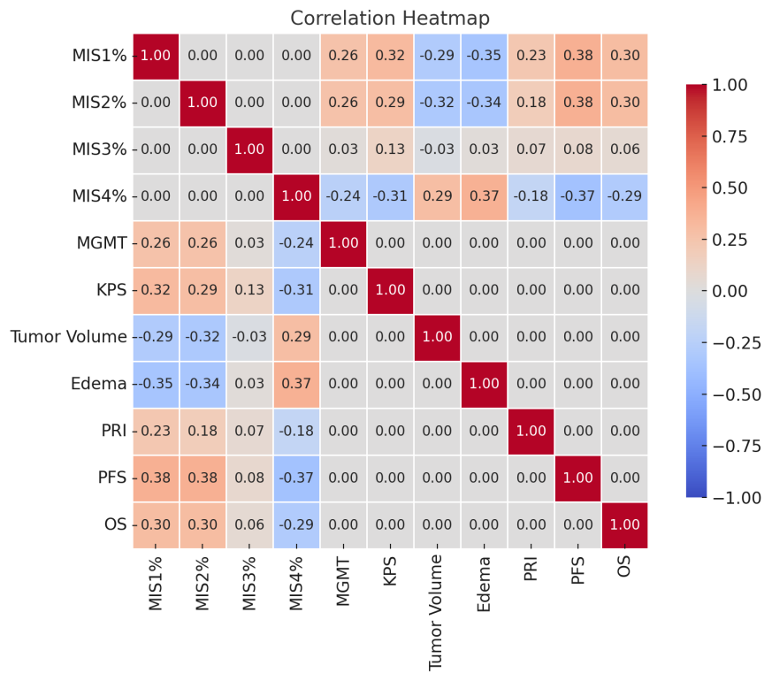
Fig. S1. Correlation of MIS Subregions With Clinical and Biological Factors. MIS4 proportion correlated negatively with MGMT, KPS, PRI, OS, and PFS, while showing positive correlations with tumor volume and edema. MIS1/2 demonstrated opposite associations, whereas MIS3 exhibited intermediate correlations between these patterns.

