Pre-contrast $T_{2} map$ (gray) & DCE-MRI (color overlay)  Post-contrast $T_{2} map$(gray) & DCE-MRI (color overlay) | 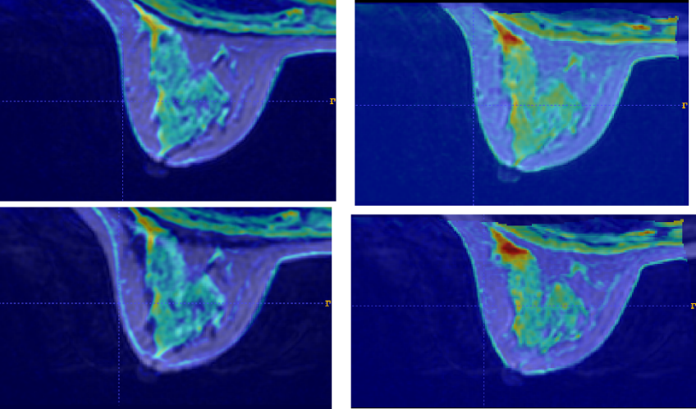  (Before Registration) (After Registration)
Additional file 2. Overlay of T2 map and DCE-MRI before and after registration.

