Supplementary Information 1 The inclusion and exclusion criteria of patients’ enrollment.
The inclusion criteria were as follows:
(i) patients performed brain radiotherapy;(ii) patients with brain surgery; and(iii) adequate image quality for radiomic and dosimic analysis.
The exclusion criteria were as follows:
(i) patients had other brain iliness; (ii) patients cannot complete radiotherapy; and (iii) treatment response cannot be assessed.
Supplementary Information 2 The RANO criteria for determining treatment response.
The Response Assessment in Neuro-Oncology (RANO) criteria were used to determine an outcome of CR (complete disappearance of all enhancing measurable, nonmeasurable, and nontarget disease sustained for at least 4 weeks), PR (≥50% decrease in the sum of products of perpendicular diameters, or ≥65% decrease in total volume, of all measurable enhancing target lesions sustained for at least 4 weeks), SD (neither sufficient shrinkage to qualify for PR nor sufficient increase to qualify for PD), and PD (≥25% increase in sum of the products of perpendicular diameters, or ≥40% increase in total volume of enhancing target lesions, on stable or increasing doses of corticosteroids).
Supplementary Information 3 CT and Dose Map Data Acquisition, Image Processing.
Each patient underwent a CT scan for treatment planning using the Brilliance CT Big Bore scanner (Philips Medical Systems, Cleveland, OH, USA) 1 to 3 days before radiation therapy. The imaging parameters of all patient CT scans were as follows: voltage (140 kVp), tube current (223 mA), exposure time (1265 ms - 1609 ms), pixel size (0.642×0.642 mm -1.1× 1.1 mm), slice thickness (3 mm-5mm), and matrices of images (X: 512, Y: 512, Z: 100-180). Then the DICOM format dose maps were converted to NIFITI format, CT images and dose maps were resampled to obtain a voxel size of 1 mm × 1 mm × 1 mm. Intensity normalization of CT images was implemented to the 0–255 gray level by 3DSlicer.
We used ANTS for images registration, the dose maps were registered to the CT images by nonlinear registration. And the GTVs, GTVtbs and CTVs from the planning CT were used as the mask to define the radiotherapy target volumes in the dose map. This approach ensures that all shape features in our dosiomics analysis were extracted from dose-segmented GTVs, GTVtbs and CTVs, i.e., from the registered dose distribution confined within anatomically defined masks.
Supplementary Information 4 Radiomic and dosiomic features
Radiomic and dosiomic features (shown in Supplementary Table.1) categorized into three classes according to their mathematical expression, including : (i) 18 first-order features (describe the distribution of the intensity within the tumor); (ii) 14 shape-based features (describing the tumor, including voxel volume, surface area); and (iii) 75 textural features (describe the statistical relationships between voxels and their surroundings as a function of both distance and intensity), including gray-level co-occurrence matrix (GLCM, 24 features), gray-level run length matrix (GLRLM, 16 features), gray-level size zone matrix (GLSZM, 16 features), gray-level dependence matrix (GLDM, 14), and neighbouring gray tone difference matrix (NGTDM,5 features).
It is worth noting that in this study, the GTVs, GTVtbs, and CTVs received doses ranging from 40 Gy to 70 Gy, delivered in 30–33 fractions. In our analysis, dose-segmented dosiomics was specifically based on the V₄₀ Gy volumes, defined as the regions of the radiotherapy target receiving at least 40 Gy.
We used the Pyradiomics (http://www.radiomics.io/ pyradiomics.html) [1] feature parameters which include a bin width of 25 to extract features from CT images and a bin width of 1 to extract features from dose map. Smaller bin widths can capture more detailed features but may introduce noise and increase computational complexity. Larger bin widths may lose some detail but help reduce noise and improve feature stability, making them suitable for multi-center and cross-device radiomics studies. In this study, we aimed to closely observe the spatial heterogeneity of the dose distribution and extract more detailed features. Given that this is a single-center study with a limited sample size, we set the bin width to 1 for dose maps. For each radiotherapy target volume, 107 radiomic features and 107 dosiomic features were extracted separately.
Supplementary Information 5 The detailed descriptions of SHAP summary plots for CTV_combined SVM model
SHAP summary plots offered a visually concise representation of the range and distribution of each feature's importance on the model's output, relating the feature’s value to its impact. In Fig. 5, we highlighted the top ten features of the CTV_combined model, noting that four dosiomic features and three radiomic features were useful for discriminating between DCR and non-DCR classifications.
The density plots for D.shape_Maximum2DDiameterSlice and D.firstorder_Minimum illustrated that the SHAP values of these features varied across the cohort. The coloring indicated that the model's output increased as the values of these features increased. Conversely, the color representation for the D.Shape_MajorAxisLength and D.firstorder_Variance demonstrated that the model's output increased as the values of these features decreased.
Supplementary Information 6 The detailed descriptions of SHAP force plots for CTV_combined SVM model
The force plot provided an interpretation of a single patient's assessment by visualizing the SHAP value of each feature as a force that increases or decreases the assessment. Each prediction started with the base value, which is the average SHAP value of all predictions. The length of the arrow indicated the extent (in percentage) to which a particular feature contributed to the SHAP value, and the color represented whether the contributions were positive (red) or negative (blue).
As shown in Fig.6 (a), the SHAP value for this patient was 0.83, which was higher than the base value, indicating that the patient could be assessed as belonging to the non-DCR classification. Among these features, the positive (red) D.MDS(Maximum2DDiameterSlice) arrow with a value of 0.39 had a significant contribution to the assessment of the non- DCR group. In Fig.6(b), for another patient, the SHAP value was -1.24, which was lower than the base value. Thus, it was assessed that this patient belonged to the DCR group. The D.MDS arrow with a value of -1.08 made a negative (blue) contribution to assessing the non-DCR classification.

References
1. van Griethuysen JJM, Fedorov A, Parmar C, Hosny A, Aucoin N, Narayan V, Beets-Tan RGH, Fillion-Robin JC, Pieper S, Aerts H: Computational Radiomics System to Decode the Radiographic Phenotype. Cancer Res 2017, 77(21):e104-e107.

Supplementary Table 1 Detailed description of features extracted from CT images and dose maps.
Feature classes | Feature lists | Feature classes | Feature lists
shape | Elongation | glcm | SumEntropy
shape | Flatness | glcm | SumSquares
shape | LeastAxisLength | gldm | DependenceEntropy
shape | MajorAxisLength | gldm | DependenceNonUniformity
shape | Maximum2DDiameterColumn | gldm | DependenceNonUniformityNormalized
shape | Maximum2DDiameterRow | gldm | DependenceVariance
shape | Maximum2DDiameterSlice | gldm | GrayLevelNonUniformity
shape | Maximum3DDiameter | gldm | GrayLevelVariance
shape | MeshVolume | gldm | HighGrayLevelEmphasis
shape | MinorAxisLength | gldm | LargeDependenceEmphasis
shape | Sphericity | gldm | LargeDependenceHighGrayLevelEmphasis
shape | SurfaceArea | gldm | LargeDependenceLowGrayLevelEmphasis
shape | SurfaceVolumeRatio | gldm | LowGrayLevelEmphasis
shape | VoxelVolume | gldm | SmallDependenceEmphasis
firstorder | 10Percentile | gldm | SmallDependenceHighGrayLevelEmphasis
firstorder | 90Percentile | gldm | SmallDependenceLowGrayLevelEmphasis
firstorder | Energy | glrlm | GrayLevelNonUniformity
firstorder | Entropy | glrlm | GrayLevelNonUniformityNormalized
firstorder | InterquartileRange | glrlm | GrayLevelVariance
firstorder | Kurtosis | glrlm | HighGrayLevelRunEmphasis
firstorder | Maximum | glrlm | LongRunEmphasis
firstorder | MeanAbsoluteDeviation | glrlm | LongRunHighGrayLevelEmphasis
firstorder | Mean | glrlm | LongRunLowGrayLevelEmphasis
firstorder | Median | glrlm | LowGrayLevelRunEmphasis
firstorder | Minimum | glrlm | RunEntropy
firstorder | Range | glrlm | RunLengthNonUniformity
firstorder | RobustMeanAbsoluteDeviation | glrlm | RunLengthNonUniformityNormalized
firstorder | RootMeanSquared | glrlm | RunPercentage
firstorder | Skewness | glrlm | RunVariance
firstorder | TotalEnergy | glrlm | ShortRunEmphasis
firstorder | Uniformity | glrlm | ShortRunHighGrayLevelEmphasis
firstorder | Variance | glrlm | ShortRunLowGrayLevelEmphasis
glcm | Autocorrelation | glszm | GrayLevelNonUniformity
glcm | ClusterProminence | glszm | GrayLevelNonUniformityNormalized
glcm | ClusterShade | glszm | GrayLevelVariance
glcm | ClusterTendency | glszm | HighGrayLevelZoneEmphasis
glcm | Contrast | glszm | LargeAreaEmphasis
glcm | Correlation | glszm | LargeAreaHighGrayLevelEmphasis
glcm | DifferenceAverage | glszm | LargeAreaLowGrayLevelEmphasis
glcm | DifferenceEntropy | glszm | LowGrayLevelZoneEmphasis
glcm | DifferenceVariance | glszm | SizeZoneNonUniformity
glcm | Id | glszm | SizeZoneNonUniformityNormalized
glcm | Idm | glszm | SmallAreaEmphasis
glcm | Idmn | glszm | SmallAreaHighGrayLevelEmphasis
glcm | Idn | glszm | SmallAreaLowGrayLevelEmphasis
glcm | Imc1 | glszm | ZoneEntropy
glcm | Imc2 | glszm | ZonePercentage
glcm | InverseVariance | glszm | ZoneVariance
glcm | JointAverage | ngtdm | Busyness
glcm | JointEnergy | ngtdm | Coarseness
glcm | JointEntropy | ngtdm | Complexity
glcm | MCC | ngtdm | Contrast
glcm | MaximumProbability | ngtdm | Strength
glcm | SumAverage

Supplementary Table 2 Univariate and multivariable logistic analysis of clinical features for predicting the treatment response.

Variables | Univariate analysis |  |  |  | Multivariate analysis
Variables | Odds ratio | 95% CI | P-value | R² | Odds ratio | 95% CI | P-value | R²
Age | 1.180 | 0.776-1.793 | 0.439 | 0.005 | — | — | — | —
Gender | 0.879 | 0.585-1.322 | 0.536 | 0.003 | — | — | — | —
Tumor type | 1.224 | 0.815-1.837 | 0.329 | 0.007 | — | — | — | —
Tumor Grade | 1.266 | 0.832-1.926 | 0.271 | 0.010 | — | — | — | —
KPS | 0.768 | 0.512-1.153 | 0.204 | 0.013 | — | — | — | —
Chemotherapy use | 1.301 | 0.772-2.193 | 0.322 | 0.009 | — | — | — | —
Supplementary Table 3 Univariate and multivariable logistic analysis of CTV dosimetric features for predicting the treatment response.
Variables | Univariate analysis |  |  |  | Multivariate analysis
Variables | Odds ratio | 95% CI | P-value | R² | Odds ratio | 95% CI | P-value | R²
CTV_Mean dose (GY) | 0.767 | 0.504-1.168 | 0.216 | 0.013 | — | — | — | —
CTV_Min dose (GY) | 0.738 | 0.487-1.118 | 0.152 | 0.017 | — | — | — | —
CTV_Max dose (GY) | 0.925 | 0.613-1.395 | 0.709 | 0.001 | — | — | — | —
CTV_D2% (GY) | 0.891 | 0.591-1.343 | 0.580 | 0.002 | — | — | — | —
CTV_D50% (GY) | 0.765 | 0.500-1.171 | 0.218 | 0.013 | — | — | — | —
CTV_D98% (GY) | 0.740 | 0.487-1.126 | 0.160 | 0.016 | — | — | — | —

Supplementary Table 4 Univariate and multivariable logistic analysis of GTV dosimetric features for predicting the treatment response.
Variables | Univariate analysis |  |  |  | Multivariate analysis
Variables | Odds ratio | 95% CI | P-value | R² | Odds ratio | 95% CI | P-value | R²
GTV_Mean dose (GY) | 0.896 | 0.54-1.486 | 0.67 | 0.002 | — | — | — | —
GTV_Min dose (GY) | 0.831 | 0.5-1.383 | 0.477 | 0.006 | — | — | — | —
GTV_Max dose (GY) | 0.929 | 0.561-1.537 | 0.773 | 0.001 | — | — | — | —
GTV_D2% (GY) | 0.923 | 0.558-1.528 | 0.756 | 0.001 | — | — | — | —
GTV_D50% (GY) | 0.902 | 0.544-1.496 | 0.69 | 0.002 | — | — | — | —
GTV_D98% (GY) | 0.834 | 0.499-1.395 | 0.49 | 0.006 | — | — | — | —

Supplementary Table 5 Univariate and multivariable logistic analysis of GTVtb dosimetric features for predicting the treatment response.
Variables | Univariate analysis |  |  |  | Multivariate analysis
Variables | Odds ratio | 95% CI | P-value | R² | Odds ratio | 95% CI | P-value | R²
GTVtb_Mean dose (GY) | 0.680 | 0.346-1.336 | 0.263 | 0.026 | — | — | — | 0.169
GTVtb_Min dose (GY) | 0.297 | 0.102-0.863 | 0.026 | 0.17 | 0.343 | 0.205-0.696 | 0.001 | 0.169
GTVtb_Max dose (GY) | 0.913 | 0.468-1.78 | 0.789 | 0.001 | — | — | — | 0.169
GTVtb_D2% (GY) | 0.836 | 0.430-1.625 | 0.597 | 0.006 | — | — | — | 0.169
GTVtb_D50% (GY) | 0.683 | 0.348-1.341 | 0.268 | 0.026 | — | — | — | 0.169
GTVtb_D98% (GY) | 0.516 | 0.254-1.05 | 0.068 | 0.074 | 1.146 | 0.515-2.618 | 0.779 | 0.169

Supplementary Table 6 Univariate and multivariable logistic analysis of CTV-GTV dosimetric features for predicting the treatment response.
Variables | Univariate analysis |  |  |  | Multivariate analysis
Variables | Odds ratio | 95% CI | P-value | R² | Odds ratio | 95% CI | P-value | R²
CTV-GTV_Mean dose (GY) | 0.792 | 0.472-1.328 | 0.376 | 0.01 | — | — | — | —
CTV-GTV _Min dose (GY) | 0.880 | 0.532-1.457 | 0.620 | 0.003 | — | — | — | —
CTV-GTV _Max dose (GY) | 0.921 | 0.556-1.525 | 0.750 | 0.001 | — | — | — | —
CTV-GTV _D2% (GY) | 0.880 | 0.529-1.464 | 0.623 | 0.003 | — | — | — | —
CTV-GTV _D50% (GY) | 0.776 | 0.458-1.313 | 0.345 | 0.011 | — | — | — | —
CTV-GTV _D98% (GY) | 0.824 | 0.495-1.371 | 0.455 | 0.007 | — | — | — | —

Supplementary Table 7 Univariate and multivariable logistic analysis of CTV-GTVtb dosimetric features for predicting the treatment response.
Variables | Univariate analysis |  |  |  | Multivariate analysis
Variables | Odds ratio | 95% CI | P-value | R2 | Odds ratio | 95% CI | P-value | R²
CTV-GTVtb_Mean dose (GY) | 0.520 | 0.254-1.063 | 0.073 | 0.073 | 1.018 | 0.678-1.62 | 0.909 | 0.140
CTV-GTVtb _Min dose (GY) | 0.382 | 0.155-0.942 | 0.037 | 0.127 | 0.604 | 0.265-1.285 | 0.171 | 0.140
CTV-GTVtb _Max dose (GY) | 0.867 | 0.446-1.684 | 0.673 | 0.004 | — | — | — | 0.140
CTV-GTVtb _D2% (GY) | 0.745 | 0.385-1.442 | 0.382 | 0.016 | — | — | — | 0.140
CTV-GTVtb _D50% (GY) | 0.546 | 0.271-1.099 | 0.09 | 0.063 | 0.907 | 0.575-1.533 | 0.742 | 0.140
CTV-GTVtb _D98% (GY) | 0.224 | 0.05-1.0 | 0.05 | 0.139 | 0.581 | 0.360-0.919 | 0.016 | 0.140

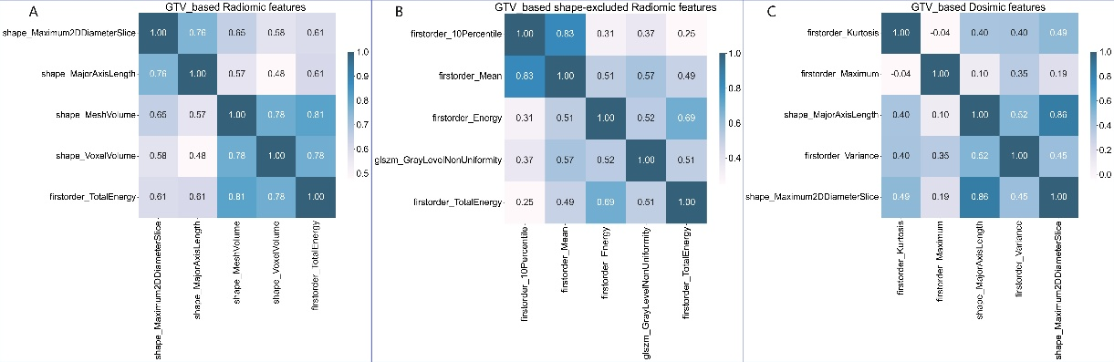
Supplementary Fig.1 Spearman correlation coefficients between each pair of radiomic features (a), radiomic features (selected from the shape-feature-excluded radiomic feature set) (b) and dosimic features (C) in GTV.

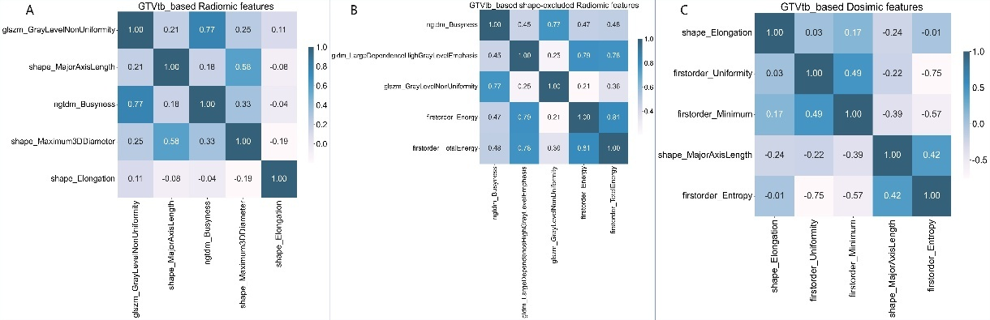
Supplementary Fig.2 Spearman correlation coefficients between each pair of radiomic features (a), radiomic features (selected from the shape-feature-excluded radiomic feature set) (b) and dosimic features (C) in GTVtb.

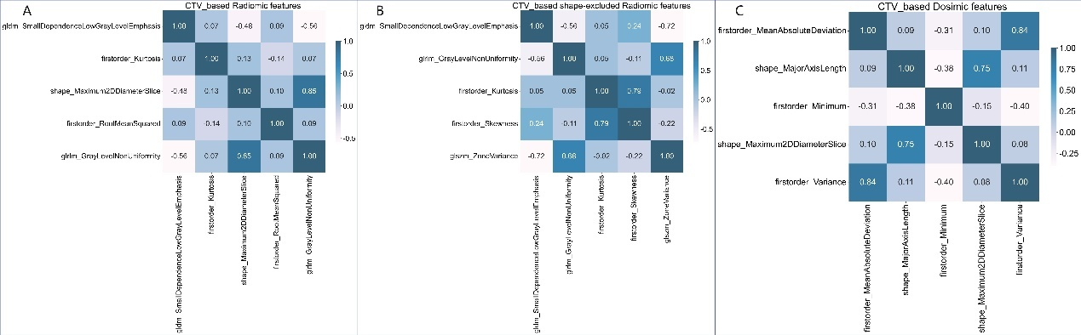
Supplementary Fig.3 Spearman correlation coefficients between each pair of radiomic features (a), radiomic features (selected from the shape-feature-excluded radiomic feature set) (b) and dosimic features (C) in CTV.

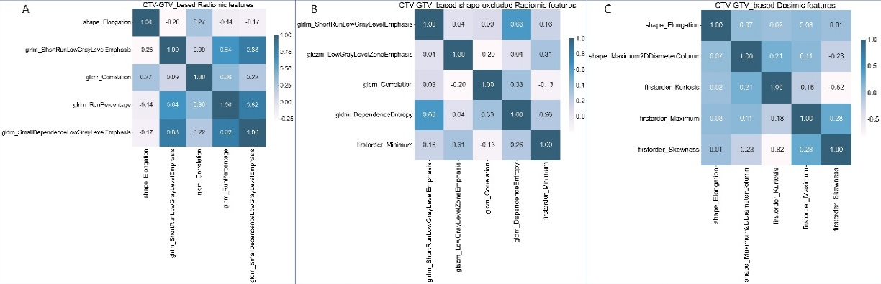
Supplementary Fig.4 Spearman correlation coefficients between each pair of radiomic features (a), radiomic features (selected from the shape-feature-excluded radiomic feature set) (b) and dosimic features (C) in CTV-GTV.

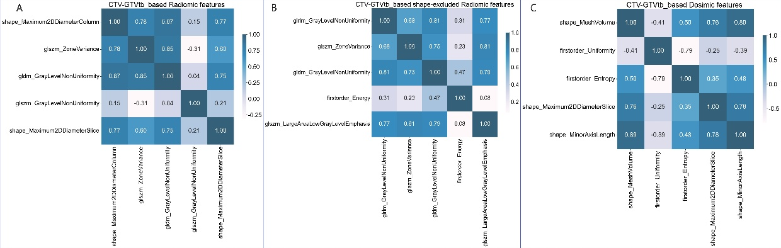
Supplementary Fig.5 Spearman correlation coefficients between each pair of radiomic features (a), radiomic features (selected from the shape-feature-excluded radiomic feature set) (b) and dosimic features (C) in CTV-GTVtb.

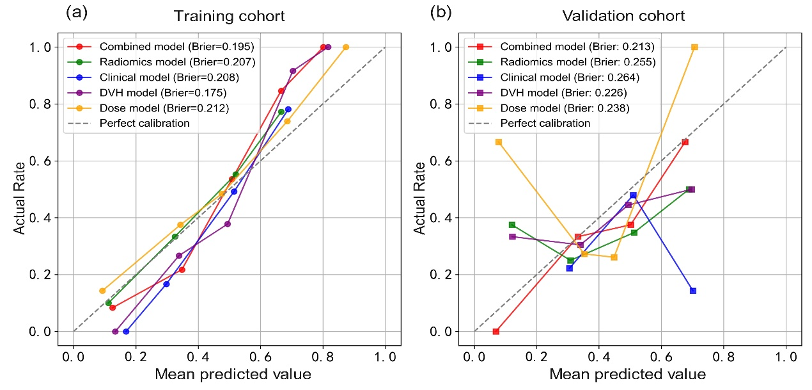
Supplementary Fig.6 Calibration curves of CTV_based models in the training cohort (a) and validation cohort (b). It depicted the calibration of each model on the basis of agreement between the predicted probability of treatment response and actual rate.

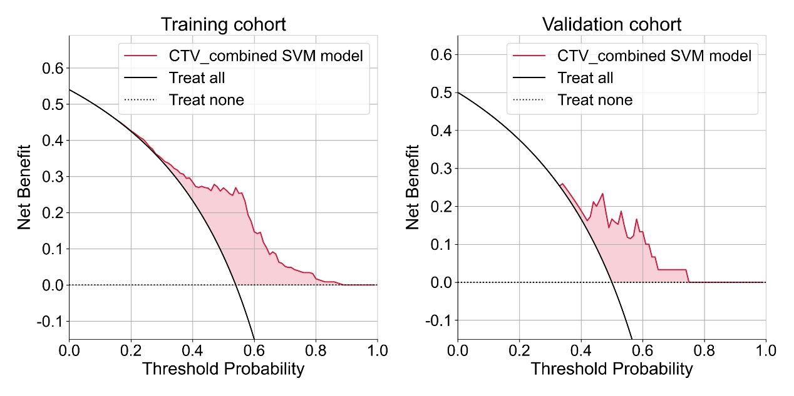

Supplementary Fig.7 Decision curves of CTV_combined SVM model in the training cohort (a) and validation cohort (b). It was employed to evaluate the clinical usefulness and net benefit of the CTV_ combined SVM model. As shown in the decision curves, the CTV_combined SVM model yields a consistently higher net benefit than the "Treat all" and "Treat none" strategies in both cohorts. In the training set, its advantage is most pronounced within the 0.30–0.80 threshold range. In the validation set, it retains favorable performance between 0.30 and 0.75, indicating good generalizability. Overall, the model demonstrates stable clinical utility in the low-to-intermediate threshold range, supporting its use in identifying patients at moderate or low risk.

Supplementary Table.8 The P-value of DeLong test to compare the AUC of the CTV_combined SVM model with that of other CTV_based SVM models.
 | Dosiomic model | Radiomic model | DVH model | Clinical model
Training cohort
Combined model | 0.0000 | 0.0001 | 0.0000 | 0.0000
Validation cohort
Combined model | 0.0000 | 0.0004 | 0.0000 | 0.0002

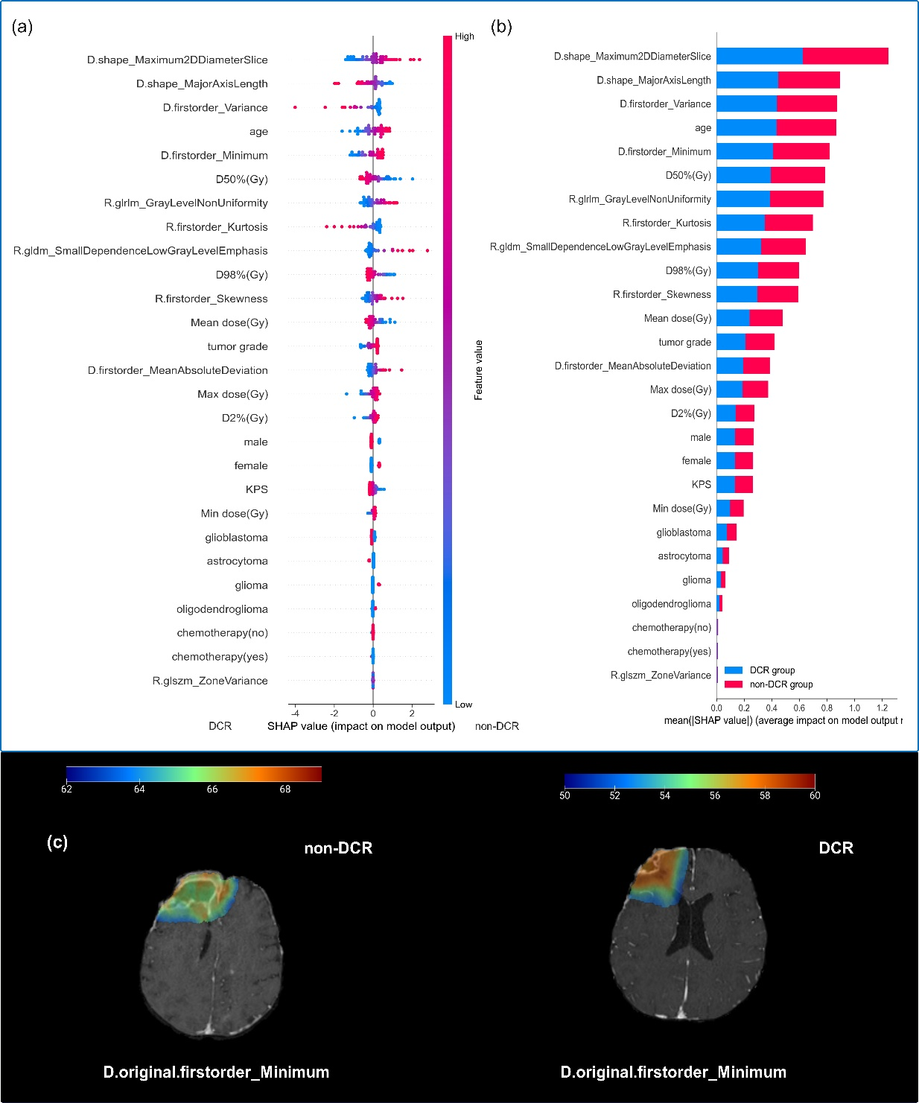

Supplementary Fig.8 SHAP summary plots (a) of the CTV_Combined SVM model and the overall contribution of each feature to the model prediction classification in order of importance (b); panel (c) illustrates the voxel-wise feature maps of “D.original.firstorder_Minimum” for two representative patients from the DCR and non-DCR groups, respectively. The DCR patient exhibits an effective dose gradient, which may be associated with improved radiotherapy response.

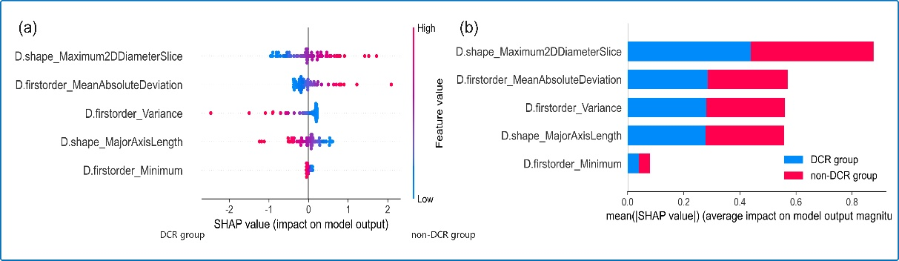
Supplementary Fig.9 SHAP summary plots (a) of the CTV_dosiomic SVM model and the overall contribution of each feature to the model prediction classification in order of importance (b).

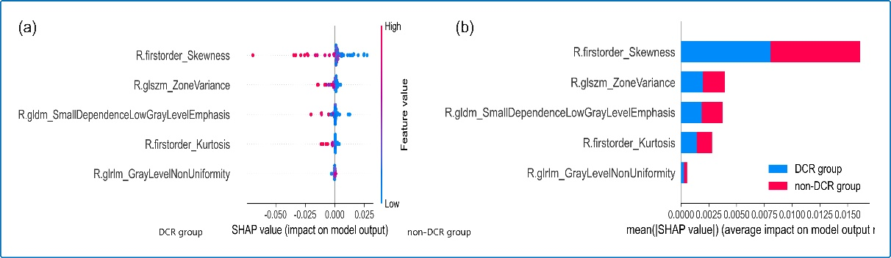
Supplementary Fig.10 SHAP summary plots (a) of the CTV_Radiomic SVM model and the overall contribution of each feature to the model prediction classification in order of importance (b).

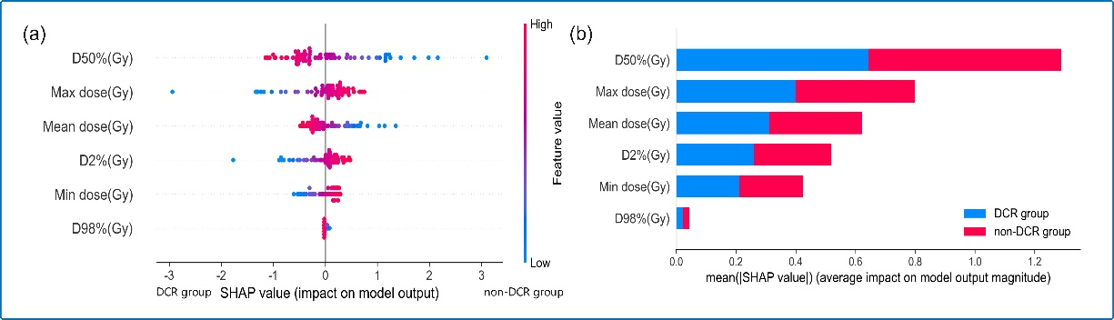
Supplementary Fig.11 SHAP summary plots (a) of the CTV_DVH SVM model and the overall contribution of each feature to the model prediction classification in order of importance (b).

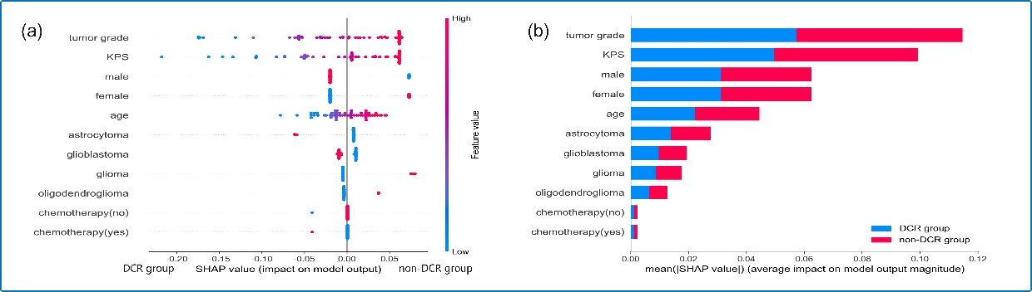
Supplementary Fig.12 SHAP summary plots (a) of the CTV_Clinical SVM model and the overall contribution of each feature to the model prediction classification in order of importance (b).

Supplementary Table.9 Univariate and multivariable logistic analysis of features from the CTV_combined model for predicting the treatment response.
Variable | Univariate analysis |  |  |  | Multivariate analysis
Variable | Odds Ratio | 95% CI | P-value | pseudoR² | Odds Ratio | 95% CI | P-value | pseudoR²
age | 1.108 | 0.686-1.791 | 0.675 | 0.002 | —— | —— | —— | 0.412
KPS | 0.305 | 0.152-0.61 | 0.001 | 0.159 | 0.266 | 0.108-0.655 | 0.004 | 0.412
Gender | 0.552 | 0.211-1.446 | 0.227 | 0.015 | —— | —— | —— | 0.412
tumor type | 2.222 | 1.263-3.91 | 0.006 | 0.093 | 1.629 | 0.819-3.243 | 0.164 | 0.412
Grade | 1.753 | 1.064-2.888 | 0.028 | 0.054 | 0.957 | 0.505-1.814 | 0.892 | 0.412
chemotherapy | 0.314 | 0.031-3.174 | 0.326 | 0.011 | —— | —— | —— | 0.412
Mean_dose_Gy | 0.699 | 0.445-1.097 | 0.119 | 0.029 | —— | —— | —— | 0.412
Min_dose_Gy | 0.636 | 0.378-1.07 | 0.088 | 0.033 | 30.074 | 0.116-7808.003 | 0.23 | 0.412
Max_dose_Gy | 0.878 | 0.588-1.312 | 0.526 | 0.004 | —— | —— | —— | 0.412
D2%_Gy | 0.865 | 0.579-1.294 | 0.481 | 0.005 | —— | —— | —— | 0.412
D50%_Gy | 0.711 | 0.454-1.113 | 0.136 | 0.026 | —— | —— | —— | 0.412
D98%_Gy | 0.515 | 0.275-0.967 | 0.039 | 0.061 | 0.195 | 0.023-1.657 | 0.134 | 0.412
R.gldm_SmallDependenceLowGrayLevelEmphasis | 1.452 | 0.903-2.333 | 0.124 | 0.031 | —— | —— | —— | 0.412
R.glrlm_GrayLevelNonUniformity | 1.052 | 0.653-1.693 | 0.836 | 0.000 | —— | —— | —— | 0.412
R.firstorder_Kurtosis | 1.338 | 0.764-2.342 | 0.308 | 0.013 | 1.508 | 0.752-6.005 | 0.322 | 0.412
R.firstorder_Skewness | 1.573 | 0.953-2.597 | 0.076 | 0.035 | 1.074 | 0.495-2.331 | 0.857 | 0.412
R.glszm_ZoneVariance | 0.632 | 0.316-1.265 | 0.195 | 0.022 | —— | —— | —— | 0.412
D.firstorder_MeanAbsoluteDeviation | 11.790 | 2.806-49.543 | 0.001 | 0.175 | 21.856 | 0.993-481.071 | 0.051 | 0.412
D.shape_MajorAxisLength | 1.079 | 0.672-1.734 | 0.753 | 0.001 | —— | —— | —— | 0.412
D.firstorder_Minimum | 0.559 | 0.316-0.987 | 0.045 | 0.048 | 0.13 | 0.0-50.573 | 0.502 | 0.412
D.shape_Maximum2DDiameterSlice | 1.005 | 0.618-1.633 | 0.985 | 0.000 | —— | —— | —— | 0.412
D.firstorder_Variance | 355.487 | 2.429-52028.532 | 0.021 | 0.118 | 0.244 | 0.0-315.167 | 0.699 | 0.412

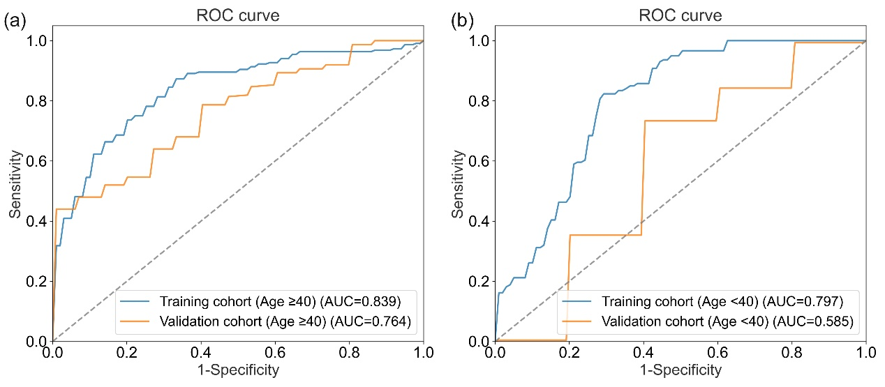
Supplementary Fig.13 The CTV_combined SVM model predictive performance in age subgroups (≤40 vs. >40 years).

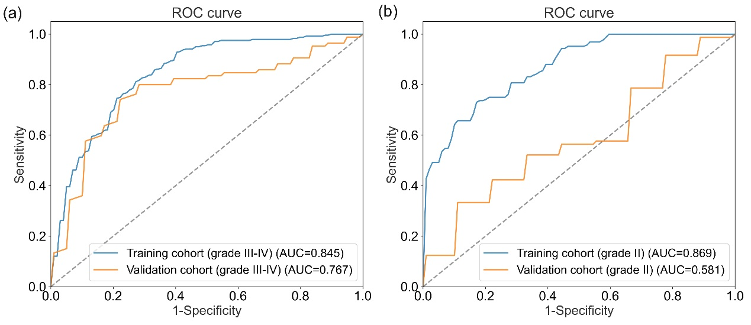
Supplementary Fig.14 The CTV_combined SVM model predictive performance in tumor grades (WHO grade 2 vs. grade 3–4).

Supplementary Table.10 Performance of the CTV_Combined SVM model for assessing radiotherapy treatment response in subgroups.
Subgroups | Training cohort |  |  |  |  | Validation cohort
Subgroups | AUC (95%CI) | SENS | SPEC | Precision | Accuracy | AUC (95%CI) | SENS | SPEC | Precision | Accuracy
Tumor grade III-IV | 0.845 (0.814-0.876) | 0.725 | 0.775 | 0.762 | 0.750 | 0.767 (0.745-0.789) | 0.529 | 0.889 | 0.84 | 0.714
Tumor grade II | 0.869 (0.854-0.884) | 0.625 | 0.889 | 0.714 | 0.808 | 0.581 (0.573-0.590) | 0.094 | 1.000 | 1.000 | 0.547
age ＜ 40 years | 0.797 (0.721-0.874) | 0.333 | 0.583 | 0.286 | 0.500 | 0.585 (0.560-0.610) | 0.378 | 0.644 | 0.476 | 0.511
age ≥40 years | 0.839 (0.820-0.858) | 0.855 | 0.633 | 0.743 | 0.755 | 0.764 (0.720-0.809) | 0.680 | 0.627 | 0.645 | 0.653

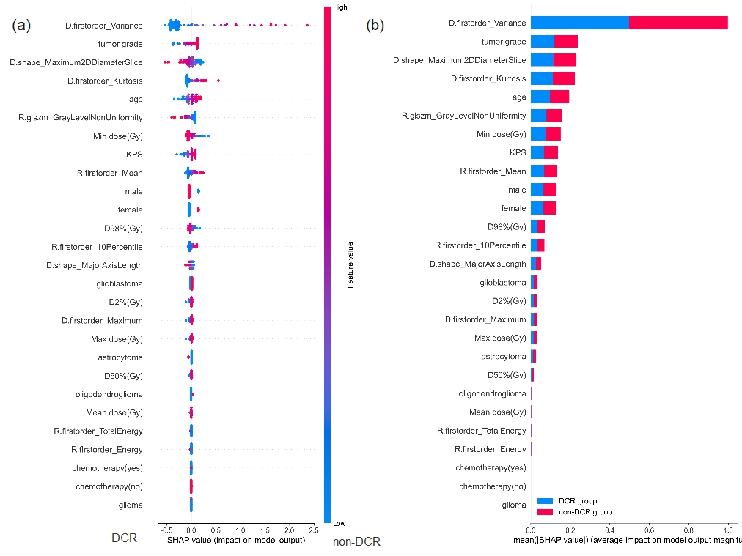
Supplementary Fig.15 SHAP summary plots (a) of the GTV_ Combined XGBoost model and the overall contribution of each feature to the model prediction classification in order of importance (b).

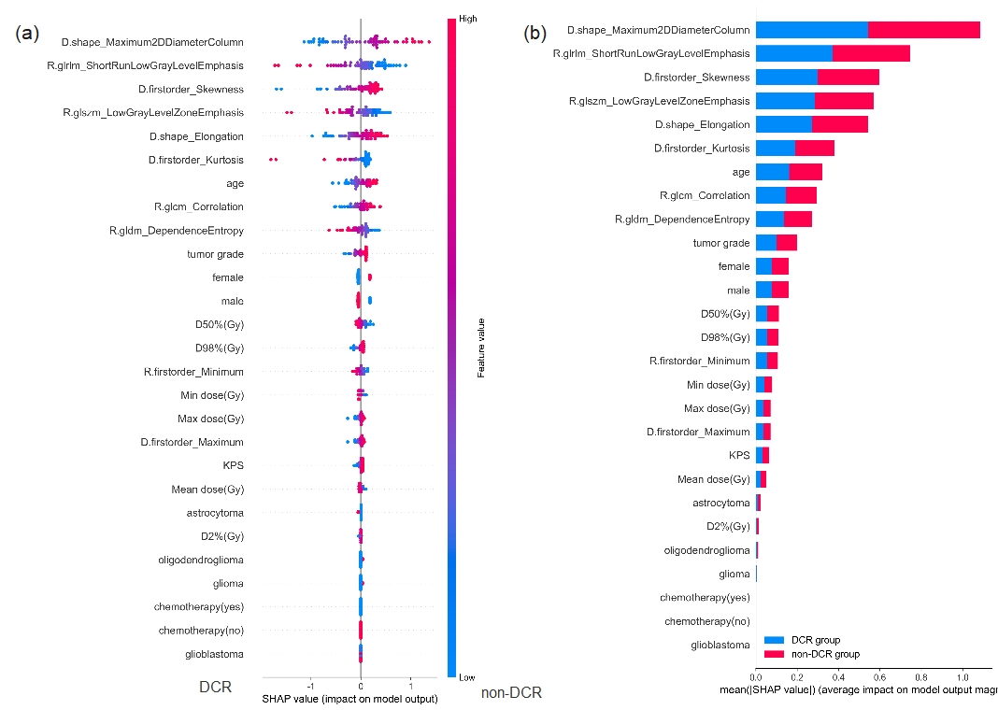
Supplementary Fig.16 SHAP summary plots (a) of the CTV-GTV_Combined LR model and the overall contribution of each feature to the model prediction classification in order of importance (b).
Supplementary Table.11 Univariate and multivariable logistic analysis of features from the GTV_combined model for predicting the treatment response.
Variable | Univariate analysis |  |  |  | Multivariate analysis
Variable | Odds Ratio | 95% CI | P-value | pseudoR² | Odds Ratio | 95% CI | P-value | pseudoR²
age | 1.329 | 0.765-2.311 | 0.313 | 0.015 | —— | —— | —— | 0.06
KPS | 0.831 | 0.492-1.402 | 0.487 | 0.007 | —— | —— | —— | 0.06
Gender | 0.765 | 0.371-1.574 | 0.467 | 0.007 | —— | —— | —— | 0.06
tumor type | 1.139 | 0.797-1.627 | 0.474 | 0.007 | —— | —— | —— | 0.06
Grade | 1.086 | 0.803-1.467 | 0.593 | 0.004 | —— | —— | —— | 0.06
chemotherapy | 0.456 | 0.089-2.332 | 0.345 | 0.037 | —— | —— | —— | 0.06
Mean_dose_Gy | 0.934 | 0.552-1.582 | 0.8 | 0.001 | —— | —— | —— | 0.06
Min_dose_Gy | 0.867 | 0.527-1.425 | 0.573 | 0.004 | —— | —— | —— | 0.06
Max_dose_Gy | 0.965 | 0.573-1.625 | 0.892 | 0 | —— | —— | —— | 0.06
D2%_Gy | 0.957 | 0.568-1.614 | 0.87 | 0 | —— | —— | —— | 0.06
D50%_Gy | 0.941 | 0.556-1.592 | 0.82 | 0.001 | —— | —— | —— | 0.06
D98%_Gy | 0.868 | 0.511-1.476 | 0.601 | 0.004 | —— | —— | —— | 0.06
R.firstorder_10Percentile | 0.92 | 0.537-1.576 | 0.762 | 0.001 | —— | —— | —— | 0.06
R.firstorder_Energy | 0.48 | 0.166-1.386 | 0.175 | 0.043 | —— | —— | —— | 0.06
R.firstorder_Mean | 0.919 | 0.545-1.551 | 0.752 | 0.001 | —— | —— | —— | 0.06
R.firstorder_TotalEnergy | 0.48 | 0.166-1.386 | 0.175 | 0.043 | —— | —— | —— | 0.06
R.glszm_GrayLevelNonUniformity | 0.533 | 0.275-1.036 | 0.064 | 0.06 | 0.533 | 0.275-1.036 | 0.064 | 0.06
D.firstorder_Kurtosis | 1.075 | 0.668-1.731 | 0.765 | 0.001 | —— | —— | —— | 0.06
D.firstorder_Maximum | 0.963 | 0.571-1.624 | 0.887 | 0 | —— | —— | —— | 0.06
D.firstorder_Variance | 1.458 | 0.795-2.675 | 0.223 | 0.025 | —— | —— | —— | 0.06
D.shape_MajorAxisLength | 0.673 | 0.389-1.166 | 0.158 | 0.029 | —— | —— | —— | 0.06
D.shape_Maximum2DDiameterSlice | 0.653 | 0.375-1.139 | 0.133 | 0.034 | —— | —— | —— | 0.06

Supplementary Table.12 Univariate and multivariable logistic analysis of features from the CTV-GTV_combined model for predicting the treatment response.
Variable | Univariate analysis |  |  |  | Multivariate analysis
Variable | Odds Ratio | 95% CI | P-value | pseudoR² | Odds Ratio | 95% CI | P-value | pseudoR²
age | 1.325 | 0.762-2.303 | 0.319 | 0.014 | —— | —— | —— | 0.117
KPS | 0.831 | 0.492-1.402 | 0.487 | 0.007 | —— | —— | —— | 0.117
Gender | 0.765 | 0.371-1.574 | 0.467 | 0.007 | —— | —— | —— | 0.117
tumor type | 1.139 | 0.797-1.627 | 0.474 | 0.007 | —— | —— | —— | 0.117
Grade | 1.086 | 0.803-1.467 | 0.593 | 0.004 | —— | —— | —— | 0.117
chemotherapy | 0.456 | 0.089-2.332 | 0.345 | 0.037 | —— | —— | —— | 0.117
Mean_dose_Gy | 0.837 | 0.494-1.418 | 0.507 | 0.006 | —— | —— | —— | 0.117
Min_dose_Gy | 0.862 | 0.521-1.427 | 0.564 | 0.005 | —— | —— | —— | 0.117
Max_dose_Gy | 0.953 | 0.566-1.607 | 0.858 | 0 | —— | —— | —— | 0.117
D2%_Gy | 0.916 | 0.542-1.55 | 0.745 | 0.001 | —— | —— | —— | 0.117
D50%_Gy | 0.824 | 0.481-1.412 | 0.481 | 0.007 | —— | —— | —— | 0.117
D98%_Gy | 0.857 | 0.513-1.432 | 0.557 | 0.005 | —— | —— | —— | 0.117
R.firstorder_Minimum | 0.773 | 0.434-1.377 | 0.382 | 0.012 | —— | —— | —— | 0.117
R.glcm_Correlation | 1.132 | 0.635-2.015 | 0.674 | 0.002 | —— | —— | —— | 0.117
R.gldm_DependenceEntropy | 0.544 | 0.288-1.028 | 0.061 | 0.057 | 0.714 | 0.353-1.342 | 0.281 | 0.117
R.glrlm_ShortRunLowGrayLevelEmphasis | 0.568 | 0.306-1.056 | 0.074 | 0.05 | 0.642 | 0.313-1.263 | 0.179 | 0.117
R.glszm_LowGrayLevelZoneEmphasis | 0.713 | 0.409-1.24 | 0.231 | 0.021 | —— | —— | —— | 0.117
D.firstorder_Kurtosis | 0.566 | 0.259-1.235 | 0.153 | 0.041 | —— | —— | —— | 0.117
D.firstorder_Maximum | 0.953 | 0.566-1.607 | 0.858 | 0 | —— | —— | —— | 0.117
D.firstorder_Skewness | 1.539 | 0.86-2.752 | 0.146 | 0.033 | —— | —— | —— | 0.117
D.shape_Elongation | 1.532 | 0.848-2.766 | 0.157 | 0.029 | —— | —— | —— | 0.117
D.shape_Maximum2DDiameterColumn | 1.656 | 0.94-2.919 | 0.081 | 0.046 | 1.619 | 0.946-3.491 | 0.09 | 0.117

