Image Analysis of CCTA
High-risk plaque features, including low-attenuation plaque (LAP), positive remodeling (PR), spotty calcification (SC) and napkin-ring sign (NRS) were measured. Detailed definitions of the above parameters were given as the following: 1) LAP was defined as any voxel <30 HU within a coronary plaque, using a dedicated plaque analysis software (Coronary Plaque Analysis, version 5.0.3, Siemens Healthineers); 2) Remodeling index was defined as a maximal lesion vessel diameter divided by proximal reference vessel diameter, with PR defined as a remodeling index ≥ 1.1; 3) SC was defined by an intra-lesion calcific plaque < 3 mm in length that comprised < 90 degrees of the lesion circumference; 4) NRS was characterized by a plaque core with low attenuation areas on CT surrounded by a rim-like area of higher attenuation.
Subtype plaque volumes were calculated based on the Hounsfield units (HU) values: necrotic core plaque (< 30 HU), noncalcified plaque (30–350HU), and calcified plaque (> 350 HU), fibro-fatty plaque (76-130 HU), fibrous plaque (131-350 HU). Necrotic core plaque volume (PV) was estimated based on the presence of low-attenuation plaque, a well-validated imaging biomarker of lipid-rich necrotic core. Necrotic core PV was defined as plaque components with HU values < 30 HU.

CT-FFR measurement
We used a machine-learning based algorithm for fractional flow reserve (FFR) simulation (cFFR, version 3.5.1 Siemens Healthineers), which was a research software and not commercially available. This model was trained on a large database of synthesized coronary anatomies, where the reference values are computed using a computational fluid dynamics based model. The lesion-specific CT-FFR values were measured at the distal shoulder of the lesion, where no plaque could be detected. For the on-site processing, after CCTA data were successfully loaded, the centerline and luminal contours for whole coronary tree were automatically generated. The centerline and luminal contour are fundamental and critical information for computing FFR value. They were manually adjusted when needed. Users then manually identified all stenotic lesions to extract their geometrical features required for cFFR algorithm. Finally, those data were input into the pre-learned model and cFFR was computed automatically at all locations in the coronary arterial tree, and the resulting values were visualized by color- coded 3D coronary maps

Online Table 1. baseline characteristics between participants completed and lost to follow-up
Variables | Participants completed follow-up(n=367) | Participants lost to follow-up (n=24) | P value
Age, (year) | 56.2 ± 9.3 | 56.1 ± 5.0 | 0.995
Male, n(%) | 247(67.3) | 16(66.7) | 0.975
BMI, (kg/m²) | 23.9 ± 2.6 | 23.8 ± 1.6 | 0.902
Risk factors, n(%)
Hypertension | 147(40.0) | 12(50.0) | 0.525
Diabetes mellitus | 116(31.6) | 6(25.0) | 0.653
Dyslipidemia | 105(28.6) | 7(29.2) | 0.861
Tobacco use |  |  | 0.456
Never smoking | 110(29.9) | 10(41.6)
Past smoking | 171(46.6) | 10(41.6)
Current smoking | 86(23.4) | 4(16.6)
Family history of CAD | 77(20.9) | 9(37.5) | 0.101
Presence of MAFLD, n(%) | 135(36.7) | 8(33.3) | 0.903
FAI | -75.8 ± 7.2 | -75.9 ± 3.0 | 0.939
Abbreviation: BMI= Body mass index; CAD= Coronary artery disease; MAFLD= Metabolic dysfunction–associated fatty liver disease; FAI= Fat attenuation index

Online Table 2. Inter-observer Reproducibility
Variables | ICC | 95%CI | P value
Total Agatston score | 0.98 | 0.97, 1.00 | <0.001
Total lesion length | 0.92 | 0.90, 0.94 | <0.001
Obstructive CAD | 0.97 | 0.95, 0.98 | <0.001
High-risk plaque
Low-attenuation plaque | 0.95 | 0.92, 0.97 | <.001
Positive remodeling | 0.92 | 0.90, 0.94 | <0.001
Spotty calcification | 0.94 | 0.90, 0.96 | <0.001
Napkin-ring sign | 0.94 | 0.92, 0.95 | <0.001
Plaque volume
Total PV | 0.96 | 0.94, 0.98 | <.001
Calcified PV | 0.99 | 0.98, 1.00 | <.001
Noncalcified PV | 0.95 | 0.92, 0.97 | <.001
Fibrous PV | 0.94 | 0.92, 0.96 | <.001
Fibro-fatty PV | 0.98 | 0.96, 0.99 | <.001
Low-attenuation PV | 0.99 | 0.98, 1.00 | <.001
CT-FFR | 0.98 | 0.96, 1.00 | <.001
FAI | 0.97 | 0.95, 0.98 | <.001
Liver attenuation measurement | 0.97 | 0.95, 0.98 | <.001
Abbreviation: CAD= Coronary artery disease; CCTA= Coronary CT angiography; CI= Confidence interval; CT-FFR= CT derived fractional flow reserve; FAI= Fat attenuation index; ICC= Intraclass correlation coefficient. MAFLD= Metabolic dysfunction–associated fatty liver disease; PV= Plaque volume.
Online Table 3. Event free survival rate between participants with and without MAFLD
 | With MAFLD | Without MAFLD
24-month event free survival rate
MACEs | 80.6%(72.3%, 88.8%) | 95.2%(91.3%, 99.0%)
Cardiac death | 95.8%(91.6%, 99.9%) | 98.9%(96.6%, 100.0%)
Non-fatal MI | 94.3%(89.0%, 99.5%) | 97.7%(95.0%, 100.0%)
Late revascularizataion | 89.2%(82.6%, 95.7%) | 98.6%(96.6%, 100.0%)
36-month event free survival rate
MACEs | 54.0%(32.2%, 75.7%) | 83.5%(72.7%, 94.2%)
Cardiac death | 75.8%(49.7%, 100.0%) | 96.3%(90.8%, 100.0%)
Non-fatal MI | 82.4%(67.3%, 97.4%) | 96.3%(92.5%, 100.0%)
Late revascularizataion | 87.1%(79.5%, 94.7%) | 90.1%(80.3%, 99.8%)
Abbreviation: MACE= Major adverse cardiovascular event; MAFLD= Metabolic dysfunction–associated fatty liver disease; MI= Myocardial infarction.

Online Table 4. Univariable and multivariable Cox regression analysis: association between MAFLD and MACEs occurrence in three medical centers
Parameters | MACEs occurrence
Parameters | HR | 95%CI | p value
The first medical center (n=138)
Presence of MAFLD | 4.62 | 1.42, 15.05 | 0.011
Model A | 4.54 | 1.38, 14.91 | 0.013
Model B | 4.21 | 1.27, 13.91 | 0.018
Model C | 4.75 | 1.37, 16.48 | 0.014
Model D | 4.33 | 1.22, 15.40 | 0.023
Model E | 4.79 | 1.26, 18.22 | 0.021
Model F | 1.07 | 0.99, 1.17 | 0.071
The second medical center (n=110)
Presence of MAFLD | 4.37 | 1.34, 14.30 | 0.014
Model A | 4.28 | 1.29, 14.12 | 0.017
Model B | 3.79 | 1.15, 12.51 | 0.028
Model C | 4.18 | 1.27, 13.73 | 0.018
Model D | 4.38 | 1.29, 14.88 | 0.018
Model E | 5.09 | 1.37, 18.86 | 0.015
Model F | 1.05 | 0.97, 1.13 | 0.217
The third medical center (n=119)
Presence of MAFLD | 4.30 | 1.31, 14.05 | 0.016
Model A | 4.15 | 1.25, 13.73 | 0.020
Model B | 3.98 | 1.20, 13.22 | 0.024
Model C | 4.43 | 1.27, 15.39 | 0.019
Model D | 4.03 | 1.13, 14.37 | 0.031
Model E | 4.47 | 1.17, 17.05 | 0.028
Model F | 1.08 | 0.97, 16.61 | 0.074
Abbreviation: CI= Confidence interval; HR= Hazard ratio; MACE= Major adverse cardiovascular event; MAFLD= Metabolic dysfunction–associated fatty liver disease.

Online Table 5. Univariable and multivariable Cox regression analysis: association between MAFLD and hard MACEs occurrence
Parameters | hard MACEs occurrence
Parameters | HR | 95%CI | p value
Presence of MAFLD | 4.04 | 1.55, 10.53 | 0.004
Model A | 4.16 | 1.59, 10.91 | 0.004
Model B | 3.36 | 1.22, 9.29 | 0.019
Model C | 4.19 | 1.52, 11.57 | 0.006
Model D | 4.81 | 1.67, 13.77 | 0.003
Model E | 4.69 | 1.62, 13.55 | 0.004
Model F | 1.01 | 0.95, 1.07 | 0.699
Model A: adjusted for age, gender, BMI; model B: model A adjusted further for hypertension, diabetes mellitus, dyslipidemia, current or past tobacco use and family history of CAD; model C: model B adjusted further for aspirin, statin, and ACEI/ARB in use; model D: model C adjusted further for total Agatston score, total lesion length, TPV, high-risk plaque features, including low attenuation plaque, positive remodeling, spotty calcification and napkin-ring sign; model E: model D adjusted further for CT-FFR; model F: model E adjusted further for FAI.
Abbreviation: ACEI= Angiotensin-converting enzyme inhibitor; ARB= Angiotensin receptor blocker; BMI= Body mass index; CAD= Coronary artery disease; CI= Confidence interval; MACE= Major adverse cardiovascular event; MAFLD= Metabolic dysfunction–associated fatty liver disease; CT-FFR= CT derived fractional flow reserve; HR= Hazard ratio; FAI= Fat attenuation index; TPV= Total plaque volume.

Online Figure 1: Kaplan-Meier survival curves of hard MACEs in participants with versus without MAFLD.
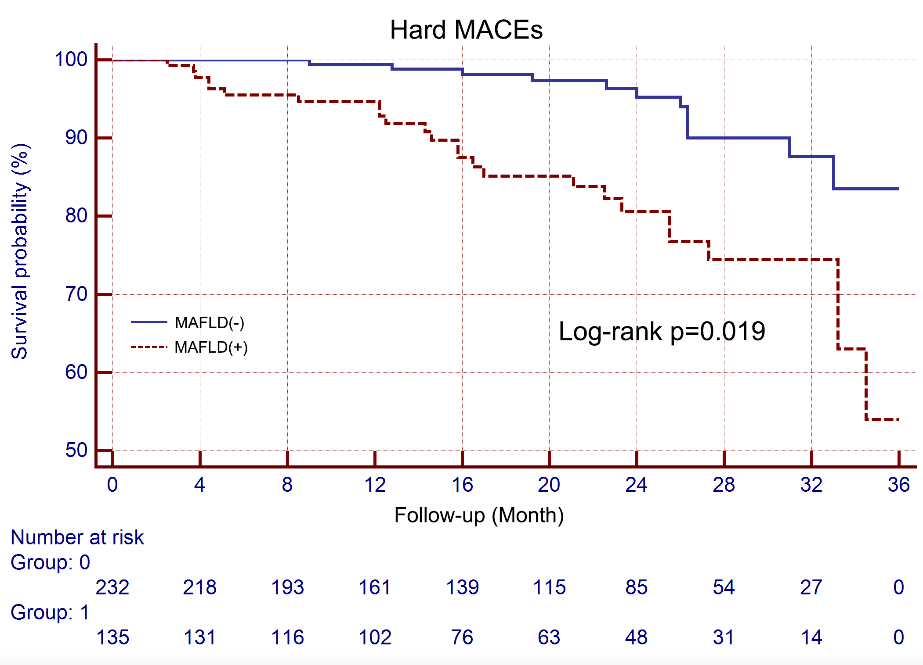
Participants with MAFLD had a significant lower 36-month hard MACEs-free survival rate than participants without MAFLD (62.1% vs. 92.7%, log-rank p= 0.019)

Abbreviations: MACEs= Major adverse cardiovascular events; MAFLD= Metabolic dysfunction–associated fatty liver disease.

