Table S1 The CT protocols of the four centers
Parameters | Hospital 1 | Hospital 2 | Hospital 3
CT version | Discovery CT750 HD (GE Healthcare, USA) or SOMATOM Definition Flash (Siemens Healthcare, Germany) | Brilliance iCT (Philips Healthcare, Netherlands) | Aquilion One (Toshiba Medical Systems, Japan); LightSpeed VCT (GE Healthcare, USA)
CT tube voltage | 100-120 kV | 100–120 kV | 110-120 kV
CT tube current | 200-500 mA | 125–360 mAs | 250-450 mA
Gantry rotation time | 0.50-0.60 s | 0.27s | 0.50s
Detector collimation (mm) | 0.625 mm | 0.625 mm | 0.625 mm
Image matrix | 512*512 | 512*512 | 512*512
Slice thickness | 1-7 mm | 1-7 mm | 1-7 mm
kV = kilovolt, mA = milliampere, mm = milimetre.

Fig. S1 Pearson correlation analysis of radiomics features and LASSO analysis. a LASSO regularization path (λ = 0.02442). b LASSO coefficient path. c The weight of 19 selected radiomics features. d Pearson correlation analysis of selected features.
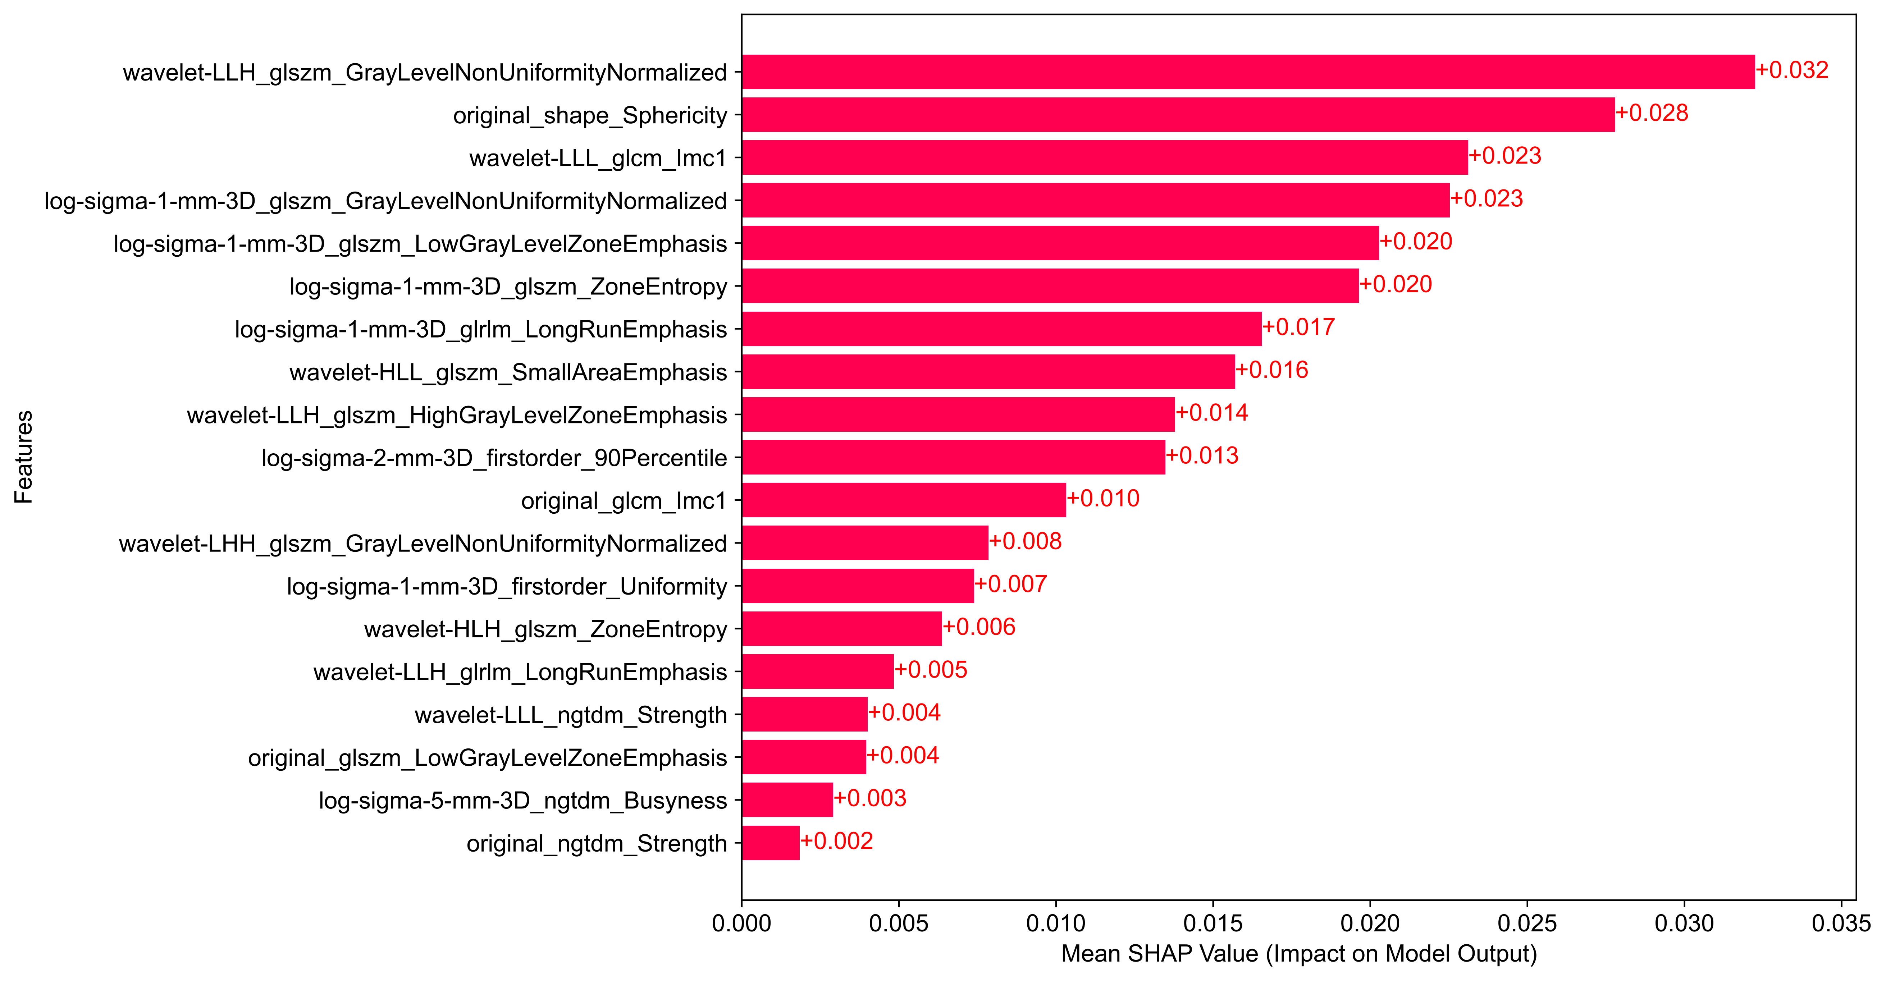
Fig. S2 The SHAP bar plot of radiomics model.

Fig. S3 The SHAP bar plot of combined model.

Table S2 The DeLong test of four machine learning models
Model name | p-value in training set | p-value in testing set
SVM | Ref | Ref
Random Forest | 0.00549 | 0.00412
Naïve Bayes | 0.00232 | 0.00371
XGBoost | 0.00472 | 0.00781

Table S3 The DeLong test of models
Model name | p-value in training set | p-value in testing set
Radiomics model | 0.06773 | 0.04561
Clinical model | < 0.001 | 0.01587
Combined model | Ref | Ref

Table S4 The results of the Cox proportional hazards model analysis
 | Training set |  | Test set
 | HR | 95% CI | HR | 95%CI
Rad-signature | 2.86 | 1.81-4.54 | 2.16 | 1.05-4.45
Combined_model_score | 3.92 | 2.49-6.16 | 2.55 | 1.25-5.21
HR: hazard ratio; CI: confidence interval

Table S5 Basic clinicopathological characteristics of all patients included in this study
 |  | LVI (-) | LVI (+) | p-value
Age (median [IQR]） |  | 67.00  [60.00-74.00] | 67.00  [60.25-74.75] | 0.564
Gender | Female | 52 (12.3%) | 7 (9.7%) | 0.534
 | Male | 371 (87.7%) | 65 (90.3%)
pT | Ta, T1 | 198 (46.8%) | 4 (5.6%) | <0.001
 | T2, T3, T4 | 225 (53.2%) | 68 (94.4%)
pN | N0 | 404 (95.5%) | 56 (77.8%) | <0.001
 | N1, N2 | 19 (4.5%) | 16 (22.2%)
Grade | Low | 67 (15.9%) | 4 (5.6%) | 0.021
 | High | 355 (84.1%) | 68 (94.4%)
Number | Single | 318 (75.2%) | 57 (79.2%) | 0.465
 | Multiple | 105 (24.8%) | 15 (20.8%)
Tumor size | <3cm | 170 (40.2%) | 28 (38.9%) | 0.835
 | ≥3cm | 253 (59.8%) | 44 (61.1%)
Calcification | Absent | 341 (80.6%) | 63 (87.5%) | 0.163
 | Present | 82 (19.4%) | 9 (12.5%)
Boundary | Well-defined | 257 (60.8%) | 49 (68.1%) | 0.239
 | Blurred | 166 (39.2%) | 23 (31.9%)
Growth pattern | Within- wall | 83 (19.6%) | 24 (33.3%) | 0.009
 | Into- cavity | 340 (80.4%) | 48 (66.7%)
DFS time (median [IQR]） |  | 30.30  [11.06-70.63] | 10.40  [4.40-27.99] | <0.001
DFS status  (Recurrence or metastasis) | Yes | 98 (23.2%) | 35 (48.6%) | <0.001
 | No | 325 (76.8%) | 37 (51.4%)

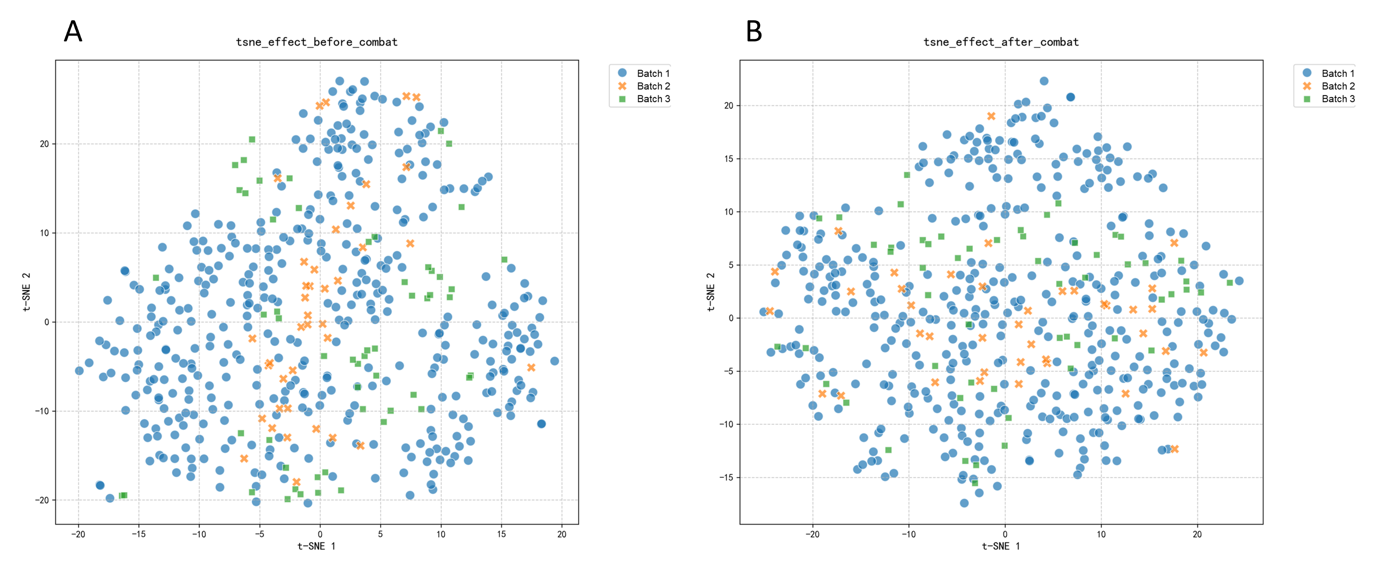
Fig. S4 Data distribution from three centers before and after Combat harmonization. (A)The t-SNE of data from three centers before Combat harmonization. (B) The t-SNE of data from three centers after Combat harmonization.

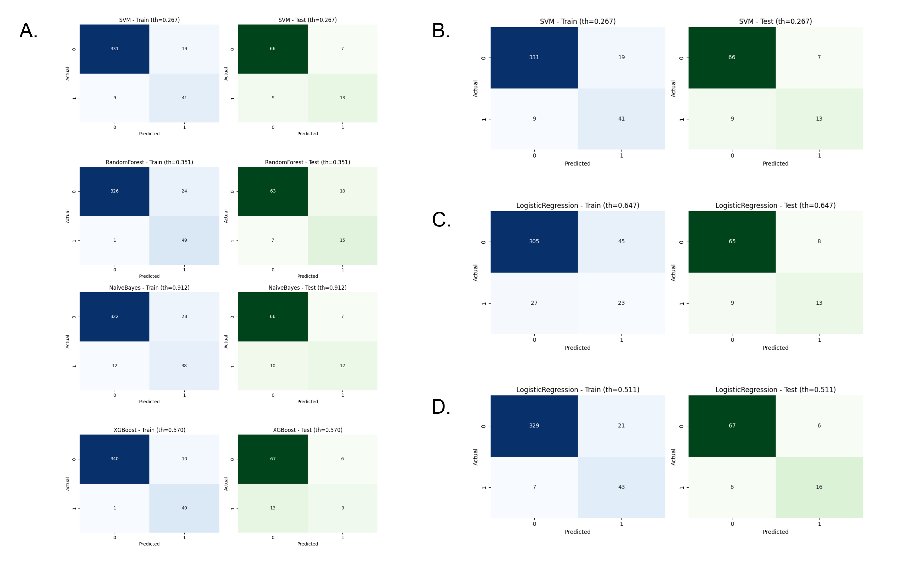
Fig. S5 The confusion matrix of models. (A) The confusion matrixes of four machine learning model, including SVM, RandomForest, NaiveBayes and XGBoost. (B) The confusion matrixes of the best performance machine learning model (SVM). (C) The confusion matrixes of the clinical model. (D) The confusion matrixes of the combined model.

Detailed explanation of class imbalance issue in model construction:
To address class imbalance during feature selection, we applied the sample_weight parameter in the LassoCV function of scikit-learn, assigning each sample a weight inversely proportional to its class frequency (e.g., a 7:1 class ratio was weighted as 1:7). This weighting scheme reduced bias toward the majority class, allowing the model to treat both classes with comparable importance and to select features that better captured discriminative patterns of the minority class.
#Applying sample_weight in LassoCV
sample_weight = np.array([7 if label == 1 else 1 for label in y])
alphas = np.logspace(-4, -1, 50, base = 10)
lassoCV_model = LassoCV(alphas=alphas, cv = 5)
lassoCV_model.fit(X, y,sample_weight=sample_weight)

During model construction, class weighting was applied to counteract class imbalance, enabling the algorithm to assign higher importance to minority class samples and reduce bias toward the majority class. This approach helped the model learn more effectively from underrepresented categories and reduced bias toward the majority class. In addition, the F1-score was selected as the primary performance metric, as it provides a balanced evaluation of both precision and recall, offering a more reliable assessment of model performance under imbalanced data conditions.
# Applying class weight adjustments
params = {
'SVM': {
'class_weight': ['balanced']
},
'XGBoost': {
'scale_pos_weight': [7]
},
'RandomForest': {
'class_weight': ['balanced', 'balanced_subsample']
},
'NaiveBayes': {}
}
# Identification of the Optimal Model Using the F1 Score
for model in models:
grid_search = GridSearchCV(models[model], params[model], cv=5, scoring='f1', n_jobs=-1)
grid_search.fit(X_train, y_train)

