Supplementary Materials
Table 17. GC-VNN Architecture Configuration
Layer | Input Dimension | Output Dimension | Activation Function | Dropout
Input | 128 × 128 | 128 × 128 | – | –
ViT | 128 × 128 | 128 × 128 | – | –
GC Layer 1 | 128 × 128 (Heads = 4) | 128 × 128 | LeakyReLU (α=0.2) | 0.3
GC Layer 2 | 128 × 128 (Heads = 4) | 256 × 256 | LeakyReLU (α=0.2) | 0.3
GC Layer 3 | 256 × 256 (Heads = 8) | 256 × 256 | LeakyReLU (α=0.2) | 0.3
GC Layer 4 | 256 × 256 (Heads = 8) | 128 × 128 | LeakyReLU (α=0.2) | 0.3
GC Layer 5 | 128 × 128 (Heads = 4) | 128 × 128 | LeakyReLU (α=0.2) | 0.3
GC Layer 6 | 128 × 128 (Heads = 4) | 128 × 128 | LeakyReLU (α=0.2) | 0.3
Pooling | 128 × 128 (Pool = 2x 2) | 1 × 64 | – | –
Dense 1 | 1 × 64 | 1 x 256 | ReLU | –
Dense 2 | 1 x 256 | 1 x 9 | Softmax | –

Table 18. GBFIO-DSNDA Feature Selection Outcome.
Class | Orientation Bins |  |  |  |  |  |  |  | Directionality
Class | Bin 0 | Bin 1 | Bin 2 | Bin 3 | Bin 4 | Bin 5 | Bin 6 | Bin 7 | 0° | 45° | 90° | 135°
AK | 7532 | 4558 | 5216 | 6911 | 8130 | 4955 | 5599 | 7275 | 0.020379 | 0.020512 | 0.021638 | 0.020188
BCC | 7909 | 3946 | 5058 | 7729 | 8572 | 4197 | 5216 | 7549 | 0.033089 | 0.032884 | 0.035742 | 0.033223
BKL | 8263 | 4167 | 5555 | 7308 | 8354 | 4348 | 5283 | 6898 | 0.042410 | 0.042756 | 0.045604 | 0.042532
DF | 8829 | 4880 | 4913 | 6573 | 8490 | 4771 | 4839 | 6881 | 0.023190 | 0.022902 | 0.023769 | 0.023293
NV | 9832 | 5012 | 5690 | 5991 | 7823 | 4672 | 4716 | 6440 | 0.033252 | 0.032283 | 0.035782 | 0.033356
Melanoma | 9037 | 4270 | 5069 | 6870 | 8040 | 4241 | 5461 | 7188 | 0.032143 | 0.031880 | 0.034437 | 0.031399
SK | 7847 | 4101 | 5441 | 7223 | 7359 | 4371 | 5638 | 8196 | 0.021091 | 0.021603 | 0.023234 | 0.020907
SCC | 8069 | 5005 | 5600 | 7270 | 8123 | 4615 | 4887 | 6607 | 0.021961 | 0.021667 | 0.023681 | 0.021965
VASC | 7745 | 4560 | 5514 | 7378 | 7611 | 4678 | 5876 | 6814 | 0.020953 | 0.021084 | 0.021812 | 0.020688

Table 19 presents the detailed classification performance of the proposed OSCC-Net across nine skin lesion classes. The model achieves high precision ranging from 0.982 for DF to 0.986 for Melanoma, while recall varies between 0.983 for AK, Melanoma, and VASC to 0.985 for BCC and NV. The F1-scores remain consistently strong, from 0.983 for DF to 0.985 for NV, indicating balanced performance across classes.
Figure 12 shows the confusion matrix of the proposed OSCC-Net for nine skin lesion classes. The diagonal values indicate correct classifications, with high counts such as 2589 for AK, 2535 for BCC, 2652 for BKL, 2552 for DF, 2614 for NV, 2483 for Melanoma, 2518 for SK, 2563 for SCC, and 2483 for VASC, reflecting excellent model accuracy. Here, misclassifications are minimal, typically ranging from 0 to 6 per class, showing strong class discrimination. Figure 13 illustrates the Area Under the Curve with Receiver Operating Characteristic (AUC-ROC) performance of the proposed OSCC-Net, where all classes achieve exceptionally high AUC values ranging from 0.998 to 0.999, indicating outstanding discrimination capability.

Table 19. Classification Report of Proposed OSCC-Net.
Class | Precision | Recall | F1-Score | Sensitivity | Specificity
AK | 0.985 | 0.983 | 0.984 | 0.9916 | 0.99927
BCC | 0.983 | 0.985 | 0.984 | 0.9926 | 0.99889
BKL | 0.984 | 0.984 | 0.984 | 0.9918 | 0.99912
DF | 0.982 | 0.984 | 0.983 | 0.9899 | 0.99898
NV | 0.985 | 0.985 | 0.985 | 0.9943 | 0.99883
Melanoma | 0.986 | 0.983 | 0.984 | 0.9924 | 0.99932
SK | 0.984 | 0.984 | 0.984 | 0.9917 | 0.99879
SCC | 0.984 | 0.984 | 0.984 | 0.9923 | 0.99893
VASC | 0.985 | 0.983 | 0.984 | 0.9904 | 0.99874

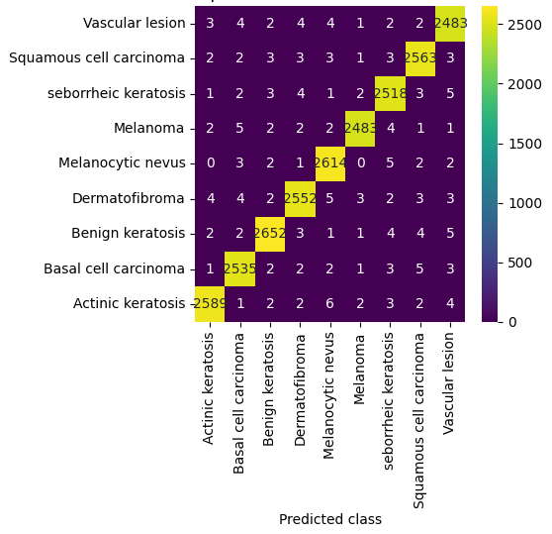
Figure 12. Confusion Matrix of Proposed OSCC-Net.
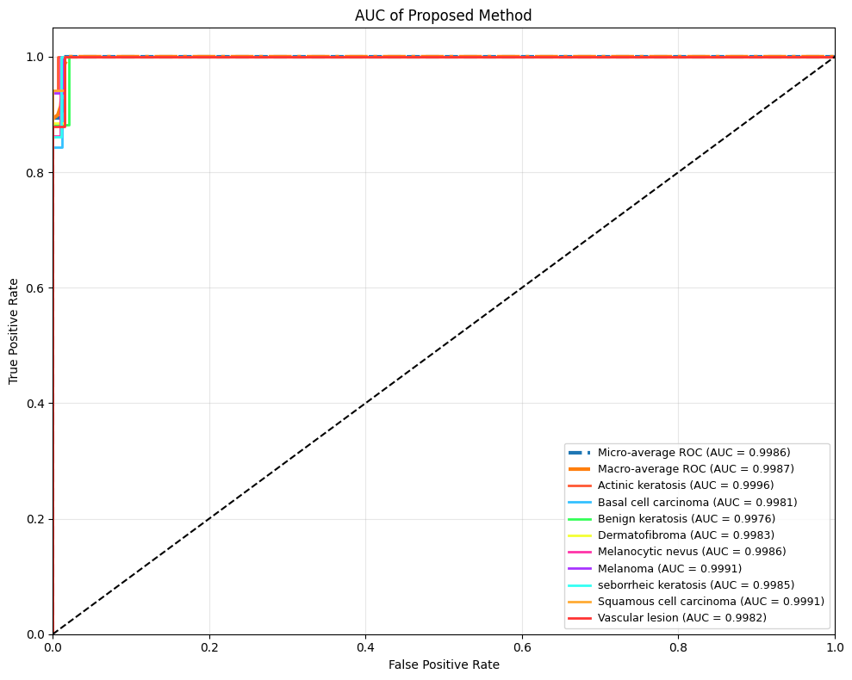
Figure 13. AUC-ROC curve of Proposed OSCC-Net.
Table 20 presents the reproducibility checklist for the proposed OSCC-Net framework, ensuring that all experiments was consistently replicated under identical conditions. The implementation was conducted in Python 3.12.0 with PyTorch 2.2.0 (CUDA 12.1) and TorchVision 0.17.0, supported by NumPy 1.26.4, Pandas 2.2.1, Scikit-learn 1.4.1, and Matplotlib 3.8.3 for data handling and visualization. To maintain experimental consistency, fixed random seeds were used across Python (42), NumPy (42), and Torch (42), while deterministic operations were enforced using torch.use_deterministic_algorithms(True). This configuration guarantees a reproducible and transparent evaluation environment for OSCC-Net’s experimental outcomes.
Table 20. Reproducibility Checklist for OSCC-Net
Category | Details
Python Version | 3.12.0
PyTorch Version | 2.2.0 (CUDA 12.1)
TorchVision Version | 0.17.0
NumPy Version | 1.26.4
Pandas Version | 2.2.1
Scikit-learn Version | 1.4.1
Matplotlib Version | 3.8.3
Random Seed Values | Python: 42, NumPy: 42, Torch: 42
Deterministic Mode | torch.use_deterministic_algorithms(True) enabled

Appendix
Table 21. AMOP Procedure Pseudocode.
Inputs: Original training dataset ($D$), Set of all class labels ($C$), Number of nearest neighbours $\left(k\right).$
Output: Balanced dataset with equal class instances ($D_{balanced}$)
1. For each class $c ∈ C$:
2. Compute number of samples $N_{c}$ in class c
3. Identify minority class $c_{min} = {argmin}_{c} \left(N_{c}\right)$
4. Identify majority class $c_{max} = argmax_{c} \left(N_{c}\right)$
5. Set target sample count $N_{target} = N_{max} = N_{c_{max}}$
6. For each instance $x_{i}$ ∈ class $c_{min}$:
7. Find k nearest neighbours of $x_{i}$ within class $c_{min}$ based on Euclidean distance
8. For each neighbour $x_{neighbor}$ in selected $k$ neighbours:
9. Compute local density $ρ_{i} = \left(\frac{1}{\left(1 + mean\left(distance\left(x_{i}, x_{neighbor}\right)\right)\right)}\right)$
10. Compute adaptive interpolation factor $λ = \frac{ρ_{i}}{\left(ρ_{i} + 1\right)}$
11. Generate a synthetic instance using Equation (1).
12. Append $x_{i}^{new}$ to minority class until $N_{target}$ samples reached
13. Merge all balanced class subsets → $D_{balanced}$
14. Return $D_{balanced}$

Table 22. STND-SWCAM Procedure Pseudocode.
Inputs: $X = \{x_{1}, x_{2}, ..., x_{N}\}$ # High-dimensional lesion feature vectors, $x_{i} ∈ R^{d}$
$Z = \{z_{1}, z_{2}, ..., z_{N}\}$ # Raw classification logits, z_i ∈ R^K
$α$ # Scaling factor for score weighting
$m$ # Low-dimensional embedding size
Output: $H(x)$ # Feature vector-oriented interpretability heatmap
# Step 1: Compute pairwise distances in high-dimensional space
$$for i = 1 to N:$$
$for j = 1 to N, j ≠ i:$
$d[i,j] = {\left|x_{i}-x_{j}\right|}^{2}$ # Squared Euclidean distance
# Step 2: Compute conditional probabilities in high-dimensional space
$$for i = 1 to N:$$
$σ_{i} = BinarySearchSigma\left(d\left[i,:\right], Perplexity_{target}\right)$ # adaptive bandwidth for target perplexity
$for j = 1 to N, j ≠ i:$
$p\left[i,j\right]= exp\left(-\frac{d\left[i,j\right]}{\left(2 * σ_{i}^{2}\right)}\right)$
Normalize $p[i,:]$ so that $sum_{j} p[i,j] = 1$
# Step 3: Compute Shannon entropy and perplexity
for $i = 1 to N:$
$H[i] = -sum_{j}\left( p\left[i,j\right] * log2\left(p\left[i,j\right]\right)\right)$ # entropy in bits
$Perp[i] = 2^H[i]$ # perplexity (effective neighbors)
# Step 4: Project features to low-dimensional embedding space
$Y = DimensionalityReduction\left(X, output_{dim}= m\right)$ # learned projection
# Step 5: Compute low-dimensional conditional probabilities
for $i = 1 to N:$
$for j = 1 to N, j ≠ i:$
$q[i,j] = exp\left(-{\left|\left|Y\left[i\right]- Y\left[j\right]\right|\right|}^{2}\right)$
Normalize $q[i,:] so that sum_{j} q[i,j] = 1$
# Step 6: Compute score weight from classification logits
for $i = 1 to N$:
$s_{i} = H[i] * α * Softmax\left(z_{i}\right)$ # scalar weight combining structure and confidence
# Step 7: Compute score-weighted low-dimensional probabilities
for$i = 1 to N$:
for $j = 1 to N, j ≠ i$:
$q_{prime\left[i,j\right]} = s_{i} * exp\left(-{\left|\left|Y\left[i\right]- Y\left[j\right]\right|\right|}^{2}\right)$
Normalize $q_{prime}\left[i,:\right]$ so that $sum_{j} q_{prime}[i,j] = 1$
# Step 8: Compute score-weighted activation vector
for $i = 1 to N:$
$A[i] = s_i * Y[i]$ # element-wise multiplication
# Step 9: Compute KL-divergence loss
$L = sum_{i} sum_{j}\left( p\left[i,j\right]* log\left(\frac{p\left[i,j\right]}{q_{prime\left[i,j\right]}}\right)\right)$
# Step 10: Generate final interpretability heatmap
$H(x) = sum_{i} \left( A\left[i\right]* f\left(x_{i}\right)\right)$ # $f(x_{i}) =$ pixel-wise contribution map
Return H(x)

Table 23. GBFIO-DSNDA Procedure Pseudocode.
Input: F = {f_1, f_2, ..., f_d} # Full set of features
N # Population size (number of candidates feature subsets)
T # Maximum number of iterations
λ_1, λ_2 # Weights for accuracy vs redundancy in fitness
LB, UB # Lower and upper bounds for feature subset values
δ, η, γ, β # Control parameters for switching, learning rate, exploitation, exploration
θ # Weight threshold for final feature selection
ε # Neighborhood radius for density estimation
Output: FS # Final selected feature subset
# Step 1: Initialize population of candidate feature subsets
$X = \left\{x_{1}, x_{2}, ..., x_{N}\right\}, x_{i} ∈ R^{d}$ # Randomly initialize feature subsets within [LB, UB]
# Step 2: Evaluate initial fitness
for $i = 1 to N$:
$Acc_{i}= EvaluateAccuracy\left(x_{i}\right)$
$$Red_{i} = EvaluateRedundancy\left(x_{i}\right)$$
$$F_{i} = λ_{1} * Acc_{i} - λ_{2} * Red_{i}$$
# Step 3: Main iterative optimization
for t = 1 to T:
# Step 3a: Determine exploration vs exploitation
$P_{switch} = \frac{1}{(1 + exp(-δ * (t/T))) }$
for $i = 1 to N:$
if $rand() < P_{switch}:$
# Exploration: random update within bounds
$x_{i} = x_{i} + β * rand(0,1) * (UB - LB)$
else:
# Exploitation: move towards best solution
$x_{i} = x_{i} + γ * \left(x_{best} - x_{i}\right)$
# Step 3b: Compute density for each candidate
for $i = 1 to N$:
$P_{i} = 0$
for $j = 1 to N, j ≠ i$:
if $distance\left(x_{i}, x_{j}\right) < ε$:
$P_{i} += 1$

# Step 3c: Compute minimum distance to higher-density neighbour
for $i = 1 to N:$
$δ_{i} = min_\left\{j \right|P_{j} > P_{i}\} distance(x_{i}, x_{j})$
# Step 3d: Compute weight for each candidate
for $i = 1 to N:$
$w_{i} = \frac{P_{i}}{\left(1 + δ_{i}\right)}$
# Step 3e: Refine candidates using DSNDA neighbourhood update
for $i = 1 to N$:
$x_{nb} = NearestHigherDensityNeighbor\left(x_{i}\right)$
$x_{i} = x_{i} + η * \left(x_{nb} - x_{i}\right)$
# Step 3f: Update fitness for new population
for $i = 1 to N$:
$Acc_{i} = EvaluateAccuracy\left(x_{i}\right)$
$Red_{i} = EvaluateRedundancy\left(x_{i}\right)$
$F_{i_{new}} = λ_{1} * Acc_{i} - λ_{2}* Red_{i}$
# Step 3g: Check stopping criteria
if $t >= T or max(F_{i_{new}} - F_{i}) < ε$:
break
# Step 4: Select final feature subset based on weight threshold
$$FS = \left\{f_{k} ∈ F \right|w_{k}≥ θ\}$$
Return FS

Table 24. GC-VNN Procedure Pseudocode.
Input: X ∈ R^(N×d) # Node feature matrix from GBFIO-DSNDA
K # Number of nearest neighbors for graph edges (KNN)
τ # Spatial distance threshold
L = 6 # Number of graph convolution layers
heads = [4,4,8,8,4,4] # MHA per layer
$d_{h} = 128$ # Node embedding dimension
batch_size = 64
num_classes = 9
Output: $Y$ # Class probabilities
# Step 1: Construct graph G = (V, E, X)
for each node $i$ in $X$:
Find KNN and nodes within distance $τ$
Set adjacency $A_{ij} = 1 if j ∈ KNN(i) or ||x_{i} - x_{j}|| < τ$ else 0
Compute degree matrix $D_{ii} = sum_{j} A_{ij}$
Compute normalized adjacency matrix $Ā = D^{-\frac{1}{2}} \left(A + I\right)D^{-\frac{1}{2}}$
# Step 2: Initial node embeddings with ViT
$H^{0} = MLP\left(MHA\left(Norm\left(X\right)\right)\right)$ # Patch-level contextual features
# Step 3: Graph Convolution Layers with multi-head attention
for $l = 0 to L-1$:
for each head $h$ in $heads[l]$:
# Compute attention coefficients $α_{ij}$
$α_{ij} = softmax\left(LeakyReLU\left(a^{T} \left[W H_{i} || W H_{j}\right]\right)\right) for j ∈ N(i)$
# Update node embeddings
$h_{i}^{'} = σ\left(sum_{\left\{j ∈ N\left(i\right)\right\}α_{ij}}* W * H_{j}\right)$
$H^{l+1}$ = concatenate(all heads)
Apply dropout 0.3
# Step 4: Pool node embeddings to get global representation
$$H_{pool} = MeanPooling\left(H^{L}\right)$$
$z = Readout\left(H_{pool}\right)$
# Step 5: Classification head
$$z_{dense} = ReLU\left(W_{d} * z + b_{d}\right)$$
$$Y = Softmax\left(W_{c}* z_{dense}+ b_{c}\right)$$
Return Y

