Supplementary Method 1. CT Imaging Features.
Supplementary Figure 1. Selected radiomics features of Intra-AP model, Peri-PP model, and Absolute-Delta model.
Supplementary Table 1. Performance of different machine learning models in for predicting VETC based on radiomics features.
Supplementary Table 2. Hosmer-Lemeshow test.

Supplementary Method 1. CT Imaging Features.
The CT imaging features included the following: (1) main tumor size: maximum edge-to-edge dimension of primary lesions; (2) multiplicity: includes one lesion or multiple lesions; (3) single-lobe involvement, including single-lobe involvement and multi-lobe involvement; (4) tumor edges: including non-smooth edges and smooth edges, nonsmooth tumor edges: nonnodular tumors in all imaging planes, such as crescent or focal extranodular extension beyond the capsule, multinodular confluence appearance, and focal infiltrative edges; (5) intratumor necrosis: after contrast enhancement, a central area of on-contrast image attenuation appeared, occupying more than 20% of the highest cross-section lesion area; (6) intratumor hemorrhage: a hyperattenuated area with a relatively lower attenuation compared with calcifications in unenhanced images; (7) arterial phase hyperenhancement: arterial phase enhancement significantly greater than that surrounding liver enhancement; (8) washout: nonperipheral visually assessed temporal reduction in overall or partial enhancement relative to composite liver tissue, resulting in lower enhancement in the portal vein or delayed phase;(9) well-defined capsule: containing well-defined and ill-defined capsules, most or all of the lesions surrounded by smooth, uniform, sharp edges with clear borders, and sharp edges seen at the portal vein or delayed phases.

Supplementary Figure 1. Selected radiomics features of Intra-AP model, Peri-PP model, and Absolute-Delta model.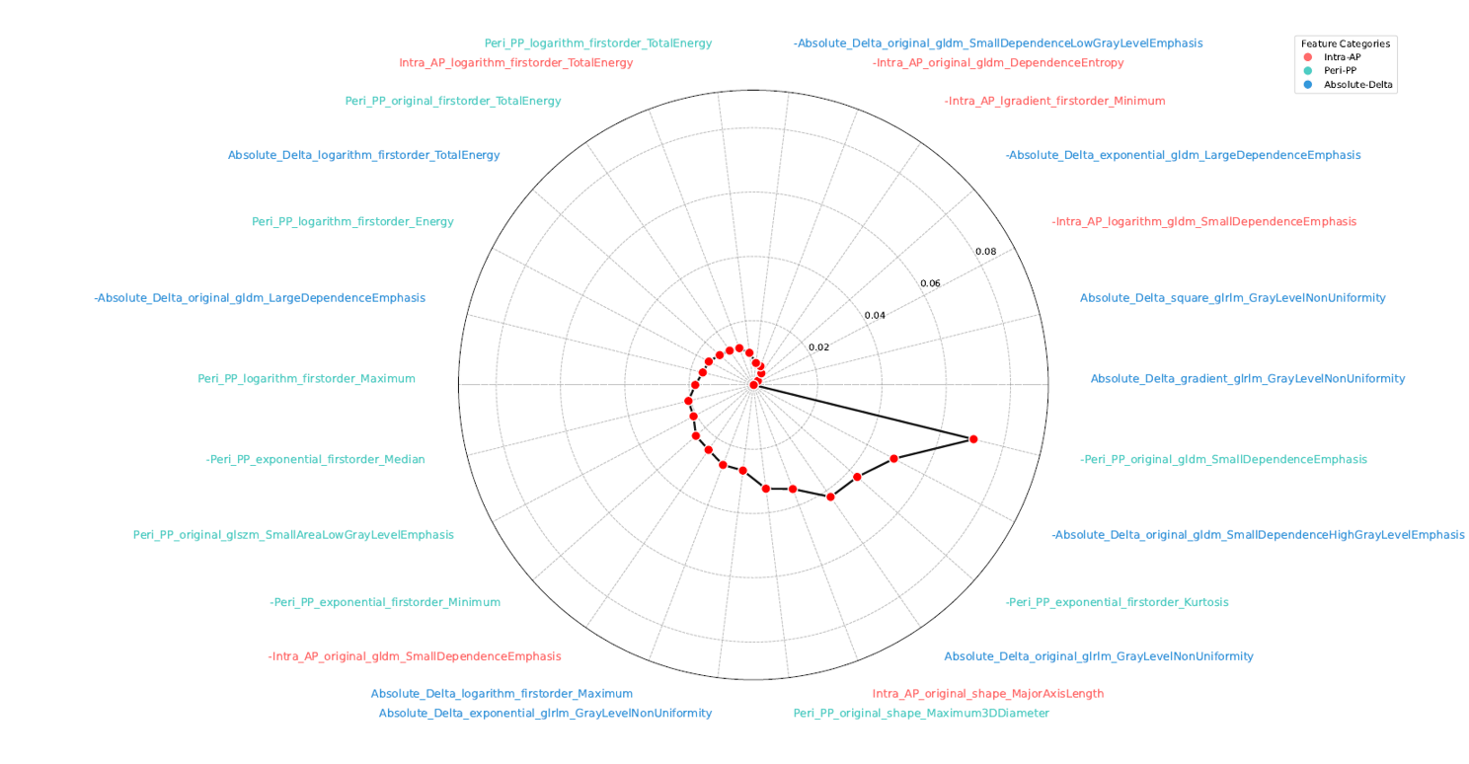
GLDM, gray-level dependence matrix; GLSZM, gray-level size zone matrix; GLRLM, gray-level run length matrix; Intra-AP, radiomics signature built from intratumoral regions of the AP CT images; Peri-PP, radiomics signature built from peritumoral regions of the PP CT images.

Supplementary Table 1. Performance of different machine learning models in for predicting VETC based on radiomics features.
Set | Types | ML model | AUC (95%CI) | Accuracy | Sensitivity | Specificity
Training Set | Intra-AP | LR | 0.807 (0.801, 0.812) | 0.782 | 0.767 | 0.797
 |  | SVM | 0.796 (0.750,0.843) | 0.782 | 0.767 | 0.797
 |  | DT | 0.856 (0.796,0.916) | 0.815 | 0.817 | 0.814
 |  | RF | 0.892 (0.835,0.949) | 0.798 | 0.783 | 0.814
 | Peri-AP | LR | 0.716 (0.711,0.721) | 0.655 | 0.567 | 0.746
 |  | SVM | 0.735 (0.706,0.765) | 0.672 | 0.650 | 0.695
 |  | DT | 0.774 (0.728,0.819) | 0.714 | 0.767 | 0.661
 |  | RF | 0.808 (0.769,0.847) | 0.739 | 0.8333 | 0.644
 | Intra-PP | LR | 0.699 (0.693,0.705) | 0.655 | 0.733 | 0.576
 |  | SVM | 0.709 (0.678,0.741) | 0.655 | 0.733 | 0.576
 |  | DT | 0.773 (0.725,0.820) | 0.714 | 0.817 | 0.610
 |  | RF | 0.837 (0.793,0.881) | 0.773 | 0.883 | 0.661
 | Peri-PP | LR | 0.810 (0.795,0.826) | 0.723 | 0.733 | 0.712
 |  | SVM | 0.812 (0.770,0.855) | 0.723 | 0.833 | 0.610
 |  | DT | 0.840 (0.782,0.899) | 0.756 | 0.700 | 0.814
 |  | RF | 0.866 (0.810,0.921) | 0.765 | 1 | 0.525
 | Absolute-Delta | LR | 0.842 (0.827,0.858) | 0.765 | 0.683 | 0.847
 |  | SVM | 0.805 (0.758,0.853) | 0.765 | 0.683 | 0.847
 |  | DT | 0.874 (0.813,0.936) | 0.807 | 0.750 | 0.864
 |  | RF | 0.893 (0.836,0.949) | 0.798 | 0.717 | 0.881
 | Relative-Delta | LR | 0.706 (0.701,0.711) | 0.664 | 0.833 | 0.492
 |  | SVM | 0.679 (0.650,0.707) | 0.664 | 0.733 | 0.593
 |  | DT | 0.788 (0.739,0.838) | 0.748 | 0850 | 0.644
 |  | RF | 0.813 (0.773,0.854) | 0.706 | 0.783 | 0.627
Internal Test Set | Intra-AP | LR | 0.788 (0.677,0.899) | 0.712 | 0.846 | 0.577
 |  | SVM | 0.791 (0.723,0.860) | 0.673 | 0.846 | 0.500
 |  | DT | 0.679 (0.584,0.774) | 0.635 | 0.731 | 0.538
 |  | RF | 0.729 (0.639,0.820) | 0.712 | 0.846 | 0.577
 | Peri-AP | LR | 0.715 (0.592, 0.837) | 0.692 | 0769 | 0.615
 |  | SVM | 0.731 (0.692, 0.770) | 0.673 | 0.885 | 0.461
 |  | DT | 0.672 (0.604, 0.741) | 0.596 | 0.846 | 0.346
 |  | RF | 0.719 (0.657, 0.781) | 0.673 | 0.962 | 0385
 | Intra-PP | LR | 0.700 (0.575, 0.824) | 0.635 | 0.885 | 0.385
 |  | SVM | 0.700 (0.662, 0.737) | 0.635 | 0.846 | 0.423
 |  | DT | 0.680 (0.610, 0.751) | 0.615 | 0.846 | 0.385
 |  | RF | 0.702 (0.640, 0.764) | 0.615 | 0.923 | 0.308
 | Peri-PP | LR | 0.772 (0.658, 0.886) | 0.712 | 0.808 | 0.615
 |  | SVM | 0.747 (0.685, 0.809) | 0.654 | 0.846 | 0.462
 |  | DT | 0.740 (0.663, 0.817) | 0.712 | 0.731 | 0.692
 |  | RF | 0.720 (0.646, 0.793) | 0.635 | 0.962 | 0.308
 | Absolute-Delta | LR | 0.800 (0.692, 0.909) | 0.712 | 0.769 | 0.654
 |  | SVM | 0.794 (0.717, 0.872) | 0.731 | 0.808 | 0.654
 |  | DT | 0.678 (0.589, 0.766) | 0.673 | 0.692 | 0.654
 |  | RF | 0.670 (0.590, 0.750) | 0.654 | 0.654 | 0.654
 | Relative-Delta | LR | 0.655 (0.526, 0.785) | 0.615 | 0.885 | 0.346
 |  | SVM | 0.655 (0.611, 0.698) | 0.635 | 0.808 | 0.462
 |  | DT | 0.567 (0.496, 0.637) | 0.538 | 0.692 | 0.385
 |  | RF | 0.594 (0.545, 0.643) | 0.596 | 0.808 | 0.385
External Test Set | Intra-AP | LR | 0.701(0.690, 0.711) | 0.627 | 0.545 | 0.690
 |  | SVM | 0.666 (0.625, 0.707) | 0.529 | 0.636 | 0.448
 |  | DT | 0.686 (0.619, 0.753) | 0.627 | 0.773 | 0.517
 |  | RF | 0.668 (0.603, 0.733) | 0.549 | 0.727 | 0.414
 | Peri-AP | LR | 0.679 (0.670, 0.688) | 0.686 | 0.727 | 0.655
 |  | SVM | 0.634 (0.588, 0.682) | 0.657 | 0.727 | 0.586
 |  | DT | 0.698 (0.619, 0.777) | 0.706 | 0.636 | 0.759
 |  | RF | 0.690 (0.625, 0.756) | 0.667 | 0.727 | 0.621
 | Intra-PP | LR | 0.657 (0.640, 0.673) | 0.627 | 0.727 | 0.552
 |  | SVM | 0.640 (0.597, 0.682) | 0.627 | 0.727 | 0.552
 |  | DT | 0.620 (0.553, 0.687) | 0.588 | 0.727 | 0.483
 |  | RF | 0.540 (0.470, 0.610) | 0.569 | 0.682 | 0.483
 | Peri-PP | LR | 0.680 (0.653, 0.708) | 0.627 | 0.591 | 0.655
 |  | SVM | 0.632 (0.563, 0.700) | 0.608 | 0.591 | 0.621
 |  | DT | 0.697 (0.600, 0.795) | 0.608 | 0.591 | 0.621
 |  | RF | 0.668 (0.582, 0.755) | 0.627 | 0.591 | 0.655
 | Absolute-Delta | LR | 0.757 (0.724, 0.790) | 0.725 | 0.591 | 0.828
 |  | SVM | 0.713 (0.643, 0.784) | 0.667 | 0.636 | 0.690
 |  | DT | 0.655 (0.560, 0.750) | 0.647 | 0.545 | 0.724
 |  | RF | 0.734 (0.643, 0.825) | 0.647 | 0.727 | 0.586
 | Relative-Delta | LR | 0.652 (0.638, 0.666) | 0.588 | 0.682 | 0.517
 |  | SVM | 0.658 (0.611, 0.705) | 0.588 | 0.591 | 0.586
 |  | DT | 0.474 (0.397, 0.552) | 0.490 | 0.500 | 0.483
 |  | RF | 0.566 (0.513, 0.618) | 0.569 | 0.636 | 0.517
Numbers in parentheses are the 95% confidence interval. VETC, Vessels encapsulating tumor clusters; LR, Logistic regression; SVM, Support vector machine; DT, Decision tree; RF, Random forest; AUC, Area under the receiver operating characteristics curve; CI, Confidence interval; Intra-AP, radiomics signature built from intratumoral regions of the AP CT images; Peri-AP, radiomics signature built from peritumoral regions of the AP CT images; Intra-PP, radiomics signature built from intratumoral regions of the PP CT images; Peri-PP, radiomics signature built from peritumoral regions of the PP CT images.

Supplementary Table 2. Hosmer-Lemeshow test.
Types | CR model | Radiomics model | Nomogram
Training Set | P = 0.558 | P = 0.528 | P = 0.737
Internal Test Set | P = 0.759 | P = 0.632 | P = 0.899
External Test Set | P = 0.789 | P = 0.753 | P = 0.849
CR, clinical and radiologic.

