SUPPLEMENTAL MATERIAL
Fig. S1. Illustration of Selected Imaging Features.
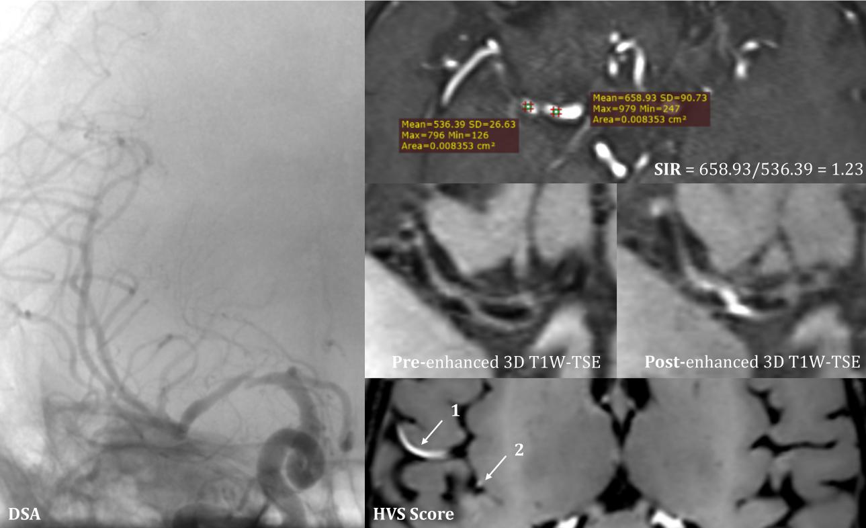
Figure legend. DSA revealed atherosclerotic plaque with severe luminal stenosis in the right middle cerebral artery. The SIR (signal-intensity ratio) was calculated between the distal and proximal portions of the stenosis on MRA. On 3D T1-weighted TSE imaging, the HVS (hyperintense vessel sign) was scored by summing the number of isolated hyperintense vessels (score = 2).
Fig. S2. Representative Illustrations of the Relevant Imaging Parameters.
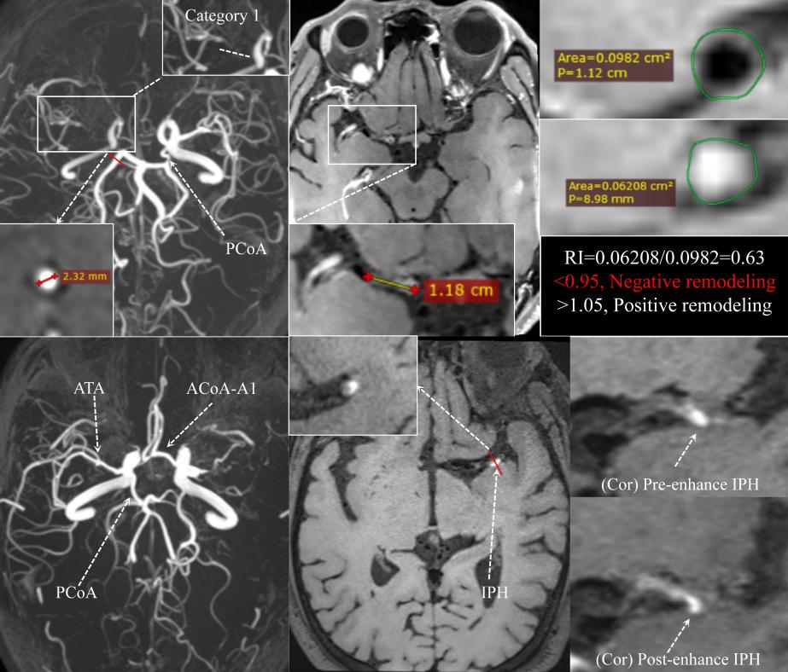
Figure legend. Imaging parameters on TOF-MRA and 3D T1W-TSE sequences including intraplaque hemorrhage (IPH), plaque location, length of the stenotic segment, arterial remodeling pattern, and the visualization (missing or intact) of the A1 segment of the anterior cerebral artery (ACA), posterior communicating artery (PCoA), and anterior temporal artery (ATA).
Fig. S3. Patient Screening Flow Chart.

Initialized Database underwent HR-VWI

(Time interval 2018.06 - 2025.03)

(N = 1235)

Age ≥ 18 years with complete clinical data.
- Underwent DSA and HR-VWI (interval ≤ 15 days).

Participants diagnosed with MMD
(n = 49)

(n = 699)

Participants diagnosed with ICAS
(n = 347)

(n = 699)

1
55
More than 50% stenosis of basilar artery.
With ipsilateral tandem stenosis (≥ 25%).
With unqualified images.

12
1
Accompanied by systemic diseases, infection, or cardiopulmonary insufficiency.
2
8

With tandem stenosis caused by other vascular diseases.
DSA demonstrating more than 50% stenosis of contralateral ICA, MCA or basilar artery.
With other intracranial pathologies such as vascular malformations, cerebral hemorrhage, or space-occupying lesions.

6
1

67
1

Previous history of cerebrovascular surgery.
2
5

MMD enrolled
(n = 41)

ICAS with collateral vessels
(n = 29)

ICAS without collateral vessels
(n = 165)

Atherosclerotic stenosis in M1-MCA (n = 29)

Atherosclerotic stenosis in M1-MCA (n = 120)

Cerebral hemisphere with smoke-like vessels (n = 59)

Figure legend. HR-VWI, high-resolution vessel wall magnetic resonance imaging; DSA, digital subtraction angiography; ICA, internal carotid artery; MCA, middle cerebral artery; ICAS, intracranial atherosclerotic stenosis; MMD, moyamoya disease.

Table S1. Differences in Bilateral Cerebral Hemisphere Features.
Features | ICAS-lcv  n = 29 | ICAS non-lcv  n = 107 | P Value
Age, mean ± SD | 54.79 ± 12.91 | 54.76 (10.96) | 0.504
Female, n (%) | 9 (31.03) | 25 (23.36) | 0.398
Smoking history, n (%) | 9 (31.03) | 47 (43.93) | 0.211
Drinking history, n (%) | 5 (17.24) | 30 (28.04) | 0.238
Diabetes, n (%) | 3 (10.34) | 28 (26.17) | 0.084
Hypertension, median (IQR) | 0.00 (0.00, 2.00) | 2.00 (0.00, 2.00) | 0.020*
Hypercholesterolemia, n (%) | 10 (34.48) | 40 (37.38) | 0.774
Hypertriglyceridemia, n (%) | 5 (17.24) | 7 (6.54) | 0.072
Vessel Wall Enhancement | 2.00 (1.00, 2.00) | 2.00 (2.00, 2.00) | <0.001*
Grade 0, n (%) | 0 (0.00) | 2 (1.87) | <0.001*
Grade 1, n (%) | 12 (41.38) | 10 (9.35) | <0.001*
Grade 2, n (%) | 17 (58.62) | 72 (67.29) | <0.001*
Grade 3, n (%) | 0 (0.00) | 23 (21.50) | <0.001*
Vascular Wall Remodeling |  |  | 0.008*
Negative remodeling, n (%) | 27 (93.10) | 74 (69.16) | 0.008*
Neutral remodeling, n (%) | 1 (3.45) | 7 (6.54) | 0.008*
Positive remodeling, n (%) | 1 (3.45) | 26 (24.30) | 0.008*
Stenosis grade, G3/G4 | 4 / 25 | 64 / 43 | <0.001*
Stenosis site |  |  | 0.015*
Category 1, n (%) | 25 (86.21) | 51 (67.29) | 0.015*
Category 2, n (%) | 4 (13.79) | 35 (32.71) | 0.015*
Stenosis length, median (IQR) | 0.90 (0.65, 1.50) | 0.80 (0.40, 1.20) | 0.059
MRA - SIR, median (IQR) | 2.24 (1.56, 2.79) | 1.44 (1.24, 2.57) | 0.022*
With IS, n (%) | 8 (27.59) | 75 (70.09) | <0.001*
HVS scores, median (IQR) | 5.00 (1.50, 12.50) | 7.00 (2.00, 10.00) | 0.588
PCoA, integral/missing | 19 (65.52) | 57 (53.27) | 0.239
ACoA, integral/missing | 27 (93.10) | 98 (91.59) | 1.000
ATA presence, n (%) | 8 (27.59) | 72 (67.29) | <0.001*
Plaque thickness, median (IQR) | 1.90 (1.70, 2.15) | 2.00 (1.70, 2.40) | 0.160
Left site, n (%) | 14 (48.28) | 58 (54.21) | 0.570
With IPH, n (%) | 1 (3.45) | 4 (3.74) | 1.000
Abbreviations: ICAS-lcv, intracranial atherosclerotic stenosis with local collaterals vessels; IS, ischemic stroke; HVS, hyperintense vessel sign; IPH, intraplaque hemorrhage; MCA, middle cerebral artery; PCA, posterior cerebral artery; ACA, anterior cerebral artery; ATA, anterior temporal artery; PoCA, posterior communicating artery; SIR, signal intensity ratio; MRA, magnetic resonance angiography; IQR, interquartile range; SD, standard deviation.

Table S2. Comparison of Characteristics between Occlusive ICAS Subgroups
Features | ICAS-lcv  n = 25 | ICAS non-lcv  n = 43 | P Value
Age, mean ± SD | 54.88 (11.22) | 55.60 (10.80) | 0.878
Female, n (%) | 7 (28.00) | 12 (27.91) | 0.993
Smoking history，n (%) | 9 (36.00) | 17 (39.53) | 0.772
Drinking history，n (%) | 5 (50.00) | 13 (30.23) | 0.356
Diabetes，n (%) | 3 (12.00) | 8 (18.60) | 0.734
Hypertension, median (IQR) | 0.00 (0.00, 2.00) | 2.00 (0.00, 2.00) | 0.037*
Hypercholesterolemia, n (%) | 9 (36.00) | 14 (32.56) | 0.772
Hypertriglyceridemia, n (%) | 3 (12.00) | 2 (4.65) | 0.349
Vessel Wall Enhancement | 2.00 (1.00, 2.00) | 2.00 (2.00, 3.00) | <0.001*
Vascular Wall Remodeling | 0.00 (0.00, 0.00) | 0.00 (0.00, 0.00) | 0.201
Negative remodeling，n (%) | 24 (96.00) | 37 (86.05) | 0.201
Neutral remodeling，n (%) | 0 (0.00) | 1 (2.33) | 0.201
Positive remodeling，n (%) | 1 (4.00) | 5 (11.63) | 0.201
Stenosis site of MCA, M1-1/M1-2 | 21/ 4 | 26 / 17 | 0.058
Stenosis length/cm, mean ± SD | 1.00 (0.80, 1.60) | 1.30 (1.00, 1.70) | 0.098
MRA - SIR, median (IQR) | 2.35 (1.92, 2.93) | 2.72 (1.96, 3.67) | 0.137
With IS, n (%) | 8 (32.00) | 32 (74.42) | <0.001*
HVS scores, median (IQR) | 5.00 (1.50, 13.50) | 8.00 (6.00, 13.00) | 0.091
PCoA, integral/missing | 16 (64.00) | 20 (46.51) | 0.164
ACoA, integral/missing | 24 (96.00) | 40 (93.02) | 1.000
ATA presence, n (%) | 6 (24.00) | 24 (55.81) | 0.011*
Plaque thickness, median (IQR) | 1.90 (1.70, 2.20) | 2.20 (1.90, 2.60) | 0.015*
Left site, n (%) | 12 (48.00) | 21 (48.84) | 0.947
With IPH, n (%) | 1 (4.00) | 4 (9.30) | 0.645
Abbreviations: ICAS-cv, intracranial atherosclerotic stenosis with local collaterals vessels; IS, ischemic stroke; HVS, hyperintense vessel sign; IPH, intraplaque hemorrhage; MCA, middle cerebral artery; PCA, posterior cerebral artery; ACA, anterior cerebral artery; ATA, anterior temporal artery; PoCA, posterior communicating artery; SIR, signal intensity ratio; MRA, magnetic resonance angiography; IQR, interquartile range; SD, standard deviation.

Table S3. Logistic regression analysis of factors related to collateral formation in occlusive ICAS.
Variables | Univariate |  | Multivariate
Variables | OR (95% CI) | P value | OR (95% CI) | P value
Hypertension | 1.59 (1.01, 2.52) | 0.048 | 1.59 (0.86, 2.96) | 0.141
Enhance grade | 5.35 (2.10, 13.59) | <0.001 | 5.95 (2.10, 16.85) | <0.001*
ATA presence | 4.00 (1.34, 11.99) | 0.013 | 8.79 (2.00, 38.81) | 0.004*
Plaque thickness | 3.79 (1.17, 12.29) | 0.026 | 4.02 (0.99, 16.38) | 0.052
Abbreviation: ICAS, intracranial atherosclerotic stenosis; ATA, anterior temporal artery; OR, odd ratio; CI, confidence interval.

Table S4. Logistic regression analysis of factors related to ischemic stroke in occlusive ICAS.
Variables | Univariate |  | Multivariate
Variables | OR (95% CI) | P value | OR (95% CI) | P value
Age | 0.96 (0.91, 1.00) | 0.060 | 0.96 (0.90, 1.02) | 0.169
Gender | 1.53 (0.53, 4.36) | 0.430 | 1.03 (0.20, 5.33) | 0.975
ICAS-lcv | 0.18 (0.06, 0.53) | 0.002 | 0.10 (0.02, 0.58) | 0.010*
Left site | 0.25 (0.09, 0.70) | 0.008 | 0.06 (0.01, 0.39) | 0.003*
HVS score | 1.17 (1.06, 1.29) | 0.002 | 1.22 (1.03, 1.43) | 0.020*
Enhance grade | 3.15 (1.43, 6.95) | 0.004 | 1.25 (0.40, 3.87) | 0.701
MRA-SIR | 2.21 (1.25, 3.90) | 0.006 | 2.90 (1.29, 6.54) | 0.009*
Abbreviation: ICAS-cv, intracranial atherosclerotic stenosis with local collaterals vessels; SIR, signal intensity ratio; MRA, magnetic resonance angiography; HVS, hyperintense vessel sign; OR, odd ratio; CI, confidence interval.

Table S5. Comparison of baseline clinical indicators between MMD and ICAS-lcv.
Indicators | ICAS-lcv  n = 29 | MMD  n = 41 | P Value
Age, mean ± SD | 54.79 ± 12.91 | 54.20 ± 9.59 | 0.775
Female, n (%) | 9 (31.03) | 15 (36.59) | 0.630
Smoking history, n (%) | 9 (31.03) | 11 (26.83) | 0.701
Drinking history, n (%) | 5 (17.24) | 6 (14.63) | 0.768
Diabetes, n (%) | 3 (10.34) | 8 (19.51) | 0.342
Hypertension |  |  | 0.774
Grade 0, n (%) | 15 (51.72) | 18 (43.90) | 0.774
Grade 1, n (%) | 1 (3.45) | 7 (17.07) | 0.774
Grade 2, n (%) | 13 (44.83) | 14 (34.15) | 0.774
Grade 3, n (%) | 0 (0.00) | 2 (4.89) | 0.774
Hypercholesterolemia, n (%) | 10 (34.48) | 11 (26.83) | 0.491
Hypertriglyceridemia, n (%) | 5 (17.24) | 7 (17.07) | 0.985
Abbreviation: MMD, moyamoya disease; ICAS, intracranial atherosclerotic stenosis; SD, standard deviation.

Table S6. Comparison of imaging features between ICAS-lcv and MMD cases.
Features | ICAS-lcv  (n = 29) | MMD  (n = 59) | P Value
Vessel Wall Enhancement | 2.00 (1.00, 2.00) | 1.00 (1.00, 2.00)
Grade 0, n (%) | 0 (0.00) | 7 (11.86) | 0.371
Grade 1, n (%) | 12 (41.38) | 26 (44.07) | 0.371
Grade 2, n (%) | 17 (58.62) | 20 (33.90) | 0.371
Grade 3, n (%) | 0 (0.00) | 6 (10.17) | 0.371
Vascular Wall Remodeling
Negative remodeling, n (%) | 27 (93.10) | 55 (93.22) | 0.968
Neutral remodeling, n (%) | 1 (3.45) | 3 (5.08) | 0.968
Positive remodeling, n (%) | 1 (3.45) | 1 (1.69) | 0.968
Stenosis grade, median (IQR) | 4.00 (4.00, 4.00) | 4.00 (3.00, 4.00) | 0.221
Stenosis site
Category 1, n (%) | 25 (86.21) | 36 (61.02) | 0.008*
Category 2, n (%) | 4 (13.79) | 6 (10.17) | 0.008*
Category 3 (ICA), n (%) | 0 (0.00) | 17 (28.81) | 0.008*
Stenosis length/cm, mean ± SD | 0.90 (0.65, 1.50) | 1.40 (0.70, 1.80) | 0.114
MRA - SIR, median (IQR) | 2.24 (1.56, 2.79) | 2.15 (1.64, 2.93) | 0.947
With IS, n (%) | 8 (27.59) | 10 (16.95)
HVS scores, median (IQR) | 5.00 (1.50, 12.50) | 5.00 (3.00, 9.00) | 0.925
PCoA presence, n (%) | 19 (65.52) | 37 (62.71) | 0.797
A1-ACA presence, n (%) | 27 (93.10) | 39 (66.10) | 0.008*
ATA presence, n (%) | 8 (27.59) | 25 (42.37) | 0.178
PCA diameter, median (IQR) | 2.07 (1.88, 2.24) | 2.54 (2.24, 2.79) | <0.001*
Abbreviations: ICAS-cv, intracranial atherosclerotic stenosis with local collaterals vessels; IS, ischemic stroke; HVS, hyperintense vessel sign; IPH, intraplaque hemorrhage; MCA, middle cerebral artery; PCA, posterior cerebral artery; ACA, anterior cerebral artery; ATA, anterior temporal artery; PoCA, posterior communicating artery; SIR, signal intensity ratio; MRA, magnetic resonance angiography; IQR, interquartile range; SD, standard deviation.

