Supplementary materials
- Supplementary Tables

Table S1 The selected features of Rad_IVIM+BOLD
Parameter | Feature name
D map | wavelet_HHL_gldm_SmallDependenceLowGrayLevelEmphasis_Dmap
 | wavelet_HLH_glszm_SmallAreaEmphasis_Dmap
 | wavelet_HLH_ngtdm_Strength_Dmap
 | wavelet_HLL_glszm_SmallAreaHighGrayLevelEmphasis_Dmap
 | wavelet_LHL_firstorder_Mean_Dmap
 | wavelet_LLL_ngtdm_Busyness_Dmap
D* map | log_sigma_2_0_mm_3D_firstorder_RootMeanSquared_D*map
 | log_sigma_4_0_mm_3D_glcm_Imc1_D*map
 | log_sigma_5_0_mm_3D_glcm_Imc2_D*map
 | wavelet_LHL_glcm_ClusterShade_D*map
 | wavelet_LHL_glszm_SmallAreaHighGrayLevelEmphasis_D*map
f map | log_sigma_3_0_mm_3D_glszm_SmallAreaEmphasis_f
 | wavelet_LHL_glrlm_LongRunHighGrayLevelEmphasis_f
 | wavelet_LLH_ngtdm_Busyness_f
BOLD | original_glcm_Idn_BOLD
 | wavelet_HHH_gldm_DependenceVariance_BOLD
 | wavelet_HHH_ngtdm_Strength_BOLD
 | wavelet_LHH_gldm_LargeDependenceHighGrayLevelEmphasis_BOLD
 | wavelet_LLH_gldm_SmallDependenceLowGrayLevelEmphasis_BOLD

Table S2 Hosmer-Lemeshow test of the single- and multi-sequence radiomics models
Rad_IVIM | Rad_BOLD | Rad_IVIM+BOLD | Set
0.563 | 0.089 | 0.787 | training
0.044 | 0.096 | 0.055 | test
Note: IVIM, intravoxel incoherent motion; BOLD, blood oxygenation level-dependent

Table S3 Hosmer-Lemeshow test of the two algorithms
IVIM_LR | IVIM_LightGBM | BOLD_LR | BOLD_LightGBM | Set
0.563 | 0.001 | 0.089 | 0.001 | training
0.044 | 0.580 | 0.096 | 0.351 | test
Note: IVIM, intravoxel incoherent motion; BOLD, blood oxygenation level-dependent; LR, logistic regression; LightGBM, Light Gradient Boosting Machine

Table S4 Hosmer-Lemeshow test of the three models
Clinic | Rad_IVIM+BOLD | Nomogram | Set
0.068 | 0.303 | 0.243 | training
0.016 | 0.156 | 0.233 | test
Note: IVIM, intravoxel incoherent motion; BOLD, blood oxygenation level-dependent

Table S5 Radiomics Quality Score (RQS) ^{[1]} assessment
 | Criteria | Points
1 | Image protocol quality - well-documented image protocols (for example, contrast, slice thickness, energy, etc.) and/or usage of public image protocols allow reproducibility/replicability | 1
2 | Multiple segmentations - possible actions are: segmentation by different physicians/algorithms/software, perturbing segmentations by (random) noise, segmentation at different breathing cycles. Analyse feature robustness to segmentation variabilities | 1
3 | Phantom study on all scanners - detect inter-scanner differences and vendor-dependent features. Analyse feature robustness to these sources of variability | 0
4 | Imaging at multiple time points - collect images of individuals at additional time points. Analyse feature robustness to temporal variabilities (for example, organ movement, organ expansion/shrinkage) | 0
5 | Feature reduction or adjustment for multiple testing - decreases the risk of overfitting. Overfitting is inevitable if the number of features exceeds the number of samples. Consider feature robustness when selecting features | 3
6 | Multivariable analysis with non radiomics features (for example, EGFR mutation) - is expected to provide a more holistic model. Permits correlating/inferencing between radiomics and non radiomics features | 1
7 | Detect and discuss biological correlates - demonstration of phenotypic differences (possibly associated with underlying gene–protein expression patterns) deepens understanding of radiomics and biology | 1
8 | Cut-off analyses - determine risk groups by either the median, a previously published cut-off or report a continuous risk variable. Reduces the risk of reporting overly optimistic results | 1
9 | Discrimination statistics - report discrimination statistics (for example, C-statistic, ROC curve, AUC) and their statistical significance (for example, p-values, confidence intervals). One can also apply resampling method (for example, bootstrapping, cross-validation) | 1
10 | Calibration statistics - report calibration statistics (for example, Calibration-in-the-large/slope, calibration plots) and their statistical significance (for example, P-values, confidence intervals). One can also apply resampling method (for example, bootstrapping, cross-validation) | 1
11 | Prospective study registered in a trial database - provides the highest level of evidence supporting the clinical validity and usefulness of the radiomics biomarker | 0
12 | Validation - the validation is performed without retraining and without adaptation of the cut-off value, provides crucial information with regard to credible clinical performance | 3
13 | Comparison to 'gold standard' - assess the extent to which the model agrees with/is superior to the current 'gold standard' method (for example, TNM-staging for survival prediction). This comparison shows the added value of radiomics | 2
14 | Potential clinical utility - report on the current and potential application of the model in a clinical setting (for example, decision curve analysis). | 2
15 | Cost-effectiveness analysis - report on the cost-effectiveness of the clinical application (for example, QALYs generated) | 0
16 | Open science and data - make code and data publicly available. Open science facilitates knowledge transfer and reproducibility of the study | 0
Total points |  | 17
[1] Lambin P, Leijenaar RTH, Deist TM, et al. Radiomics: the bridge between medical imaging and personalized medicine. Nat Rev Clin Oncol. 2017;14(12):749-762. doi:10.1038/nrclinonc.2017.141.

2、Supplementary Figures
Figure S1. Illustrations of IVIM-derived D, D*, f maps and the BOLD-derived T2* map among patients with pathologically confirmed by mild and moderate-to-severe RF. IVIM, intravoxel incoherent motion; D, true diffusion coefficient; D*, pseudo-diffusion coefficient; f, perfusion fraction; BOLD, blood oxygen level-dependent; RF, renal fibrosis
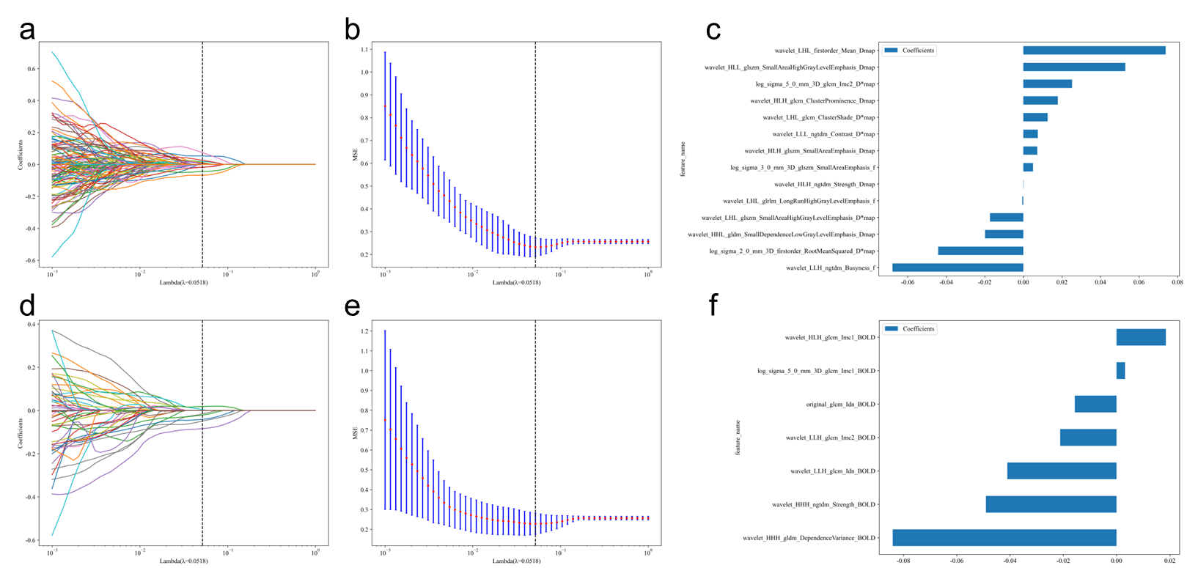
Figure S2. Feature selection of single-sequence IVIM and BOLD radiomics (Rad_IVIM, Rad_BOLD). (a, d) LASSO regression with 10-fold cross-validation was used to select features by shrinking the coefficients of irrelevant variables to zero. The optimal λ (λ = 0.0518 for Rad_IVIM; λ = 0.0518 for Rad_BOLD), indicated by the dashed vertical line, was chosen based on the minimum binomial deviance. (b, e) The penalty plots of radiomics feature coefficients. (c, f) The final features of Rad_IVIM and Rad_BOLD and their corresponding coefficients. LASSO, least absolute shrinkage and selection operator; IVIM, intravoxel incoherent motion; BOLD, blood oxygenation level-dependent
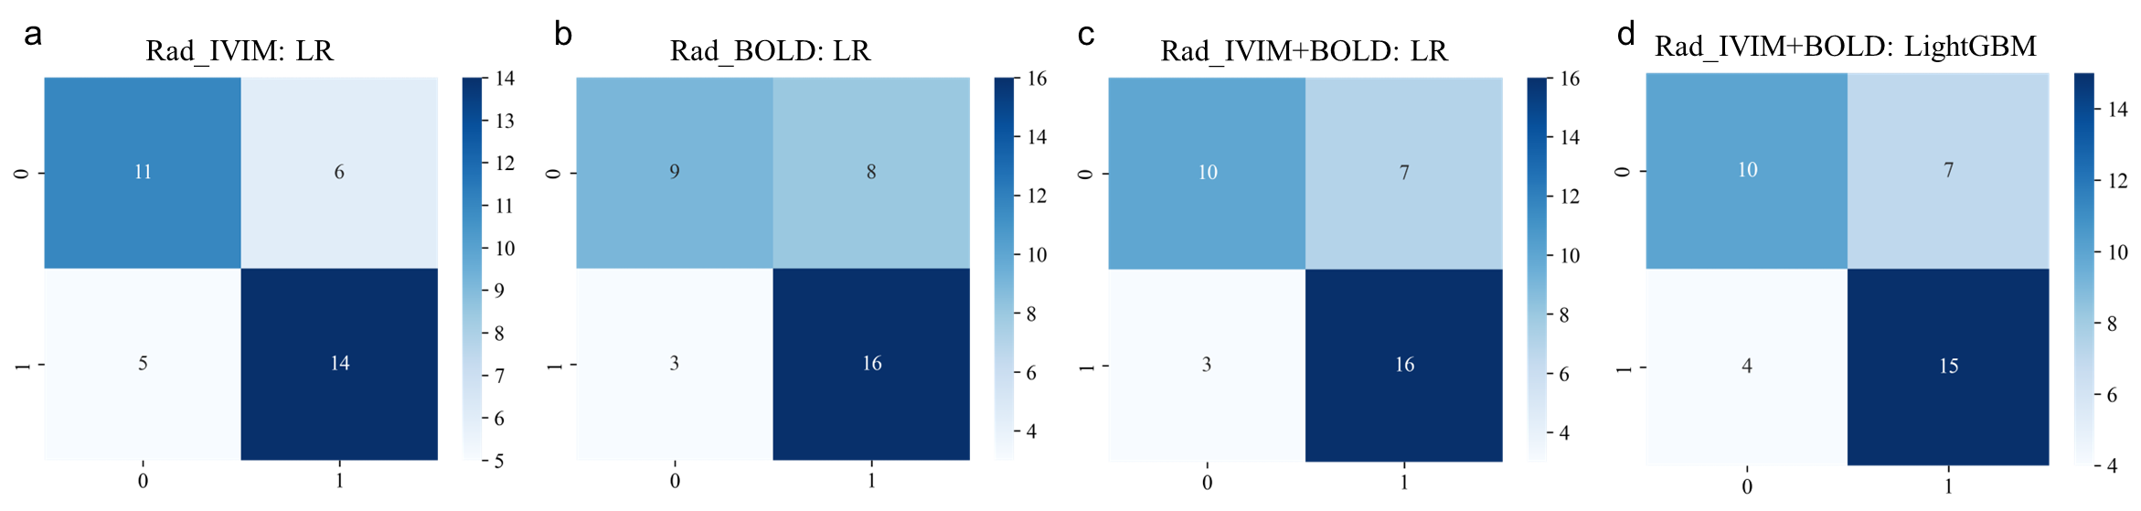
Figure S3. Confusion matrices of radiomics models on the external test set. The matrices illustrate the classification performance of the (a) Rad_IVIM, (b) Rad_BOLD, (c) Rad_IVIM+BOLD (LR), and (d) Rad_IVIM+BOLD (LightGBM) models. Each matrix displays the counts of true positive, false positive, false negative, and true negative classifications for distinguishing mild from moderate-to-severe renal fibrosis. LR, logistic regression; LightGBM, Light Gradient Boosting Machine
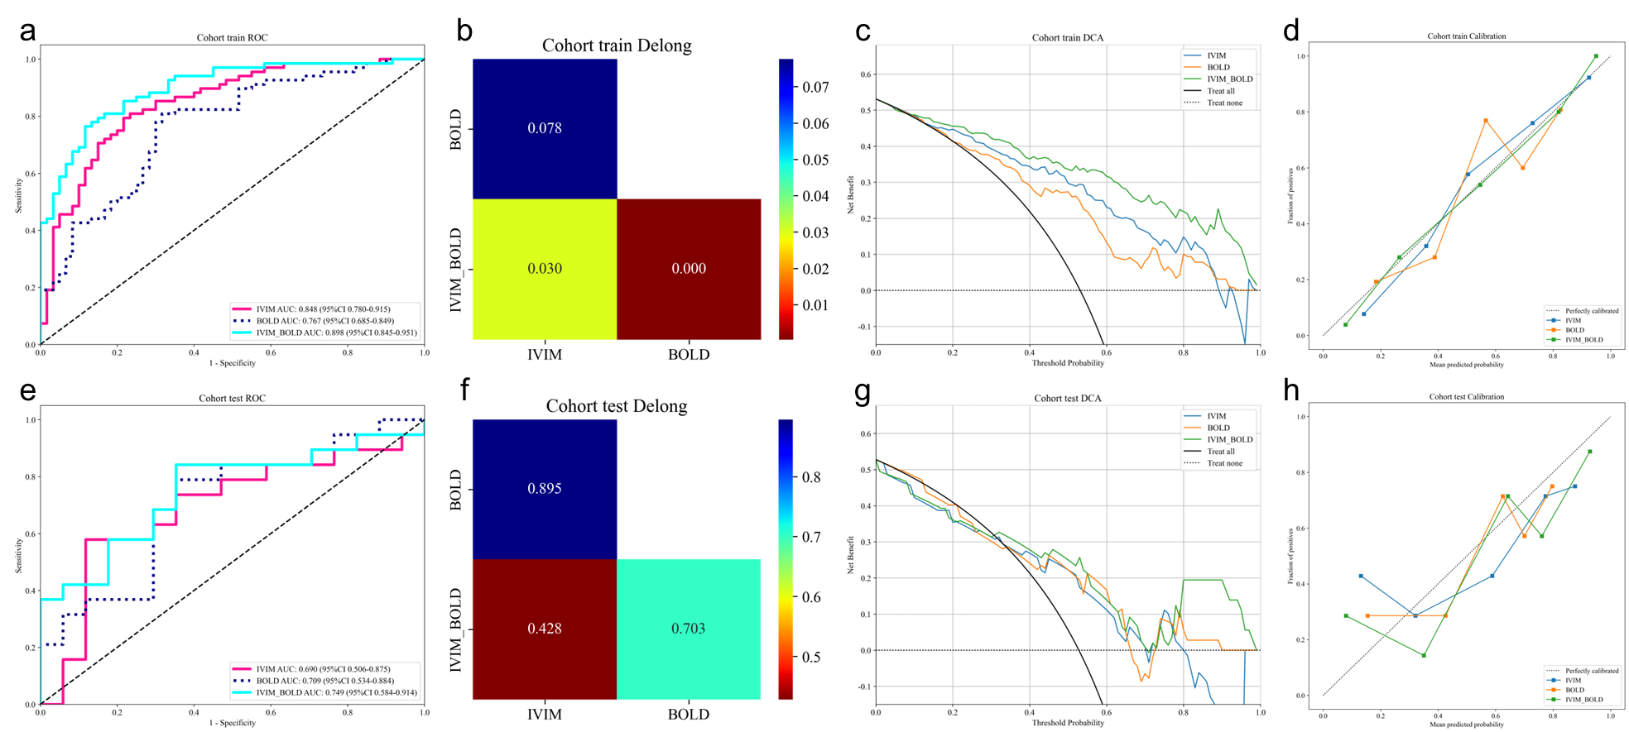
Figure S4. Performance of the Rad_IVIM, Rad_BOLD and Rad_IVIM+BOLD models in evaluating the severity of renal fibrosis in patients with chronic kidney disease. ROC curves, Delong test, DCA and Calibration curves of three models in the training (a-d) and test sets (e-h). IVIM, intravoxel incoherent motion; BOLD, blood oxygen level-dependent; ROC, receiver operating characteristic; DCA, decision curve analysis
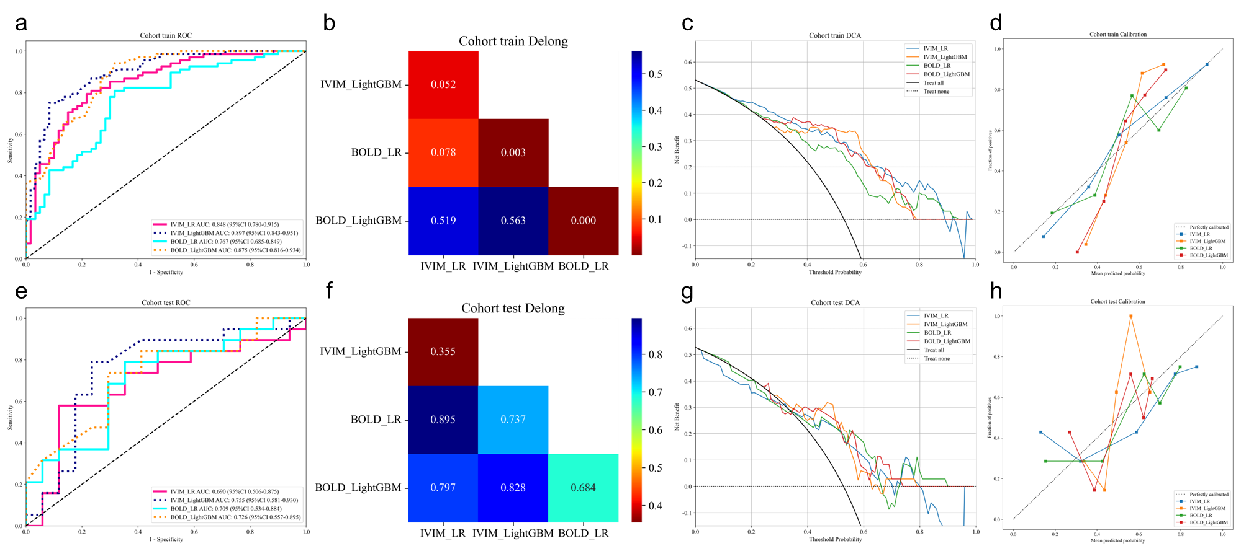
Figure S5. Performance of the two algorithms (LR and LightGBM) in Rad_IVIM and Rad_BOLD models. ROC curves, Delong test, DCA and Calibration curves of two models in the training (a-d) and test sets (e-h). LR, logistic regression; LightGBM, Light Gradient Boosting Machine; IVIM, intravoxel incoherent motion; BOLD, blood oxygen level-dependent; ROC, receiver operating characteristic; DCA, decision curve analysis

