Appendix A: Supplementary Data

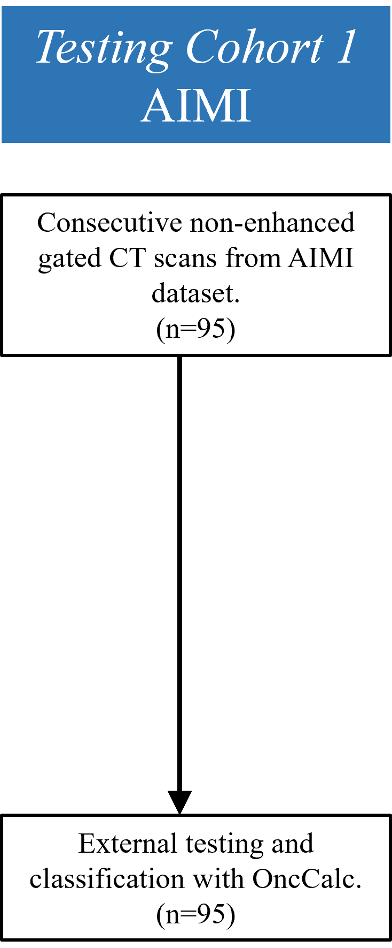
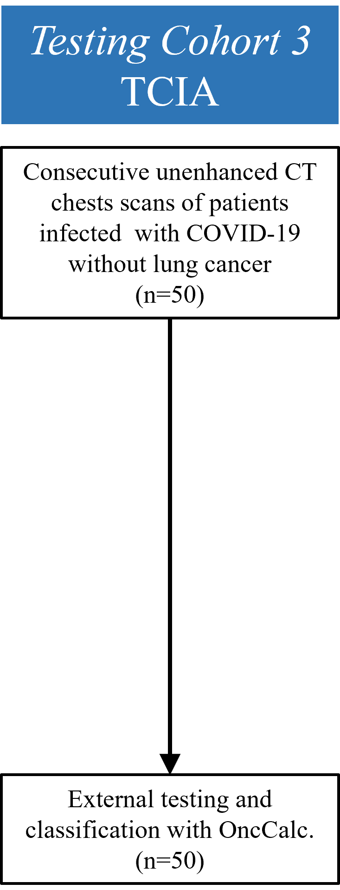
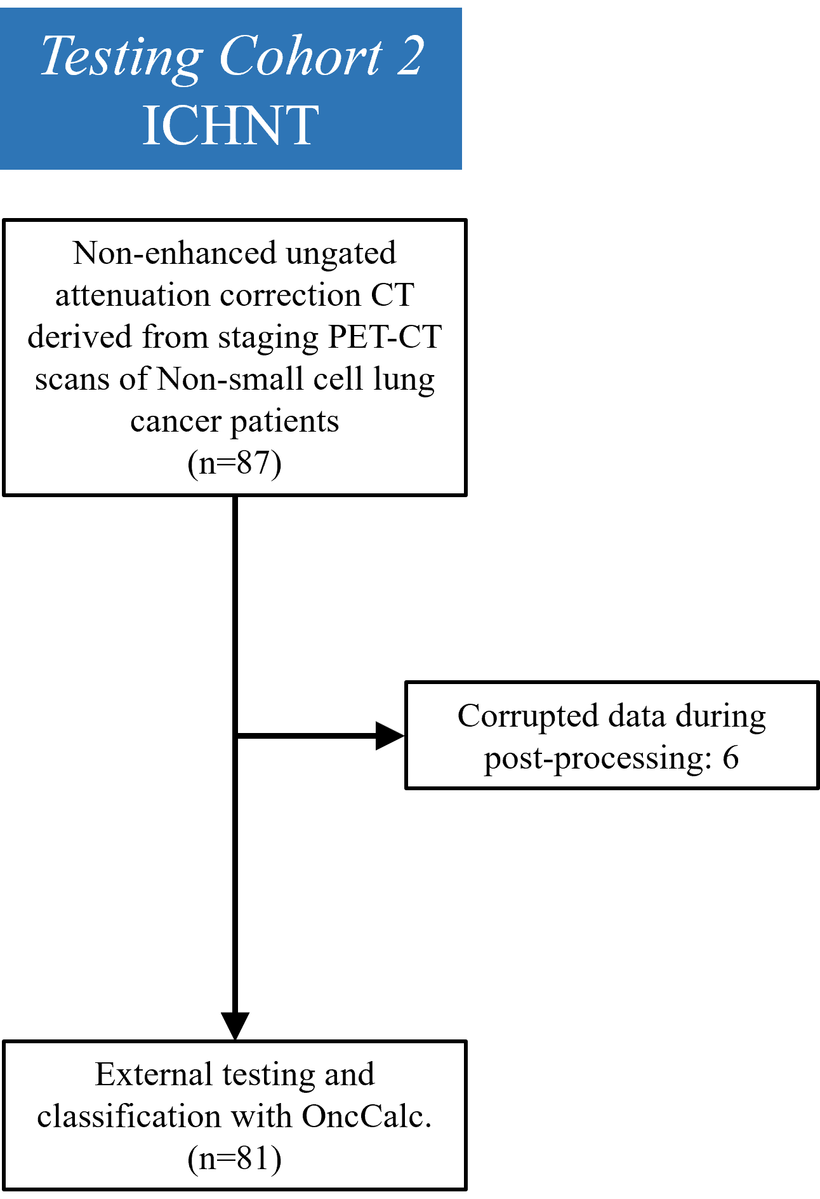

Figure S1: CONSORT diagrams of the study cohorts


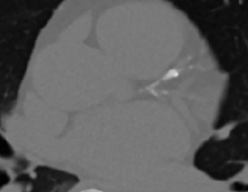
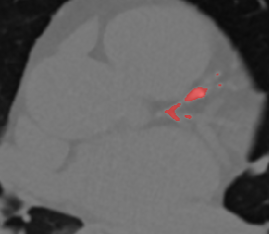
a
b
c

Figure S2 : Omitted coronary artery in an TotalSegmentator-analysed case. a) TotalSegmentator-derived mask, the left arrow in this image points to the right ventricle which is coloured in grey (cardiac chambers). The right arrow points to the LAD which has not been segmented b) The original image, with the green arrow pointing to the LAD. c) LAD with CAC highlighted in red. LAD: left ascending descending artery.

