Supplementary Material for “Automated Deep-Learning Quantification of Intramuscular Fat in Lumbar Spine Muscles on Dixon MRI: Validation and Normative Reference Values from 173 Healthy Adults”
Supplementary Figure 1 – Exclusion of Epimuscular Fat
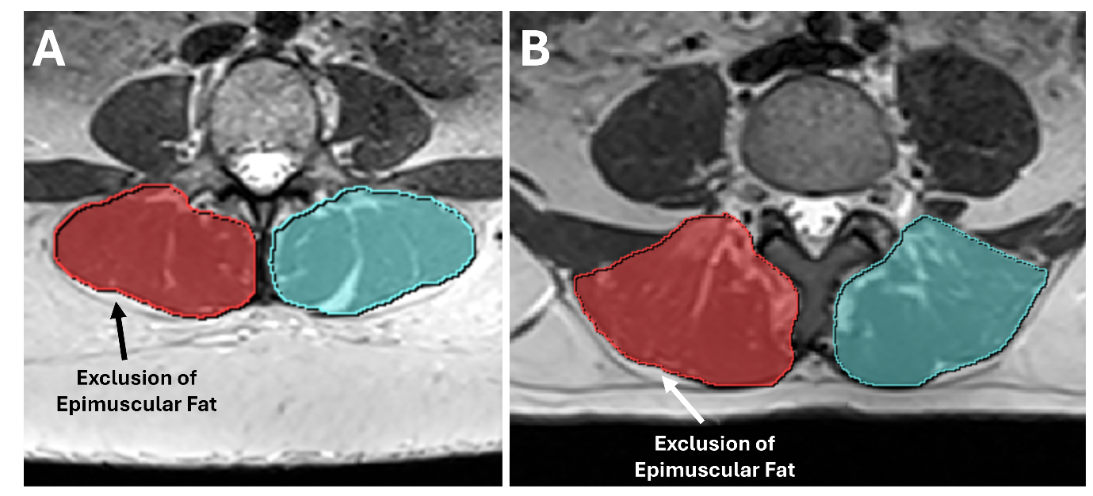Supplementary Figure 1. Two examples of the posterior delineation of the paraspinal ES+M complex, where the epimyseal border is used to define the posterior boundary. The epimuscular fat tent, excluded from the segmentation, is indicated by arrows in both panels.
Supplementary Figure 2 – Example of Nonlinear Data Augmentation
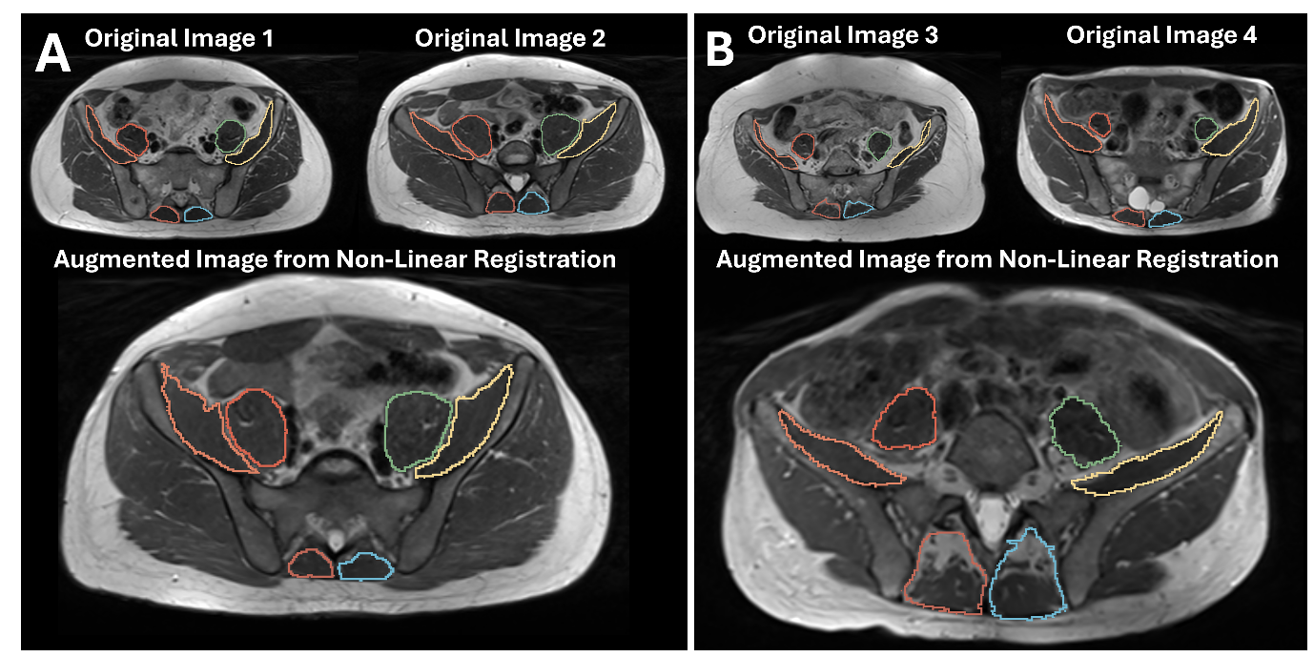Supplementary Figure 2. Example of two augmented images using nonlinear registration between two manually segmented images. Top: original images involved in the pairwise B-spline registration. Bottom: an augmented image resulting from an early stopped registration.

Supplementary Figure 3 – Bland-Altman Analysis of Automated FF vs Manual
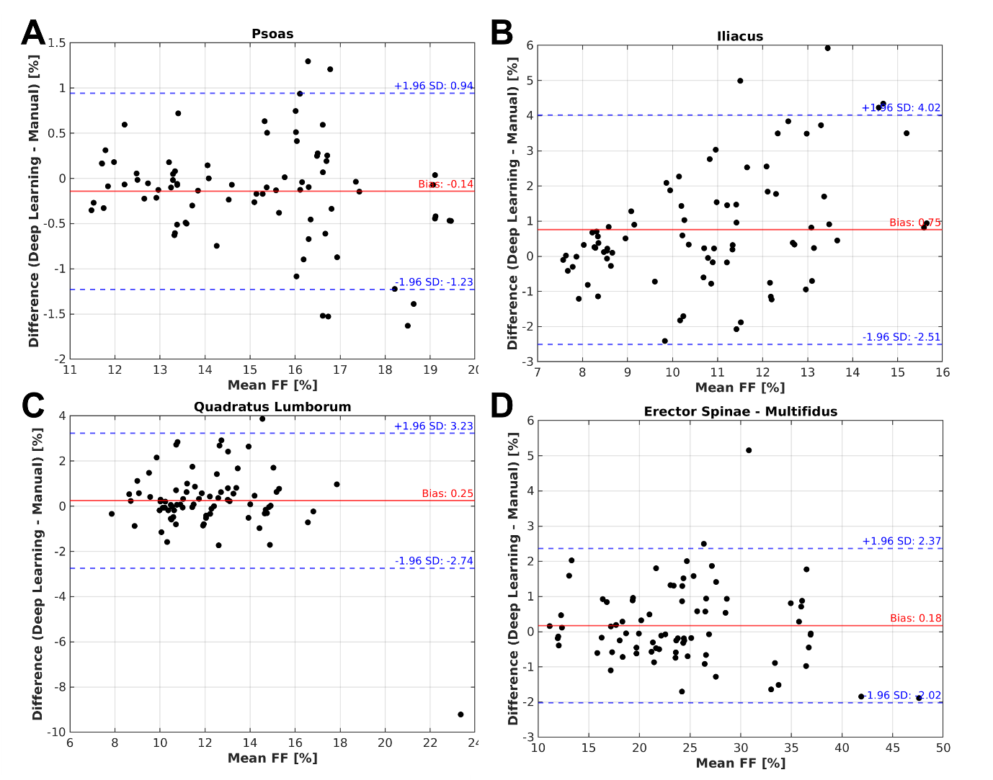Supplementary Figure 3. Bland-Altman analysis of the FF for psoas (A), iliacus (B), quadratus lumborum (C) and erector spinae - multifidus (D), comparing deep learning and manual segmentations. The solid lines represent mean differences (bias), and dashed lines indicate limits of agreement (±1.96 standard deviations). Each plot shows the mean FF of the two methods on the x-axis against their differences on the y-axis, illustrating consistency and variability across methods.

Supplementary Figure 4 – FF distributions by sex and physical activity groups
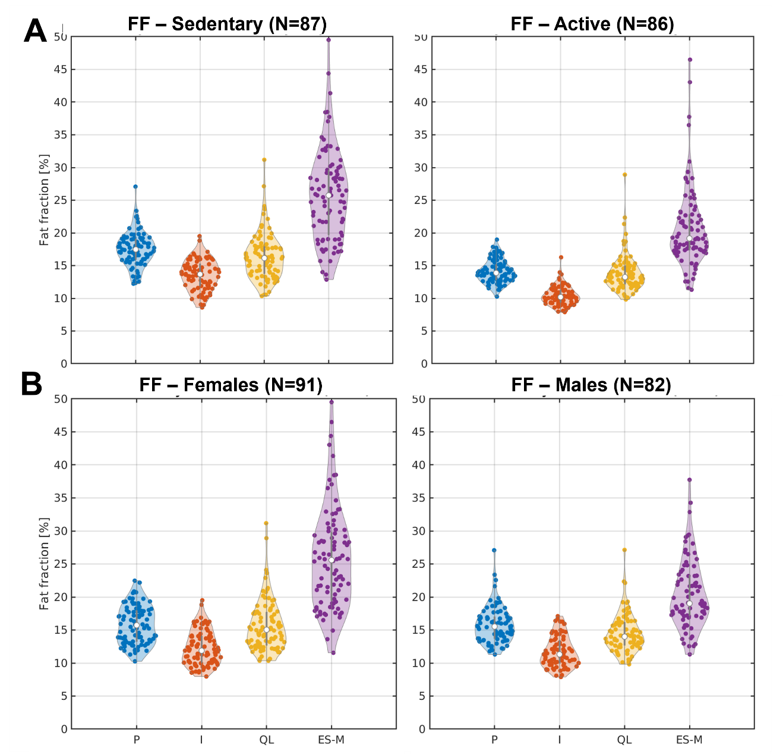
Supplementary Figure 4. Violin plots illustrating the distribution of FF values for the full dataset grouped by physical activity (A) and sex(B), measured with the deep learning-based automated method.

Digital Supplementary Material
In addition, four animated gifs showing the segmentation accuracy have been uploaded. Each gif goes through each axial slice showing the outline of the automated and manual segmentations.

