Additional file
A study on the correlation between cardiac magnetic resonance characteristics and myocardial fibrosis in overweight and obese individuals
Lulu Liu ¹, Yuheng Yao ¹, Hongqing Yu¹, Jian Zhai ^{1, *}
Imaging Center, The First Affiliated Hospital of Wannan Medical College, Wuhu 241001, China
*Corresponding author：
Jian Zhai
E-mail: yjszhaij@126.com

Table S1 Comparison of myocardial strain parameters between LGE-positive and LGE-negative subgroups within BMI groups
Table S2 Logistic regression analysis
Table S3 Analysis of Multicollinearity
Table S4 ROC curve parameters
Table S5 Intra- and Interobserver reproducibility for CMR parameters
Figure S1 Correlation Heatmap of BMI, EATV, and Myocardial Strain Parameters Logistic regression analysis
Table S1 Comparison of myocardial strain parameters between LGE-positive and LGE-negative subgroups within BMI groups

Variables | Control group  (n = 77) | Overweight group (n = 37) |  | obese group (n = 78) |  | F/H | P-value
Variables | Control group  (n = 77) | LGE（-）  (n = 25) | LGE（+）  (n = 12) | LGE（-）  (n = 45) | LGE（+）  (n = 33) | F/H | P-value
ε s（%） | 40.05±16.32 | 36.73±11.90 | 33.92±13.32 | 37.03±17.03 | 23.12±17.92^{abcd} | 6.400 | ＜0.001
ε e（%） | 23.82±10.78 | 20.72±8.98 | 19.44±8.21 | 22.75±10.98 | 12.39±9.15^{abcd} | 7.538 | ＜0.001
ε a（%） | 15.20 (10.28,21.12) | 15.00 (12.40,19.70) | 13.15 (12.32,18.25) | 13.55 (9.23,16.55) | 7.50^{abd} (3.83,15.15) | 16.045 | 0.003
SRs（s⁻¹） | 1.80 (1.50,2.32) | 1.70 (1.20,2.00) | 1.45ª (1.20,1.65) | 1.60 (1.08,2.15) | 1.15^{abd} (0.47,1.70) | 22.650 | ＜0.001
SRe（s⁻¹） | -2.60 (-3.30,-1.90) | -2.10 (-2.70,-1.80) | -1.75ª (-2.30,-1.43) | -2.25 (-2.85,-1.40) | -0.85^{abd} (-1.85,-0.57) | 37.561 | ＜0.001
SRa（s⁻¹） | -1.35 (-1.90,-1.08) | -1.30 (-1.70,-1.00) | -0.90ª (-1.40,-0.60) | -1.40 (-1.80,-0.88) | -0.95ª (-1.52,-0.40) | 11.312 | 0.023
B-PRS(%) | 61.39 (53.84,74.39) | 58.99 (49.91,69.96) | 57.42 (45.58,75.05) | 47.58ª (35.30,74.76) | 26.63^{abcd} (9.82,53.51) | 30.511 | ＜0.001
B-PCS(%) | -18.09(-19.87,-16.52) | -16.83 (-19.72,-15.00) | -19.38 (-19.74,-14.50) | -17.56 (-19.45,-14.80) | -14.38^{abcd} (-17.64,-7.35) | 19.235 | ＜0.001
B-PLS(%) | -12.61 (-15.30,-9.29) | -9.27 (-13.24,-7.56) | -6.09^{abd} (-8.89,-0.68) | -11.09 (-17.42,-6.83) | -7.13^{ad} (-11.59,-3.06) | 26.472 | ＜0.001
M-PRS(%) | 35.29 (25.83,41.68) | 30.92 (23.11,36.68) | 29.57 (23.53,38.19) | 26.37ª (22.00,30.30) | 17.00^{abcd} (5.95,26.11) | 40.807 | ＜0.001
M-PCS(%) | -20.36 (-22.30,-18.45) | -19.29 (-20.61,-16.92) | -18.91 (-21.61,-17.26) | -17.41ª (-19.37,-15.75) | -13.76^{abc} (-19.33,-4.96) | 33.812 | ＜0.001
M-PLS(%) | -15.61 (-17.54,-14.10) | -12.25ª (-16.08,-10.15) | -11.75ª (-15.52,-9.30) | -12.55ª (-15.79,-9.31) | -7.76^{abd} (-13.21,-3.70) | 36.151 | ＜0.001
A-PRS(%) | 27.09 (21.90,34.54) | 27.89 (21.25,45.49) | 32.70 (29.01,37.80) | 20.93^{abc} (14.62,31.80) | 8.70^{abcd} (6.25,19.61) | 43.878 | ＜0.001
A-PCS(%) | -21.18 (-24.10,-19.65) | -20.04 (-23.02,-17.72) | -20.81 (-22.65,-16.91) | -19.38ª (-21.05,-17.27) | -16.23^{abc} (-20.95,-6.18) | 21.452 | ＜0.001
A-PLS(%) | -17.14 (-18.88,-15.55) | -16.01 (-17.41,-12.33) | -15.46 (-17.09,-13.35) | -14.20ª (-17.02,-11.37) | -6.80^{abd} (-12.89,-3.61) | 37.907 | ＜0.001
G-PRS(%) | 39.08 (31.26,45.86) | 36.91 (31.76,43.70) | 40.64 (31.55,45.84) | 29.80ª (24.35,38.89) | 17.69^{abcd} (6.51,27.19) | 42.988 | ＜0.001
G-PCS(%) | -19.91 (-22.03,-18.17) | -18.38 (-20.44,-16.95) | -18.66 (-21.03,-17.24) | -17.95ª (-19.52,-16.15) | -14.54^{abc} (-19.12,-6.21) | 26.183 | ＜0.001
G-PLS(%) | -15.04 (-16.55,-13.81) | -12.93ª (-14.63,-10.43) | -10.92ª (-14.59,-9.50) | -14.18ª (-15.90,-9.72) | -7.50^{abd} (-9.99,-3.53) | 45.921 | ＜0.001
εs: stored strain; εe: pipe strain; εa: pump strain; SRs: positive peak strain rate; Sre: early negative peak strain rate; Sra: late negative peak strain rate. B (Basal): basal segment; M (Mid): middle segment; A (Apical): apical segment; G (Global): overall. PRS, PCS, and PLS represent peak radial, circumferential, and longitudinal strain, respectively. “a” indicates P < 0.05 compared with the control group (adjusted by Dunn's test); “b” indicates P < 0.05 compared with the overweight-LGE(-) group (adjusted by Dunn's test); ‘c’ indicates P < 0.05 compared with the overweight-LGE(+) group (adjusted by Dunn's test); “d” indicates P < 0.05 compared with the obese-LGE(-) group (adjusted by Dunn's test).

Table S2 Logistic regression analysis
 | Single-factor analysis |  |  |  |  |  | Multi-factor analysis
Variables | β | S.E | Z | P | OR (95%CI) |  | β | S.E | Z | P | OR (95%CI)
M-PRS | -0.05 | 0.02 | -3.37 | ＜0.001 | 0.95 (0.92—0.98)
A-PRS | -0.07 | 0.02 | -3.85 | ＜0.001 | 0.93 (0.90—0.97) |  | -0.08 | 0.03 | -2.59 | 0.010 | 0.93 (0.87—0.98)
B-PCS | 0.11 | 0.04 | 3.12 | 0.002 | 1.12 (1.04—1.20)
A-PCS | 0.05 | 0.02 | 2.02 | 0.043 | 1.05 (1.01—1.10)
B-PLS | 0.05 | 0.02 | 2.34 | 0.019 | 1.05 (1.01—1.10) |  | 0.09 | 0.05 | 1.92 | 0.054 | 1.10 (1.00—1.21)
A-PLS | 0.06 | 0.03 | 2.31 | 0.021 | 1.06 (1.01—1.12)
ε a | -0.06 | 0.03 | -2.10 | 0.035 | 0.94 (0.89—0.99)
EATV | 0.03 | 0.01 | 5.37 | ＜0.001 | 1.03 (1.02—1.04) |  | 0.02 | 0.01 | 3.20 | 0.001 | 1.03 (1.01—1.04)
BMI | 0.31 | 0.06 | 5.04 | ＜0.001 | 1.36 (1.21—1.54) |  | 0.20 | 0.07 | 2.88 | 0.004 | 1.22 (1.07—1.40)
εs: stored strain; εe: pipe strain; εa: pump strain; SRs: positive peak strain rate; Sre: early negative peak strain rate; Sra: late negative peak strain rate. B (Basal): basal segment; M (Mid): middle segment; A (Apical): apical segment. PRS, PCS, and PLS represent peak radial, circumferential, and longitudinal strain, respectively. EATV: epicardial adipose tissue volume; BMI: body mass index.

Table S3 Analysis of multicollinearity
Variables | tolerance | VIF | P
A-PRS | 0.938 | 1.067 | 0.017
B-PLS | 0.947 | 1.056 | 0.028
EATV | 0.574 | 1.742 | 0.003
BMI | 0.580 | 1.723 | 0.002
Table S4 ROC curve parameters
Variables | AUC | Sensitivity | Specificity | Yorden Index | Optimal threshold
BMI | 0.859 | 0.97 | 0.752 | 0.722 | 28.35
A-PRS | 0.745 | 0.754 | 0.673 | 0.427 | 18.25
EATV | 0.831 | 0.879 | 0.68 | 0.559 | 83.705

Table S5 Intra- and Interobserver reproducibility for CMR parameters
 | Intraobserver ICC (95% CI) | Interobserver ICC (95% CI)
EATV | 0.94 (0.89–0.97) | 0.91 (0.85–0.95)
G-PRS | 0.89 (0.82–0.94) | 0.86 (0.78–0.92)
G-PCS | 0.91 (0.85–0.95) | 0.88 (0.80–0.93)
G-PLS | 0.92 (0.86–0.96) | 0.89 (0.82–0.94)
B-PRS | 0.88 (0.81–0.93) | 0.85 (0.77–0.91)
B-PCS | 0.90 (0.83–0.94) | 0.87 (0.79–0.92)
B-PLS | 0.89 (0.82–0.93) | 0.86 (0.78–0.91)
M-PRS | 0.87 (0.79–0.92) | 0.84 (0.75–0.90)
M-PCS | 0.90 (0.83–0.94) | 0.87 (0.79–0.92)
M-PLS | 0.88 (0.81–0.93) | 0.85 (0.77–0.91)
A-PRS | 0.88 (0.80–0.93) | 0.85 (0.76–0.91)
A-PCS | 0.89 (0.82–0.94) | 0.86 (0.78–0.92)
A-PLS | 0.87 (0.79–0.92) | 0.84 (0.75–0.90)
εs | 0.90 (0.83–0.95) | 0.87 (0.79–0.92)
εe | 0.87 (0.78–0.92) | 0.84 (0.75–0.90)
εa | 0.89 (0.82–0.94) | 0.86 (0.78–0.92)
SRs | 0.88 (0.81–0.93) | 0.85 (0.77–0.91)
SRe | 0.86 (0.77–0.91) | 0.83 (0.74–0.89)
SRa | 0.87 (0.79–0.92) | 0.84 (0.75–0.90)

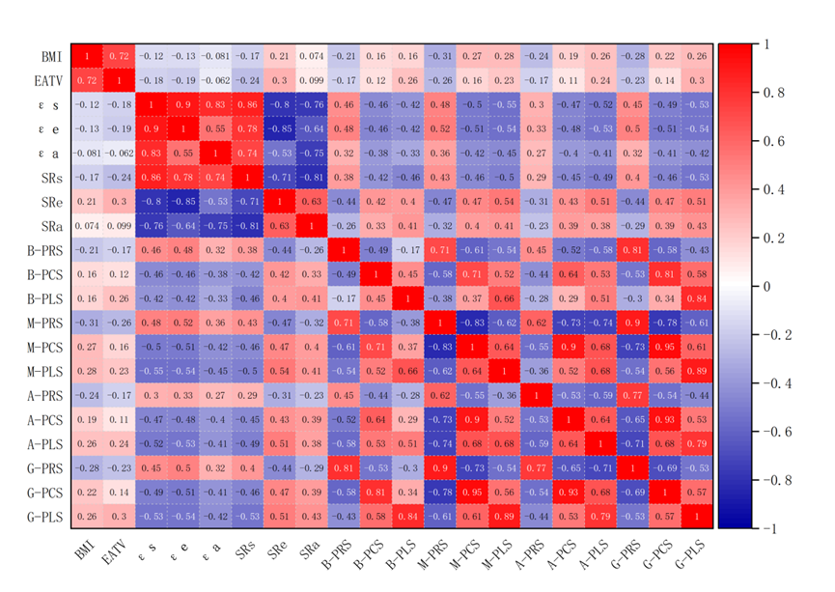
Figure S1 Correlation Heatmap of BMI, EATV, and Myocardial Strain Parameters
Logistic regression analysis

