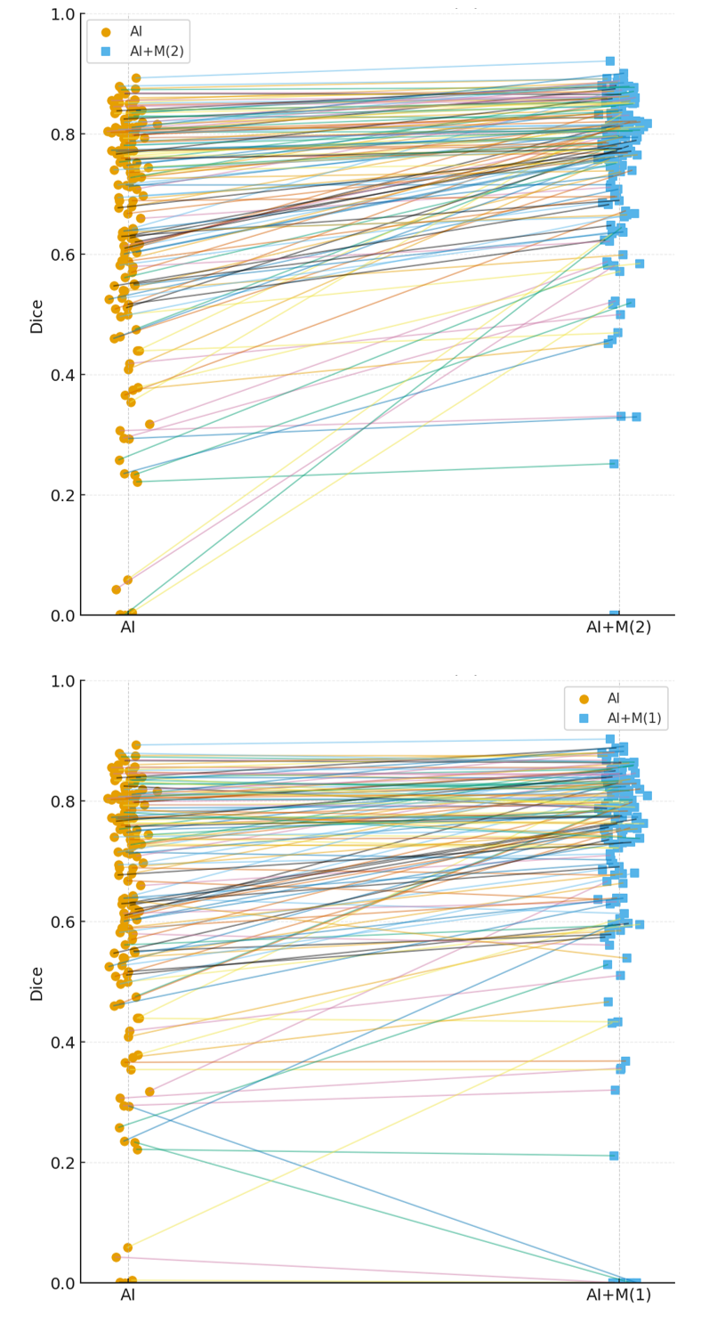
Fig. S1. Per-case paired Dice plots for baseline and two refinements. AI: automatic delineation. AI+M(1, 2): the first and second manual refinements of the automatically delineated GTV by the same junior oncologist.
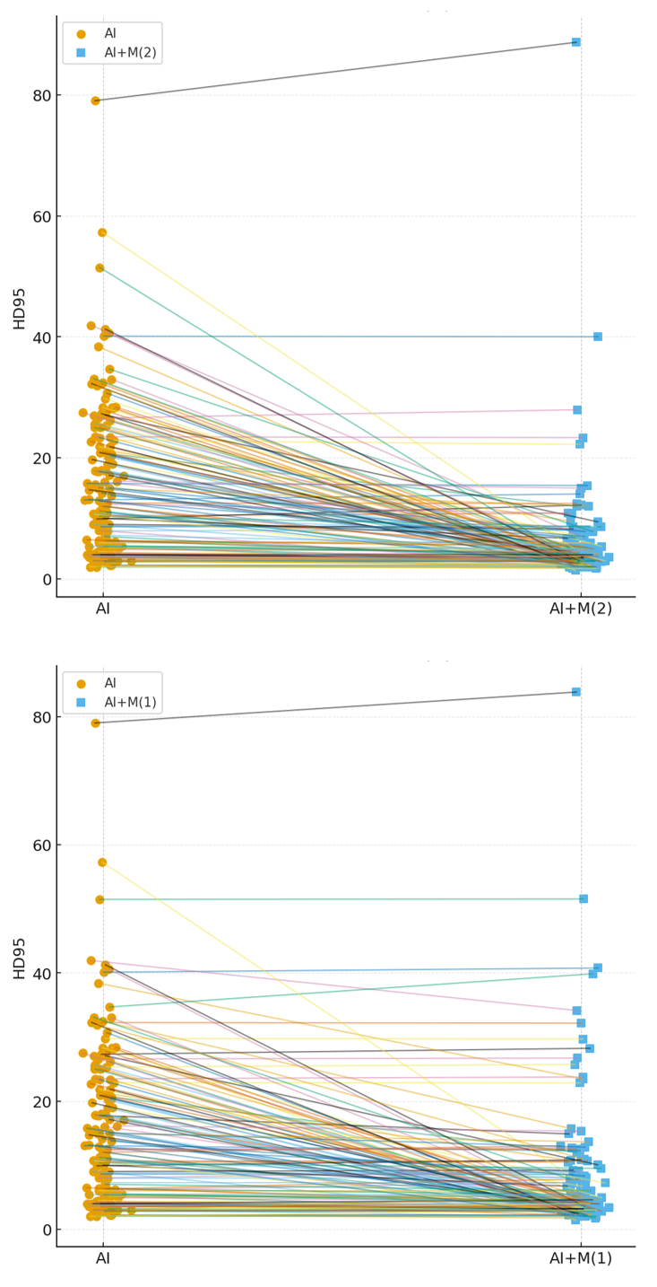
Fig. S2. Per-case paired HD95 plots for baseline and two refinements. AI: automatic delineation. AI+M(1, 2): the first and second manual refinements of the automatically delineated GTV by the same junior oncologist.
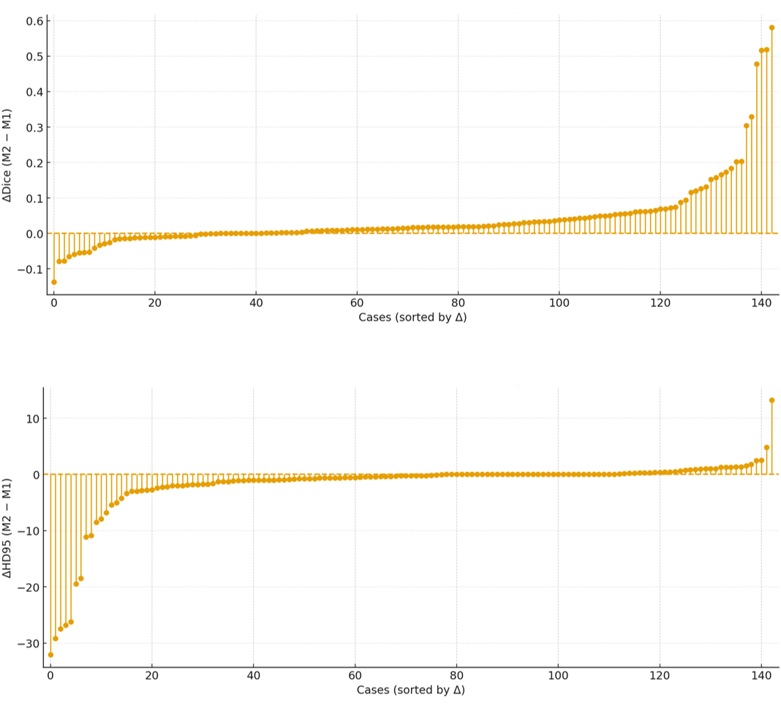
Fig. S3. Comparison of two manual refinements on the testing set of 143 cases: the difference between case-level dice and HD95. M(1, 2): the first and second manual refinements.

