Supplementary Figure 1: Patient enrollment flowchart. PD, Parkinson’s disease; PD-CI, Parkinson’s disease with cognitive impairment; PD-NCI, Parkinson’s disease with normal cognition; PDD, Parkinson’s disease with dementia; PD-MCI, Parkinson’s disease with mild cognitive impairment.

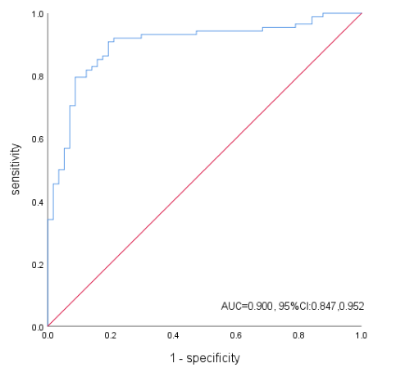
Supplementary Figure 2: The receiver operating characteristics curve demonstrates the diagnostic performance of the predictive model for Parkinson’s disease with cognitive impairment in the test set. AUC, area under the curve.

