Supplementary material

Supplementary Table S1. Interobserver reproducibility of microstructural parameters assessed by intraclass correlation coefficients (ICCs).
Feature | ICC
Vin | 0.967
Dex | 0.96
d | 0.975
Cellularity | 0.962
ADC_25HZ | 0.927
ADC_50HZ | 0.869
ADC_PGSE | 0.959
ADC_Zoomit | 0.977

Supplementary Table S2. Effect size and post-hoc power analysis for continuous variables
Variable | Test | Effect Size (r) | Z Statistic | p | Post-hoc Power | Power Level
d | Mann–Whitney U | 0.538 | 3.882 | <0.001 | 0.999 | Very high
ADC_Zoomit | Mann–Whitney U | 0.526 | 3.79 | <0.001 | 0.999 | Very high
Dex | Mann–Whitney U | 0.454 | 3.276 | 0.001 | 0.992 | Very high
Vin | Mann–Whitney U | 0.386 | 2.781 | 0.005 | 0.964 | Very high
ADC_PGSE | Mann–Whitney U | 0.321 | 2.313 | 0.021 | 0.878 | High
ADC_25Hz | Mann–Whitney U | 0.281 | 2.028 | 0.043 | 0.784 | Moderate
ADC_50Hz | Mann–Whitney U | 0.264 | 1.9 | 0.057 | 0.736 | Moderate
Cellularity | Mann–Whitney U | 0.225 | 1.624 | 0.104 | 0.62 | Moderate

Supplementary Table S3. Pairwise comparison of AUC values using DeLong’s test for correlated ROC curves
Comparison | AUC 1 | AUC 2 | Z Statistic | p
Vin vs Dex | 0.726 | 0.766 | -0.379 | 0.705
Vin vs d | 0.726 | 0.815 | -0.936 | 0.349
Vin vs Cellularity | 0.726 | 0.632 | 3.235 | 0.001
Vin vs ADC_25Hz | 0.726 | 0.665 | 0.666 | 0.505
Vin vs ADC_50Hz | 0.726 | 0.655 | 0.698 | 0.485
Vin vs ADC_PGSE | 0.726 | 0.688 | 0.449 | 0.654
Vin vs ADC_Zoomit | 0.726 | 0.808 | -0.901 | 0.368
Dex vs d | 0.766 | 0.815 | -2.174 | 0.03
Dex vs ADC_25Hz | 0.766 | 0.665 | 0.913 | 0.361
Dex vs ADC_50Hz | 0.766 | 0.655 | 0.998 | 0.318
Dex vs ADC_PGSE | 0.766 | 0.688 | 0.697 | 0.486
Dex vs ADC_Zoomit | 0.766 | 0.808 | -0.44 | 0.66
d vs Cellularity | 0.815 | 0.632 | 1.674 | 0.094
d vs ADC_25Hz | 0.815 | 0.665 | 1.455 | 0.146
d vs ADC_50Hz | 0.815 | 0.655 | 1.544 | 0.123
d vs ADC_PGSE | 0.815 | 0.688 | 1.209 | 0.227
d vs ADC_Zoomit | 0.815 | 0.808 | 0.083 | 0.934
ADC_Zoomit vs ADC_25Hz | 0.665 | 0.808 | 3.041 | 0.002
ADC_Zoomit vs ADC_50Hz | 0.655 | 0.808 | 3.134 | 0.002
ADC_Zoomit vs ADC_PGSE | 0.688 | 0.808 | 3.012 | 0.003
ADC_Zoomit vs Cellularity | 0.632 | 0.808 | 1.894 | 0.058

Supplementary Table S4. Feature coefficients of the combined logistic regression model.
Feature | Regression Coefficient | Absolute Coefficient
BI_RADS | 1.189275639 | 1.189275639
DWI_signal | -0.922204769 | 0.922204769
TIC | 0.763788724 | 0.763788724
edema | 0.720224652 | 0.720224652
ADC_Zoomit | -0.618989834 | 0.618989834
Age | 0.544767808 | 0.544767808
d | 0.512591623 | 0.512591623
morphology | 0.472745918 | 0.472745918
fin | 0.424681439 | 0.424681439
FGT | -0.376606845 | 0.376606845
Maximum_diameter | 0.062458282 | 0.062458282

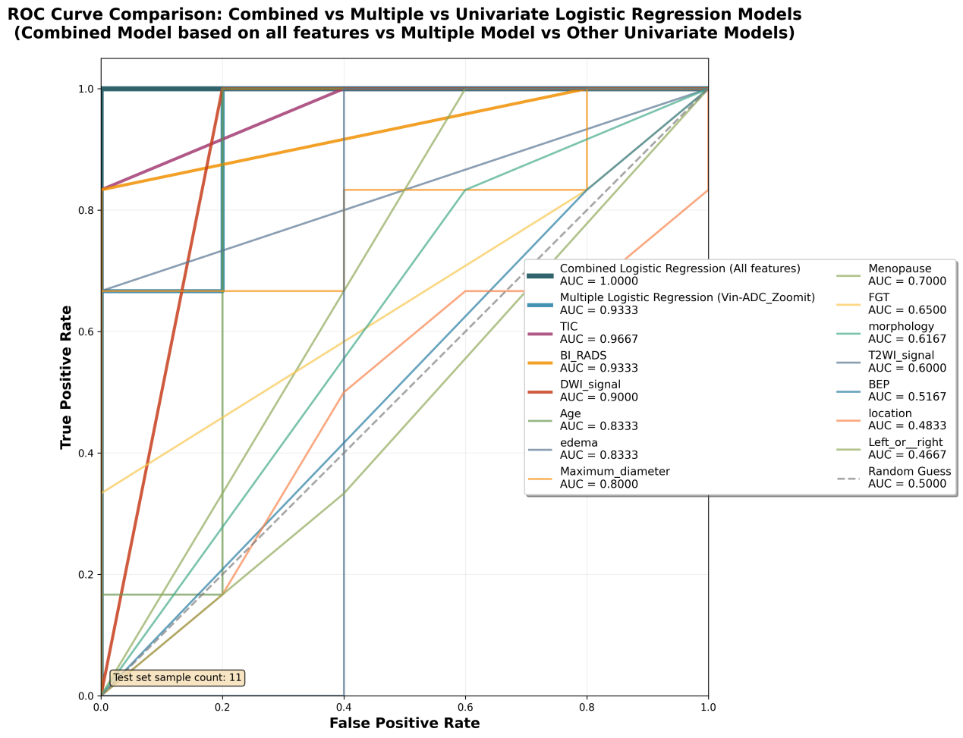
Supplementary Fig S1. ROC curve comparison of logistic regression models. ROC curves comparing the diagnostic performance of the combined logistic regression model, the multivariable model based on diffusion-derived parameters, and individual univariable models derived from clinical and imaging features. The combined model demonstrated the highest diagnostic performance. The dashed diagonal line represents the performance of a random classifier.

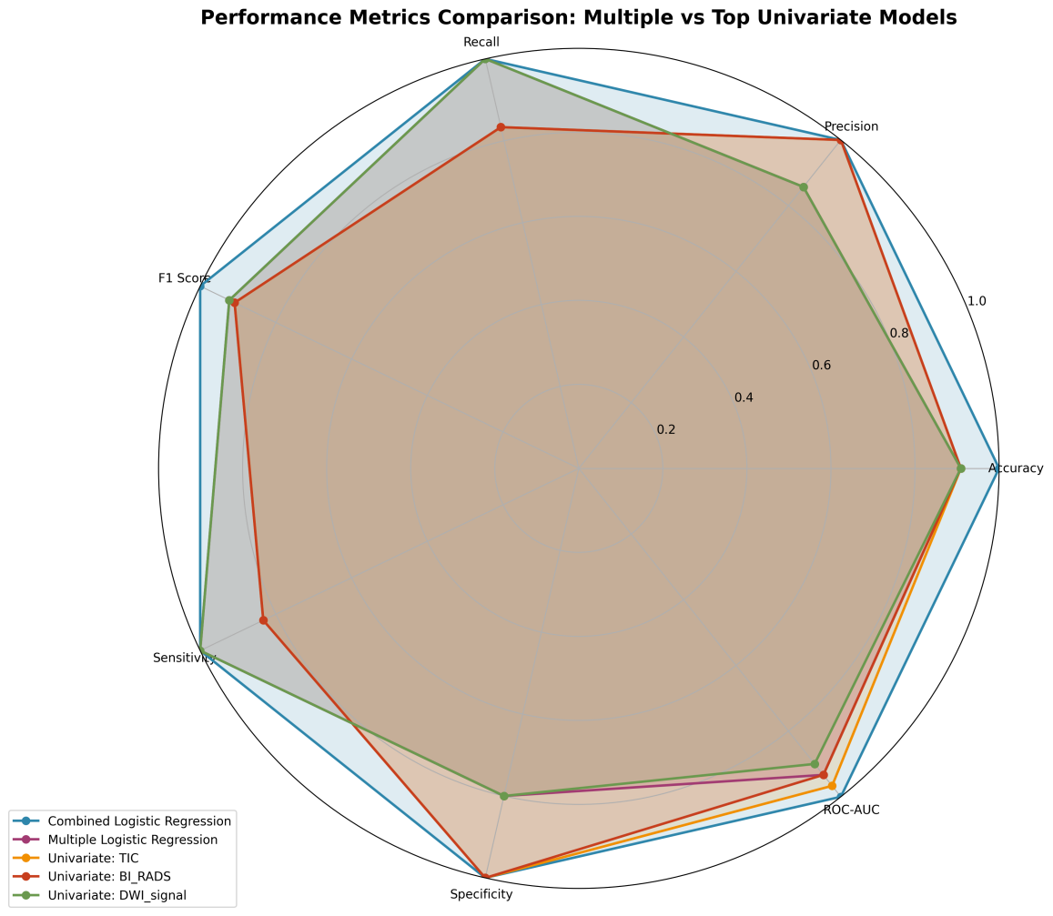

Supplementary Fig S2. Radar chart comparing the performance metrics of different logistic regression models. Radar plot showing the comparison of diagnostic performance metrics among the combined logistic regression model, the multivariable logistic regression model based on diffusion-derived parameters, and selected top-performing univariable models (TIC, BI-RADS, and DWI signal). The evaluated metrics include accuracy, precision, recall, F1 score, sensitivity, specificity, and AUC. The combined model integrating clinical/imaging features and diffusion-derived parameters achieved the highest overall performance.

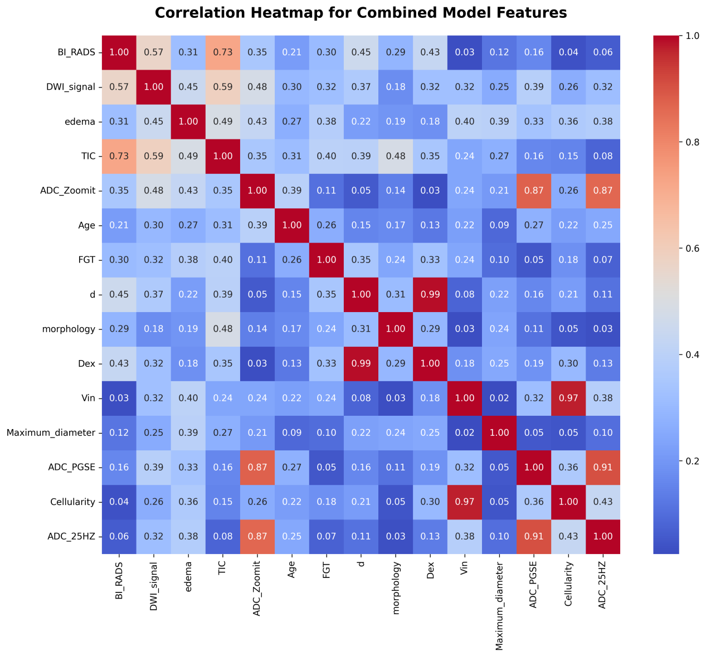
Supplementary Fig. S3. Correlation heatmap of selected clinical, conventional MRI, and diffusion-derived parameters included in the combined model. Warmer colors indicate stronger positive correlations between variables.
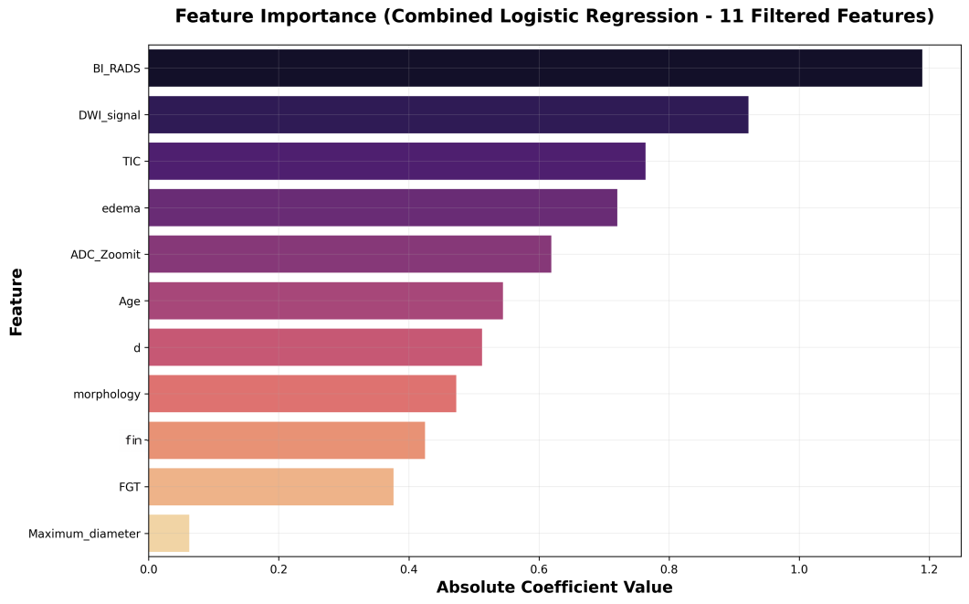
Supplementary Fig. S4. Relative contribution of selected features in the combined logistic regression model based on absolute regression coefficients.

