Supplementary Materials
Deep Learning for the Diagnosis of Lumbar Disc Herniation: A Systematic Review and Meta-Analysis

Supplementary Figure S1. Sensitivity analyses of diagnostic performance for LDH ( LOO_Exclude_Chu, 2025 )

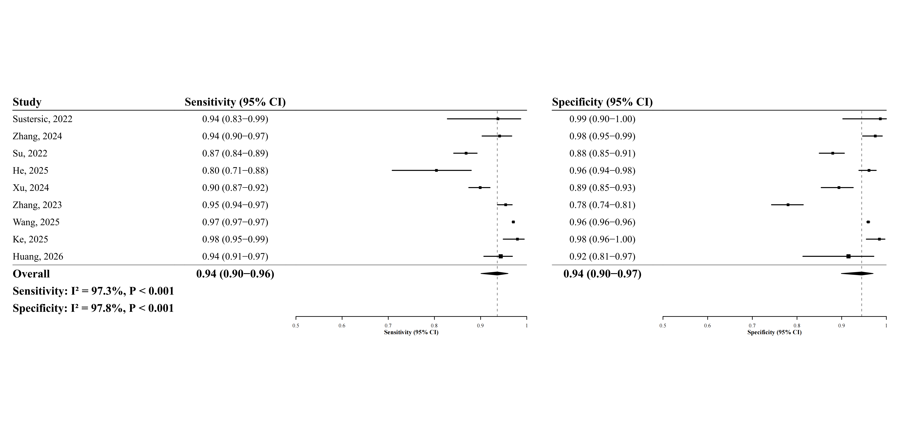

Supplementary Figure S2. Sensitivity analyses of diagnostic performance for LDH ( LOO_Exclude_He, 2025 )

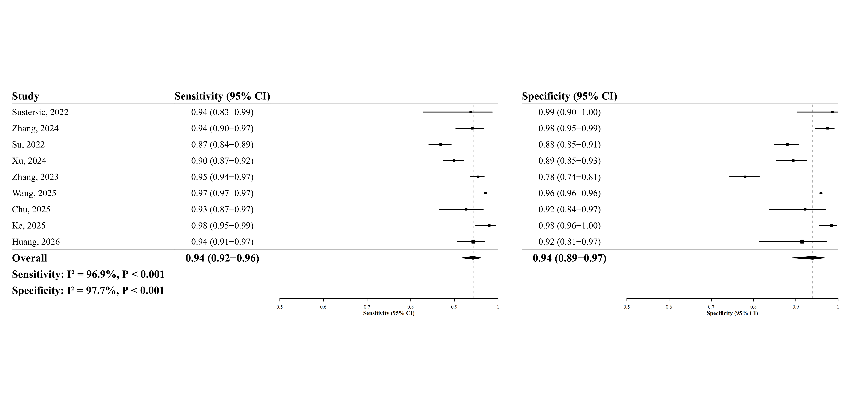

Supplementary Figure S3. Sensitivity analyses of diagnostic performance for LDH ( LOO_Exclude_Huang, 2026 )

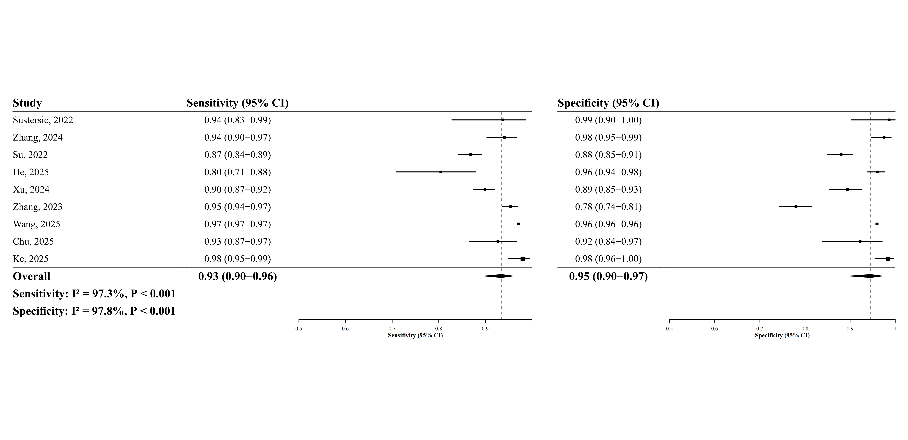

Supplementary Figure S4. Sensitivity analyses of diagnostic performance for LDH ( LOO_Exclude_Ke, 2025 )

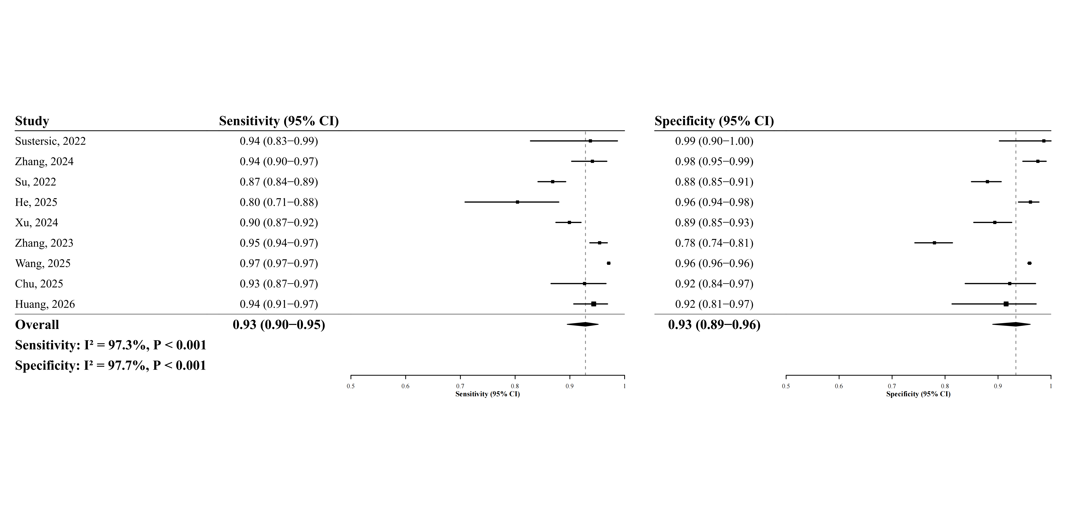

Supplementary Figure S5. Sensitivity analyses of diagnostic performance for LDH ( LOO_Exclude_Su, 2022 )

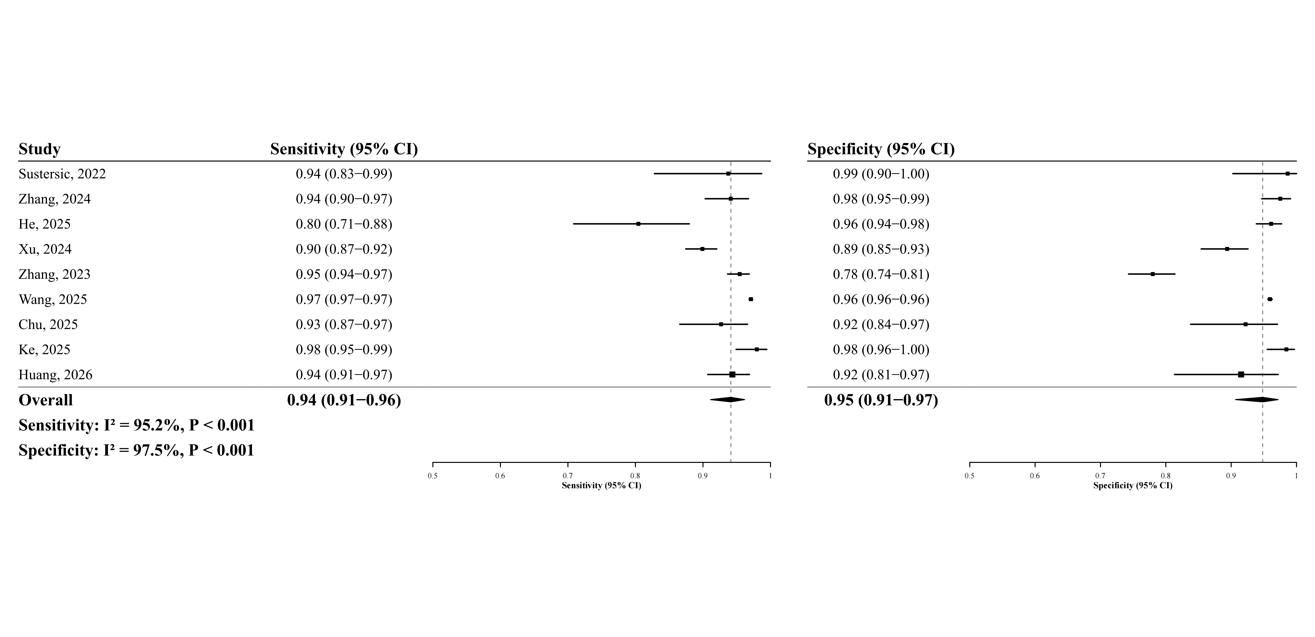

Supplementary Figure S6. Sensitivity analyses of diagnostic performance for LDH ( LOO_Exclude_Sustersic, 2022 )

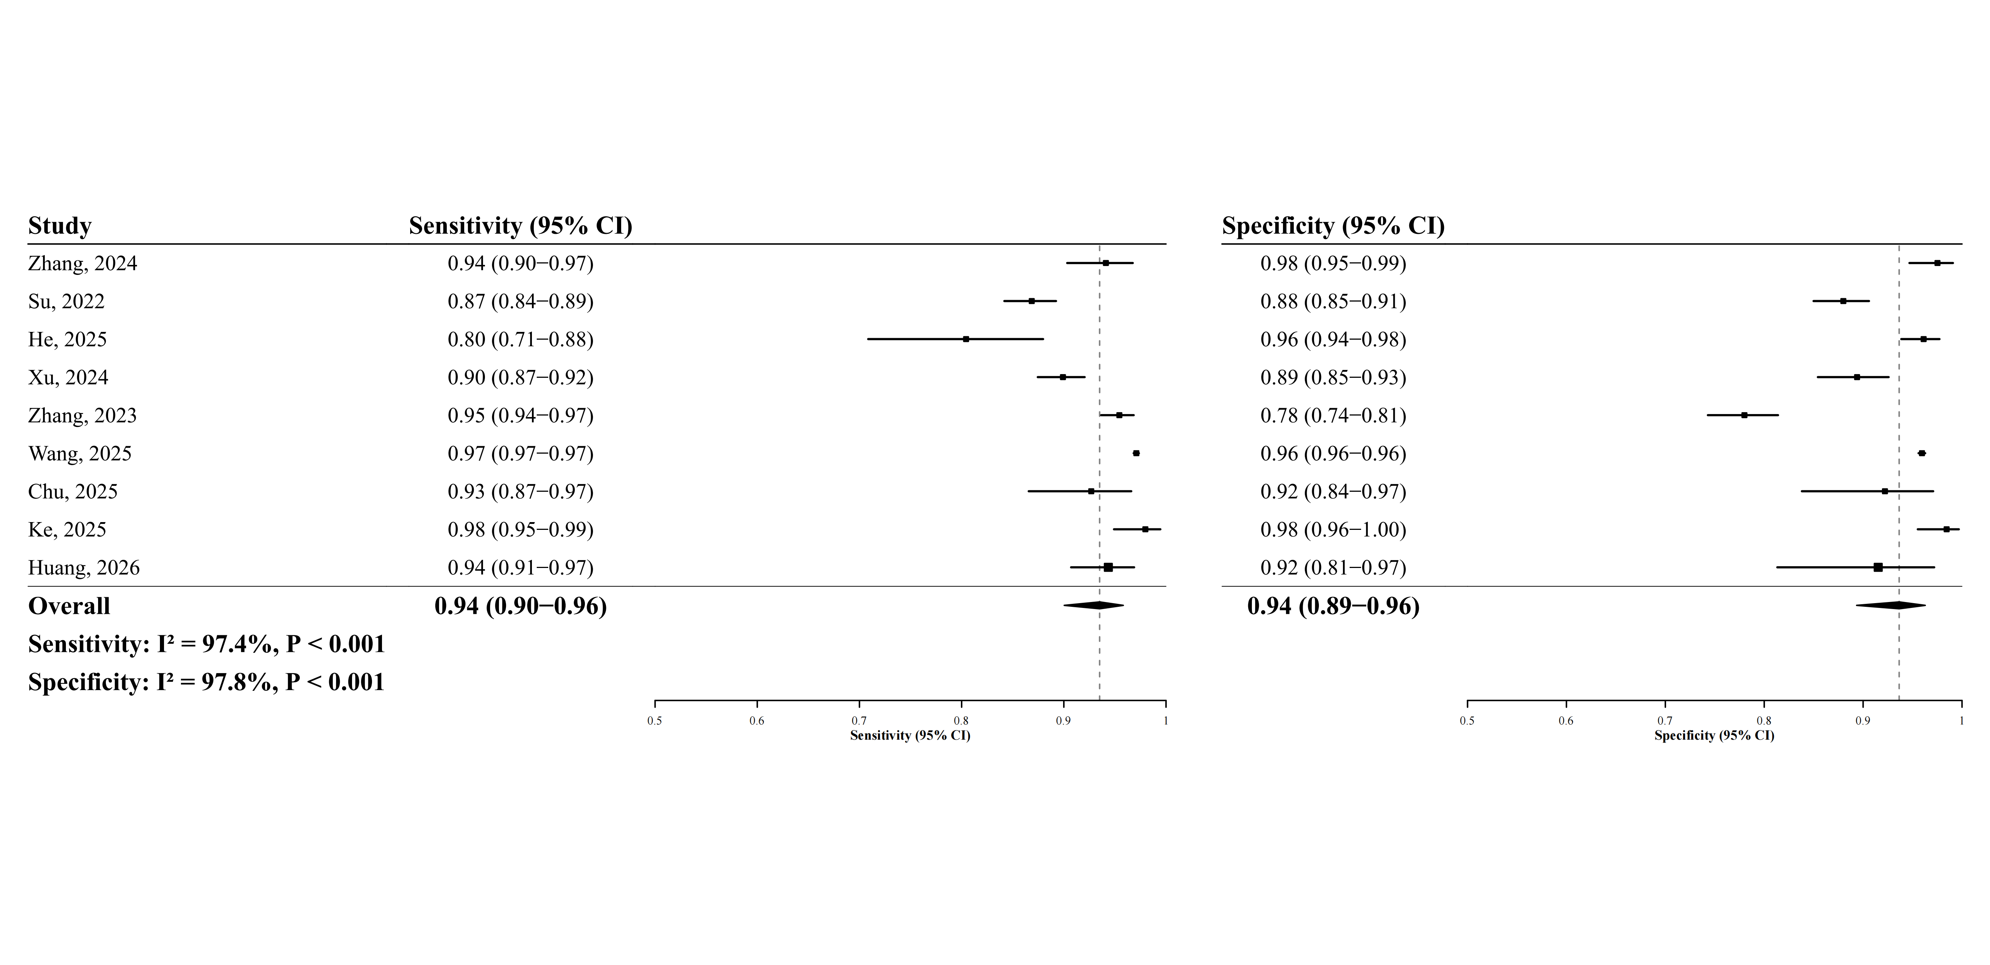

Supplementary Figure S7. Sensitivity analyses of diagnostic performance for LDH ( LOO_Exclude_Wang, 2025 )

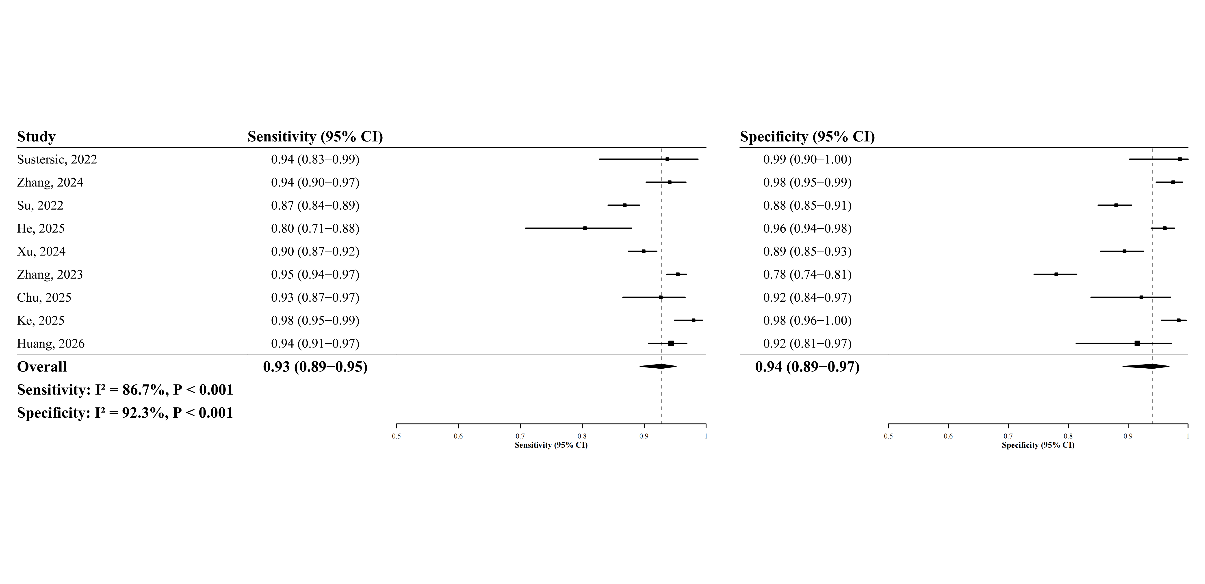

Supplementary Figure S8. Sensitivity analyses of diagnostic performance for LDH ( LOO_Exclude_Xu, 2024 )

Supplementary Figure S9. Sensitivity analyses of diagnostic performance for LDH ( LOO_Exclude__Zhang, 2023 )

Supplementary Figure S10. Sensitivity analyses of diagnostic performance for LDH ( LOO_Exclude_Zhang, 2024 )

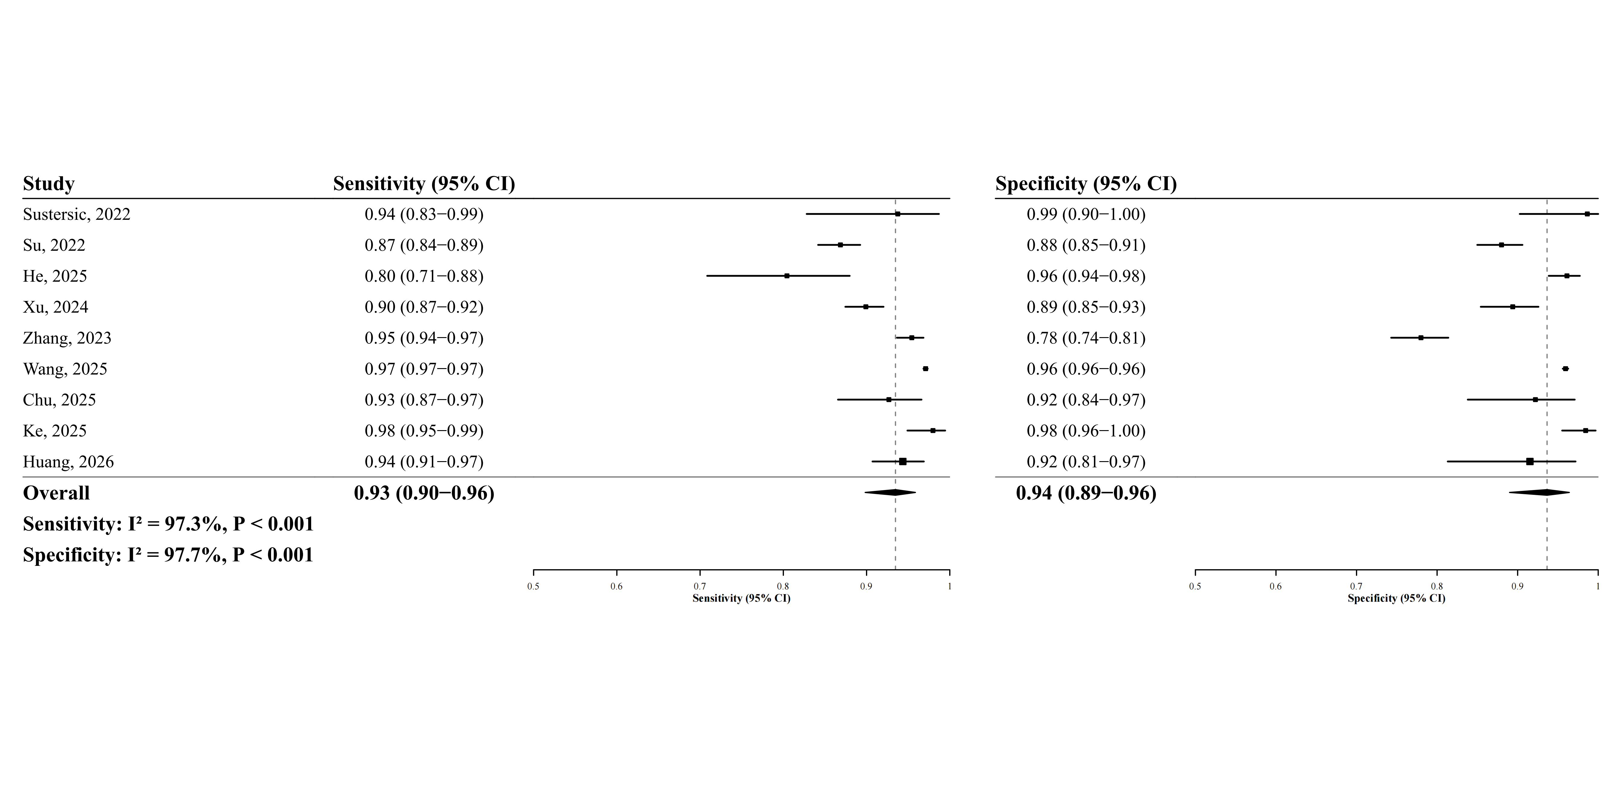

Supplementary Figure S11. Sensitivity analyses of diagnostic performance for LDH ( LOO_Exclude_Definition_Heterogeneity )

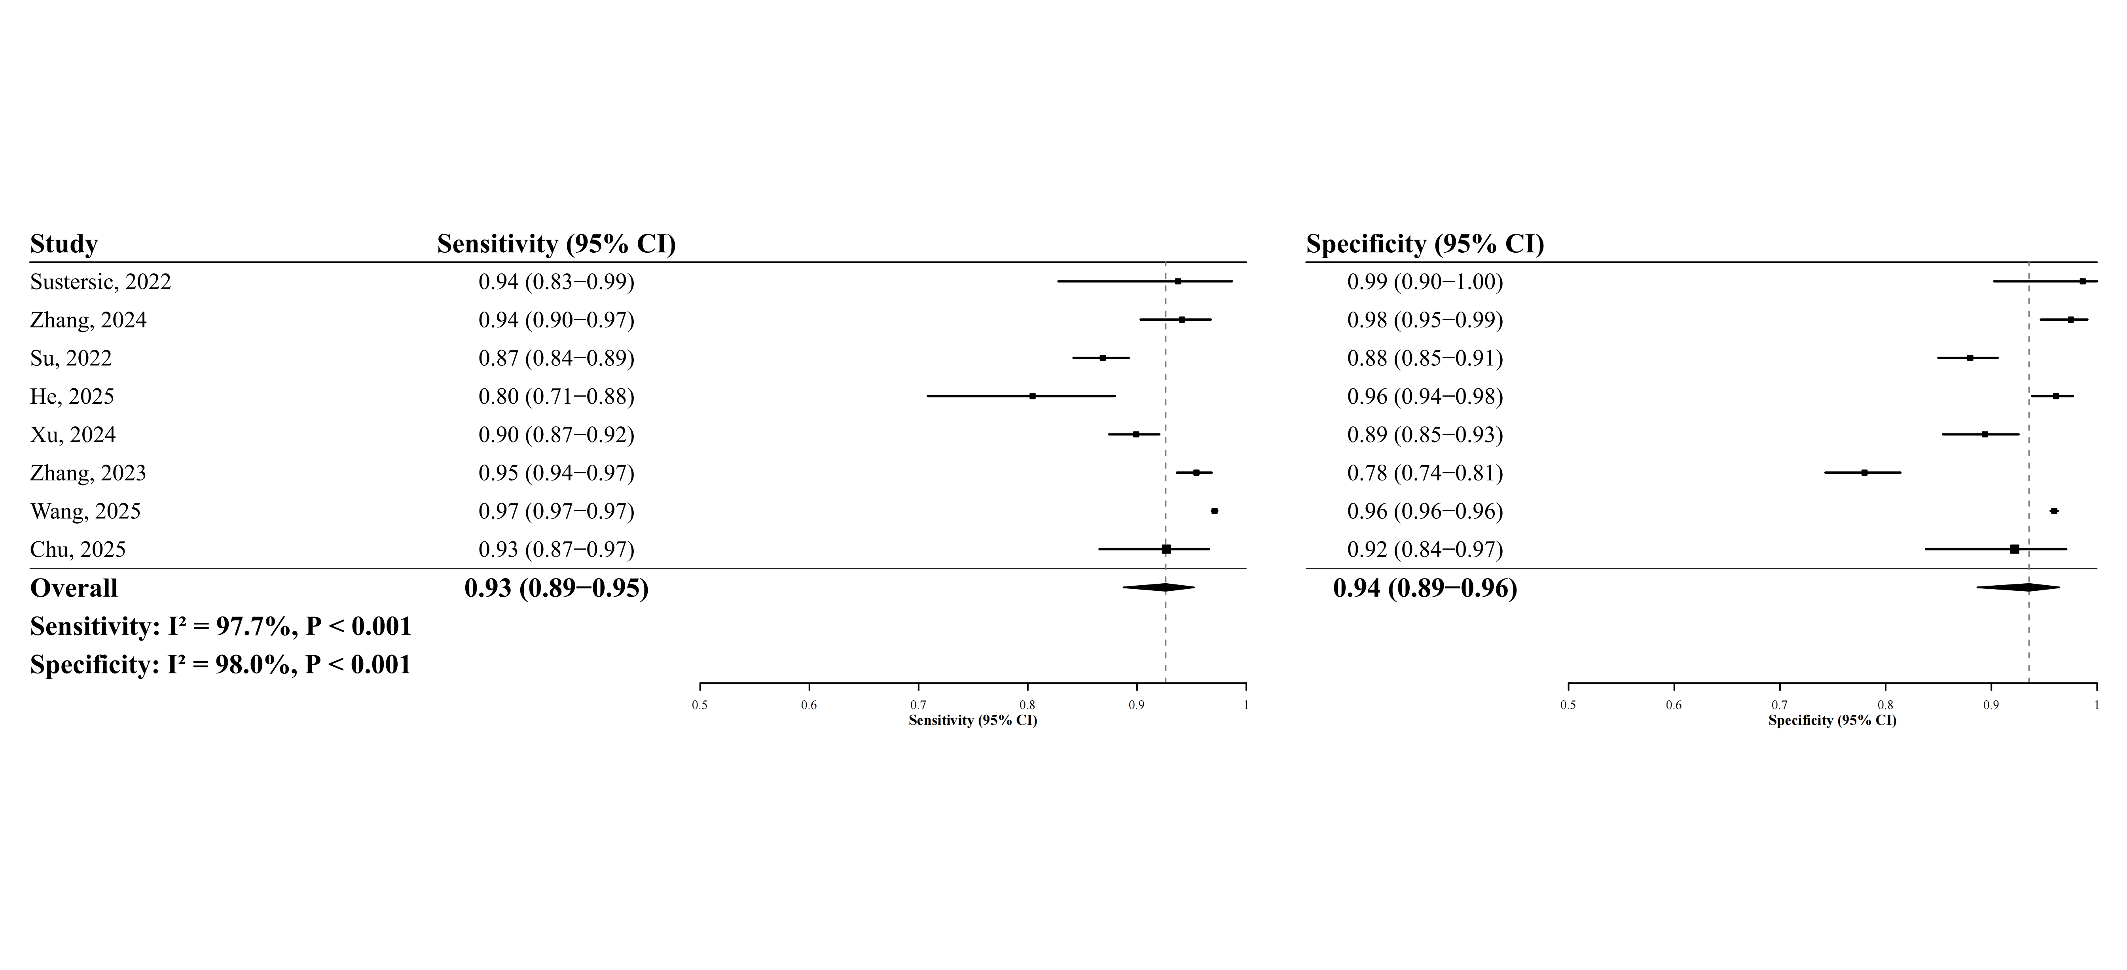

Supplementary Figure S12. Sensitivity analyses of diagnostic performance for LDH ( LOO_Exclude_Calculated_Data )

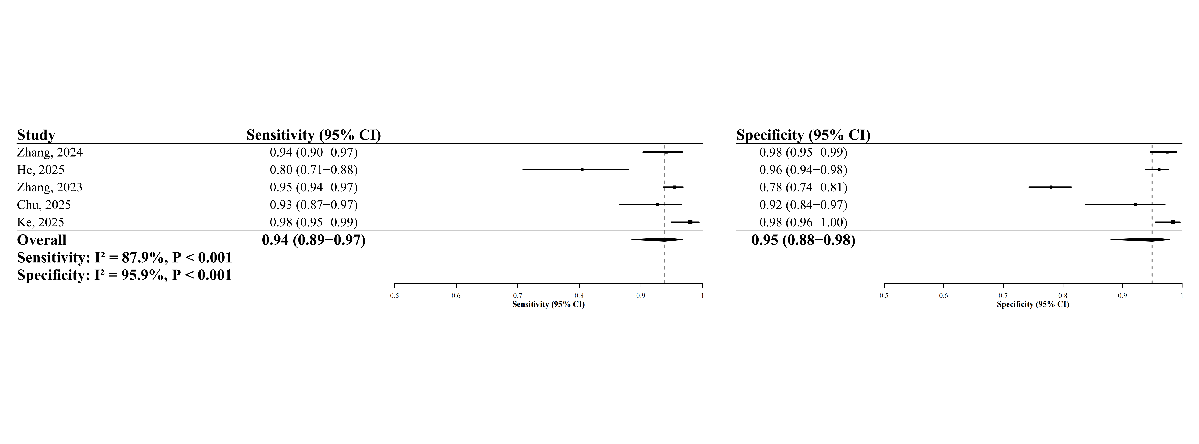

Supplementary Figure S13. Sensitivity analyses of diagnostic performance for LDH ( LOO_Exclude_NonMRI )

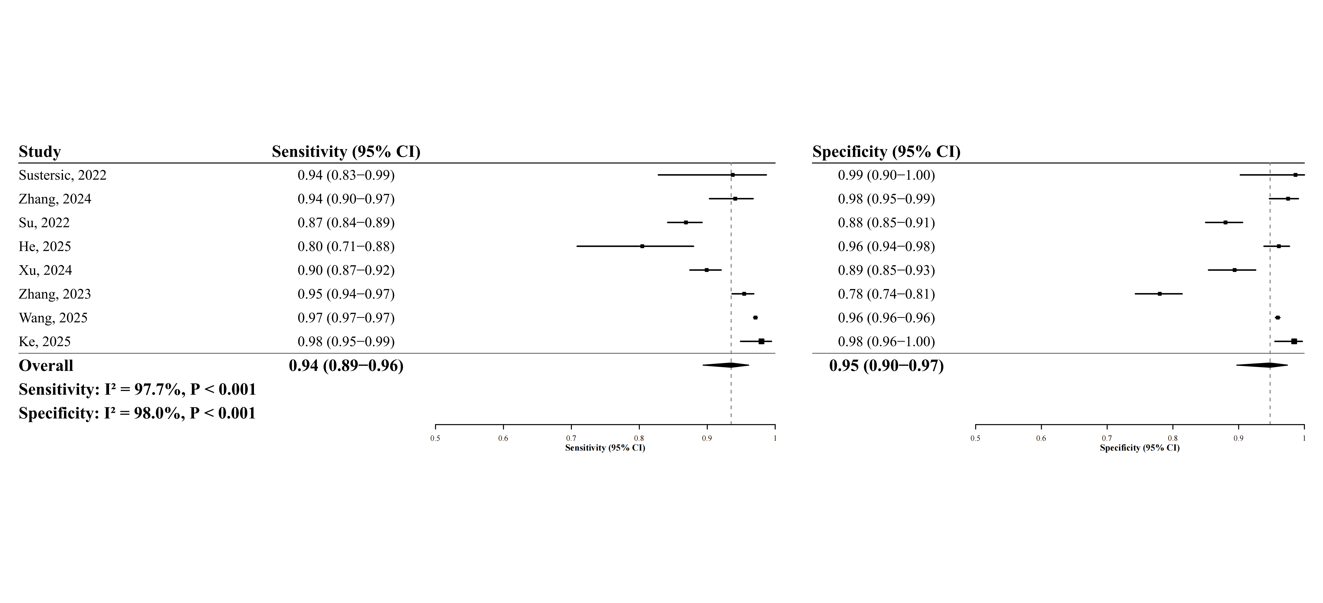

Supplementary Figure S14. Sensitivity analyses of diagnostic performance for LDH ( LOO_Exclude__Transformer_Architecture )

Supplementary Figure S15. Sensitivity analyses of diagnostic performance for LDH ( LOO_Exclude_Detection_Architecture )

