Supplementary Material
Radiomics-Based Unsupervised Clustering and Deep Learning Nomogram for Response Prediction After Neoadjuvant Chemotherapy in Locally Advanced Laryngeal Cancer

Table of Contents
Supplementary Material 1
Supplementary Figures and Figure legends 3
Figure S1. Example Images of RECIST 1.1 3
Figure S2. Cumulative distribution function 4
Figure S3. Correlation between subtype A and subtype B for remission and non-remission 5
Figure S4. Predictor selection using the Boruta test 6
Figure S5. Predictor selection using the LASSO regression analysis with tenfold cross-validation. 7
Figure S6. The calibration curve 8
Figure S7. The clinical decision curve 9
Figure S8. Clinical evaluation of the remission score for NAC response assessment 10
Figure S9. The impact of the remission score on doctors' diagnostic performance 11
Supplementary Tables 12
Table S1. Multivariate Logistic regression analysis 12
Table S2. Rad-score 13
Table S3. Clinical factors of the Center 1 and Center 2 14
Appendix 15
Appendix S1. Tumor treatment and response assessment 15
Appendix S2. CT image acquisition, segmentation, and radiomics feature extraction 16
Appendix S3. Development of Models 17
Appendix S4. Clinical evaluation 18
Appendix S5. Statistical analysis 19
Appendix S6. Development and performance of the remission model 20

Supplementary Figures and Figure legends

Figure S1. Example Images of RECIST 1.1

Figure S1. Example Images of Response Evaluation Criteria in Solid Tumors (RECIST) Version 1.1. NAC, neoadjuvant chemotherapy.

Figure S2. Cumulative distribution function

Figure S2. Cumulative distribution function (CDF).

Figure S3. Correlation between subtype A and subtype B for remission and non-remission
Figure S3. Correlation between subtype A and subtype B for remission and non-remission in the training (A) and test (B) sets. Correlation between subtype A and subtype B for enhancement modes in the training (C) and test (D) sets.

Figure S4. Predictor selection using the Boruta test

Figure S4. (A) Feature Importance Score Boxplot. The horizontal axis is the name of each radiomics feature, and the vertical axis is the Z value of each variable. The box plot shows the Z value of each variable during model calculation. The green boxes represent important variables, and the yellow and red boxes represent unimportant variables. (B) Feature Importance Score Trajectory Plot.

Figure S5. Predictor selection using the LASSO regression analysis with tenfold cross-validation
Figure S5. (A) Tuning parameter (lambda) selection of deviance in the LASSO regression based on the minimum criteria (left dotted line) and the 1-SE criteria (right dotted line). (B) A coefficient profile plot was created against the log (lambda) sequence. In the present study, predictor's selection was according to the minimum criteria (left dotted line), where 3 nonzero coefficients were selected LASSO, least absolute shrinkage and selection operator; SE, standard error.

Figure S6. The calibration curve

Figure S6. The calibration curves in the training (A) and test (B) sets.

Figure S7. The clinical decision curve
Figure S7. The clinical decision curves in the training (A) and test (B) sets.

Figure S8. Clinical evaluation of the remission score for NAC response assessment
Figure S8. The predictive performance of junior and senior doctors with or without AI assistance. ROC, receiver operating characteristic curve. AI, artiﬁcial intelligence.

Figure S9. The impact of the remission score on doctors' diagnostic performance
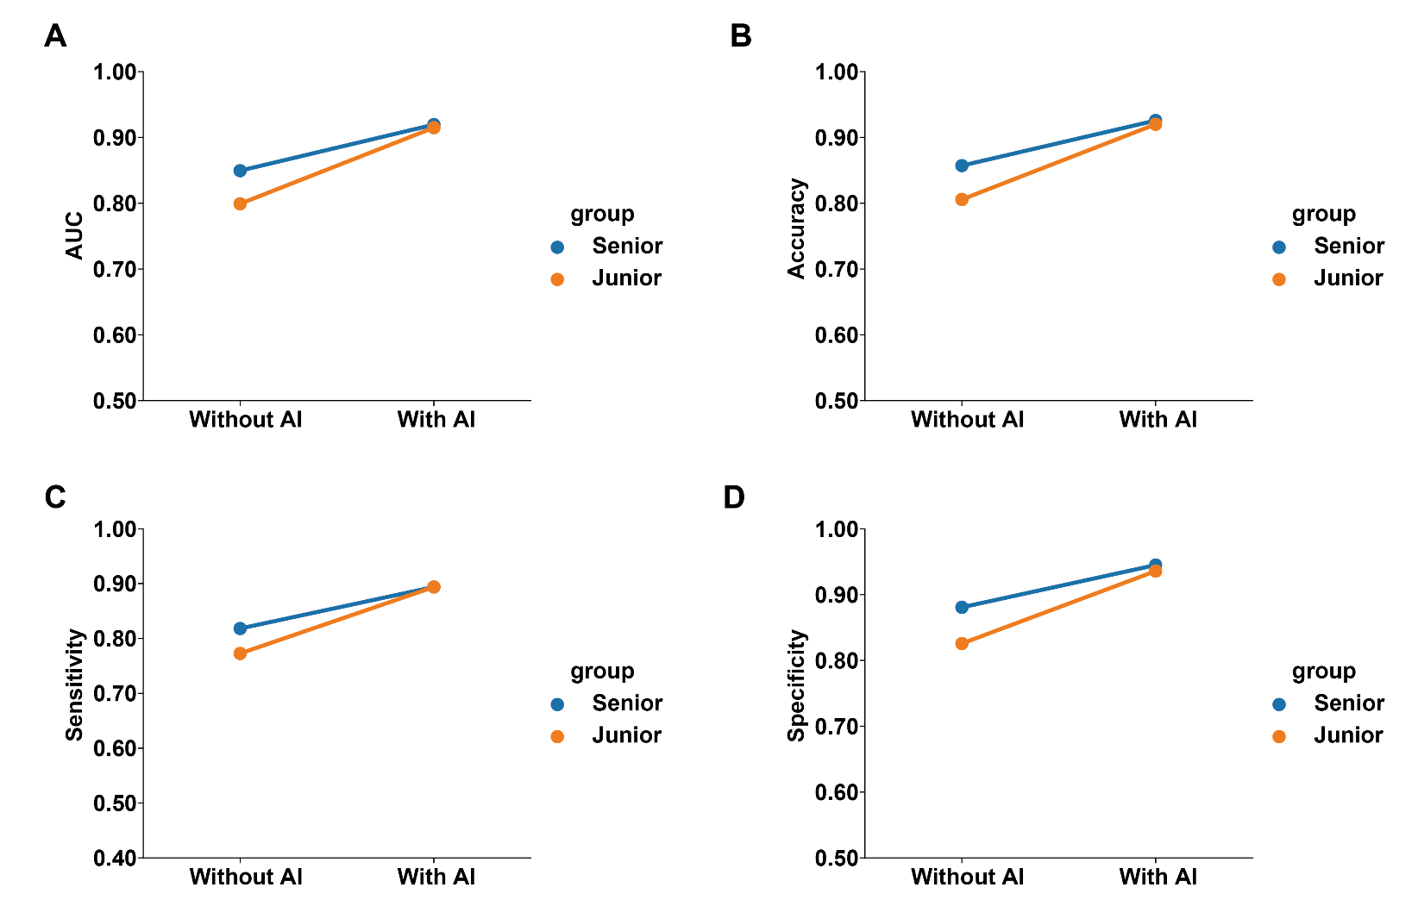
Figure S9. The diagnostic performance is reflected in terms of AUC (A), accuracy (B), sensitivity (C), and specificity (D). AUC, area under the receiver operating characteristic curve.

Supplementary Tables

Table S1. Multivariate Logistic regression analysis
 | B | SE. | Wald χ² | P | OR (95%CI)
Pathological LNM | 0.702 | 0.458 | 2.354 | 0.125 | 2.019(0.823-4.952)
cartilage invasion | 2.143 | 0.636 | 11.347 | <0.001 | 8.525(2.450-29.662)
paraglottic/preepiglottic space invasion | 0.933 | 0.450 | 4.295 | 0.038 | 2.541(1.052-6.138)

Table S2. Rad-score
Radiomics features | Coefficients
exponential_firstorder_Median | -0.00193911
gradient_glszm_LargeAreaLowGrayLevelEmphasis | -7.28E-05
logarithm_firstorder_Minimum | 0.000182283
Rad-score | (-0.00193911)×exponential_firstorder_Median  +(-7.28E-05)×gradient_glszm_LargeAreaLowGrayLevelEmphasis  +(0.000182283)×logarithm_firstorder_Minimum  +1.05305302536406

Table S3. Clinical factors of the Center 1 and Center 2
Clinical factors | Center 1 (n=112) | Center 2 (n=63) | P
Age(years) | 62.53±8.30 | 62.79±8.06 | 0.837
Status |  |  | 0.467
remission | 40 | 26
non-remission | 72 | 37
Sex |  |  | 0.914
Female | 8 | 5
Male | 104 | 58
Primary site |  |  | 0.933*
Supraglottic | 33 | 17
Glottic | 71 | 41
Subglottic | 8 | 5
cT stage |  |  | 0.280
T3 | 71 | 45
T4 | 41 | 18
Tobacco consumption |  |  | 0.236
None | 20 | 7
Yes | 92 | 56
Alcohol consumption |  |  | <0.05
None | 35 | 11
Yes | 77 | 52
Neoadjuvant therapy cycles |  |  | 0.083
2 | 94 | 46
3 | 18 | 17
Pathological LNM |  |  | 0.805
None | 43 | 23
Yes | 69 | 40
Cartilage invasion |  |  | <0.05
None | 19 | 30
Yes | 93 | 33
Enhancement pattern |  |  | 0.539
arterial phase | 48 | 24
venous phase | 64 | 39
Paraglottic/Preepiglottic space invasion |  |  | 0.203
None | 51 | 35
Yes | 61 | 28
Numerical data are presented as mean ± standard deviation, categorical data as numbers (n)
P: the p value of comparison between Center 1 and Center 2； *Fisher's exact test；
cartilage invasion and paraglottic/preepiglottic space invasion were radiological features

Appendix

Appendix S1 Tumor treatment and response assessment
Treatment: For NAC, TPF remedy was administered as docetaxel 60 mg/m² intravenously every 3 weeks on days 1, 22, and 43; cisplatin 60 mg/m² intravenously every 3 weeks on days 1, 22, and 43; and fluorouracil 600 mg/m²/d as a continuous 120 h infusion on days 1–5, 22–26, and 43–47. Additionally, GP remedy was administered as gemcitabine 1 g/m² intravenously every 3 weeks on days 1, 8, 22, 29, 43, and 64, and cisplatin 80 mg/m² intravenously every 3 weeks on days 1, 2, 22, 23, 43, and 44. All two or three cycles were administered at intervals of 3 weeks.

Response assessment: Two radiologists and radiation oncologists with 10 years of professional experience each measured the maximum diameter of the tumor at each axial slice on thin-slice contrast-enhanced CT in the venous phase within 1-2 weeks before NAC and within 1 week after completion of two or three cycles of NAC, respectively; subsequently, they calculated the regression rate using the formula, regression rate = (maximum diameter of the lesion before NAC - maximum diameter of the lesion at the same slice after NAC) / maximum diameter of the lesion before NAC, and obtained the average value of these rates. Efficacy assessment was conducted in accordance with the Response Evaluation Criteria in Solid Tumors (RECIST) Version 1.1^{[1]}, where Complete Response (CR) was defined as the complete disappearance of lesions with the short diameter of lymph nodes < 10 mm, Partial Response (PR) as a regression rate ≥ 30%, Progressive Disease (PD) as a progression rate ≥ 20% or the appearance of new lesions, and Stable Disease (SD) as efficacy falling between PR and PD (Figure S1).

[1] Eisenhauer EA, Therasse P, Bogaerts J, et al. New response evaluation criteria in solid tumours: revised RECIST guideline (version 1.1). Eur J Cancer. 2009; 45: 228-47.

Appendix S2 CT image acquisition, segmentation, and radiomics feature extraction
CT image acquisition: Hospital 1: The CT scanner model was Somatom Definition Flash (Siemens Healthineers, Germany). The tube voltage was 120 kV, the tube current was 250–400 mAs (automatic tube current modulation technology), the detector collimation was 64×0.625 mm, the matrix was 512×512, and the slice thickness was 1.0 mm. Intravenous injection of 80–90 ml of contrast agent Ultravist (Bayer Pharmaceuticals) with an iodine concentration of 350 mg/ml was performed at a flow rate of 3.0 ml/s. Arterial phase and venous phase scans were performed sequentially at 25 s and 45 s after contrast agent injection.
Hospital 2: The CT scanner models were Somatom Definition AS (Siemens Healthineers, Germany) and GE Discovery 750 (GE Healthcare, USA). The tube voltage was 120 kV, the tube current was 200–300 mAs (automatic tube current modulation technology), the detector collimation was 80×0.5 mm or 64×0.625 mm, the matrix was 512×512, and the slice thickness was 1.0 mm. Intravenous injection of 80–90 ml of contrast agent Ultravist (Bayer Pharmaceuticals) with an iodine concentration of 350 mg/ml was performed at a flow rate of 2.5 ml/s. Arterial phase and venous phase scans were performed sequentially at 25 s and 60 s after contrast agent injection.
All patients included in the study underwent preoperative CT scans using a multi-slice CT system while in the supine position. The CT scans were performed from the skull base to the sternoclavicular joint. During the scanning process, patients were instructed to maintain calm respiration and avoid swallowing to minimize motion artifacts.
Segmentation: During data preprocessing, we applied spatial normalization and fixed-resolution resampling techniques to address variations between different CT scanners. Spatial normalization was used to reduce voxel spacing discrepancies and ensure a consistent spatial scale across the images. The fixed-resolution resampling method standardized the voxel size to 1 × 1 × 1 mm³, eliminating variations caused by different scanner resolutions. For the purpose of standardizing the window width and window level, the former was set to 50, and the latter was set to 350, values confirmed as appropriate during the ROI segmentation process. This standardization ensures consistent contrast and brightness across images, facilitating accurate segmentation of the ROIs. The whole venous-phase tumor was manually delineated slice-by-slice by a radiologist (junior) with 4 years of experience in head and neck cancer imaging and then confirmed by an experienced radiologist with 16 years (senior) on the ITK-SANP platform (V.3.8, www.itksnap.org). During delineation, necrotic and cystic areas were avoided as much as possible.
Radiomics feature extraction: The “Pyradiomics” toolkit was used to extract 1834 radiomic features from venous-phase tumors, categorized into five groups: (1) first order features, (2) shape features, (3) texture features, (4) wavelet features, and (5) Laplacian of Gaussian (LoG) features.

Appendix S3 Development of Models
Instead of selecting only the best model as in previous works, we performed frame fusion on the predictions of all models to utilize the strengths of all models. The decision fusion model was created by combining predictions at the decision level using stacking, where a meta-classifier integrated output from multiple base classifiers to produce the final prediction. In this study, the key clinical features and Rad-score were applied to seven machine-learning classifiers, including GaussianNB (GNB), decision tree (DT), K nearest neighbors (KNN), logistic regression (LR), random forest (RF), support vector machine (SVM), and XGBoost (XGB), to develop the fusion model for predicting remission status. All seven classifiers adopted default hyperparameters from official toolkit configurations without additional hyperparameter tuning via grid/random search. Meanwhile, the fusion models were evaluated using five-fold cross-validation, and the predicted probability values from these fusion models were obtained to construct the nomogram. For the DL signature model, the largest tumor ROI slice of each patient, which was processed along with its corresponding label by a ResNet-101 network, was used to generate the predicted probability of remission for each patient. Nomogram model-predicted probability values were also obtained for patients, and the remission score groups, based on these values and functioning as a dichotomous variable, were categorized scores surpassing cutoff value as the high remission score group, while scores below cutoff value are classified as the low remission score group. For the interpretation of DL signature model, Gradient-weighted Class Activation Mapping (Grad-CAM) was used for visualization to distinguish salient visual features, highlighting the input features with the largest weight in deep learning classification.

Appendix S4 Clinical evaluation
In this section, we evaluate the efficacy of neoadjuvant chemotherapy (NAC) in laryngeal cancer patients based on the evaluation criteria established for head and neck squamous cell carcinoma. Evaluating the efficacy of NAC in locally advanced laryngeal cancer:

1.The presence of tumor necrosis (including primary tumor and metastatic lymph nodes) [1].
2. Four or more cervical metastatic lymph nodes [2].
3. P16-negative [3].

A score of 1 point was assigned for each item, the total evaluation score of each patient was accumulated in all items. For the NAC treatment response prediction, it was defined as potential NAC non-remission group when the total evaluation score exceeded 2, and otherwise as potential NAC remission group [4].

[1] Jiang Y, Liang Z, Chen K, et al. A dynamic nomogram combining tumor stage and magnetic resonance imaging features to predict the response to induction chemotherapy in locally advanced nasopharyngeal carcinoma. Eur Radiol. 2023; 33(3): 2171-2184.
[2] Zhao Q, Dong A, Cui C, et al. MRI-Based Metastatic Nodal Number and Associated Nomogram Improve Stratification of Nasopharyngeal Carcinoma Patients: Potential Indications for Individual Induction Chemotherapy. J Magn Reson Imaging. 2023; 57(6): 1790-1802.
[3] Chen WS, Luo SD, Chiu TJ, et al. Ribophorin II Overexpression Is Associated with Poor Response to Induction Chemotherapy with Docetaxel, Cisplatin, and Fluorouracil in P16-Negative Locally Advanced Head and Neck Squamous Cell Carcinoma. J Clin Med. 2021; 10(18): 4118.
[4] Liao H, Zhao Y, Pei W, et al. An interpretable machine learning model assists in predicting induction chemotherapy response and survival for locoregionally advanced nasopharyngeal carcinoma using MRI: a multicenter study. Eur Radiol. 2025; 35(8): 5121-5134.

Appendix S5 Statistical analysis
When the missing value of the observation index data was greater than or equal to 20%, the observation index was removed. For missing values below 20%, the multiple imputation method was employed to fill the gap^{[1]}. Continuous variables were expressed as mean±SD and compared by independent t-test with normal distribution or Mann–Whitney U test with abnormal distribution. The differences in categorical variables were analyzed by the chi-square test or Fisher's exact test. Univariate Logistic regression analysis was used to obtain the independent predictive factors of remission in locally advanced laryngeal cancer. Receiver operating characteristic (ROC) curve analysis and Precision-Recall (PR) Curve analysis were performed to determine the diagnostic performance of each model. The model's diagnostic accuracy, sensitivity, specificity, positive predictive value (PPV), and negative predictive value (NPV) were calculated.

[1] Farrar D, Fairley L, Santorelli G, et al. Association between hyperglycaemia and adverse perinatal outcomes in south Asian and white British women: analysis of data from the Born in Bradford cohort. Lancet Diabetes Endocrinol. 2015; 3(10):795-804.

Appendix S6 Development and performance of the remission score model
All prediction models constructed in this study followed the 10 events per variable (EPV) rule[1]. Since the number of positive cases in the training set was 40, the number of variables incorporated into the models should not exceed 4. The fusion model was established using a stacking strategy that incorporated the average of the predicted probability values for remission with the LR classifier, built by seven machine-learning classifiers. The calibration curves, clinical decision curves (DCA) of the nomogram model for the training set and test set revealing good calibration performance and strong clinical utility (Figure S6, S7). Notably, the cluster model exhibited higher PR values than AUC values in both the training and test sets, but the remission score still achieved the highest PR values in both sets.

[1] HARRELL, F E. Regression modeling strategies: with applications to linear models, logistic regression, and survival analysis. Springer. 2010.

