Supplementary
Detailed CT imaging protocols

- Preparation before scanning:
Patients were trained to hold their breath before scanning.
- The position and mode of scanning:
Supine position, hands holding head, cross-sectional spiral scanning.
- Scanning angle:
90 degrees right angle to the CT scanning bed.
- Scanning range:
From the tip of the lung to the bottom of the lung.
- Scanners:
- Primary center:
  - Ingenuity 64 (Philips Healthcare, Best, The Netherlands)
  - Sensation 16 (Siemens Medical Solutions, Forchheim, Germany)
  - SOMATOM Definition Flash 64 (Siemens Medical Solutions, Forchheim, Germany)
- External center 1:
  - Revolution 256 (GE Healthcare, Boston, U.S.A)
  - Edge (Siemens Medical Solutions, Forchheim, Germany)
  - IQON 64 (Philips Healthcare, Best, The Netherlands).
- External center 2:
  - Brilliance iCT 256 (Philips Healthcare, Best, The Netherlands).
- Field of view (FOV):
35cm*35cm*35cm~40cm*40cm*40cm, depending on the shape of the patient, the skin of the chest wall should be included.
- Scanning parameters:
Slice thickness: 1mm-3mm; gap: 1-3mm; matrix: 512 × 512; voltage: 100-120kV; electric current: automatic mA (100-300mA); revolutions: 0.5-1.0s/r.
- Reconstruction algorithm:
High resolution algorithm.
- Observation parameters:
Lung window width: 1600-2000 HU, lung window level: -800- -600 HU.

Table S1: Characteristics in the primary cohort and two external validation cohorts for
benign nodules
 | PTC *  (n=954) | IVC †  (n=240) | EVC1‡  (n=101) | EVC2§  (n=40)
Age ( years) | 51.85±12.32 | 52.46 ± 11.79 | 51.21±15.31 | 54.07 ± 12.96
Gender
Male | 478 | 108 | 43 | 18
Female | 476 | 132 | 58 | 22
Maximum diameter (mm) | 4.68±1.53 | 4.60±1.37 | 4.58±1.51 | 4.70±1.31
* PTC= primary training cohort, †IVC= internal validation cohort, ‡EVC1= external validation cohort 1, §EVC2= external validation cohort 2.

Table S2. Diagnostic performance of the seven subgroups in the primary cohort
 | 10mm | 9mm | 8mm | 7mm | 6mm | 5mm | ≤4mm
Correctly Diagnosed cases (n) | 80 | 109 | 139 | 150 | 155 | 139 | 70
Total Cases (n) | 109 | 145 | 176 | 211 | 226 | 212 | 115
Accuracy | 0.734 | 0.752 | 0.790 | 0.711 | 0.686 | 0.656 | 0.609

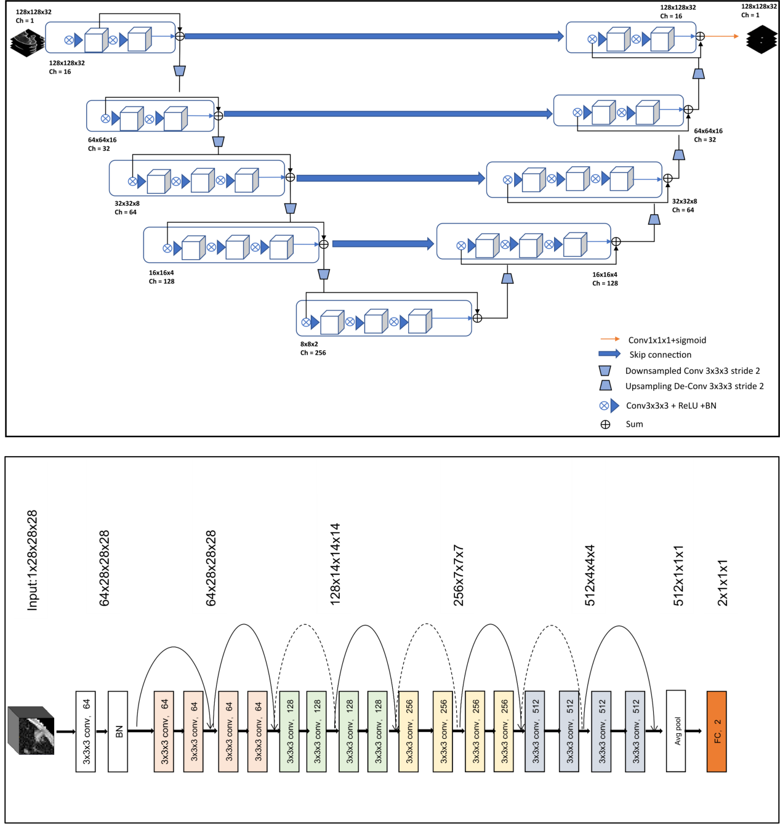
Figure S1 Network architectures of the deep learning components for pulmonary nodule analysis.

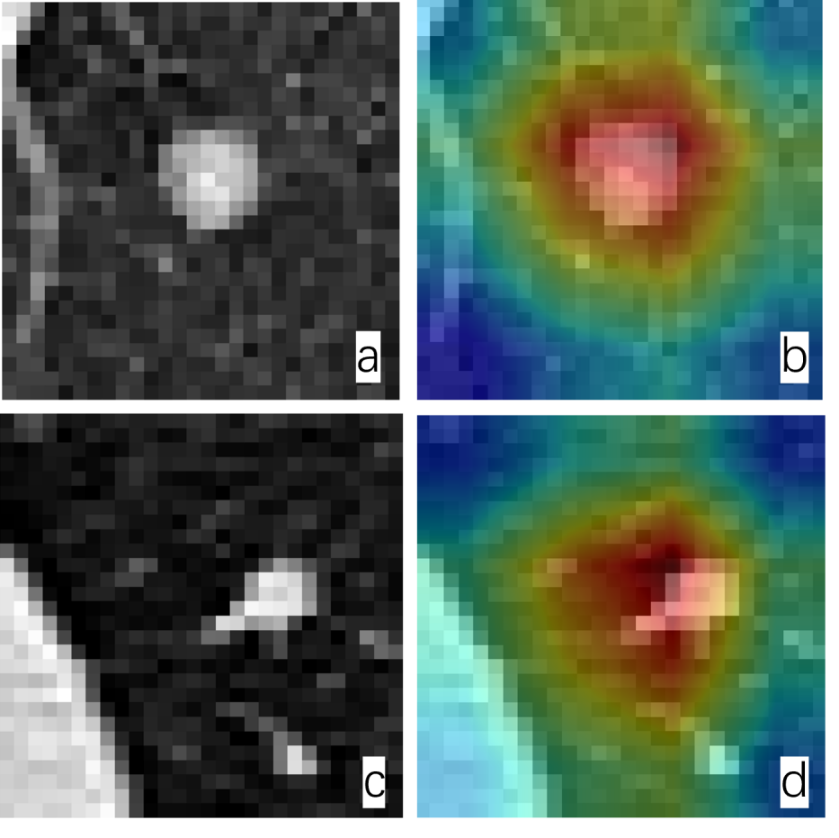
Figure S2.Grad-CAM visualization of the deep learning model for pulmonary nodule evaluation.
(a, b) Malignant Nodule Case: A 61-year-old female with stage IV rectal cancer presenting with a 10 mm pulmonary nodule, where the model predicts a high pulmonary metastasis probability of 0.999. The corresponding Grad-CAM heatmap (b) demonstrates a highly localized, high-intensity red activation core that is precisely confined within the lesion proper and its immediate heterogeneous margin features, indicating the model's dense focus on intrinsic tumor tissue.
(c, d) Benign Nodule Case: A 51-year-old female with no history of malignancy presenting with an 8 mm pulmonary nodule, where the model predicts a very low metastasis probability of 0.004. In contrast, the heatmap (d) displays a more diffuse and displaced attention pattern, where the high-activation zones conspicuously shift away from the center of the lesion, prioritizing the peri-nodular lung parenchyma and the peripheral regions containing long fibrotic bands.

