SUPPLEMENTARY MATERIALS
Table S1 Variance inflation factors (VIF) of plaque parameters
Variable | VIF | Variable | VIF
Plaque parameters
Total-CPV | 11.05 | Total-NCPV | 5.08
Total-CPAV | 10.90 | Total-NCPAV | 4.78
Branch vessel parameters
LAD-CPAV | 1.86 | LAD-NCPAV | 1.67
LCX-CPAV | 1.80 | LCX-NCPAV | 1.51
RCA-CPAV | 2.49 | RCA-NCPAV | 2.00

Table S2 Schoenfeld Residual Test for Proportional Hazards Assumption of Seven Covariates
Covariate | χ² | df | P-value
LAD-CPAV | 0.5875 | 1 | 0.4434
LAD-NCPAV | 4.3419 | 1 | 0.0372
LCX-CPAV | 0.2052 | 1 | 0.6506
LCX-NCPAV | 1.0588 | 1 | 0.3035
RCA-CPAV | 0.2477 | 1 | 0.6187
RCA-NCPAV | 1.9819 | 1 | 0.1592
CT-FFR | 0.6718 | 1 | 0.4124
Global | 9.0948 | 7 | 0.2459
Note: H₀: The proportional hazards assumption holds for each covariate. A p-value < 0.05 indicates violation of the PH assumption. The global test combines all seven covariates (df = 7).

Table S3. Number of patients in each risk group, AUC, sensitivity, specificity, and Youden index for each ROC-derived cutoff
Cutoff | AUC | 95% CI | Sensitivity | Specificity | Youden index | High-risk N | High-risk events | Low-risk N | Low-risk events
Total-CPV>68.78 mm³ | 0.655 | 0.582–0.728 | 0.672 | 0.642 | 0.314 | 157 | 45 | 224 | 22
Total-NCPV>108.81 mm³ | 0.731 | 0.668–0.793 | 0.731 | 0.671 | 0.402 | 152 | 49 | 229 | 18
Total-TPV>206.78 mm³ | 0.727 | 0.665–0.789 | 0.731 | 0.661 | 0.393 | 155 | 49 | 226 | 18
Total-CPAV>4.54% | 0.665 | 0.590–0.739 | 0.612 | 0.706 | 0.318 | 133 | 41 | 248 | 26
Total-NCPAV>4.68% | 0.745 | 0.681–0.809 | 0.731 | 0.687 | 0.418 | 147 | 49 | 234 | 18
Total-TPAV>11.11% | 0.738 | 0.675–0.801 | 0.642 | 0.735 | 0.377 | 126 | 43 | 255 | 24
Total-CPV: total-calcified plaque volume; Total-NCPV: total-noncalcified plaque volume; Total-TPV: total-total plaque volume; Total-CPAV: total-calcified percent atheroma volume; Total-NCPAV: total-noncalcified percent atheroma volume; Total-TPAV: total-total percent atheroma volume.
Table S4. Predictive hazard ratios of plaque parameters above the risk cutoff value for hard endpoints
Plaque parameter | HR | 95% CI | P value
Total-CPV>68.78 mm³ | 2.347 | 0.525–10.490 | 0.264
Total-NCPV>108.81 mm³ | 11.706 | 1.410–97.204 | 0.023
Total-TPV>206.78 mm³ | 4.729 | 0.918–24.372 | 0.063
Total-CPAV>4.54% | 3.131 | 0.701–13.988 | 0.135
Total-NCPAV>4.68% | 12.568 | 1.513–104.381 | 0.019
Total-TPAV>11.11% | 6.637 | 1.288–34.209 | 0.024
Total-CPV: total-calcified plaque volume; Total-NCPV: total-noncalcified plaque volume; Total-TPV: total-total plaque volume; Total-CPAV: total-calcified percent atheroma volume; Total-NCPAV: total-noncalcified percent atheroma volume; Total-TPAV: total-total percent atheroma volume.
Table S5. Hazard ratios of plaque parameters for hard endpoints: raw and standardized (per 1-SD) estimates
Plaque parameter | HR | 95% CI | P-value | HR per 1 SD | 95% CI | P value
Total-CPV (mm³) | 1.002 | 0.999–1.005 | 0.062 | 1.513 | 0.980–2.337 | 0.062
Total-NCPV (mm³) | 1.005 | 1.000–1.010 | 0.039 | 1.596 | 1.024–2.486 | 0.039
Total-TPV (mm³) | 1.002 | 1.000–1.004 | 0.027 | 1.616 | 1.055–2.474 | 0.027
Total-CPAV (%) | 1.073 | 1.023–1.125 | 0.004 | 1.758 | 1.201–2.572 | 0.004
Total-NCPAV (%) | 1.222 | 1.111–1.345 | <0.001 | 2.483 | 1.612–3.825 | <0.001
Total-TPAV (%) | 1.073 | 1.036–1.113 | <0.001 | 2.143 | 1.456–3.154 | <0.001
Total-CPV: total-calcified plaque volume; Total-NCPV: total-noncalcified plaque volume; Total-TPV: total-total plaque volume; Total-CPAV: total-calcified percent atheroma volume; Total-NCPAV: total-noncalcified percent atheroma volume; Total-TPAV: total-total percent atheroma volume.

Table S6 Bootstrap = 500 Internal Validation
Model | Apparent C | Optimism | Corrected Dxy | Corrected C
Plaque Parameters Model | 0.744 | 0.078 | 0.410 | 0.705
CT-FFR Model | 0.593 | 0.056 | 0.130 | 0.565
Combined Model | 0.750 | 0.084 | 0.416 | 0.708

Table S7 Brier Score (Lower is Better; 6-Parameter Plaque Model)
Model | 6-Month | 12-Month | 18-Month
Null model | 0.1064 | 0.1348 | 0.1196
Plaque model | 0.1006 | 0.1190 | 0.0996
CT-FFR model | 0.1054 | 0.1314 | 0.1138
Combined model | 0.1012 | 0.1191 | 0.0992

Table S8 Incremental Value of the Combined Model over the Plaque Model (6-Parameter Plaque Model as Reference)
Metric | 95% CI | Statistic | P
Likelihood ratio test (LRT) | — | χ² = 2.05 | 0.152
∆C-index | 0.010 (–0.027–0.046) | — | —
Continuous NRI | 0.161 (–0.105–0.281) | — | 0.219
IDI | 0.003 (–0.004–0.032) | — | 0.445
Table S9 Distribution of 67 MACE Events by Time Window
Time Window | Cumulative  Events | Proportion  (%)
≤30 days (1 month) | 17 |  | 25.4
≤60 days (2 months) | 29 |  | 43.3
≤90 days (3 months) | 36 |  | 53.7
≤180 days (6 months) | 46 |  | 68.7
≤270 days (9 months) | 48 |  | 71.6
≤365 days (12 months) | 61 |  | 91
Entire follow-up (18 months) | 67 |  | 100
Table S10 Period-Stratified Cox Regression with 90-Day Landmark (HR per 1 SD of Plaque Risk Score)
Period | Plaque Score HR  (per 1 SD) | 95% CI | P
≤90 days | 2.115 | 1.452–3.081 | <0.001
>90 days | 3.304 | 2.244–4.866 | <0.001

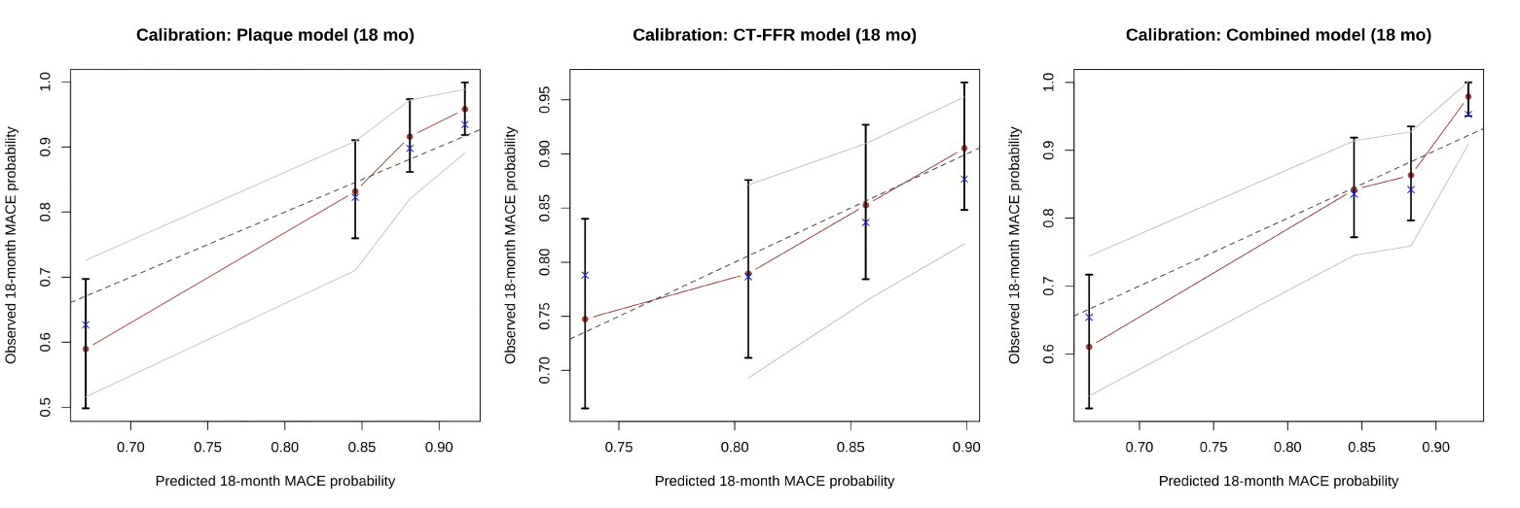
Figure S1 18-month MACE probability calibration curve (Bootstrap = 200)
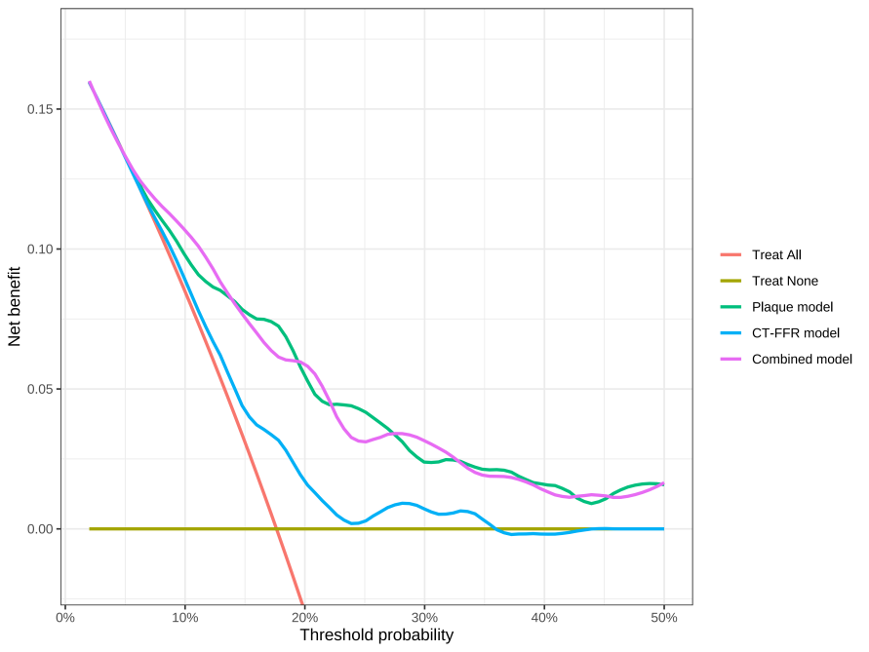
Figure S2 18-month MACE decision curve analysis (DCA)

