SUPPLEMENTARY MATERIAL

Table S1. Descriptive statistics and variability in each echotexture feature across different sizes of the region of interest. 2

Figure S1. Distribution of each echotexture feature across sizes of the region of interest. Each violin plot displays the median (white line), interquartile range (box), and kernel density estimation of the data distribution. ROI: Region of interest. 8

Table S2. Spearman's rank correlation coefficients (ρ) with 95% bootstrap confidence intervals between each echotexture feature across sizes of the region of interest (ROI). 10

Figure S2. Scatterplots of correlations between sizes of the region of interest for each echotexture feature. Feature values of the fixed-size regions of interest are matched to the indices of the whole-muscle region of interest images. ROI: Region of interest. 17

Figure S3. Example of sizes of the region of interest and corresponding Echovariation values in the same ultrasound image. EV: Echovariation; ROI: Region of interest. 18

Table S1. Descriptive statistics and variability in each echotexture feature across different sizes of the region of interest.
Features | Whole-muscle ROI  (n = 130) | ROI 300x300  (n = 130) | ROI 200x200  (n = 130) | ROI 100x100  (n = 130) | ROI 50x50  (n = 130) | Between-group (Friedman test) | Post-hoc analysis (Wilcoxon tests with Bonferroni Correction)
Echointensity | 84.06±23.47  0.26 | 94.11±23.50  0.23 | 98.00±24.58  0.26 | 108.37±26.20  0.22 | 115.37±29.88  0.25 | <0.001ª | Full-muscle vs 300x300: <0.001ª  Full-muscle vs 200x200: <0.001ª  Full-muscle vs 100x100: <0.001ª  Full-muscle vs 50x50: <0.001ª  300x300 vs 200x200: <0.001ª  300x300 vs 100x100: <0.001ª  300x300 vs 50x50:  <0.001ª  200x200 vs 100x100: <0.001ª  200x200 vs 50x50:  <0.001ª  100x100 vs 50x50:  <0.001ª
Variance | 1217.34±290.37  0.26 | 1321.83±425.14  0.39 | 1212.14±516.18  0.50 | 953.88±615.60  0.56 | 619.46±518.74  0.64 | <0.001ª | Full-muscle vs 300x300: 0.002ª  Full-muscle vs 200x200: >0.999  Full-muscle vs 100x100: <0.001ª  Full-muscle vs 50x50: <0.001ª  300x300 vs 200x200: <0.001ª  300x300 vs 100x100: <0.001ª  300x300 vs 50x50:  <0.001ª  200x200 vs 100x100: <0.001ª  200x200 vs 50x50:  <0.001ª  100x100 vs 50x50:  <0.001ª
Standard Deviation | 34.63±4.23  0.14 | 35.86±5.96  0.20 | 34.00±7.48  0.24 | 29.56±8.95  0.29 | 23.27±8.86  0.34 | <0.001ª | Full-muscle vs 300x300: 0.005ª  Full-muscle vs 200x200: >0.999  Full-muscle vs 100x100: <0.001ª  Full-muscle vs 50x50: <0.001ª  300x300 vs 200x200: <0.001ª  300x300 vs 100x100: <0.001ª  300x300 vs 50x50:  <0.001ª  200x200 vs 100x100: <0.001ª  200x200 vs 50x50:  <0.001ª  100x100 vs 50x50:  <0.001ª
Skew | 0.48±0.32  0.70 | 0.31±0.33  0.92 | 0.30±0.34  1.08 | 0.21±0.36  1.62 | 0.17±0.46  2.69 | <0.001ª | Full-muscle vs 300x300: <0.001ª  Full-muscle vs 200x200: <0.001ª  Full-muscle vs 100x100: <0.001ª  Full-muscle vs 50x50: <0.001ª  300x300 vs 200x200: >0.999  300x300 vs 100x100: 0.034ª  300x300 vs 50x50:  0.041ª  200x200 vs 100x100: 0.086  200x200 vs 50x50:  0.136  100x100 vs 50x50:  >0.999
Kurtosis | 0.01±0.58  -4.39 | -0.31±0.47  -0.78 | -0.29±0.49  -1.09 | -0.42±0.56  -0.64 | -0.36±0.61  -1.16 | <0.001ª | Full-muscle vs 300x300: <0.001ª  Full-muscle vs 200x200: <0.001ª  Full-muscle vs 100x100: <0.001ª  Full-muscle vs 50x50: <0.001ª  300x300 vs 200x200: >0.999  300x300 vs 100x100: 0.330  300x300 vs 50x50:  >0.999  200x200 vs 100x100: 0.015ª  200x200 vs 50x50:  0.295  100x100 vs 50x50:  >0.999
Correlation | 0.97±0.00  0.01 | 0.97±0.00  0.01 | 0.96±0.01  0.01 | 0.95±0.02  0.02 | 0.91±0.04  0.05 | <0.001ª | Full-muscle vs 300x300: 0.734  Full-muscle vs 200x200: <0.001ª  Full-muscle vs 100x100: <0.001ª  Full-muscle vs 50x50: <0.001ª  300x300 vs 200x200: <0.001ª  300x300 vs 100x100: <0.001ª  300x300 vs 50x50:  <0.001ª  200x200 vs 100x100: <0.001ª  200x200 vs 50x50:  <0.001ª  100x100 vs 50x50:  <0.001ª
Dissimilarity | 5.98±0.68  0.11 | 6.05±0.70  0.12 | 6.20±0.79  0.14 | 6.29±1.00  0.16 | 6.32±1.55  0.23 | <0.001ª | Full-muscle vs 300x300: 0.712  Full-muscle vs 200x200: <0.001ª  Full-muscle vs 100x100: 0.023ª  Full-muscle vs 50x50: 0.657  300x300 vs 200x200: <0.001ª  300x300 vs 100x100: 0.043ª  300x300 vs 50x50:  >0.999  200x200 vs 100x100: >0.999  200x200 vs 50x50:  >0.999  100x100 vs 50x50:  >0.999
Contrast | 61.92±13.61  0.22 | 62.49±14.03  0.24 | 65.18±15.97  0.25 | 66.15±20.87  0.29 | 66.92±34.84  0.42 | 0.013ª | Full-muscle vs 300x300: >0.999  Full-muscle vs 200x200: 0.019ª  Full-muscle vs 100x100: 0.692  Full-muscle vs 50x50: >0.999  300x300 vs 200x200: <0.001ª  300x300 vs 100x100: 0.483  300x300 vs 50x50:  >0.999  200x200 vs 100x100: >0.999  200x200 vs 50x50:  >0.999  100x100 vs 50x50:  >0.999
Homogeneity | 0.16±0.03  0.13 | 0.16±0.02  0.11 | 0.15±0.02  0.13 | 0.15±0.02  0.17 | 0.15±0.03  0.23 | <0.001ª | Full-muscle vs 300x300: 0.022ª  Full-muscle vs 200x200: <0.001ª  Full-muscle vs 100x100: <0.001ª  Full-muscle vs 50x50: <0.001ª  300x300 vs 200x200: <0.001ª  300x300 vs 100x100: <0.001ª  300x300 vs 50x50:  <0.001ª  200x200 vs 100x100: 0.159  200x200 vs 50x50:  0.302  100x100 vs 50x50:  >0.999
Angular Second Moment (ASM) | 0.00±0.00 | 0.00±0.00 | 0.00±0.00 | 0.00±0.00 | 0.00±0.00 | 0.931 | -
Energy | 0.02±0.01  0.16 | 0.02±0.01  0.16 | 0.02±0.00  0.16 | 0.02±0.00  0.20 | 0.03±0.00  0.15 | <0.001ª | Full-muscle vs 300x300: 0.083ª  Full-muscle vs 200x200: >0.999  Full-muscle vs 100x100: <0.001ª  Full-muscle vs 50x50: <0.001ª  300x300 vs 200x200: <0.001ª  300x300 vs 100x100: <0.001ª  300x300 vs 50x50:  <0.001ª  200x200 vs 100x100: <0.001ª  200x200 vs 50x50:  <0.001ª  100x100 vs 50x50:  <0.001ª
Max Probability | 0.00±0.01  0.00 | 0.00±0.01  0.00 | 0.00±0.01  0.00 | 0.00±0.00  0.00 | 0.00±0.00  0.37 | <0.001ª | Full-muscle vs 300x300: >0.999  Full-muscle vs 200x200: >0.999  Full-muscle vs 100x100: 0.003ª  Full-muscle vs 50x50: <0.001ª  300x300 vs 200x200: >0.999  300x300 vs 100x100: <0.001ª  300x300 vs 50x50:  <0.001ª  200x200 vs 100x100: <0.001ª  200x200 vs 50x50:  <0.001ª  100x100 vs 50x50:  <0.001ª
Entropy | 7.04±0.20  0.03 | 7.08±0.23  0.04 | 6.99±0.30  0.05 | 6.74±0.38  0.06 | 6.29±0.46  0.07 | <0.001ª | Full-muscle vs 300x300: 0.03ª  Full-muscle vs 200x200: 0.335  Full-muscle vs 100x100: <0.001ª  Full-muscle vs 50x50: <0.001ª  300x300 vs 200x200: <0.001ª  300x300 vs 100x100: <0.001ª  300x300 vs 50x50:  <0.001ª  200x200 vs 100x100: <0.001ª  200x200 vs 50x50:  <0.001ª  100x100 vs 50x50:  <0.001ª
Cluster Shade | 8.03±0.20  0.03 | 8.07±0.23  0.03 | 7.98±0.30  0.04 | 7.72±0.38  0.05 | 7.23±0.45  0.06 | <0.001ª | Full-muscle vs 300x300: 0.037ª  Full-muscle vs 200x200: 0.266  Full-muscle vs 100x100: <0.001ª  Full-muscle vs 50x50: <0.001ª  300x300 vs 200x200: <0.001ª  300x300 vs 100x100: <0.001ª  300x300 vs 50x50:  <0.001ª  200x200 vs 100x100: <0.001ª  200x200 vs 50x50:  <0.001ª  100x100 vs 50x50:  <0.001ª
Cluster Prominence | 10.89±0.31  0.02 | 10.92±0.32  0.03 | 10.81±0.38  0.04 | 10.45±0.46  0.04 | 9.70±0.51  0.04 | <0.001ª | Full-muscle vs 300x300: 0.79  Full-muscle vs 200x200: 0.04ª  Full-muscle vs 100x100: <0.001ª  Full-muscle vs 50x50: <0.001ª  300x300 vs 200x200: <0.001ª  300x300 vs 100x100: <0.001ª  300x300 vs 50x50:  <0.001ª  200x200 vs 100x100: <0.001ª  200x200 vs 50x50:  <0.001ª  100x100 vs 50x50:  <0.001ª
Short Run Emphasis (SRE) | 0.73±0.07  0.09 | 0.73±0.08  0.10 | 0.74±0.09  0.13 | 0.76±0.12  0.19 | 0.81±0.16  0.18 | <0.001ª | Full-muscle vs 300x300: >0.999  Full-muscle vs 200x200: >0.999  Full-muscle vs 100x100: 0.029ª  Full-muscle vs 50x50: <0.001ª  300x300 vs 200x200: 0.074  300x300 vs 100x100: 0.005ª  300x300 vs 50x50:  <0.001ª  200x200 vs 100x100: 0.005ª  200x200 vs 50x50:  <0.001ª  100x100 vs 50x50:  0.001ª
Long Run Emphasis (LRE) | 429.95±128.88  0.22 | 396.67±104.74  0.21 | 371.32±104.19  0.23 | 326.23±96.09  0.25 | 276.20±96.80  0.30 | <0.001ª | Full-muscle vs 300x300: <0.001ª  Full-muscle vs 200x200: <0.001ª  Full-muscle vs 100x100: <0.001ª  Full-muscle vs 50x50: <0.001ª  300x300 vs 200x200: <0.001ª  300x300 vs 100x100: <0.001ª  300x300 vs 50x50:  <0.001ª  200x200 vs 100x100: <0.001ª  200x200 vs 50x50:  <0.001ª  100x100 vs 50x50:  <0.001ª
Gray Level Uniformity (GLU) | 10782.22±2900.69  0.26 | 2675.19±258.78  0.09 | 1750.11±193.76  0.10 | 843.23±105.41  0.12 | 401.44±60.86  0.13 | <0.001ª | Full-muscle vs 300x300: <0.001ª  Full-muscle vs 200x200: <0.001ª  Full-muscle vs 100x100: <0.001ª  Full-muscle vs 50x50: <0.001ª  300x300 vs 200x200: <0.001ª  300x300 vs 100x100: <0.001ª  300x300 vs 50x50:  <0.001ª  200x200 vs 100x100: <0.001ª  200x200 vs 50x50:  <0.001ª  100x100 vs 50x50:  <0.001ª
Run Length Uniformity (RLU) | 17271.65±4348.38  0.21 | 7492.23±1476.92  0.19 | 3447.37±747.16  0.21 | 944.78±251.50  0.29 | 277.56±92.38  0.30 | <0.001ª | Full-muscle vs 300x300: <0.001ª  Full-muscle vs 200x200: <0.001ª  Full-muscle vs 100x100: <0.001ª  Full-muscle vs 50x50: <0.001ª  300x300 vs 200x200: <0.001ª  300x300 vs 100x100: <0.001ª  300x300 vs 50x50:  <0.001ª  200x200 vs 100x100: <0.001ª  200x200 vs 50x50:  <0.001ª  100x100 vs 50x50:  <0.001ª
Run Percentage (RPC) | 15.25±3.05  0.19 | 13.56±1.26  0.10 | 9.19±0.96  0.10 | 4.79±0.60  0.13 | 2.55±0.38  0.13 | <0.001ª | Full-muscle vs 300x300: <0.001ª  Full-muscle vs 200x200: <0.001ª  Full-muscle vs 100x100: <0.001ª  Full-muscle vs 50x50: <0.001ª  300x300 vs 200x200: <0.001ª  300x300 vs 100x100: <0.001ª  300x300 vs 50x50:  <0.001ª  200x200 vs 100x100: <0.001ª  200x200 vs 50x50:  <0.001ª  100x100 vs 50x50:  <0.001ª
Data are presented as mean ± standard deviation and robust coefficient of variation for each size of the region of interest. ª statistically significant difference (p-value<0.05); ROI: Region of interest.

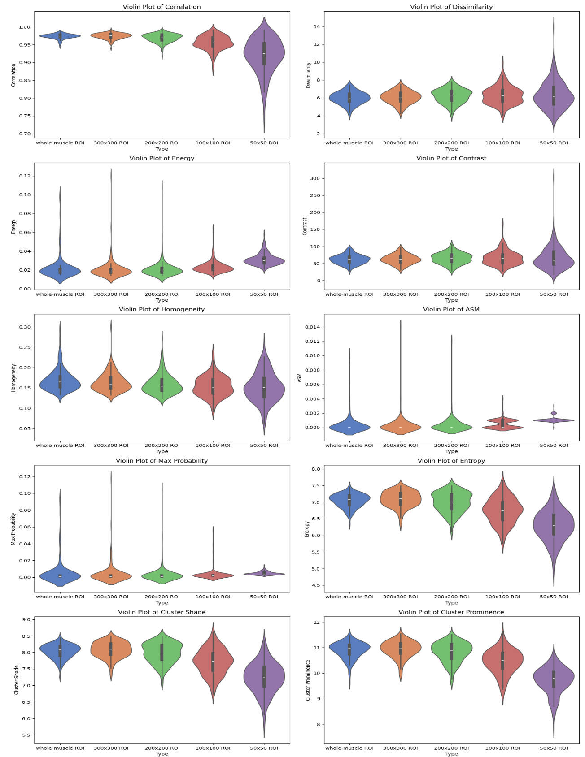
Figure S1. Distribution of each echotexture feature across sizes of the region of interest. Each violin plot displays the median (white line), interquartile range (box), and kernel density estimation of the data distribution. ROI: Region of interest.
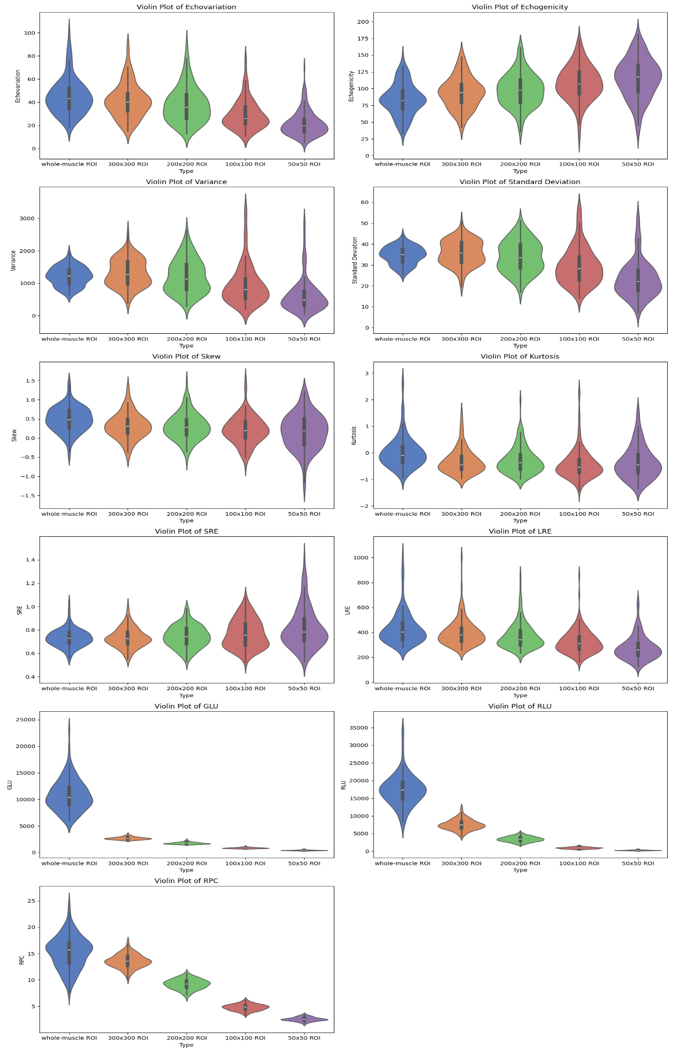

Table S2. Spearman's rank correlation coefficients (ρ) with 95% bootstrap confidence intervals between each echotexture feature across sizes of the region of interest (ROI).
Echointensity | Whole-muscle ROI | 300x300  ROI | 200x200  ROI | 100x100  ROI | 50x50  ROI
Whole-muscle ROI | -
300x300  ROI | 0.92*  (0.87, 0.95)  (p<0.001ª) | -
200x200  ROI | 0.87*  (0.80, 0.91)  (p<0.001ª) | 0.96*  (0.94, 0.97)  (p<0.001ª) | -
100x100  ROI | 0.63  (0.51, 0.73)  (p<0.001ª) | 0.77  (0.70, 0.83)  (p<0.001ª) | 0.86*  (0.80, 0.90)  (p<0.001ª) | -
50x50  ROI | 0.38  (0.22, 0.53)  (p<0.001ª) | 0.50  (0.35, 0.63)  (p<0.001ª) | 0.58  (0.44, 0.70)  (p<0.001ª) | 0.87*  (0.80, 0.91)  (p<0.001ª) | -
*correlations with ρ >0.80; ªstatistically significant differences (p-value<0.05)

Variance | Whole-muscle ROI | 300x300  ROI | 200x200  ROI | 100x100  ROI | 50x50  ROI
Whole-muscle ROI | -
300x300  ROI | 0.71  (0.61, 0.81)  (p<0.001ª) | -
200x200  ROI | 0.58  (0.45, 0.69)  (p<0.001ª) | 0.83*  (0.78, 0.88)  (p<0.001ª) | -
100x100  ROI | 0.38  (0.22, 0.55)  (p<0.001ª) | 0.56  (0.43, 0.68)  (p<0.001ª) | 0.78  (0.69, 0.85)  (p<0.001ª) | -
50x50  ROI | 0.27  (0.18, 0.41)  (p=0.002ª) | 0.41  (0.25, 0.54)  (p<0.001ª) | 0.60  (0.46, 0.70)  (p<0.001ª) | 0.75  (0.64, 0.82)  (p<0.001ª) | -
*correlations with ρ >0.80; ªstatistically significant differences (p-value<0.05)

Standard Deviation | Whole-muscle ROI | 300x300  ROI | 200x200  ROI | 100x100  ROI | 50x50  ROI
Whole-muscle ROI | -
300x300  ROI | 0.71  (0.61, 0.81)  (p<0.001ª) | -
200x200  ROI | 0.58  (0.45, 0.69)  (p<0.001ª) | 0.83*  (0.78, 0.88)  (p<0.001ª) | -
100x100  ROI | 0.38  (0.22, 0.55)  (p<0.001ª) | 0.56  (0.43, 0.68)  (p<0.001ª) | 0.78  (0.69, 0.85)  (p<0.001ª) | -
50x50  ROI | 0.27  (0.12, 0.41)  (p=0.002ª) | 0.41  (0.25, 0.54)  (p<0.001ª) | 0.60  (0.46, 0.70)  (p<0.001ª) | 0.75  (0.64, 0.82)  (p<0.001ª) | -
*correlations with ρ >0.80; ªstatistically significant differences (p-value<0.05)

Skew | Whole-muscle ROI | 300x300  ROI | 200x200  ROI | 100x100  ROI | 50x50  ROI
Whole-muscle ROI | -
300x300  ROI | 0.69  (0.58, 0.78)  (p<0.001ª) | -
200x200  ROI | 0.50  (0.35, 0.64)  (p<0.001ª) | 0.81*  (0.74, 0.87)  (p<0.001ª) | -
100x100  ROI | 0.09  (-0.07, 0.27)  (p=0.306) | 0.25  (0.09, 0.41)  (p=0.004ª) | 0.39  (0.24, 0.54)  (p<0.001ª) | -
50x50  ROI | -0.06  (-0.21, 0.11)  (p=0.534) | 0.11  (-0.05, 0.29)  (p=0.207) | 0.16  (-0.01, 0.32)  (p=0.066) | 0.52  (0.36, 0.66)  (p<0.001ª) | -
*correlations with ρ >0.80; ªstatistically significant differences (p-value<0.05)

Kurtosis | Whole-muscle ROI | 300x300  ROI | 200x200  ROI | 100x100  ROI | 50x50  ROI
Whole-muscle ROI | -
300x300  ROI | 0.48  (0.34, 0.61)  (p<0.001ª) | -
200x200  ROI | 0.28  (0.11, 0.45)  (p=0.002ª) | 0.66  (0.55, 0.77)  (p<0.001ª) | -
100x100  ROI | -0.04  (-0.22, 0.14)  (p=0.615) | 0.21  (0.04, 0.36)  (p=0.018ª) | 0.43  (0.27, 0.56)  (p<0.001ª) | -
50x50  ROI | -0.03  (-0.20, 0.15)  (p=0.766) | 0.12  (-0.05, 0.29)  (p=0.169) | 0.12  (-0.06, 0.30)  (p=0.178) | 0.42  (0.27, 0.56)  (p<0.001ª) | -
*correlations with ρ >0.80; ªstatistically significant differences (p-value<0.05)

Correlation | Whole-muscle ROI | 300x300  ROI | 200x200  ROI | 100x100  ROI | 50x50  ROI
Whole-muscle ROI | -
300x300  ROI | 0.61  (0.47, 0.71)  (p<0.001ª) | -
200x200  ROI | 0.43  (0.27, 0.57)  (p<0.001ª) | 0.71  (0.60, 0.80)  (p<0.001ª) | -
100x100  ROI | 0.29  (0.11, 0.44)  (p<0.001ª) | 0.36  (0.21, 0.51)  (p<0.001ª) | 0.66  (0.55, 0.75)  (p<0.001ª) | -
50x50  ROI | 0.25  (0.08, 0.40)  (p=0.005ª) | 0.27  (0.10, 0.42)  (p=0.002ª) | 0.48  (0.31, 0.60)  (p<0.001ª) | 0.64  (0.51, 0.74)  (p<0.001ª) | -
*correlations with ρ >0.80; ªstatistically significant differences (p-value<0.05)

Dissimilarity | Whole-muscle ROI | 300x300  ROI | 200x200  ROI | 100x100  ROI | 50x50  ROI
Whole-muscle ROI | -
300x300  ROI | 0.82*  (0.74, 0.87)  (p<0.001ª) | -
200x200  ROI | 0.73  (0.62, 0.82)  (p<0.001ª) | 0.93*  (0.90, 0.95)  (p<0.001ª) | -
100x100  ROI | 0.51  (0.35, 0.65)  (p<0.001ª) | 0.66  (0.55, 0.75)  (p<0.001ª) | 0.80*  (0.72, 0.85)  (p<0.001ª) | -
50x50  ROI | 0.37  (0.20, 0.52)  (p<0.001ª) | 0.44  (0.29, 0.57)  (p<0.001ª) | 0.51  (0.37, 0.63)  (p<0.001ª) | 0.74  (0.63, 0.81)  (p<0.001ª) | -
*correlations with ρ >0.80; ªstatistically significant differences (p-value<0.05)

Contrast | Whole-muscle ROI | 300x300  ROI | 200x200  ROI | 100x100  ROI | 50x50  ROI
Whole-muscle ROI | -
300x300  ROI | 0.82*  (0.74, 0.87)  (p<0.001ª) | -
200x200  ROI | 0.73  (0.62, 0.81)  (p<0.001ª) | 0.94*  (0.90, 0.96)  (p<0.001ª) | -
100x100  ROI | 0.54  (0.39, 0.67)  (p<0.001ª) | 0.69  (0.58, 0.78)  (p<0.001ª) | 0.81*  (0.73, 0.86)  (p<0.001ª) | -
50x50  ROI | 0.41  (0.25, 0.54)  (p<0.001ª) | 0.48  (0.34, 0.61)  (p<0.001ª) | 0.55  (0.42, 0.66)  (p<0.001ª) | 0.74  (0.65, 0.82)  (p<0.001ª) | -
*correlations with ρ >0.80; ªstatistically significant differences (p-value<0.05)

Homogeneity | Whole-muscle ROI | 300x300  ROI | 200x200  ROI | 100x100  ROI | 50x50  ROI
Whole-muscle ROI | -
300x300  ROI | 0.85*  (0.79, 0.89)  (p<0.001ª) | -
200x200  ROI | 0.75  (0.66, 0.83)  (p<0.001ª) | 0.90*  (0.85, 0.93)  (p<0.001ª) | -
100x100  ROI | 0.42  (0.23, 0.59)  (p=0.001ª) | 0.53  (0.36, 0.67)  (p<0.001ª) | 0.70  (0.58, 0.80)  (p<0.001ª) | -
50x50  ROI | 0.18  (-0.01, 0.36)  (p=0.043ª) | 0.24  (0.07, 0.41)  (p=0.005ª) | 0.33  (0.17, 0.49)  (p<0.001ª) | 0.66  (0.54, 0.76)  (p<0.001ª) | -
*correlations with ρ >0.80; ªstatistically significant differences (p-value<0.05)

Angular Second Moment (ASM) | Whole-muscle ROI | 300x300  ROI | 200x200  ROI | 100x100  ROI | 50x50  ROI
Whole-muscle ROI | -
300x300  ROI | 0.57  (0.38, 0.74)  (p<0.001ª) | -
200x200  ROI | 0.50  (0.20, 0.68)  (p<0.001ª) | 0.70  (0.54, 0.84)  (p<0.001ª) | -
100x100  ROI | 0.02  (-0.17, 0.22)  (p=0.800) | 0.29  (0.10, 0.45)  (p=<0.001ª) | 0.44  (0.28, 0.59)  (p<0.001ª) | -
50x50  ROI | -0.02  (-0.21, 0.19)  (p=0.811) | 0.09  (-0.12, 0.33)  (p=0.301) | 0.18  (-0.02, 0.39)  (p=0.036ª) | 0.38  (0.25, 0.49)  (p<0.001ª) | -
*correlations with ρ >0.80; ªstatistically significant differences (p-value<0.05)

Energy | Whole-muscle ROI | 300x300  ROI | 200x200  ROI | 100x100  ROI | 50x50  ROI
Whole-muscle ROI | -
300x300  ROI | 0.78  (0.70, 0.85)  (p<0.001ª) | -
200x200  ROI | 0.63  (0.51, 0.75)  (p<0.001ª) | 0.83*  (0.74, 0.91)  (p<0.001ª) | -
100x100  ROI | 0.20  (0.00, 0.40)  (p=0.020ª) | 0.42  (0.23, 0.59)  (p<0.001ª) | 0.64  (0.48, 0.76)  (p<0.001ª) | -
50x50  ROI | 0.03  (-0.17, 0.22)  (p=0.736) | 0.17  (-0.01, 0.35)  (p=0.047ª) | 0.33  (0.16, 0.49)  (p<0.001ª) | 0.66  (0.53, 0.77)  (p<0.001ª) | -
*correlations with ρ >0.80; ªstatistically significant differences (p-value<0.05)

Max Probability | Whole-muscle ROI | 300x300  ROI | 200x200  ROI | 100x100  ROI | 50x50  ROI
Whole-muscle ROI | -
300x300  ROI | 0.64  (0.46, 0.78)  (p<0.001ª) | -
200x200  ROI | 0.49  (0.30, 0.65)  (p<0.001ª) | 0.67  (0.51, 0.80)  (p<0.001ª) | -
100x100  ROI | 0.12  (-0.09, 0.30)  (p=0.169) | 0.28  (0.09, 0.0.46)  (p=0.001ª) | 0.39  (0.20, 0.56)  (p<0.001ª) | -
50x50  ROI | -0.02  (-0.20, 0.15)  (p=0.784) | 0.13  (-0.05, 0.31)  (p=0.155) | 0.30  (0.13, 0.47)  (p<0.001ª) | 0.47  (0.32, 0.62)  (p<0.001ª) | -
*correlations with ρ >0.80; ªstatistically significant differences (p-value<0.05)

Entropy | Whole-muscle ROI | 300x300  ROI | 200x200  ROI | 100x100  ROI | 50x50  ROI
Whole-muscle ROI | -
300x300  ROI | 0.65  (0.52, 0.75)  (p<0.001ª) | -
200x200  ROI | 0.45  (0.20, 0.59)  (p<0.001ª) | 0.83*  (0.77, 0.88)  (p<0.001ª) | -
100x100  ROI | 0.16  (-0.04, 0.35)  (p=0.071) | 0.48  (0.34, 0.60)  (p<0.001ª) | 0.74  (0.65, 0.81)  (p<0.001ª) | -
50x50  ROI | 0.06  (-0.13, 0.21)  (p=0.537) | 0.34  (0.16, 0.47)  (p<0.001ª) | 0.56  (0.42, 0.67)  (p<0.001ª) | 0.78  (0.68, 0.84)  (p<0.001ª) | -
*correlations with ρ >0.80; ªstatistically significant differences (p-value<0.05)

Cluster Shade | Whole-muscle ROI | 300x300  ROI | 200x200  ROI | 100x100  ROI | 50x50  ROI
Whole-muscle ROI | -
300x300  ROI | 0.66  (0.54, 0.75)  (p<0.001ª) | -
200x200  ROI | 0.45  (0.29, 0.60)  (p<0.001ª) | 0.83*  (0.76, 0.87)  (p<0.001ª) | -
100x100  ROI | 0.15  (-0.04, 0.34)  (p=0.087) | 0.47  (0.32, 0.60)  (p<0.001ª) | 0.74  (0.65, 0.81)  (p<0.001ª) | -
50x50  ROI | 0.05  (-0.13, 0.21)  (p=0.556) | 0.32  (0.15, 0.46)  (p<0.001ª) | 0.55  (0.42, 0.67)  (p<0.001ª) | 0.78  (0.68, 0.84)  (p<0.001ª) | -
*correlations with ρ >0.80; ªstatistically significant differences (p-value<0.05)

Cluster Prominence | Whole-muscle ROI | 300x300  ROI | 200x200  ROI | 100x100  ROI | 50x50  ROI
Whole-muscle ROI | -
300x300  ROI | 0.75  (0.66, 0.82)  (p<0.001ª) | -
200x200  ROI | 0.54  (0.39, 0.67)  (p<0.001ª) | 0.85*  (0.78, 0.90)  (p<0.001ª) | -
100x100  ROI | 0.19  (0.00, 0.38)  (p=0.033ª) | 0.48  (0.31, 0.62)  (p<0.001ª) | 0.73  (0.62, 0.81)  (p<0.001ª) | -
50x50  ROI | 0.08  (-0.10, 0.25)  (p=0.386) | 0.31  (0.13, 0.46)  (p<0.001ª) | 0.51  (0.35, 0.63)  (p<0.001ª) | 0.79  (0.71, 0.85)  (p<0.001ª) | -
*correlations with ρ >0.80; ªstatistically significant differences (p-value<0.05)

Short Run Emphasis (SRE) | Whole-muscle ROI | 300x300  ROI | 200x200  ROI | 100x100  ROI | 50x50  ROI
Whole-muscle ROI | -
300x300  ROI | 0.78  (0.68, 0.85)  (p<0.001ª) | -
200x200  ROI | 0.62  (0.48, 0.73)  (p<0.001ª) | 0.89*  (00.84, 0.92)  (p<0.001ª) | -
100x100  ROI | 0.37  (0.19, 0.53)  (p<0.001ª) | 0.59  (0.46, 0.70)  (p<0.001ª) | 0.75  (0.64, 0.83)  (p<0.001ª) | -
50x50  ROI | 0.29  (0.12, 0.46)  (p<0.001ª) | 0.42  (0.25, 0.57)  (p<0.001ª) | 0.48  (0.32, 0.62)  (p<0.001ª) | 0.68  (0.56, 0.77)  (p<0.001ª) | -
*correlations with ρ >0.80; ªstatistically significant differences (p-value<0.05)

Long Run Emphasis (LRE) | Whole-muscle ROI | 300x300  ROI | 200x200  ROI | 100x100  ROI | 50x50  ROI
Whole-muscle ROI | -
300x300  ROI | 0.83*  (0.75, 0.88)  (p<0.001ª) | -
200x200  ROI | 0.68  (0.55, 0.78)  (p<0.001ª) | 0.90*  (0.84, 0.94)  (p<0.001ª) | -
100x100  ROI | 0.41  (0.22, 0.57)  (p<0.001ª) | 0.60  (0.46, 0.72)  (p<0.001ª) | 0.80*  (0.72, 0.86)  (p<0.001ª) | -
50x50  ROI | 0.28  (0.08, 0.44)  (p=0.002ª) | 0.37  (0.20, 0.52)  (p<0.001ª) | 0.49  (0.35, 0.62)  (p<0.001ª) | 0.72  (0.61, 0.80)  (p<0.001ª) | -
*correlations with ρ >0.80; ªstatistically significant differences (p-value<0.05)

Gray Level Uniformity (GLU) | Whole-muscle ROI | 300x300  ROI | 200x200  ROI | 100x100  ROI | 50x50  ROI
Whole-muscle ROI | -
300x300  ROI | 0.41  (0.24, 0.56)  (p<0.001ª) | -
200x200  ROI | 0.32  (0.14, 0.48)  (p<0.001ª) | 0.91*  (0.85, 0.94)  (p<0.001ª) | -
100x100  ROI | 0.21  (0.03, 0.40)  (p=0.017ª) | 0.64  (0.51, 0.75)  (p<0.001ª) | 0.80*  (0.71, 0.86)  (p<0.001ª) | -
50x50  ROI | 0.18  (0.02, 0.35)  (p=0.044ª) | 0.46  (0.29, 0.60)  (p<0.001ª) | 0.56  (0.41, 0.68)  (p<0.001ª) | 0.77  (0.68, 0.84)  (p<0.001ª) | -
*correlations with ρ >0.80; ªstatistically significant differences (p-value<0.05)

Run Length Uniformity (RLU) | Whole-muscle ROI | 300x300  ROI | 200x200  ROI | 100x100  ROI | 50x50  ROI
Whole-muscle ROI | -
300x300  ROI | 0.51  (0.36, 0.65)  (p<0.001ª) | -
200x200  ROI | 0.48  (0.32, 0.61)  (p<0.001ª) | 0.91*  (0.86, 0.94)  (p<0.001ª) | -
100x100  ROI | 0.32  (0.15, 0.49)  (p<0.001ª) | 0.61  (0.49, 0.72)  (p<0.001ª) | 0.77  (0.67, 0.84)  (p<0.001ª) | -
50x50  ROI | 0.25  (0.08, 0.43)  (p=0.004ª) | 0.45  (0.29, 0.59)  (p<0.001ª) | 0.55  (0.41, 0.68)  (p<0.001ª) | 0.81*  (0.75, 0.86)  (p<0.001ª) | -
*correlations with ρ >0.80; ªstatistically significant differences (p-value<0.05)

Run Percentage (RPC) | Whole-muscle ROI | 300x300  ROI | 200x200  ROI | 100x100  ROI | 50x50  ROI
Whole-muscle ROI | -
300x300  ROI | 0.26  (0.09, 0.43)  (p=0.002ª) | -
200x200  ROI | 0.27  (0.09, 0.44)  (p=0.002ª) | 0.90*  (0.84, 0.94)  (p<0.001ª) | -
100x100  ROI | 0.22  (0.05, 0.39)  (p=0.012ª) | 0.60  (0.46, 0.72)  (p<0.001ª) | 0.77  (0.67, 0.84)  (p<0.001ª) | -
50x50  ROI | 0.22  (0.04, 0.39)  (p=0.013ª) | 0.43  (0.26, 0.57)  (p<0.001ª) | 0.56  (0.41, 0.68)  (p<0.001ª) | 0.81*  (0.74, 0.86)  (p<0.001ª) | -
*correlations with ρ >0.80; ªstatistically significant differences (p-value<0.05)

Figure S2. Scatterplots of correlations between sizes of the region of interest for each echotexture feature. Feature values of the fixed-size regions of interest are matched to the indices of the whole-muscle region of interest images. ROI: Region of interest.
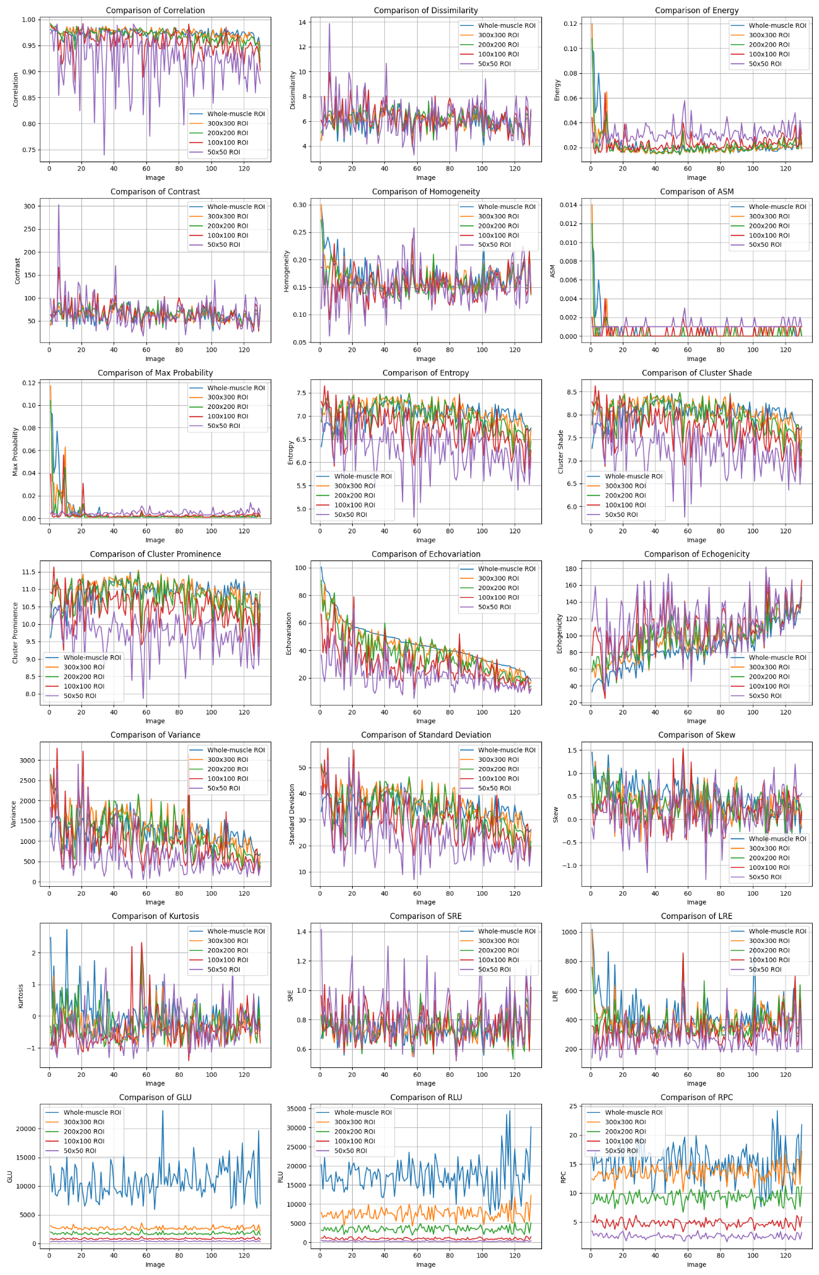

Figure S3. Example of sizes of the region of interest and corresponding Echovariation values in the same ultrasound image. EV: Echovariation; ROI: Region of interest.
