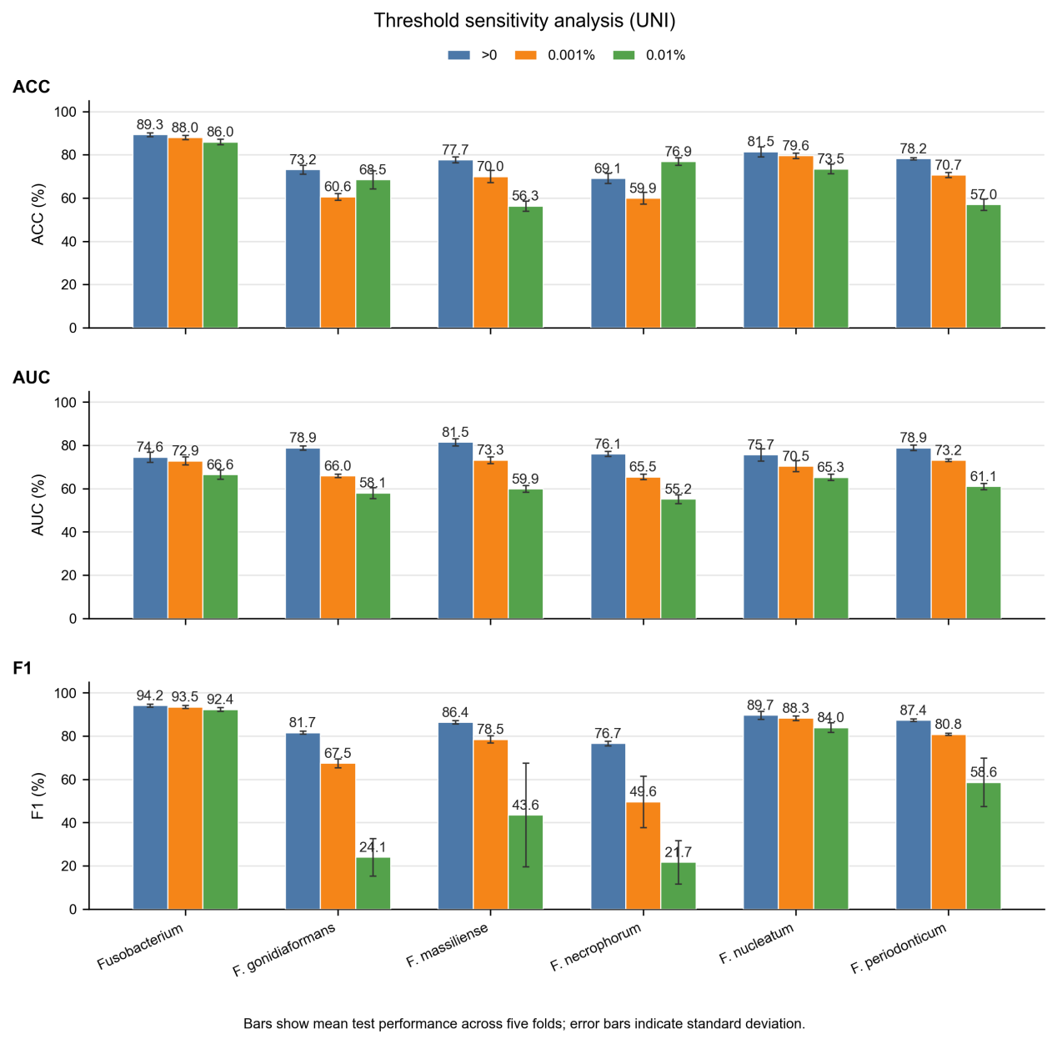
Supplementary Figure 1: Threshold sensitivity analysis for Fusobacterium-associated label prediction using the UNI model.

